Public Policy & Advocacy: Part II
4/22/09

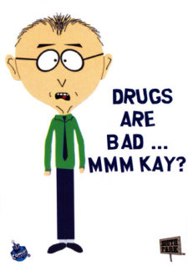
A. The Tragic War on Drugs
The Problem
- Drug use can cause a number of problems
- Current Strategy: Reduce drug supply, enforce criminalization of drug use
- By examining the consequences of the current strategy, one can predict what types of behaviors are likely to increase or decrease
Consequences of Current Strategy
- Reducing supply = increased prices
  - Demand for drugs is relatively inelastic (consistent across prices), so drug users will need to engage in additional violent and property crimes to obtain drugs
  - Selling drugs becomes increasingly profitable, increasing the number who choose to be a drug dealer; competition leads to more violence
- Reducing supply = inconsistent consumption
  - Severe withdrawal reactions
  - Overdose due to new environment,
- Criminalization modifies professional behavior
  - Police receive less reinforcement for focusing on violent crimes and murder cases
  - Prison guards, private prisons, and psychologists reinforced by current economic system
- Impact on larger society
  - System reinforces existing class structure
  - Diverts funds from education, healthcare reform, renewable energy, etc.
Potential Solutions
- Societal: Address poverty, prisons, gun control, and existing drug policy
- Personal: Editorials, moral refusal, activism

B. The Economic Recession: A Failure to Enforce Immediate Consequences for Behavior
The Problem
- Economic policy over the past 16 years has largely revolved around deregulation (e.g. the removal of contingencies)
  - Clinton: NAFTA, WTO, repeal of the Glass-Steagall Act
  - G. W. Bush: Repeal of the estate tax, tax cuts for the most wealthy
- Loss of jobs (economic well-being)
- Loss of upward social mobility (justice)
- Ethics code holds that psychologists pursue the advancement of human well-being and justice
- Economic justice and prosperity essential for optimizing societal happiness

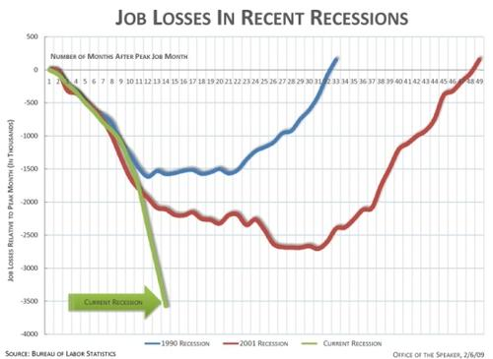

Consequences of Current Strategy
- Businesses reinforced for moving jobs to Mexico, Canada, China, and others
- Bankers reinforced for making risky investments
- System reinforces existing class structure
Possible Solutions
- Reinstate contingencies (laws) that governed the nation for decades of prosperity
- Income tax brackets:
http://www.ntu.org/main/page.php?PageID=19

