Answer Sheet

Homework #6: Working with t-tests and ANOVA

# | Question Type | Response
1 | t-test Write-up (4pts)
2 | t-test Write-up (4pts)
3 | t-test Write-up (4pts)
4 | ANOVA Write-up (4pts)
5 | ANOVA Write-up (4pts)
6 | ANOVA Write-up (4pts)
7 | Analysis Choice (1pt)
8 | Analysis Choice (1pt)
9 | Analysis Choice (1pt)
10 | Analysis Choice (1pt)
Neatness = 2pts
Homework #6
PSY 211
Due 4/8/09

SPSS Review and Working with t-tests

Instructions: Type your responses to the assigned questions on the answer sheet provided. Attach a printout of your SPSS Output after the answer sheet. Be sure to include a typed cover page too. If you include a picture of the old actor, Mr. T, on your cover page, you will receive one bonus point – a reward for carefully reading these instructions.

t-tests

For this section, you will learn to run a between-group t-test, the most commonly used type of
t-test, and the second most common statistical analysis used in the social sciences (after the correlation).

Background Information. The between-group t-test is used when you have two groups or categories of people. It lets you see how the groups differ in terms of their scores on some continuous variable (a variable with an ordered rating system, like our 1 to 9 scales, age, etc.). The t-test is basically a means to an end. It provides us with a p-value, the probability that a result is due to “chance” or “sampling error”. The p-value shows up in the Output and tells us whether the result is likely due to chance. If p < .05, the difference between groups is reliable. If not, there is no reliable difference, and we tend to ignore the result.

Running a t-test. Go to the Analyze menu, point to Compare Means, and choose “Independent-Samples T Test”

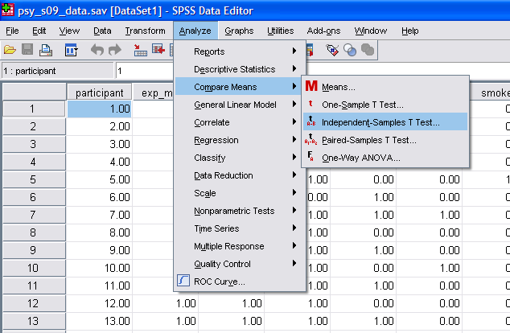

In the window that pops up, we always put the independent variable (grouping or categorical variable) in the “Grouping Variable” section of the box. In the “Test Variable(s)” box, put any continuous dependent variables you want to examine (you can choose more than one if you like). The analysis will tell us if the groups differ in terms of their scores on the “Test Variables”.

Try putting Smoking (#6) in the “Grouping Variable” area, and put ADHD Symptoms (#91) and Extraversion (#104) in the “Test Variables” section, so we can see if smokers differ on these variables. At this point you will notice that the OK button is still gray, so we need to do one more step.

Single-click where it says “smoke(? ?)” in the Grouping Variables area. Then, click on the Define Groups button. SPSS needs you to tell it which numbers were used to describe the groups. In the data file, we arbitrarily coded nonsmoker = 0 and smoker = 1, so type a 0 where is says “Group 1” and a 1 where it says “Group 2”. If you ever need to examine how variables were coded, you could use the Variable View option in SPSS or simply look in our Excel Data Guide file.

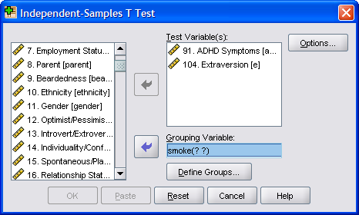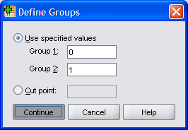

Click the Continue button, and then the OK button to run the analyses. Your Output should look something like this:

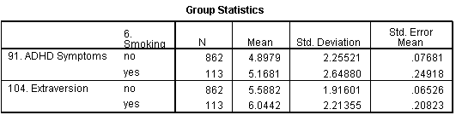

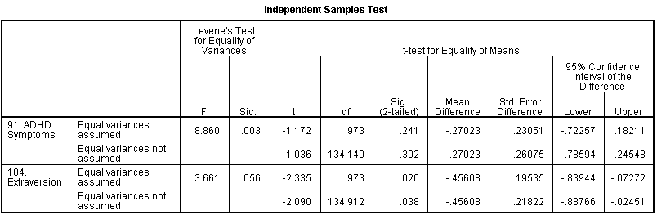

Using the top box, we see that smokers reported a marginally higher level of ADHD symptoms (M = 5.12, SD = 2.65) than did non-smokers (M = 4.88, SD = 2.56). The second box in the Output tells us whether the difference we observed in our sample is reliable. Based on the size of the difference and the number of people in our study, would we expect this difference to hold up for the population in general, or is it just a chance finding? The box tells us the t-value
(-1.172), the degrees of freedom (a reference number, 973). If we weren’t using a computer, we would compare this observed t-value to a critical t-value or cut score to determine whether the result is significant (p < .05). However, SPSS gives us the exact p-value, or the exact probability of obtaining this result by chance (.241). Basically, we’d expect to find this type of weak group difference just by chance alone 24% of the time. Because the p-value is greater than .05, the result is not statistically significant. The observed difference in our sample is not a reliable or trustworthy effect. At the population level, we would not typically expect smokers and non-smokers to differ in terms of ADHD symptoms.

In contrast, smokers (M = 5.12, SD = 2.65) scored higher than non-smokers (M = 5.12, SD = 2.65) on extraversion. The t-value (-2.335), degrees of freedom (973) and p-value (.020) are noted. For this analysis, p < .05, so the observed difference is trustworthy. At the population level, we would expect smokers to be more extraverted than non-smokers.

Questions: 4pts each
- Conduct a t-test examining whether choosing to Recycle (#2) is related to differences in ACT scores (#113). Report the results in APA style, using the APA Style Guide at the end of this assignment. Remember to calculate and include Cohen’s d (you must hand-calculate this value based on the formula in the notes).
- Conduct a t-test examining whether Support for Universal Health Care (#4) is related to differences in Racial Acceptance (#86). Report the results in APA style, using the APA Style Guide at the end of this assignment. Remember to calculate and include Cohen’s d (you must hand-calculate this value based on the formula in the notes).
- Conduct a t-test examining Gender (#11) differences in Political Views (#109). Report the results in APA style, using the APA Style Guide at the end of this assignment. Remember to calculate and include Cohen’s d (you must hand-calculate this value based on the formula in the notes).

ANOVA

ANOVA is similar to the between-group t-test. It is used when there are more than two categories or groups of people. Again, these groups are compared in terms of their scores on some continuous variable.

Go to the Analyze menu, point to Compare Means, and choose One-Way ANOVA.

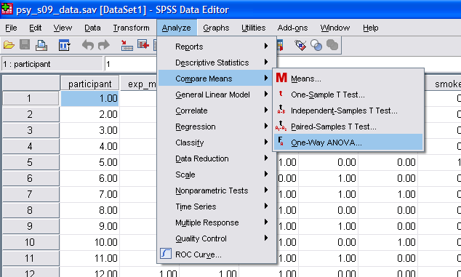

In the window that pops up, you put the categorical variable in the Factor area and the continuous dependent variable in the Dependent List area (feel free to include more than one). For practice, put Sleeping Position (#24) in the Factor area, and put Road Rage (#57) and Need for Structure (#70) in the Dependent List area. Before clicking OK, click on the Options button. Choose Descriptive in the pop-up window, telling SPSS to include basic descriptive statistics with our Output. Click Continue and then OK.

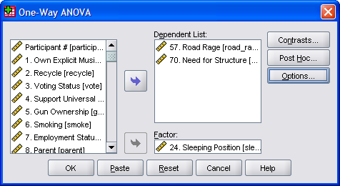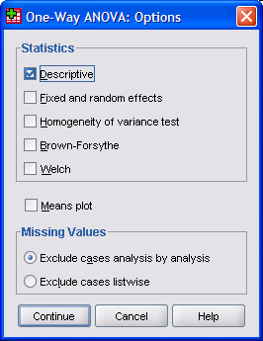

The Output should look something like this:

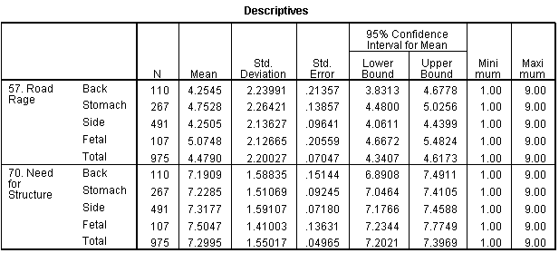

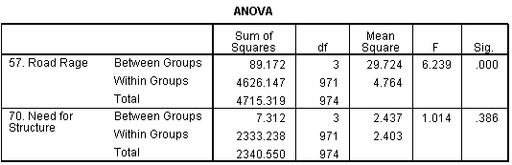

The top box is very detailed, so examine it slowly. The box tells how many people were in each group, and provides their basic descriptive statistics. For example, 107 people report sleeping in a fetal position, and as a group, they had the highest road rage scores (M = 5.07, SD = 2.13).

The second box in the SPSS Output provides the results of the ANOVA analysis, which are used to indicate whether there were any reliable differences across the groups of people. The F-value and degrees of freedom values are provided. If you are unfamiliar with these statistics from PSY 211, just be aware that they are used in the process of calculating a p-value. The p-value is listed in the table as “.000” due to rounding. [If you click on this value several times, a more exact value appears (e.g. 0.000339). The p-value can never be zero because there is always some probability that a result could be due to chance – in this case, the odds are very small.] Because p < .05, there are some reliable group differences present.

There were no significant group differences in Need for Structure because p = .39, which is obviously greater than .05. The minor mean differences in need for structure across groups are merely due to chance.

Questions: 4pts each
- Conduct an ANOVA analysis examining whether favorite Movie Genre (#23) is related to differences on the second Life Satisfaction variable (#60). Report the results in APA style, using the APA Style Guide at the end of this assignment. You do not need to include any Cohen’s d calculations but may if you like.
- Conduct an ANOVA analysis examining whether one’s Favorite Season (#22) differences in Cell Phone Use (#55). Report the results in APA style, using the APA Style Guide at the end of this assignment. You do not need to include any Cohen’s d calculations but may if you like.
- Conduct an ANOVA analysis examining whether one’s favorite Food Choice (#17) differences in Emotional Pain (#69). Report the results in APA style, using the APA Style Guide at the end of this assignment. You do not need to include any Cohen’s d calculations but may if you like.

Choosing Tests

For the following questions, indicate which statistical analysis is most appropriate for comparing the variables. Options include correlation, regression, between-group t-test, and ANOVA.

Questions: 1pt each
- What statistical analysis would be most appropriate for examining the relationship between the following variables? Sadness (#66) to predict Crying (#52)
- What statistical analysis would be most appropriate for examining the relationship between the following variables? Gender (#11) to predict Tanning (#45)
- What statistical analysis would be most appropriate for examining the relationship between the following variables? Extraversion (#104) and Neuroticism (#105) to predict Leadership (#90)
- What statistical analysis would be most appropriate for examining the relationship between the following variables? perceived Best Trait (#19) to predict Somatization (#40)

APA Style Guide
Note: You have my permission to copy any or all of this writing for this or future assignments.

Correlation Only (Significant, p < .05):

Example 1: The correlation between IQ and hours of television watched was significant, r = -.35, p = .02. That is, people who were smarter watched moderately less television.

Example 2: The correlation between IQ and hours of television watched was significant, r = -.35, p < .05. That is, people who were smarter watched moderately less television.

Include the correlation. When significant, say “p < .05” or provide the exact p-value. Then describe the results in plain English.

Correlation Only (Non-Significant, p > .05):

Example 1: IQ and number of hours of television watched were not significantly related, r = .08, p = .67. Thus, one’s level of intelligence was not related to time spent watching television.

Example 2: IQ and number of hours of television watched were not sizably related, r = .08, ns. Thus, one’s level of intelligence was not related to time spent watching TV.

Include the correlation. When non-significant, say “ns” for non-significant, or include the exact p-value. Then describe the results in plain English.

Several Correlations, followed by Multiple Regression:

Example 1: Family stress (r = .48, p < .05), work stress (r = .56, p < .05), and school stress (r = .21, p < .05) all significantly predicted overall life stress. However, social support did not predict level of life stress, r = .03, ns. Thus, although social support was not related to life stress, one’s level of school stress was slightly related, family stress was modestly related, and work stress was strongly related to level of life stress. To examine the overall contribution of the three significant predictors (school stress, family stress, and life stress) in accounting for life stress, multiple regression was used. The results of the multiple regression analysis indicate that these three predictors accounted for a large proportion of the variance in life stress, R² = .40, p < .05. Thus, school stress, family stress, and work stress together account for 40% of the differences in overall life stress.

Example 2: Several factors were hypothesized to predict college GPA. Being encouraged to read (r = .19, p = .002) and conscientiousness (r = .26, p < .001) had small positive relationships with college GPA. ADHD symptoms had a small negative relationship (r = -.17, p = .007). Hours of work per week was not correlated with GPA (r = .08, p = .22). Thus, being encouraged to read and being conscientious are related to better grades, but having ADHD symptoms is related to lower grades. The number of hours people spend on employment was not related to grades. Multiple regression was used to examine the combined effect of being encourages to read, conscientiousness, and ADHD symptoms on college GPA. These three predictors combined to modestly predict GPA, R = .33, R² = .11, p < .001. Therefore, being encouraged to read, conscientiousness, and ADHD symptoms explain 11% of the differences in college grades.

First, describe the correlational results, where you compare each of the predictors to the dependent variable. Then, provide a rationale for the regression analyses. In reporting the results, people usually include R, R², or both, followed by the p-value. Then, describe the results in plain English.
APA Style Guide (continued)

t-test (Significant, p < .05):

Example: Females (M = 2.34, SD = 2.06) tan slightly more often than males (M = 1.60, SD = 1.46), which was a significant effect, d = .42, t(298) = 3.11, p = .002. Thus, women are more likely to go tanning than men.

Be sure to include the basic descriptives (M and SD), d (calculated by hand), t, df (in parentheses), and the p-value. You may list p<.05 instead of the exact p-value if you like.

t-test (Non-Significant, p > .05):

Example: Smokers (M = 5.01, SD = 2.38) were slightly moodier than non-smokers (M = 4.50, SD = 2.18); however, this differences was non-significant, d = .26, t(298) = 1.64, p = .10. That is, smoking is unrelated to moodiness.

Be sure to include the basic descriptives (M and SD), Cohen’s d (calculated by hand), t, df (in parentheses), and the p-value. You may list ns instead of the exact p-value if you like.

ANOVA (Significant, p < .05):

Example: Music device preference was significantly related to openness to experience, F(2,297) = 4.30, p = .02. People who listen to vinyl or cassettes were highest (M = 8.33, SD = 0.78) on openness to experience, followed by .mp3 listeners (M = 6.91, SD = 1.75), followed by CD listeners (M = 6.86, SD = 1.66). People who use older music devices are more open.

Include the degrees of freedom (the top two df values in the Output), the F-value, and the p-value. Include basic descriptive statistics as well. You may calculate out a Cohen’s d to compare any two of the specific groups, if you so choose.

ANOVA (Non-Significant, p > .05):

Example: Drivers, walkers, and bikers did not differ significantly in terms of religious involvement, F(2,297) = 1.65, p = .19. Thus, transportation mode is not related to involvement with religion.

Keep the results concise. Include the degrees of freedom (the top two df values in the Output), the F-value, and the p-value. You may list ns instead of the exact p-value if you like.

