Answers

Question | Answer
1. M = | 23.21
2. Percent = | 22.1%
3. Shape = | Negative skew
4. Why atypical? | Bearded lady
5. r = | .13
6. r = | .34
7. Trait = | Openness to Experience
8. Trait = | Conscientiousness
9. Anger 1 or 2? | Anger #2
10. Why not perfectly correlated? | Any one of the following reasons:  - Questions have slightly different wording  - Same construct, but measured differently  - Measurement error  - Inconsistent or random responding by participants  - Usually variables do not correlate perfectly with anything
11. Magnitude = | Medium (or Modest)
12. Magnitude = | Small
13. Significant? | No (not significant)
14. Significant? | Yes (significant)
15. ACTs biased? | No  (no major bias, the correlations are similar for males and females)
16. Explain findings. | Among non-smokers, anxiety is only has a small correlation with cell phone throwing. Among smokers, anxiety is modestly correlated with cell phone throwing. Basically, anxiety is a bigger predictor of cell phone throwing among smokers.
17. Estimated r = | Anywhere between r = .23 and r = .63 is acceptable
18. Closely related? | No (not closely related)
19. (a) R = | .36
(b) R² = | .13
20. (a) R = | .30
(b) R² = | .09
21. Results for #5 in APA style. | The correlation between watching movies and sports participation was statistically significant, r = .13, p < .001. People who watch movies are slightly more likely to play sports.
22. Results for #19 in APA style. | Several factors were hypothesized to predict volunteering. Religious fundamentalism (r = .27, p < .001) and leadership (r = .26, p < .001) had small positive correlations with volunteering. However, intelligence was unrelated to volunteering (r = .02, p = .56). Thus, people who are more involved in religious activities or have greater leadership volunteer more, but intelligence is not related to volunteering. Multiple regression was used to examine the combined effect of religious fundamentalism and leadership upon volunteering. These two predictors combined to modestly predict volunteering, R = .36, R² = .13, p < .001. Therefore, religious fundamentalism and leadership explain 13% of the differences in volunteering.

Homework #4
PSY 285
Due 3/4/09

Rationale:
This assignment is designed to improve your competence and fluidity in running correlational analyses in SPSS and ensure you have a basic understanding of regression.

Instructions:
Your assignment should include the following:
- Typed cover sheet
- Type all answers on a neat, one-page answer sheet (you can steal the last page from this document if you like)
- Attach all SPSS Output as an appendix (-5 if missing)

Accessing the Classroom Data File

For this course, lecture notes and other basic course materials are on the course web site. However, information that must be kept private (grades, published articles, data files, etc.) is on BlackBoard. Thus, to access our data file, log on to BlackBoard:
http://blackboard.cmich.edu

Go to the Course Materials folder. There are two important files. Students who do not take a few extra minutes to thoughtfully examine these files will struggle throughout the course.

(1) An SPSS document, called Data File (psy_s09_data.sav), includes all of the survey data. This is an important file. I suggest looking over it in Data View and Variable View (see HW#2) to make sure you understand the file as well as possible. If you’re curious about any variables, you can run some basic descriptive statistics (see HW#2). To open the file, you should first download it. You can then open it through SPSS, using the File menu (File→Open→Data), or you can simply double-click on the file to open it. The double-click method sometimes does not work or takes three tries.

(2) An Excel document, called Data Guide (psy_s09_data_guide.xls), describes the data file in excellent detail. You should refer to this file for more detail about specific survey questions. If you print the file using Landscape Orientation, it should only be about 6-8 pages. I’d recommend printing it out so you can easily refer back to it throughout the semester.

Review Questions: 1pt each (refer to HW#2 if confused about how to perform the operations; remember to print off your Output and attach it to the back of your homework):

- What was the mean Age (variable #122) for our sample?
- What percentage of our participants report that their favorite season is winter or spring? See the Favorite Season variable (#22).
- What is the shape of the distribution for Food Sharing (#81)?
- Examine participant 964 on variables 1 – 12. What is atypical about this participant?
- What is the correlation between Watching Movies (#50) and Sports Participation (#56)?
- What is the correlation between Road Rage (#57) and the 2nd Anger variable (#63)?
- Of the “Big 5” personality traits (#104 - #108), which one correlates most strongly with Vocabulary (#123)?
- Of the “Big 5” personality traits (#104 - #108), which one has the weakest correlation with Laughing (#52)?
- There are two Anger variables (#34 and #63). Correlate them with Cell Phone Throwing (#100), Loving Parental Relationships (#93), and Regretfulness (#102). Which Anger variable has better construct validity?
- There are two Confidence variables (#26 and #30). Why aren’t they perfectly correlated?
- How would you describe the magnitude of the correlation (e.g. small/medium/large) between ACT Scores (#113) and Vocabulary (#123)?
- How would you describe the magnitude of the correlation (e.g. small/medium/large) between Shame (#62) and Body Satisfaction (#84)?
- Is the correlation between Text Messaging (#43) and Academic Focus (#90) statistically significant?
- Is the correlation between Text Messaging (#43) and Being Hopeful for Obama (#92) statistically significant?

Split Analyses

SPSS allows people to run correlational analyses that are split by group. For example, it is possible to compare whether the correlation between two variables differs across groups (e.g. Is the correlation between Extraversion and Happiness different for males and females?).

To split the analyses by group, go to the Data menu, and choose Split file. In the window that pops up, choose Organize Output by Groups. Then, select a categorical variable (e.g. gender, ethnicity, relationship status, etc.) and move it to the “Groups Based on” area. For this example, move Gender (#11) to the “Groups Based on” area. Then click OK.

From now on, any analyses we conduct will present separate results for males and females, rather than the entire sample.
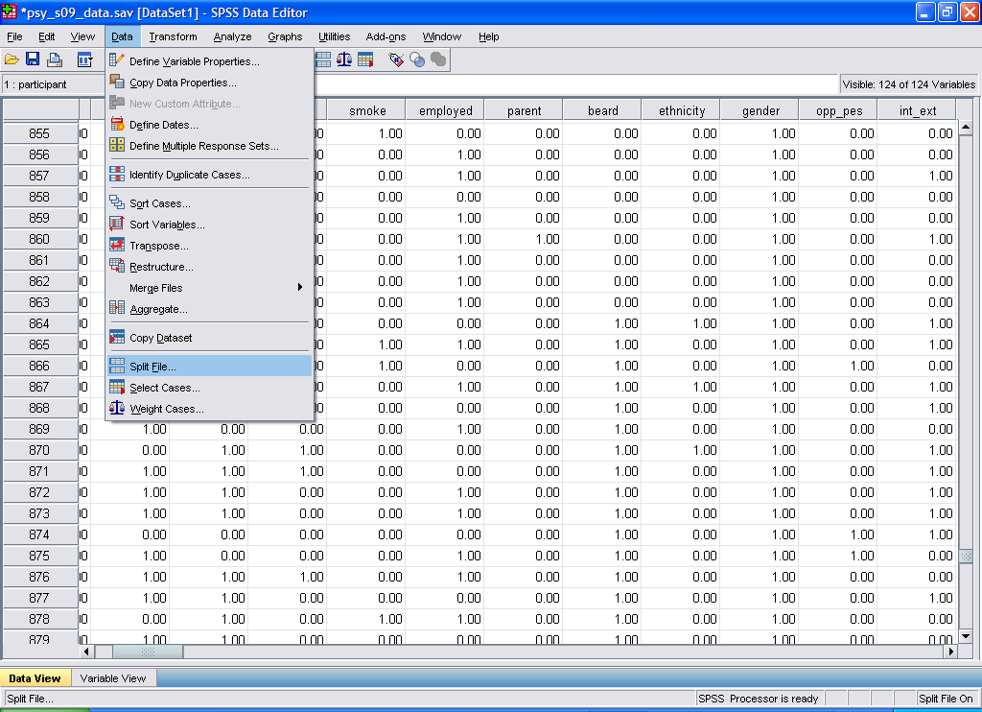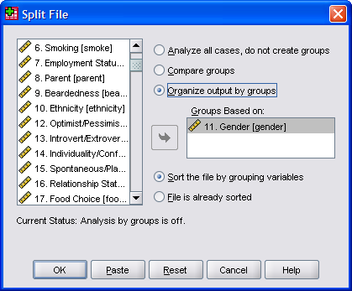

As an example, now run a correlation between Extraversion (#104) and Happiness (#64). The Output (see below) should be separated by gender. Notice that the value of the correlations differs by group. In fact, the correlation is slightly higher for males (r = .29) than for females (r = .21). This difference is relatively small, but extraversion probably plays a greater role in happiness for males than females.

11. Gender = female
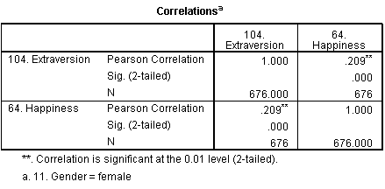

11. Gender = male
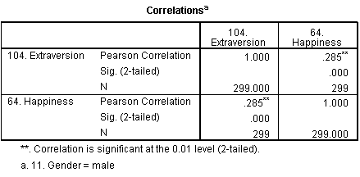

Questions: 2pts each (remember to print off your Output and attach it to the back of your homework):

- Set the file so it is split by gender. Find the correlation between ACT Scores (#113) and College Grades (#112). Based on this information, do the ACTs appear strongly biased against females?
- Now, go set the file so it is split by the Smoking variable (#6) instead of gender. Find the correlation between being Anxiety (#59) and Cell Phone Throwing (#100). How would you explain the results in plain English that a non-statistics student could understand?

Before going onto the next section, reset the split file command so that results will not be split by category. In the Split File pop-up window, click Reset. Then, click OK.

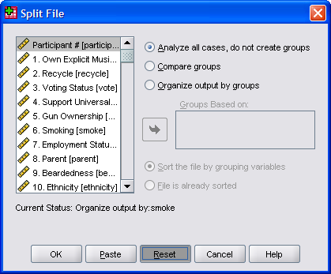

Scatterplots

Although SPSS has many statistical features, it is also useful for generating various graphs. To make a scatterplot, go to the Graphs menu, point to Legacy Dialogs, and choose Scatter/Dot (note different versions of SPSS organize menus differently, so simply find the Scatter/Dot command).

A pop-up window will appear. Select Simple Scatter and click the Define button. A new window pops up. To make a scatterplot, move one variable to the X Axis area and one to the Y axis area, then click the OK button. For example, move Anxiety (#59) to the X Axis area and Tanning (#44) to the Y Axis area; click OK.

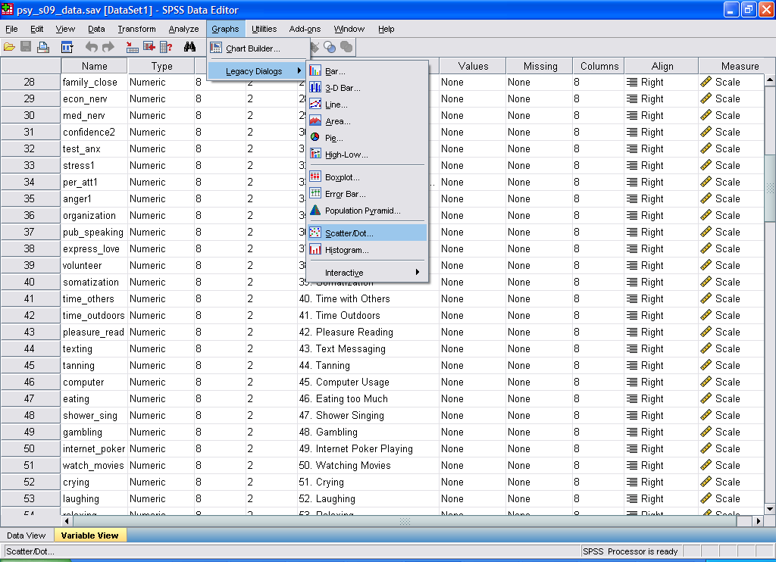

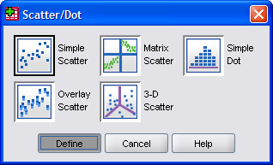

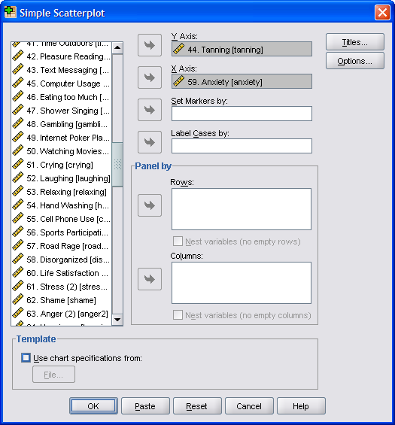
Your Output should look something like this:

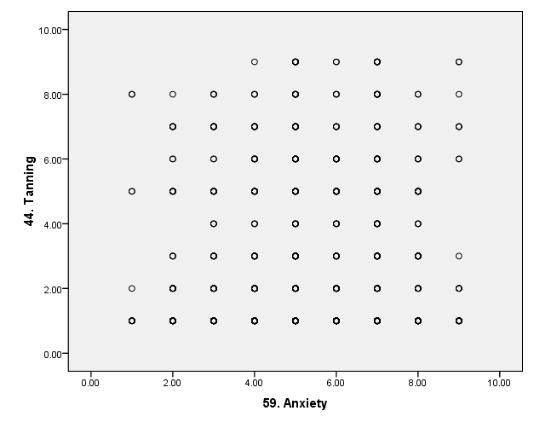

There does not appear to be much of a correlation between anxiety and tanning frequency.

Questions: 2pts each (remember to print off your Output and attach it to the back of your homework):

- Make a scatterplot with High School Grades (#111) on the X Axis and ACT Scores (#113) on the Y Axis. By estimating, what is the approximate correlation between the two variables?
- A friend of yours says that if you keep working so hard, you’re going to get stressed out. Make a scatterplot comparing Hours of Work (#121) to the 1st Stress variable (#32). Are the two variables closely related?

Multiple Regression

When conducting correlational analyses, you may be disappointed to see that correlation values are often fairly small. The main reason for this is that behavior is multidetermined. Usually several different factors combine to make people who they are and behave in certain ways.

Multiple regression allows us to examine how well several factors combine to predict a single variable. Instead of the symbol r, we use R to represent a correlation when using multiple regression. R values are interpreted the same way as r values for the most part, but R simply shows how well multiple variables combine to predict some outcome. R ranges from 0 to 1.

Multiple regression has three steps.
- Come up with a theory. For example, we might think that having loving parental relationships (#93), time for leisure (#103) and a good education (#110) all combine to make people happy (#64).
- Test that theory with correlations (just like you learned to conduct previously). For example, see whether these three hypothesized variables actually correlate with happiness (then, compare to the correlation table below). Our theory was partially correct. Loving parental relationships and satisfaction with leisure time both correlated with happiness. However, one’s level of education did not correlate significantly.
- After figuring out which variables correlate with the desired outcome, see how well they combine to predict the outcome using multiple regression. For example, we can examine the combined effect of loving parental relationships and leisure satisfaction on happiness, using one big correlation. We ignore the education variable because it was unrelated to happiness. For an explanation of how to run multiple regression, see below.

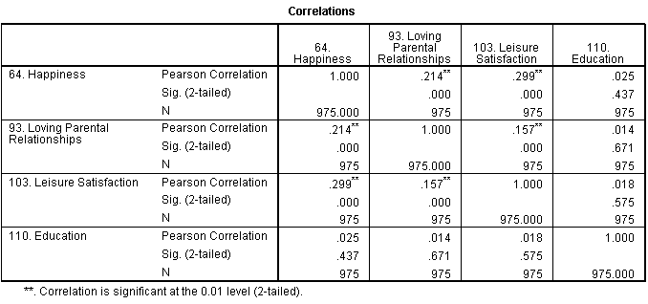

The multiple regression analyses are not very difficult. Simply go to the Analyze menu, point to Regression, and choose Linear.

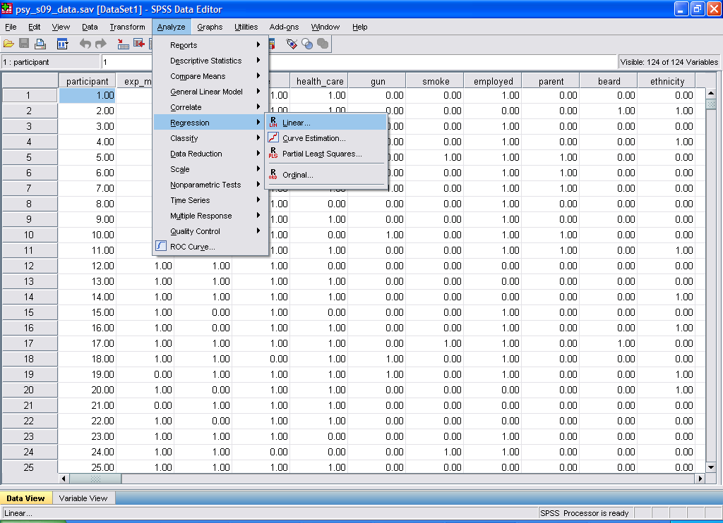

A window pops up. Where it says Independent(s), we enter our Independent variables, the predictors or causes (usually there are several). Where it says Dependent, we enter the single dependent variable, which is also known as the outcome variable or effect. To practice using our example, enter Happiness (#64) for the Dependent variable. Enter Loving Parental Relationships (#93) and Leisure Satisfaction (#103) in the Independents section. Leave out the Education variable because we already know it’s unrelated from running the correlations. Then, press OK.

The Output should look something like this:

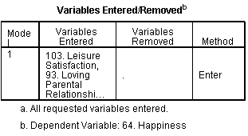
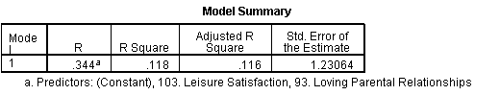
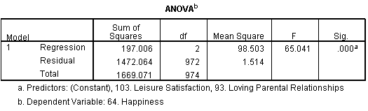
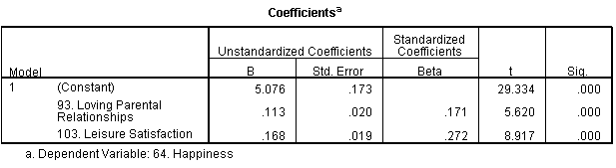

In this entire section of Output, we can actually ignore most of the information. Everything we need is in the 2nd and 3rd boxes.
- The box I have shaded blue (where it says “R”) is the R value. It is similar to the r-values you’re already familiar with; however, it indicates the combined effect of both predictors. In this case, loving parental relationships and leisure satisfaction combine to correlate R = .34 with happiness. That is, together they modestly predict happiness.
- The R Square value in the red box stands for R² and is similar to r². It tells how much of the variability in the outcome variable we’re able to account for. In this example, loving parental relationships and leisure satisfaction account for 12% of the variability in happiness.
- Finally, in the green box is a p-value, similar to the p-values you’ve already learned about. If p<.05, the finding is trustworthy. It is obviously lower than .05, so the finding is trustworthy.

Questions: 2pts each (remember to print off your Output and attach it to the back of your homework):

- Your friend says that Religious Fundamentalism (#77), Leadership (#89), and Intelligence (#94) all lead someone to do more Volunteering (#38). Examine these correlations. If any of these variable significantly correlate with volunteering (p<.05), incorporate them into a multiple regression. What is the R value using the significant predictors to predict volunteering? What is the R² value?
- Your friend argues that someone you know has very little Family Closeness (#27) due to several factors, including problems Expressing Love (#37), being Financially Distressed (#99), and Neuroticism (#105). Examine these correlations. If any of these variable significantly correlate with family closeness (p<.05), incorporate them into a multiple regression. What is the R value using the significant predictors to predict family closeness? What is the R² value?

Reporting Results

Questions: 2pts each
- Using the APA-style guide on the next page, report the results from question #5 in APA format.
- Using the APA-style guide on the next page, report the results from question #19 in APA format.

APA Style Guide
Note: You have my permission to copy any or all of this writing for this or future assignments.

Correlation Only (Significant, p < .05):

Example 1: The correlation between IQ and hours of television watched was significant, r = -.35, p = .02. That is, people who were smarter watched moderately less television.

Example 2: The correlation between IQ and hours of television watched was significant, r = -.35, p < .05. That is, people who were smarter watched moderately less television.

Include the correlation. When significant, say “p < .05” or provide the exact p-value. Then describe the results in plain English.

Correlation Only (Non-Significant, p > .05):

Example 1: IQ and number of hours of television watched were not significantly related, r = .08, p = .67. Thus, one’s level of intelligence was not related to time spent watching television.

Example 2: IQ and number of hours of television watched were not sizably related, r = .08, ns. Thus, one’s level of intelligence was not related to time spent watching TV.

Include the correlation. When non-significant, say “ns” for non-significant, or include the exact p-value. Then describe the results in plain English.

Several Correlations, followed by Multiple Regression:

Example 1: Family stress (r = .48, p < .05), work stress (r = .56, p < .05), and school stress (r = .21, p < .05) all significantly predicted overall life stress. However, social support did not predict level of life stress, r = .03, ns. Thus, although social support was not related to life stress, one’s level of school stress was slightly related, family stress was modestly related, and work stress was strongly related to level of life stress. To examine the overall contribution of the three significant predictors (school stress, family stress, and life stress) in accounting for life stress, multiple regression was used. The results of the multiple regression analysis indicate that these three predictors accounted for a large proportion of the variance in life stress, R² = .40, p < .05. Thus, school stress, family stress, and work stress together account for 40% of the differences in overall life stress.

Example 2: Several factors were hypothesized to predict college GPA. Being encouraged to read (r = .19, p = .002) and conscientiousness (r = .26, p < .001) had small positive relationships with college GPA. ADHD symptoms had a small negative relationship (r = -.17, p = .007). Hours of work per week was not correlated with GPA (r = .08, p = .22). Thus, being encouraged to read and being conscientious are related to better grades, but having ADHD symptoms is related to lower grades. The number of hours people spend on employment was not related to grades. Multiple regression was used to examine the combined effect of being encourages to read, conscientiousness, and ADHD symptoms on college GPA. These three predictors combined to modestly predict GPA, R = .33, R² = .11, p < .001. Therefore, being encouraged to read, conscientiousness, and ADHD symptoms explain 11% of the differences in college grades.

First, describe the correlational results, where you compare each of the predictors to the dependent variable. Then, provide a rationale for the regression analyses. In reporting the results, people usually include R, R², or both, followed by the p-value. Then, describe the results in plain English.
Answer Sheet

Question | Answer
1. M =
2. Percent =
3. Shape =
4. Why atypical?
5. r =
6. r =
7. Trait =
8. Trait =
9. Anger 1 or 2?
10. Why not perfectly correlated?
11. Magnitude =
12. Magnitude =
13. Significant?
14. Significant?
15. ACTs biased?
16. Explain findings.
17. Estimated r =
18. Closely related?
19. (a) R =
(b) R² =
20. (a) R =
(b) R² =
21. Results for #5 in APA style.
22. Results for #19 in APA style.

