Experiments IV
4/1/09

A. Overview
Factorial Designs
- Study involving more than one categorical independent variable
- Examine the effects of anxiety and mortality salience on war support, both within the same experiment
Factorial Matrix
Anxiety Level
low high
low  MS | low A, low MS | high A, low MS
high | low A, high MS | high A, high MS

Anxiety Level
low high
low  MS | 3.6 | 4.9
high | 5.3 | 7.8

Notation
- Factor = categorical independent variable
- Level = category of the factor
- Condition = experimental group or cell
- Summarized using numbers
  - 2 x 3
  - 2 x 4 x 8
  - # of Factors = # of numbers
  - # of Levels on a factor = numbers themselves
  - # of conditions = product of the numbers
B. Main Effects
Introduction
- Definition: Overall effect of a single independent variable
- Refers to a significant mean difference among levels on a factor
- Can be as many main effects as there are factors

Anxiety Level
low high
4.25

6.55
low  MS | 3.6 | 4.9
high | 5.3 | 7.8

4.45 6.35

There is a main effect of anxiety on war support. There is also a main effect of mortality salience upon war support.

Anxiety Level
low high
4.85

7.90
low  MS | 4.8 | 4.9
high | 8.0 | 7.8

6.40 6.35

There is a main effect of mortality salience on war support; however, anxiety is unrelated to war support.

Graphs
- One IV goes on the X-axis (bottom)
- Any additional IVs require a key and are represented using different lines or bars
- The DV goes on the Y-axis (side)

One-way, no main effect

One-way, main effect
2 x 2, no main effects

2 x 2, one main effect

2 x 2, one main effect

2 x 2, two main effects
2 x 4, two main effects

C. Interactions
Introduction
- Most difficult concept in PSY 285?
- Definition: Occurs when the effect of one independent variable depends on the level of another independent variable

Is CBT or psychodynamic therapy related to lower depression scores?

Answer: it depends! Let’s look at depression scores.

Personality Type
Open-minded Avoidant
28.5

28.0
CBT  Therapy | 40 | 17
Dynamic | 15 | 41

27.5 29.0

There is no main effect of personality type or therapy on depressive symptoms. However, there is an interaction between personality and therapy type. Open-minded people do better in dynamic therapy, whereas avoidant people do better in CBT.

Are loud obnoxious commercials more effective than typical commercials in affecting consumer behavior?

Answer: it depends! Let’s look at the percentage of people who start buying the product.

Commercial
Obnoxious Typical
16%

15%
Rare  Frequency | 25% | 7%
Often | 6% | 24%

15.5% 15.5%

There is no main effect of commercial type or frequency, but there is an interaction. Obnoxious commercials are effective when used rarely, and typical commercials are effective when used often.

D. Main Effects and Interactions Combined

Commercial
Obnoxious Typical
21%

20%
Rare  Frequency | 25% | 17%
Often | 6% | 34%

15.5% 25.5%

There was a main effect for commercial type but not frequency. Typical commercials, on average, worked better than obnoxious commercials. However, an interaction was also present. Specifically, typical commercials worked best when used often, whereas obnoxious commercials worked best when used rarely.

For lots of good examples of graphs, check out this psychwiki page…

http://www.psychwiki.com/wiki/What_is_an_Interaction%3F
1
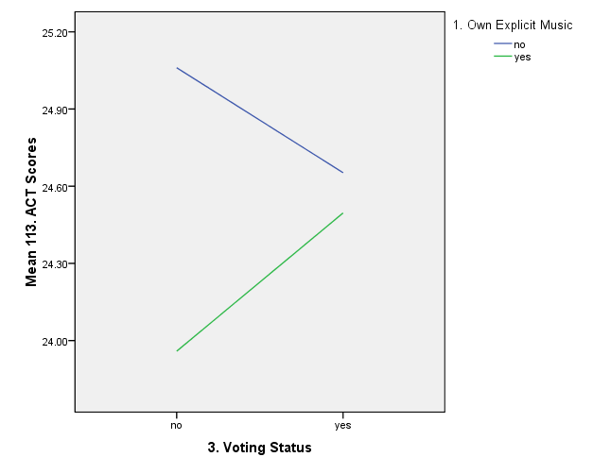

2
3
4
5

