Correlations: Part I, The Basics
2/23/08
A. Overview
Correlation Coefficient
- Several types, but the Pearson correlation coefficient (r) is the most common
- Numeric value indicating the direction and strength of the relationship between two variables, ranges from -1.00 to +1.00
  - Should involve two continuous variables with relatively normal distributions
  - Can involve dichotomous variables, but may weaken results
Direction
- Positive = direct relationship
  - As X increases, Y increases
  - As X decreases, Y decreases
- Negative = inverse relationship
  - As X increases, Y decreases
  - As X decreases, Y increases
Magnitude
impossible! | more extreme than +1.00
large | +.50 to +1.00 | positive  (direct)
medium | +.30 to +.49 | positive  (direct)
small | +.10 to +.29 | positive  (direct)
zero / near-zero | 0 ish
small | -.10 to -.29 | negative  (inverse)
medium | -.30 to -.49 | negative  (inverse)
large | -.50 to -1.00 | negative  (inverse)
impossible! | more extreme than -1.00

- Coefficient of Determination (r²): The proportion of the differences in one variable that can be explained by another
Direct Relationship, r = +.55
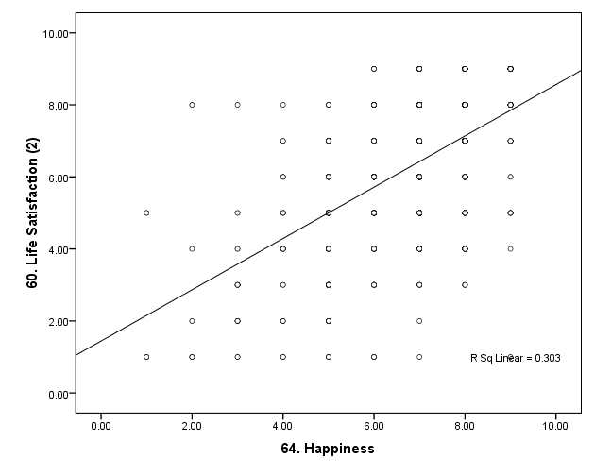
Inverse Relationship, r = -.34
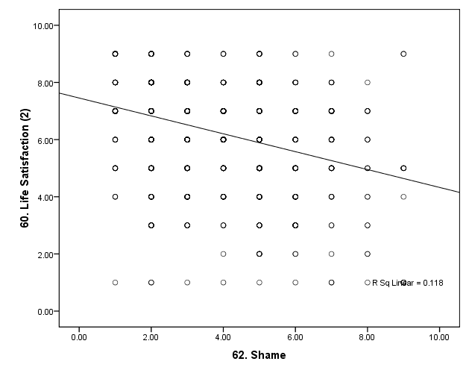

Practice Questions
If the correlation between hours studying and exam grades is r = .50, what is the coefficient of determination, and what does it mean?
Coefficient of determination = r² = .50*.50 = .25
This means that studying explains 25% of the differences in exam grades. Other factors account for the remaining 75% of the variability in exam grades.

If the correlation between depression and body satisfaction is r = -.30, what is the coefficient of determination, and what does it mean?
Coefficient of determination = r² = -.30*-.30 = .09
This means that depression accounts for 9% of the individual differences in body satisfaction. Other factors account for the remaining 91%.

Name the direction for each correlation.
Describe the magnitude.
r = .52

r = -.18

r = -.49

r = 1.03

r = -.09

B. Identifying Magnitude from Scatterplots

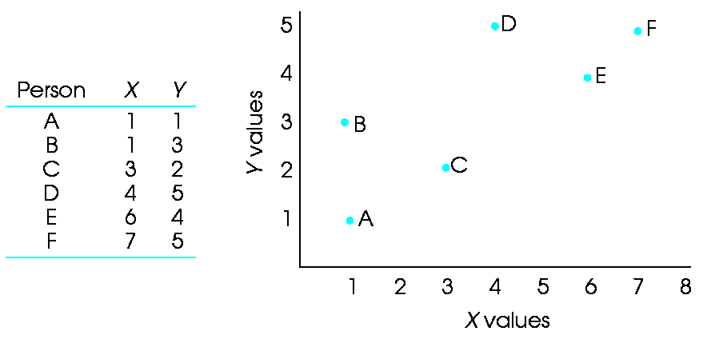

Find the correlation coefficient for these scatterplots:

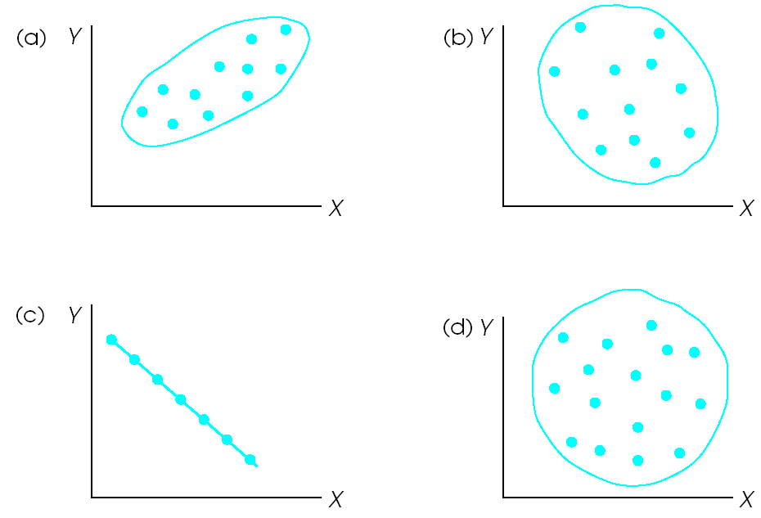
Rule of thumb:
stick = 1.0, hot dog = 0.8, sub sandwich = 0.5, egg = 0.3, circle = 0.0
If you can tell the difference between an egg and a bratwurst, you’re in good shape
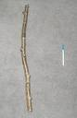
C. Factors that Impact the Correlation Coefficient
Outliers
- Can increase or decrease. Should use a priori decision rules
- Usually not a major factor
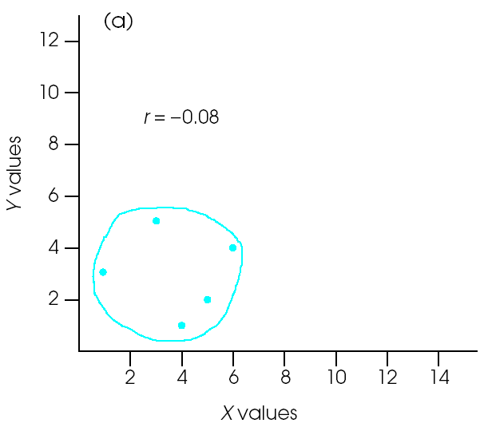
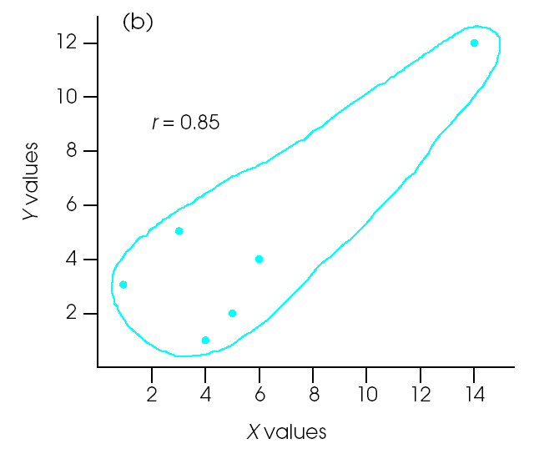
Range Restriction
- Findings are often similar across studies, but when they are not, range restriction might be the problem
- Correlation coefficient represents the amount that two variables co-vary, or vary together
  - Cannot have co-variation without variation
  - Correlation coefficients thrive on variability
- When the range is restricted or variability is quite low, correlations will be weaker
- When there is good variability, correlations will be strong

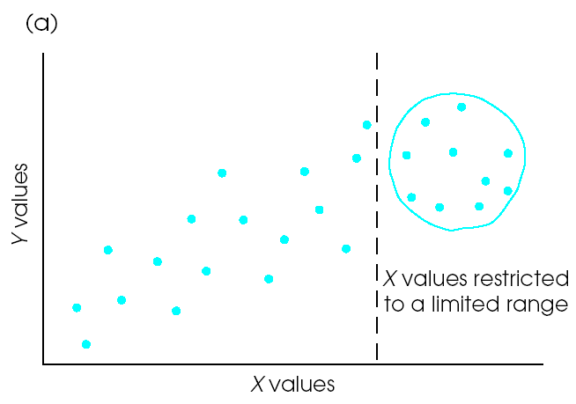
Examples | Restricted Range | Normal  Range | Exaggerated Range
IQ | College | Community | Poker tables
Emotional Display | Schizoid | Community | General Inpatient ward
Wealth | College | Most Communities | San Francisco

Measurement Reliability
- Measurement error deflates correlation coefficients
- Poorly measured constructs underestimate true correlations
- Reliably measured constructs more accurately estimate true correlations
- Ways to improve reliability:
  - More items / observations
  - More judges / raters
  - Include ratings occurring over time

Example
Do people with high scores on schizotypy have decreased emotional reactions to positive affective stimuli?
Bad:
- Single-item happiness scale after one stimulus
Good:
- Multi-item emotion rating scales
- Behavioral rating scales
- Open-ended responses
- Multiple time points
- Multiple affective stimuli

