Surveys
9/24/08

A. Definition
- Structured set of questions, generally used to gauge individual difference on constructs or behavior

B. Different Types
Type | Strengths | Weaknesses
Paper | Simple, easy, researcher can answer any questions | Expensive, poor for environment, time-consuming to administer and score
Electronic | Cheap, efficient, good for providing feedback, good for large samples, can be completed any time anywhere by anyone |   Difficulty of long surveys, risk of random responding, complexity of coding
Interview | Good for highly personal data, details, or conditional questioning | Very time-consuming, expensive recordings, difficult to code
Phone | Good for gathering other-report data | Difficult to provide instructions, possibly expensive

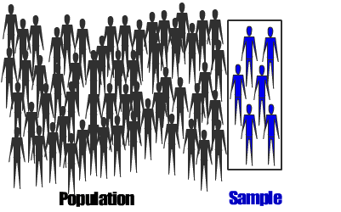

C. Samples
Population vs. Sample
- Population: everyone you
want to draw conclusions about
  - Depressed people, ADHD children, lawyers, Americans
- Sample: people actually used in the study
Types of Samples
- Convenience sampling: Use whoever is available, usually college students
- Probability sampling: Attempt to accurately characterize the population as much as possible
  - Random, stratified, and cluster
Impact of Samples
- Sampling error: Differences in results that vary by sample
- Basic descriptive statistics, such as M, SD, and percentages are highly vulnerable to sampling error
- Advanced descriptive statistics that describe the relationship between variables (e.g. r ) are more stable across samples
  - Thrive on variability, so weakened by range restriction

D. Question Wording Tips
- Parsimony is key. Keep it simple.
- Avoid compound sentences
- Avoid abbreviations, slang/colloquialisms, jargon
- Avoid the word “not”

E. Response Scales
Open-ended
- Good qualitative detail
- Can guide future research or improve experimental design
- Difficult to translate into quantitative data
Closed-ended: Categorical
- Like multiple choice tests, Y/N, T/F, etc.
- Categories should include all important responses
- Avoid DK, NA, and Other options
- Effect sizes (e.g. r ) thrive on variability, so avoid dichotomizing continuous variables
Closed-ended: Continuous with Anchors
- Numeric scale where each number has an “anchor” or label
- Easily rated, necessary when norms are needed
Closed-ended: Continuous w/ 2 or 3 Anchors
- Use a numeric scale with labeled “anchors” at the mid point (optional) and extreme values
- Participants can respond quickly
- Slightly less reliable, but fine for research
Closed-ended: Hash marks and Sliders
- Most precise
- Most reliable?
- Time-consuming to score paper-and-pencil versions

F. Psychometric Properties
Good survey items
- Have a broad range of means
- Have high variability
- Correlate well with other survey items and total scores

G. Survey Feedback
- Recall from ethics lecture, researchers should aim to make participation enjoyable
- Relatively innocuous feedback increases enjoyment of research, facilitates voluntary participation
- Computer scoring + researcher feedback
- Computer scoring + conditional logic and automated feedback
- Good for clinical skills

