Small N Designs
11/19/08

A. Overview
- Large sample sizes can be difficult to obtain
- Some researchers reject the idea that bigger samples are better
- Historical factors have contributed to the rise and fall of particular methodologies

B. Case Studies
Overview
- Detailed accounts of single cases
- AKA case histories, case reports
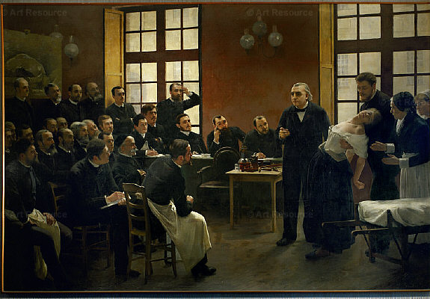
- Various types
  - Prototypes
  - Extreme cases
  - Critical incidents
Early Examples
- Charcot
- Freud
Modern Examples
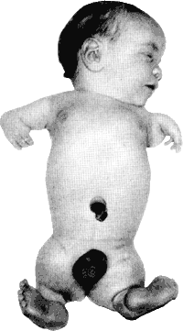
- Thalidomide
- Fetal Alcohol Syndrome
- SSRI-induced suicidality
- Eye Movement Desensitization and Reprocessing (EMDR)
Advantages
- Excellent detail
- Focuses attention, facilitating more comprehensive research
- Useful when a single incident proves a claim
- Promotes discussion and prevention
- Provides a narrative that facilitates action
Disadvantages
- Prone to biases, both of the researcher and the subject
- Facilitates pseudoscience
- Poor external validity
- Difficult to show internal validity

C. A Statistical Uprising
Shifting Zeitgeist
- Disenchantment with case studies and informal methods of drawing conclusions
- WWI and WWII: Focus on selecting military recruits, and thus individual differences
- Shift from idiographic to nomothetic approach
New Statistics

- Early 1900s
- Pearson and Galton discover new statistical techniques, including correlation, regression, and chi-square
- While working for Guinness, Gosset (Student) discovers the t-test
- Fisher develops the use of inferential statistics

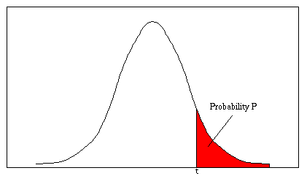
D. An Anti-Inferential Backlash
Statistical Considerations
- Any effect size (even r = .01) will be statistically significant, given a large enough sample size
- Leads to poorer science
  - Rather than attempting to control behavior, researchers simply see if, on average, one group scores higher than another
Rise of Behaviorism
- Rather than attempting to get a reliable result by using larger and larger samples, instead exercise closer experimental control
- Used to develop basic principles of learning, involving operant conditioning
- Basic vs. applied research

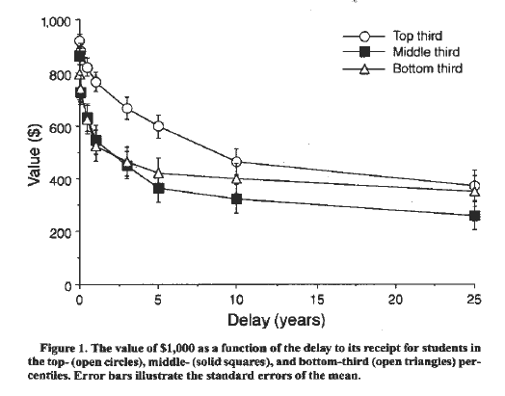

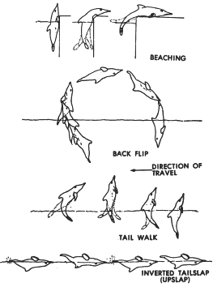
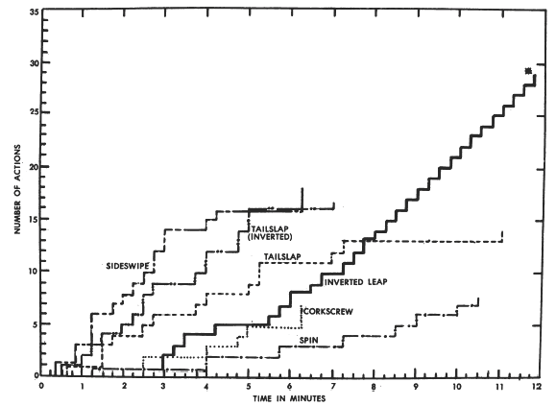
E. Single-Subject Design
Overview
- Study an individual (or small sample) in detail
- Like a case study, but much more focus on data and control
- Terminology
  - A = baseline phase, where data is collected in absence of any treatment
(a control phase)
  - B = some treatment or manipulation
  - C, D, E, etc = other treatments
  - B₁, B₂, B₃ = variation of same treatment
- Measurements of some DV gathered over time during each stage
Common Designs
- A-B
- A-B-A
- A-B-A-B
- Multiple baselines
- Changing Criteria
Strengths
- High control; get results or keep monitoring the intervention until desired results are obtained
- Excellent for applied clinical care; changing simple behaviors or physiological processes
Weaknesses
- Low external validity
- Data collection is extensive and tedious
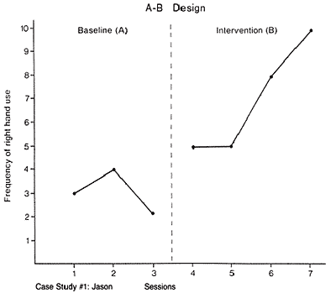

Frequency of Emotion Words

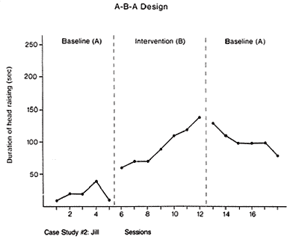

Minutes Spent Reading Each Day

Multiple Baselines (Same individual, two different behaviors)

