Science of Psychology
8/27/08
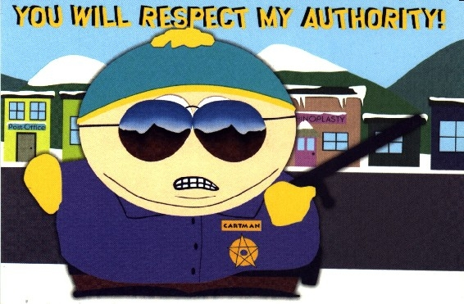
A. Epistemology
Background
- Definition: theory of knowledge
- What is knowledge?
- How do we know what we know?
Authority
- Relying upon an expert or respected source of information
- Quick, easy, often accurate
- May be biased due to a vested interest in a particular point of view
  - Does information on the benefits of an SSRI come from a drug company commercial or a textbook?
  - Does information on nuclear power come from General Electric or a university’s engineering department?
- Experts can disagree significantly
- If an expert comments outside their area of study, they are no longer an expert
  - Socrates example (Appendix)
  - Bill Clinton on Democracy Now!
Reason
- Logic, a priori knowledge, persuasion, or theory

Experience
- a posteriori
- Based on empirical (observed) evidence
- Limited by cognitive biases:
  - Overconfidence bias
  - Belief perseverance
  - Confirmation bias
  - Availability heuristic
  - Me-too fallacy

B. Scientific Thinking
Free Will vs. Determinism
- Free will
  - “I’m happy because I choose to be”
  - “I’m a good student because I’m motivated”
  - Human behavior can be caused by internal sources
  - Independent of any external events or prior learning history
- Determinism
  - “I’m happy due to factors such as my genetic endowment, a supportive upbringing, being born in the USA, and many available friends”
  - “I’m a good student because I’m motivated, and I’m motivated because of my neurotic mother and overbearing father, my genius sister, and the lack of available jobs for non-college graduates.”
  - Humans are a part of nature and, thus, subject to natural law (cause and effect)
  - All behavior is determined by external causes, which may be known or unknown
  - Holbach example (Appendix)
  - Science intends to uncover the external causes of behavior
  - Psychology research is, therefore, controversial because it calls into question social institutions, such as religion, militaries, prisons, loyalty to sports teams, the American dream
Objectivity vs. Subjectivity
- Objectivity: findings are independent of personal values, opinions, and beliefs; an ideal
- If objective, findings could be replicated by a different team of researchers
Data-Driven
- Variables are operationalized (defined in measurable terms)
- Results are quantifiable
Revisable
- Because knowledge can never be complete and the world is always changing, no finding can ever be proven with complete certainty
- New evidence or changing circumstances may lead to different conclusions
- Researchers must be humble, open-minded, flexible, and able to tolerate ambiguity
- Public is less tolerant, e.g. “The verdict is still out on evolution” or “We still don’t have all the facts on global warming”
- Must balance skepticism with a desire to act on the best information currently available
- “If we are empiricists, if we believe that no bell in us tolls to let us know for certain when truth is in our grasp, then it seems a piece of idle fantasticality to preach so solemnly our duty of waiting for the bell.” - William James

C. Science vs. Pseudoscience
Pseudoscience
- Literally “fake science”
- Arguments appear scientific but lack convincing evidence
- Grain of truth
- Exaggerated claims
- Vague
- Often untestable
- Reification – making up a word for something in order to make it exist
- Here Be Dragons
Diagnostic Examples
- Drapetomania – uncontrollable urge to escape slavery
- Chlorosis – adolescent femininity, late 1800s
- Halitosis – bad breath
- Watch for changing names:
  - Multiple Personality Disorder → Dissociative Identity Disorder
  - Manic-depression → Bipolar Disorder
  - Masochistic Personality Disorder → Self-defeating Personality Disorder
  - Hyperactive Child Syndrome → Minimal Brain Dysfunction → Hyperkinetic Reaction of Childhood → Attention Deficit Disorder (ADD) → Attention-Deficit/Hyperactivity Disorder (ADHD)
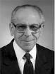
- “Psychiatry, in a sense, has lost some of its treasured diseases- in particular, homosexuality. They had to replace it. And they always replace it with the most vulnerable members of society - children and old people; geriatric psychiatrists are flourishing, child psychiatrists. Of course, these are purely made-up things. Smoking is now a disease.” – Thomas Szasz
- “I submit that the traditional definition of psychiatry, which is still in vogue, places it alongside such things as alchemy and astrology, and commits it to the category of pseudo science.” – Thomas Szasz
Treatment Examples
- Rebirthing Therapy
- Critical Incident Stress Debriefing
- Eye Movement Desensitization and Reprocessing (EMDR)
- Prior treatments for schizophrenia:
  - Starving, blistering, bleeding, ice baths, spinning, tranquilizing chair, drowning, morphine, opium, straightjackets, sterilization, castration, eugenics, beatings, clitoridectomies, teeth pulling, removal of various body parts, coma therapy, seizure-induction, spinal fractures, electroshock, lobotomy

D. Goals of Psychological Research
Description
- Classify and define
  - Big 5 personality traits
  - Correlates of anxiety
Prediction
- Regression: Statistical technique of predicting one score based on scores from other variables
  - Reoffense rates
  - Odds of success in therapy
  - ACT scores to predict GPA
Explanation
- Describes how two variables are related
  - Deviant peers → Drug use?
  - Drug use → Deviant peers?
  - Low SES → both
Control
- Use psychological principles to achieve desired objectives
  - Relate material to oneself to improve later recall
  - Reciprocity norms to increase charitable contributions
- According to determinism, all behavior is controlled by various causes. Psychology hopes to explicate those causes so people can live more skillfully

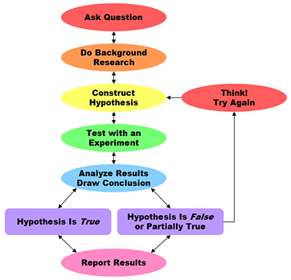
E. Scientific Method
Steps (PSY 100 version)
- Theory – framework based on
logic and prior research
- Hypotheses – specific predictions
- Design + Run the Study
- Analyze and Report Results
- Revise and Expand Theory

B.F. Skinner’s Rules
- Rejected textbook explanation
of the scientific method
- “But it is time to insist that science does not progress through carefully designed steps called ‘experiments,’ each of which has a well-defined beginning and end.” - Skinner
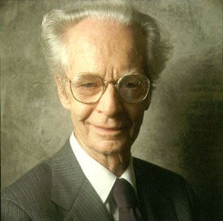
- (1) “When you run onto something interesting, drop everything else and study it.”
- (2) “Some ways of doing research are easier than others.”
- (3) “Some people are lucky.”
- (4) “Apparatuses sometimes break down.”
- (5) “Serendipity – the art of finding one thing
while looking for something else.”
Excerpts from Apology
Written by Plato on Socrates
http://classics.mit.edu/Plato/apology.html
An oracle proclaims that Socrates is the smartest person alive. Socrates does not believe this to be true and seeks empirical evidence to the contrary. He goes around meeting all types of authority figures in an effort to find someone smarter than himself, only to no avail. He makes numerous authority figures appear foolish and earns many enemies. Groups of students follow him around to observe the spectacle, and eventually he is held in court on charges of corrupting the youth; eventually, he is put to death.
“Accordingly I went to one who had the reputation of wisdom, and observed to him - his name I need not mention; he was a politician whom I selected for examination - and the result was as follows: When I began to talk with him, I could not help thinking that he was not really wise, although he was thought wise by many, and wiser still by himself; and I went and tried to explain to him that he thought himself wise, but was not really wise; and the consequence was that he hated me, and his enmity was shared by several who were present and heard me. So I left him, saying to myself, as I went away: Well, although I do not suppose that either of us knows anything really beautiful and good, I am better off than he is - for he knows nothing, and thinks that he knows. I neither know nor think that I know. In this latter particular, then, I seem to have slightly the advantage of him. Then I went to another, who had still higher philosophical pretensions, and my conclusion was exactly the same. I made another enemy of him, and of many others besides him….
And I said to myself, Go I must to all who appear to know, and find out the meaning of the oracle. And I swear to you, Athenians, by the dog I swear! - for I must tell you the truth - the result of my mission was just this: I found that the men most in repute were all but the most foolish; and that some inferior men were really wiser and better. I will tell you the tale of my wanderings and of the "Herculean" labors, as I may call them, which I endured only to find at last the oracle irrefutable. When I left the politicians, I went to the poets; tragic, dithyrambic, and all sorts. And there, I said to myself, you will be detected; now you will find out that you are more ignorant than they are. Accordingly, I took them some of the most elaborate passages in their own writings, and asked what was the meaning of them - thinking that they would teach me something. Will you believe me? I am almost ashamed to speak of this, but still I must say that there is hardly a person present who would not have talked better about their poetry than they did themselves. That showed me in an instant that not by wisdom do poets write poetry, but by a sort of genius and inspiration; they are like diviners or soothsayers who also say many fine things, but do not understand the meaning of them. And the poets appeared to me to be much in the same case; and I further observed that upon the strength of their poetry they believed themselves to be the wisest of men in other things in which they were not wise. So I departed, conceiving myself to be superior to them for the same reason that I was superior to the politicians.
At last I went to the artisans, for I was conscious that I knew nothing at all, as I may say, and I was sure that they knew many fine things; and in this I was not mistaken, for they did know many things of which I was ignorant, and in this they certainly were wiser than I was. But I observed that even the good artisans fell into the same error as the poets; because they were good workmen they thought that they also knew all sorts of high matters, and this defect in them overshadowed their wisdom….”
Excerpt from The Illusion of Free Will
Written by Baron Holbach
http://myweb.facstaff.wwu.edu/wasserr/114/The_Illusion_of_Free_Will.pdf
“In whatever manner man is considered, he is connected to universal nature, and submitted to the necessary and immutable laws that she imposes on all the beings she contains, according to their peculiar essences or to the respective properties with which, without consulting them, she endows each particular species. Man's life is a line that nature commands him to describe upon the surface of the earth, without his ever being able to swerve from it, even for an instant. He is born without his own consent; his organization does in nowise depend upon himself; his ideas come to him involuntarily; his habits are in the power of those who cause him to contract them; he is unceasingly modified by causes, whether visible or concealed, over which he has no control, which necessarily regulate his mode of existence, give the hue, to his way of thinking, and determine his manner of acting. He is good or bad, happy or miserable, wise or foolish, reasonable or irrational, without his will being for anything in these various states. Nevertheless, in spite of the shackles by which he is bound, it Es pretended he is a free agent, or that independent of the causes by which he is moved, he determines his own will, and regulates his own condition….
The errors of philosophers on the free agency of man, have arisen from their regarding his will as the primum mobile, the original motive of his actions; for want of recurring back, they have not perceived the multiplied, the complicated causes which, independently of him, give motion to the will itself; or which dispose and modify his brain, while he himself I is purely passive in the motion he receives….
In short, the actions of man are never free; they are always the necessary consequence of his temperament, of the received ideas, and of the notions, either true or false, which he has formed to himself of happiness; of his opinions, strengthened by example, by education, and by daily experience….
If, for a short time, each man was willing to examine his own peculiar actions, search out their true motives to discover their concatenation, he would remain convinced that the sentiment he has of his natural free agency, is a chimera that must speedily be destroyed by experience.
Nevertheless it must be acknowledged that the multiplicity and diversity of the causes which continually act upon man, frequently without even his knowledge, render it impossible, or at least extremely difficult for him to recur to the true principles of his own peculiar actions, much less the actions of others: they frequently depend upon causes so fugitive, so remote from their effects, and which, superficially examined, appear to have so little analogy, so slender a relation with them, that it requires singular sagacity to bring them into light. This is what renders the study of the moral man a task of such difficulty; this is the reason why his heart is an abyss, of which it is frequently impossible for him to fathom the depth….
Man… resembles a swimmer who is obliged to follow the current that carries him along he believes himself a free agent, because he sometimes consents, sometimes does not consent, to glide with the stream, which notwithstanding, always hurries him forward; he believes himself the master of his condition, because he is obliged to use his arms under the fear of sinking.”

