Experiments III
10/22/08

A. Review of Group Designs
Between-group design | 1. Independent groups design: Each participant randomly assigned to one experimental condition
2. Nonequivalent groups design: Groups of participants are compared along naturally occurring categories
(not an experiment, but uses same analyses as one)
Within-subject design | 1. Each participant goes through multiple experimental conditions

T-tests and ANOVA
- IV: Categorical
- DV: Continuous
- t-test when there is a single IV with only two categories
- ANOVA when there is a single IV with several categories or there are multiple IVs

Technical Terms
- Factor = Categorical independent variable
- Level = One of the specific categories of an independent variable
Practice #1
In a randomized controlled trial comparing surgery, medication, and placebo treatments for heart disease, a researcher examined how well these treatments improve blood pressure.

How many factors?
One. Treatment type
How many levels?
Three. Surgery, medication, and placebo
What type of analysis would you use?
ANOVA. The IV is categorical and has multiple
levels, and the DV is continuous.

Practice #2
Participants in a study complete 10 frames of bowling. During half of the frames, participants bowl as quickly as possible. During the other half, participants bowl normally. The DV is number of points.

How many factors?
One. Bowling condition.
How many levels?
Two. Speed or control.
What type of analysis would you use?
t-test. The IV is categorical and has two levels,
and the DV is continuous

Practice #3
A researcher has each participant complete a survey measure of Need for Cognition and compares these scores to GPA.

How many factors?
Trick question. No categorical variables.

How many levels?
Trick question. No categorical variables.

What type of analysis?
Correlational. Both variables are continuous.

Practice #4
A researcher wants to study memory span. She examines whether caffeine improves memory over a placebo control, and she also examines gender differences in memory span.

How many factors?
Two. Pill and gender.
How many levels?
Two for pill (caffeine vs. placebo) and two for
gender (male vs. female)
Type of analysis?
ANOVA because multiple categorical IVs are
present
B. Brainstorming Categorical Variables
Participant variables
- Easy to think of naturally occurring participant variables that are categorical
- Gender, ethnicity, gun ownership, political party, favorite music genre, relationship status, sleep position, preferred defense mechanism, diagnostic classification, occupation, major
Experimental variables
- Textbooks on experimental research often focus on treatment studies
  - Common, easy to understand
  - Far removed from most laboratory psychology research
How might you want to affect a participant?
What are some things you could
do to make people behave differently?
- What other types of experimental variables might a researcher choose to manipulate?
  - Mood, cognitive load, arousal, salience, mortality salience, various primes, social rejection, drunkenness, reinforcement schedule, anxiety, shame, sleep deprivation, group size, fatigue
  - Brainstorm as a class
C. Control Groups
Overview
- Internal Validity: Ability to draw causal conclusions about the ability of a treatment or manipulation to produce observed effects
- Goal: Determine if a treatment works, or what components of treatment are essential
- Control Condition
  - Can be a non-treatment group
  - Can include all non-essential components of treatment, all aspects not thought to cause change

Placebo
- Substance lacking an active treatment ingredient
- Any observed effect (placebo effect) is due to a self-fulfilling prophecy
- Ethical?
- Inert placebo: Most commonly used, has virtually no physiological effect
  - Sugar pill compared
- Active placebo: Has some physiological effect, but still lacks the active treatment ingredient

  - Causes dry mouth, constipation, stomachache, etc.
  - Produces a greater
effect than inert placebos
  - Which placebo is better
for internal validity?
  - Which placebo do you
choose if you work for
Pfizer or Eli Lilly?
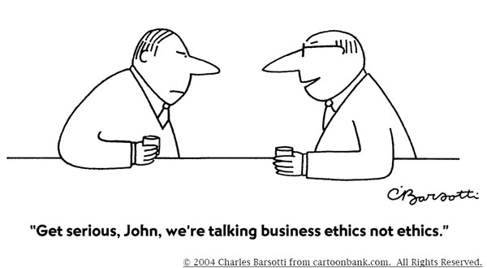
Waiting List
- More common for behavioral and psychological interventions
- Ethical?
Treatment as Usual (TAU)
- Common in a variety of medical and psychological treatment studies, where some modestly beneficial treatment already exists
- Often compared to a treatment with some fundamentally new component
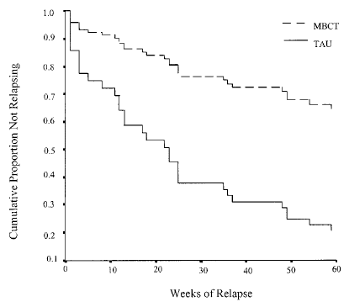

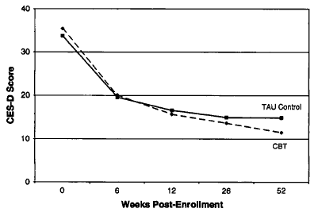

Yoked Control Group
- Some aspect of the control group (time span, number of sessions, number of doses, etc.) is matched to the treatment group

