Experiments I
10/13/08

A. Overview
Experiment
- Study where a researcher systematically varies one factor to observe its impact on some other factor
- People with GAD randomly assigned to three treatments so the researchers can examine which one best reduces anxiety

- Students assigned to a “mortality salience” or control condition so the research can examine the impact on “war support”
id!
Independent Variable (IV)
- Manipulated by the experimenter
- Situations, tasks, instructions, or treatments
- Typically categorical
Dependent Variable (DV)
- Outcome variable presumeably influenced by the IV
- Behavior frequencies, mood, attitude, symptoms
- Typically continuous
Confounds (3rd variables)
- Measure and/or control for confounding variables
- Happens when there are unwanted differences in circumstances across experimental conditions
- Demographic or baselines differences, different researchers, environmental settings
- Plan: Think of potential confounds up front and control them as best as possible
  - Train researchers to be neutral
  - Maintain similar lab settings
  - Monitor demographic characteristics
Goal
- Research consumers: Read articles to better understand strengths and weaknesses in experiments
- Researchers: Design strong experiments

B. Validity Issues
Validity
- Ability to find the truth
Measurement Validity
- How well a device measures what it is supposed to measure
- Face, content, criterion, and construct validity
- Reliability is also important
  - Low reliability yields low validity
Conclusion Validity
- How well the researchers’ conclusions are supported by statistical evidence
- Type I error: Accidentally finding a significant result that isn’t correct or true
  - Usually happens when researchers use too many IVs and start mining their data
  - Outliers
- Type II error: Researcher fails to find a true effect
  - Can occur due to poor measurement Outliers and range restriction
  - Low power
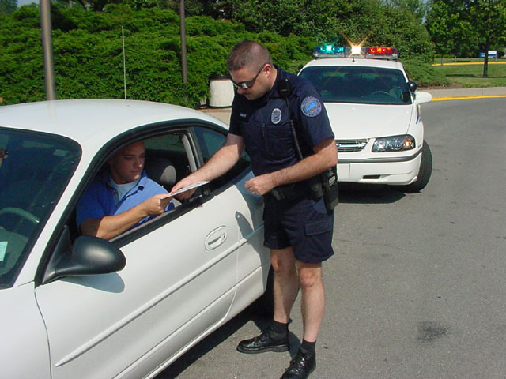
    - Effect size (r or d) is large enough to seem interesting, but the result is not statistically significant (p value), due to small sample size
- P-values: interpret significance tests
correctly, no cheating
1mph over??
  - If p = .06, still must conclude
non-significant
- Effect sizes: interpret effect sizes
correctly, no exaggerating
  - If r = .49, must still call it a
modest effect
Internal Validity
- How well the results of a study are free from confounds and alternative explanations
- Ability of a study to support a causal relationship between variables
This is why most findings cannot be “true” or “proven”

Results could vary in a new context or century
- Primary concern when designing experiments
External Validity
- Generalizability
- Across other samples, environments, researchers, and times
- Ecological validity: extent that results in the
lab will generalize to the real world
C. Pre-post Designs
Overview
- Often concerned with how people change as a result of some type of treatment or manipulation
- Examine scores on the DV (e.g. anxiety) before and after the presentation of the IV (e.g. treatment)

Experimental  Group | pretest | Treatment | posttest
Control  Group | pretest |  | posttest

Threats to Internal Validity
- What are some reasons that one group might outperform the other group, aside from treatment effects?

- History threat: some historical event happens between pre- and post- test that affects one group more than the other
  - May occur due to demographic differences across groups
- Maturation threat: one group is going through natural developmental processes that creates the appearance of a treatment effect
  - May occur due to age differences across groups
- Regression toward the mean: Typically, high scores regress or move closer to the mean over time
  - 1) Initial high scores are somewhat due to error or chance
  - 2) People get better on their own
  - Huge problem if one group starts off more severe at pretest than the other group

- Even greater problem if no control group, which is common in most individual therapy and medical cases
This is a big reason why pseudoscientific treatments like ice baths, birthing therapy, ECT, and clitoridectomies “work” – also a great cause of superstition
  - “Improvement” could have occurred naturally

- Mortality: AKA attrition or dropout; one group loses more people than the other
  - Can exaggerate treatment effects if non-responders or people with side effects drop out, and only people who respond well continue with treatment
  - Past examples with psychiatric medication studies
- Social-cognitive threats: many ways in which interactions with other people involved in the study can modify treatment effects
  - People can usually guess what treatment they are getting, even in “blind” and “double-blind” studies
  - Control group might learn about components of a treatment and do them on their own (diffusion threats)
  - Control group might feel resentful and try to alter the results (participant reactance)
  - Control group might try to show their personal strength by overcoming problems even without treatment (compensatory rivalry)

D. Questions to ask when reviewing an article
Measurement
- Does the measure appear valid?
- Is a measure failing to tap some important aspect of a construct?
- Does a measure predict anything useful?
- Is there evidence that the measure relates to theoretically-important constructs?
- Does the measure have good internal consistency and test-retest reliability?
Conclusions
- Did the researchers engage in data mining?
- Any outliers or range restriction present?
- Adequate sample size?
- Correctly interpret p values?
- Exaggeration of importance of results?
Internal Validity
- Are there any possible confounds?
External Validity
- Would different results be obtained in other samples of people?
- Would different results be obtained if other researchers had conducted the study?
- Would the same results occur in a real-world setting?

