Quasi-Experimental and Applied Research
11/17/08

A. Overview
Applied Research
- Previous lectures in this section
  - Applying concepts to real-world situations
  - Using existing knowledge in psychology to solve real-world problems
- Current lecture on conducting research in real-world situations, often under circumstances that are not ideal
  - How can we improve student health at CMU?
  - How can we prevent criminal recidivism among juveniles in Midland?
  - How can we recruit more people for our RSO?
- Often when developing or examining a new program, we lack a real control group and face many potential confounds

B. Quasi-Experimental Designs
Overview
- Quasi-Experiments: “quasi” = “almost”
- Missing some important component of a real experiment
Control Groups in Experiments
- A control group is identical to an experimental group, except for one missing component
- Participants are randomly assigned
Control Groups in Quasi-Experiments
- May not always have a control group
- If a control group is present, it may differ from the experimental group in a number of uncontrolled ways
- Usually does not have random assignment
Non-Equivalent Control Group Design
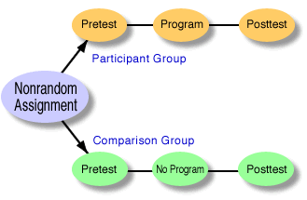
Usually, in quasi-experimental designs, the term “comparison group” is generally used instead of “control group”
- Choose two groups (e.g. two schools) that are similar
- Make one group the experimental group and one the comparison group
- Examine how scores on a DV change before and after the experimental program is implemented
- Because there was no random assignment, the two groups probably differ in a number of ways (e.g. age, gender, ethnicity, personality)
- Confounds reduce internal validity
- Reduce the problem of these confounds by choosing a control group that matches the experimental group as closely as possible
Interrupted Time Series Design
- Usually no comparison group
- Gather data extensively before and after a program is implemented
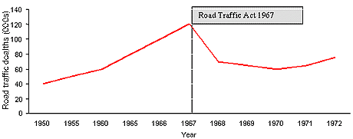
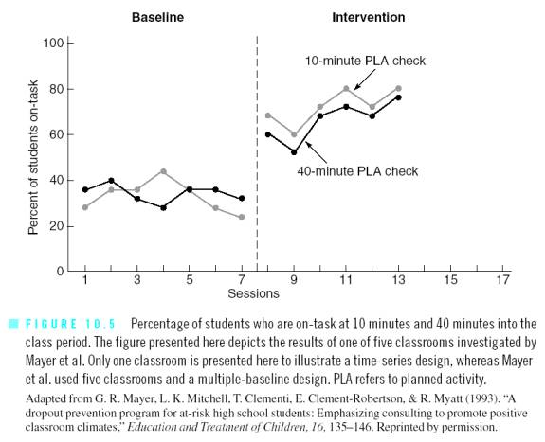

- Can combine time series design with non-equivalent comparison group design

C. Program Evaluation
Overview
- Program evaluation: study geared toward evaluating the effectiveness of specific programs
- Often draws upon quasi-experimental designs, but includes other aspects of research
Needs Analysis
- Three main steps
  - Determine whether a sufficient number of people believe a problem exists
  - Review research to determine whether an appropriate intervention exists
  - Determine whether people facing the problem would make use of the intervention program
- Sufficient support?
  - Availability heuristic problem
  - Census or other public demographic data
  - Examine available resources (competitors)
  - Use survey research; don’t need IRB approval if for informal use only
  - Key informants, focus groups, and community forums
Formative Evaluations
- Monitor progress of a program
- Fidelity check: examine whether the program is being implemented as planned
- Program audit: continued collection of data on how a program is being used
- Pilot studies: examine initial success; consider modifying aspects of the program
Summative Evaluations
- Assess overall effectiveness of a program
- Highly threatening to politicians and corporations, who value self-promotion over science-promotion and the public good
Cost-Effectiveness Analysis
- Used to examine the efficiency of competing programs
- Outcomes are measured in improvement per dollar

