Z-scores and Standardized Distributions
PSY 211
10-3-07

A. Shifting focus of the course

- Descriptive statistics → Inferential statistics
  - Rather than describing our sample, start to focus on how variables are reliably related in the population
- To make these grand conclusions, must have a basic understanding of probability
- Will also hit on peripheral topics related to probability, when useful

B. Basics of Probability

- Probability of an event or outcome, (E), is the number of ways the desired outcome can happen divided by the total number of outcomes

p(E) = # of ways desired event can happen
# of total possible outcomes

p(E) = “hits” or “successes”
# of possible outcomes

What is the probability of drawing an Ace out of a complete deck of 52 cards?

p(Ace) = 4 / 52 = 0.08 or 8%

What is the probability of rolling an odd number, using a standard die?

p(odd number) = 3 / 6 = 0.50 = 50%

A standard roulette wheel has 2 green spaces, 18 red spaces, and 18 black spaces. What is the probability of the wheel stopping on red?

p(red) = 18 / 38 = 0.47 = 47%

An illustration of how statistics show that betting on games of chance is usually not very smart…

If you spin the roulette wheel 100 times at $5 a spin, how much will pay to play?

100 * $5 = $500

Based on probability, if you always bet on red, how often will you win?

p(red) = 0.47 or 47% of the time, so 47 of 100

If the casino pays you $10 for each time you “hit” on red, what are your expected winnings?

47 * $10 = $470

Profit: Winnings minus cost to play
$470 - $500 = -$30

Casinos make money because people have a poor understanding of statistics and make cognitive errors:
- Confirmation bias: only remember times winning at the casino, forget losses
- Positive illusions: I’m more skilled at gambling than others
- Seeing patterns in random events
C. Probabilities in Psychology

- As shown above probability means proportion
  - p(Ace) = proportion of Aces in the deck
- Can calculate probabilities of various scores in psychology by looking at frequency tables or frequency distributions (histograms, polygons, curves), or by making calculations

- What is the probability that a randomly selected CMU student will say Taco Bell is their favorite fast food place?
- What is the probability they will say McDonald’s OR Burger King is their favorite?

- p(depressed 3 days per week)?
- p(depressed <2 days per week)?
- p(depressed >3 days per week)?
- p(sleep 7 hours/night)?
- p(sleep >8 hours/night)?

D. Problem

- The above methods for findings probabilities (proportions) require that we have access to every single data point. Often, we only know the M and SD
- E.g., for hand washing, M = 6.7, SD = 3.9.
What proportion of people wash their hands more than 15 times per day?
- Can convert scores to a common metric to determine this
- It can be difficult to compare measures that use different scales, which is why societies come up with common metrics (dollars, meters, degrees)
E. Probability and Normal Distributions

- Normal Distribution: family of distributions with same general shape, symmetric, with scores concentrated in the middle. “Bell-shaped”
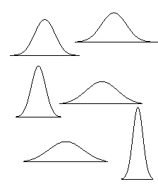
- Z Distribution: normal distribution, specifically designed to have M = 0, SD = 1
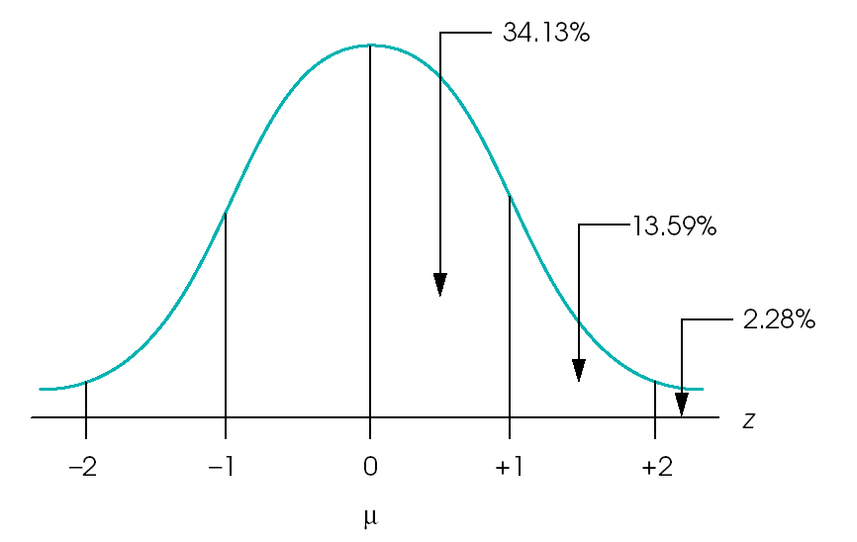
- Z scores: scores on the Z distribution, which represent a standard metric
- Can convert scores from any scale to Z scores, allowing us to estimate probabilities
F. Calculating Z scores

- Remember, Z scores are just a common scale, so this is no harder than converting Fahrenheit to Celsius

- Z score = X – Mean
SD

where X is the raw score on the scale that you want to convert to a Z score.

You got an 80 on a history exam (M = 83, SD = 5). What was your Z score?

Z score = (80-83) / 5 = -0.6, meaning you scored 0.6 standard deviations below average

You got a 71 on an organic chemistry exam (M = 57, SD = 14). What is your Z score?

Z score = (71-57) / 14 =

Which test should you put on the refrigerator?
.3413 (p)= 34.13%
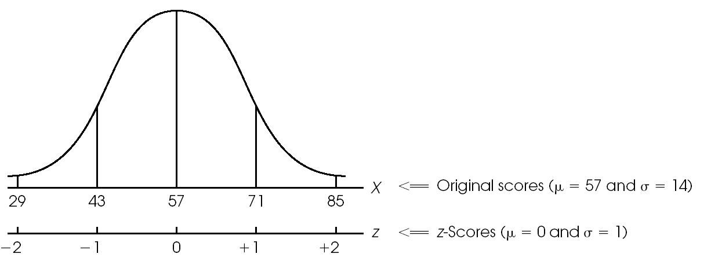
.1359 (p) = 13.59%
.0228 (p) = 2.28%

p(X<43) =

p(X>85) =

p(43<X<71) =

p(Z>-1) =

p(1<Z<2) =

- For more complex Z scores (e.g. Z=1.42), we can use a Unit Normal Table (Appendix B1,
p. 687 – 690)

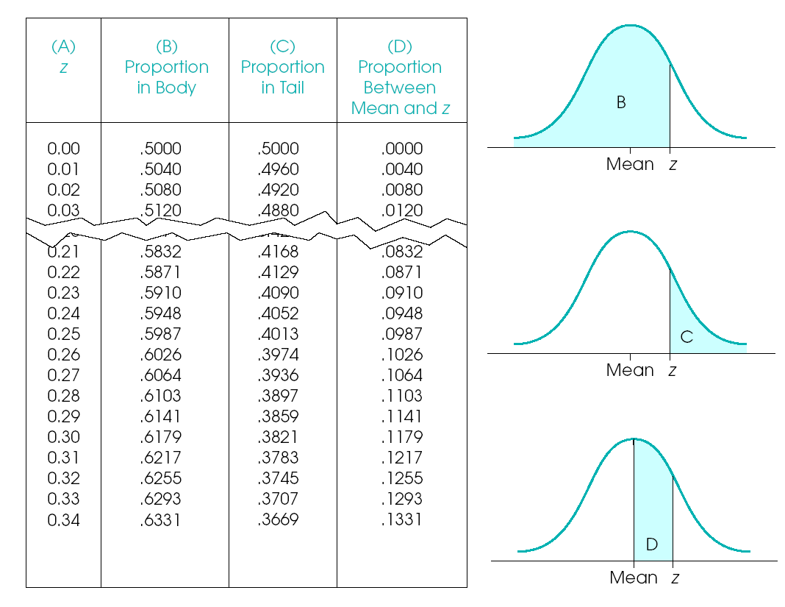
G. Converting Z scores to raw scores

- Z scores can be converted back and forth, so you can take a Z score and put it back on some other scale:

X = Mean_{desired} + (Z score)*(SD_{desired})

or

X = Mean_{new} + (Z score)*(SD_{new})

Someone got a Z score of -1 on the organic chemistry exam (M = 57, SD = 14), what was their raw exam score?

X = Mean_{desired} + (Z score)*(SD_{desired})
= 57 + (-1)*(14)
= 57 + - 14 = 43

Convert the Z score of -1 to a scale with a mean of 83 and SD of 5:

X = 83 + (-1)*(5) = 83 + -5 = 78

H. Transformed standard scores

- Distance is commonly measured in meters, but some people prefer other scales (e.g. miles)
- Z scores have two weaknesses:
  - Decimals
  - Negative numbers
- Nobody wants to find out they have a negative IQ, exam score, or job performance rating
- Other commonly used standard scores:
  - IQ scores: M = 100, SD = 15
  - T scores: M = 50, SD = 10
  - SAT or GRE scores: M = 500, SD = 100

- Transform Z scores to these scales using the same formula as above:
X = Mean_{desired} + (Z score)*(SD_{desired})

- Thus…
IQ score = 100 + (Z)*(15)
T score = 50 + (Z)*(10)
SAT score = 500 + (Z)*(100)

- To transform back to Z scores, use the initial Z score formula:
Z score = X – Mean
SD
- Thus…
Z = (IQ – 100) / 15
Z = (T – 50) / 10
Z = (SAT – 500) / 100

You got a 30 on a vocabulary test (M = 25, SD = 5), convert this to an IQ score:

You got 550 on the GRE verbal section, convert this to a Z score:

I. 68-95-99 rule
- About 68% of people are within ±1 SD of the mean
- About 95% of people are within ±2 SD of the mean
- About 99% of people are within ±3 SD of the mean

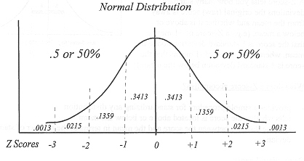
Population
µ ± 1σ = +1 ~ -1 (z) = contains 68% of the scores (cases)
µ ± 2 σ = +2 ~ -2 (z) = contains 95% of the scores (cases)
µ ± 3 σ = +3 ~ -3 (z) = contains about 99.7% of the scores (cases)

Sample (same as population, but different symbols)
± 1s = +1 ~ -1 (z) = contains 68% of the scores (cases)
± 2 s = +2 ~ -2 (z) = contains 95% of the scores (cases)
± 3 s = +3 ~ -3 (z) = contains about 99.7% of the scores (cases)

Just for Fun…

Here are several short personality scales. I have supplied the M and SD for each scale (large CMU sample). You can determine your raw score, convert it to a Z score, and look up your percentile in Appendix B1

Use the following scale to rate how well each item describes you:

1 | 2 | 3 | 4 | 5
Very Inaccurate | Moderately Inaccurate | Neutral | Moderately Accurate | Very Accurate

Self-consciousness (M = 14.8, SD = 3.8)
- Am easily intimidated.
- Am afraid that I will do the wrong thing.
- Find it difficult to approach others.
- Am afraid to draw attention to myself.
- Only feel comfortable with friends.

Total Score =
Z-score =
Percentile =

Assertiveness (M = 16.2, SD = 3.5)
- Take charge.
- Try to lead others.
- Can talk others into doing things.
- Seek to influence others.
- Take control of things.

Total Score =
Z-score =
Percentile =

Achievement Striving (M = 19.2, SD = 3.4)
- Go straight for the goal.
- Work hard.
- Turn plans into actions.
- Plunge into tasks with all my heart.
- Do more than what's expected of me

Total Score =
Z-score =
Percentile =

