t-Tests for Two Independent Groups
PSY 211
10-31-07

A. Shifting Focus

- Previously, we focused on comparing the mean score for a treatment (or experimental) group to an untreated (control) population mean
  - z test when population SD is known
  - t test when only sample SD is known
- Generally in research, we do not know much about the population
- Usually, research involves comparing two groups or samples of participants
  - Experimental condition vs. control
  - Male vs. Female
  - Smoker vs. non-Smoker

B. Different Statistical Tests

Test | Description | Ch.
z-test | Compare treated sample to untreated population (σ known) | 7-8
single sample t-test | Compare treated sample to untreated population (s known) | 9
between-group t-test  (between-subject t-test) | Compare two different groups of participants | 10
within-subject t-test  (repeated-measures t-test) | Compare same group of participants across two time periods | 11
ANOVA, chi square | Later in the semester
C. Between Group T-test – Rationale

- We might like to compare two groups of people
  - Vegetarians vs. non-Vegetarians
  - Caffeine vs. Placebo
- Cannot measure entire populations of each group, so use samples
Population A
Caffeine Users
Population B
Non-Caffeine Users
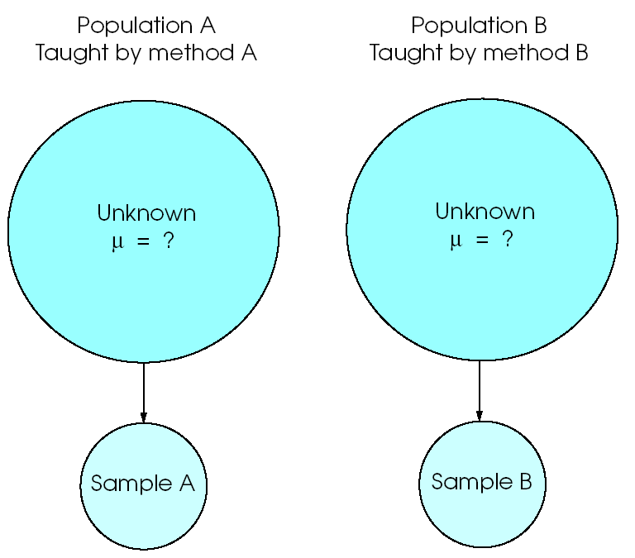

- Due to sampling error, any minor differences between groups might be a chance occurrence
- Use t-test to determine if differences are likely due to chance or group status
Non-skippers
Skippers
Grades Grades

- Visual inspection of these histograms shows some possible group differences
- Only be due to sampling error?
- Large enough that we would expect reliable differences across these groups at the population level?

D. Between-Group t-test

- H₀: μ₁ – μ ₂ = 0 (No mean difference)
- H₁: μ₁ – μ ₂ ≠ 0 (There is a mean difference)
- The book gives a very complex description of the between-group t-test formula. The formula below is slightly simpler and will work for any problems we do in PSY 211. Use this formula.
_{t =} $\frac{(M_{1}−M_{2})}{\text{SE}}$ _{where SE =} $\sqrt{\frac{s_{1}^{2}}{n_{1}}+\frac{s_{2}^{2}}{n_{2}}}$
On the exam, I will supply you with a formula sheet (formulas announced in advance) and any z or t tables needed.

E. Hand Calculation

For our classroom survey project, 43 people said they often skip school (Skippers), and 283 people said they don’t often skip school (non-Skippers). Skippers had an average GPA of 3.26 (SD = 0.64), and non-Skippers had an average of 3.54 (SD = 0.45). Did the two groups significantly differ on GPA?

t = $\frac{(M_{1}−M_{2})}{\text{SE}}$ where SE = $\sqrt{\frac{s_{1}^{2}}{n_{1}}+\frac{s_{2}^{2}}{n_{2}}}$

SE = $\sqrt{\frac{\text{.}{\text{64}}^{2}}{\text{43}}+\frac{\text{.}{\text{45}}^{2}}{\text{283}}}$ = $\sqrt{\frac{\text{.}\text{41}}{\text{43}}+\frac{\text{.}\text{20}}{\text{283}}}$
=$\sqrt{\text{.}\text{00953}+\text{.}\text{000707}}$=
=$\sqrt{\text{.}\text{0102}}$= .10

t = (3.26-3.54) / .10 = -2.8 .

What is the t critical value?
Use Appendix B2, but what is the df?

df_{total} = df₁ + df₂ = (n₁ – 1) + (n₂ – 1) = 42 + 282 = 324
critical t = ±1.98, so it is significant!

F. SPSS Example

- The above example shows that hand calculations for t-tests are tedious
- SPSS can do it for us
- Gender differences in crying:

Group sample sizes
Group Means
Group standard deviations

t value
df_{total}
p<.05?
M₁ – M₂
SE

- We are mainly interested in the t value and whether it is statistically significant – very easy.

- Note: We can double check the t value by dividing the mean difference by the SE:
t = $\frac{(M_{1}−M_{2})}{\text{SE}}$ = 1.0844 / .2004 = 5.41 ☺

- We can also double check using the raw values in the first box from the Output
t = $\frac{(M_{1}−M_{2})}{\text{SE}}$ where SE = $\sqrt{\frac{s_{1}^{2}}{n_{1}}+\frac{s_{2}^{2}}{n_{2}}}$

SE = $\sqrt{\frac{1\text{.}{\text{80}}^{2}}{\text{223}}+\frac{1\text{.}{\text{38}}^{2}}{\text{103}}}$ = $\sqrt{\frac{3\text{.}\text{24}}{\text{223}}+\frac{1\text{.}\text{90}}{\text{103}}}$
= $\sqrt{\text{.}\text{0145}+\text{.}\text{0184}}$ = $\sqrt{\text{.}\text{0329}}$
= .181

t = (3.036 – 1.951) / .181 = 5.99

Our hand calculation is pretty close, differs slightly due to rounding. On the exam, I might just give you the SE, or I might give you numbers that work out well (don’t require a lot of rounding).

APA-style write-up:
Females (M = 3.04, SD = 1.80) reported crying more often than males (M = 1.95, SD = 1.38). This result was significant, t(324) = 5.41, p < .05. Thus, females cry more than males.

1) Provide the mean and standard deviation for each group.
2) Describe the result of the statistical test, including the t, df, and p values.
3) Provide a summary in plain English.

Learning Check:
What does a significant t-value mean?

G. Correlation Coefficient (r), our long lost friend…

- When running correlations in SPSS, you may have noticed that there were p-values for each correlation

- SPSS converts the r to t, and does a t-test to see if it is statistically significant
- * = significant at alpha of 0.05 (less than 5% chance that result is due to sampling error)
- ** = significant even at alpha of 0.01 (less than 1% probability that result is due to chance)
- Exact p-value “Sig. (2-tailed)” tells us the probability that a result of this magnitude would occur by chance (“.000” really means “<.001”)

Learning Check:
Is computer enjoyment related to self-esteem?
What is the p-value?
Is vocabulary related to happiness?
What is the p-value?
H. Effect Size

Studies of tens of thousands of people show that Aspirin significantly (reliably) reduces headaches and fatal heart attacks, p < .05. Aspirin works for both headaches and heart health, but is Aspirin better (more effective) at treating headaches or heart problems?

Both results are statistically significant…

But Aspirin reduces maybe 70% of headaches, and only about 1% of deaths due to heart attack.

The lesson: A result can be statistically significant (trustworthy), but we would still like more information on effect size (magnitude of the effect).

- Significance testing tells whether a result is reliable – whether we can trust a result
- It does not tell us how big, important, impressive, or effective a result may be
- Because significance tests depend on sample size, most huge studies will find significant results, even for small effects

- Common measures of effect size:
r, r², Cohen’s d (see table on last page)
If you only know the SD for both individual samples, average them to estimate the overall SD, which is used in this equation.
- Cohen’s d = $\frac{(M_{1}−M_{2})}{s}$

= (Mean difference) / standard deviation

IQ Example:
Children from high SES families have an average IQ of 110, and those from low SES families have an average IQ of 90. What is the effect size?

d = (110 – 90) / 15 = 20/15 = 1.33 ← We’re done!

- You could do a t-test to see if this effect is reliable; it’s a big effect, but if the sample is small, it might just be due to sampling error. The t-test tells us whether we can trust the result.

Earlier example on Gender and crying:

d = (3.04 – 1.95) / 1.6 = 0.68

- If according to t-tests both this and the above results were significant, which would you conclude is bigger?

Lesson: Do a significance test and calculate Cohen’s d, so you can show that a finding is reliable and show how big the effect is.

APA write-ups:

Females (M = 3.04, SD = 1.80) reported crying more often than males (M = 1.95, SD = 1.38). This result was significant, d = 0.68, t(324) = 5.41, p < .05. Thus, females cry more than males, which was a large effect.

People who are in a relationship (M = 5.67, SD = 1.23) reported higher levels of happiness than those not in a relationship (M = 5.26, SD = 1.38). This result was significant, d = 0.32, t(324) = 2.84, p = .005. People are happier if in a relationship, and this was a medium effect.

Females (M = 6.05, SD = 1.21) reported greater levels of happiness than males (M = 5.56, SD = 1.19). This was a medium effect but was not significant,
d = 0.41, t(55) = 1.36, p = .18. Thus, females were moderately happier than males, but this difference was not reliable. Further research may wish to examine this finding using a larger sample.
From a small study I did a few years ago.

The correlation coefficient is an effect size, so these results are pretty easy to write up:
When a sample is too small, even good sized correlations may not be reliable.
Intelligence was modestly correlated with happiness, but this result was not statistically significant, r = .41, ns.
Aspirin use was associated with a slight increase in heart functioning, r = .02, p < .05. Thus, Aspirin has a very small impact on heart functioning, which was reliably shown in the sample.
If a study is huge, it may be able to reliably detect miniscule effects.

Effect | r | r² | d
Small | ≥ .1 | ≥ .01 | ≥ 0.2
Medium | ≥ .3 | ≥ .09 | ≥ 0.5
Large | ≥ .5 | ≥ .25 | ≥ 0.8

Note:
- r ranges from -1 to 1
- d ranges from -∞ to ∞, but usually not too big (kind of like z)
- d values in this table are different from those on p. 262 of the book. Use these values.
Ideas for Applied Participation Hours
These still require approval by me in advance

Interview someone in your desired profession:
- Job requirements
- How statistics are used, or how statistics/science could be used
- Advice on preparation

Conduct a naturalistic observation from a public hallway in the library, HP, Rowe hall, restaurant, etc.
- Record some group characteristic and make a some type of rating on a continuous (e.g. 0-10 rating) scale; do a t-test
  - Gender and observed depression/anxiety/dominance
  - Major and intelligence
  - Cell phone talking and autonomy
  - Hat wearing and guardedness
- Record some continuous variable and compare it to another continuous variable; do a correlation
  - Order leaving class and impatience
  - Height and assertiveness
  - Attractiveness and cheerfulness
  - Drunkenness and flirting

Ideas for Term Papers
Still ask me questions for help

- Look through the classroom data file and find one variable that interests you the most.
- Look through the remaining variables and hypothesize which ones would be most strongly related
- Run some initial analyses to see if there is anything interesting you might tolerate writing about for the term paper

Pick a topic related to your major or primary field of study so that the scientific articles you read will actually benefit you

Pick a topic you might consider investigating again in the future if you have to conduct your own research study

Pick a topic related to some research that is currently going on at CMU, especially if you are in a lab or want to be in a lab

Pick a topic of broad interest so that you could share the paper with a future employer or family member

