Introduction to t-Tests
PSY 211
10-29-07

A. Introduction

- The confusion of “t”:
  - Temperature
  - Time
  - T scores
  - t tests (have nothing to do with T scores)

B. Similarities to z test

Significance Tests
z tests | t tests
z = (M – μ)  σ_{M} | t = (M – μ)  s_{M}

- Main difference is how the standard error of the mean is calculated:
  - z test: σ_{M} = σ / $\sqrt{n}$
  - t test: s_{M} = s / $\sqrt{n}$
- Use the t test when we know the sample SD instead of the population SD
- Often we don’t know the population SD for every measure we want to use, so this can be very helpful

Key difficulty in statistics: Choosing the correct statistical test based on available information

C. Differences from z test

- t test is based on the t distribution
  - Like the z distribution, but shape depends on “degrees of freedom” (df = n – 1)
  - For large samples, similar to z distribution
  - For small samples, much flatter (like a hill instead of a mountain)
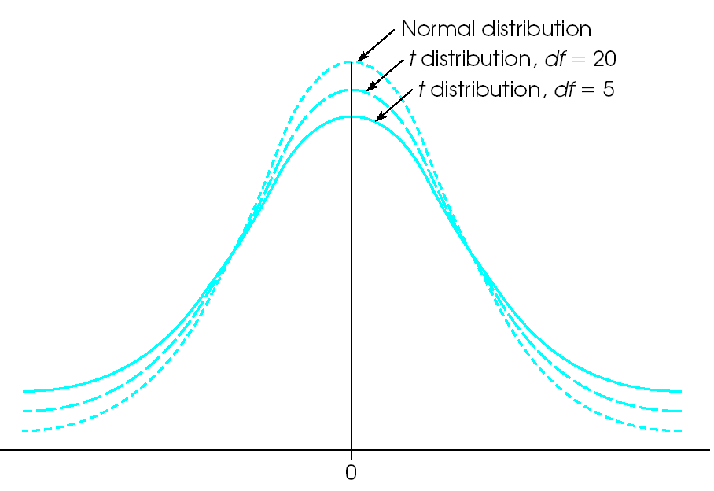
Shape depends on sample size
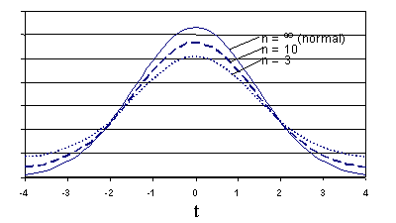
- Because the t distribution varies slightly depending on sample size, the critical value also varies depending on sample size

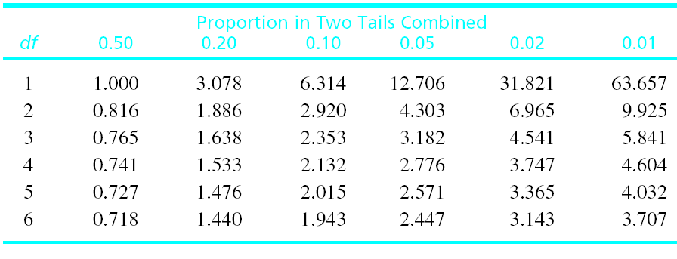

- For small samples, critical t value is very large
- In other words, it’s difficult to get a significant result using small samples
- For large samples, the critical t value shrinks down (getting closer to the ±1.96 value we’re accustomed to)

With the z test, we generally used a critical value of ±1.96. Because the critical value for the t test depends on sample size, we must use Appendix B2 (p. 691) to find the critical value.

- What are degrees of freedom (df), and why do we use that instead of the exact sample size?

  - df = n – 1
  - Corrects the sample size to
give a slightly better estimate
  - Index number for identifying
a critical value
  - Formal definition (beyond the
scope of PSY 211): Number of independent pieces of information
needed for a calculation

- In Appendix B2, look up critical value according to df (degrees of freedom), not n (sample size)

D. Practice Problems

 | Problem #1 |  | Problem #2
Research Problem | A sociology textbook says that the average American family has 2.4 children. In a study of  n = 36 low SES families, you find that they have an average of 3.9 children (SD = 1.2). Do low SES families differ on number of children? |  | On a scale from 0 to 10, the average American reports a stress level of 5.5. A sample of n = 49 PSY 211 students report a stress level of 7.0  (SD = 2.0). Do PSY 211 students differ on level of stress?
Step 1:  Set H₀ & H_{A} | H₀:  H_{A}: |  | H₀:  H_{A}:
Step 2:  Critical t  and rejection region | α =  tails? =  df =  critical t = |  | α =  tails? =  df =  critical t =
Step 3:  Calculate t | t = |  | t =
Step 4:

Make conclusion, report in APA format

E. More on Reporting Results

- General format:
Description of statistical finding, statistic,
p value. Summary in lay terms.

- Examples:
People who graduated from college earned significantly higher incomes, t(42) = 5.67,
p < .05. Thus, graduating from college was related to increased salaries.
“42” is the df, not the sample size
A computer may give an exact p value, you can put that instead if you like (p = .013)

Adult heterosexual male patients diagnosed
with hip arthritis reported having sex with
their wives less frequently than most American males, t(14) = 2.68, p = .02. Hip arthritis leads to decreased sexual activity.
Ritalin was no more helpful in improving concentration among those diagnosed with ADHD than those in the general population, t(99) = 0.18, ns. Therefore, Ritalin’s ability to improve concentration is not restricted to a diagnostic group.

We’ll hold off on Cohen’s d and the r² material until next time.

