Samples and Inferential Statistics
PSY 211
10-10-07

A. Overview

- Z scores and probabilities considered thus far are limited to a sample of a single score (n = 1)

Let us assume that nationally, the average income for a college graduate is $50,000 (SD = $15,000). President Rao is interested in how CMU students fair compared to the national average, so he calls up a random CMU graduate and asks her salary. She says her salary is $65,000. Nationally, what is the probability of someone making this much or more?

Z = (X – M) / SD = (65,000 – 50,000) / 15,000 = 1

Go to Z table, use column C to find the proportion of people with a score greater than a Z of 1.00…

≈ 0.16 or 16%

Describe this result.

What can we infer from this result?

- The above example involves making inferences (predictions based on probability) about how a single individual is likely to be

- Usually in psychology, we are more concerned with groups of people
  - Females vs. Males
  - Obese vs. Non-obese
  - Therapy vs. Pill
  - CMU vs. Western Michigan

- To draw conclusions about group differences, usually we use multiple participants (n = 25,
n = 100, n = 637, etc.)

- Groups are more reliable than individuals

President Rao is unconvinced by the single participant, so he has his secretary call up nine more randomly selected recent graduates of CMU (n = 10). Assume the average salary for this group is $65,000. Nationally, what is the probability that a group of 10 graduates will have this salary or greater?

Now assume the secretary calls a large random sample of recent CMU graduates (n = 300), and the average salary is still about $65,000. Nationally, what is the probability that a random group of graduates this large would have a salary of $65,000 or greater?

- As the above example shows, it can be difficult to determine whether a sample mean is different due to real differences or just due to sampling error (chance findings)
B. Sampling Error (Revisited)

- Definition: Samples are generally not identical to the population, and no sample is perfect. Sample statistics may differ slightly from the corresponding population parameters, and these fluctuations or errors are called sampling error
- Understanding sampling error will help us to tease apart whether results are reliable or just due to chance
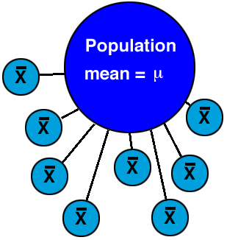

- Imagine that nationally, the average college student drinks 4.1 alcoholic beverages per week. In a study of your own (n = 30), you find that the average is 4.7. In a different sample, you find that the average is 3.8. In another sample you find that the average is 4.3.
- Because most samples are a bit different, it is likely that each will yield slightly different statistics
- Thus, psychologists tend to ignore small, unreliable differences

C. Distribution of Sampling Means

- I described choosing three different samples
- Now imagine pulling all possible samples from the population of interest
- This huge set of all possible samples forms an orderly pattern which makes it possible to predict the characteristics of a sample with some accuracy. This is called:
- The Distribution of Sample Means: the collection of sample means for all the possible random samples of a particular size (n) that can be obtained from a population

Class example involving height

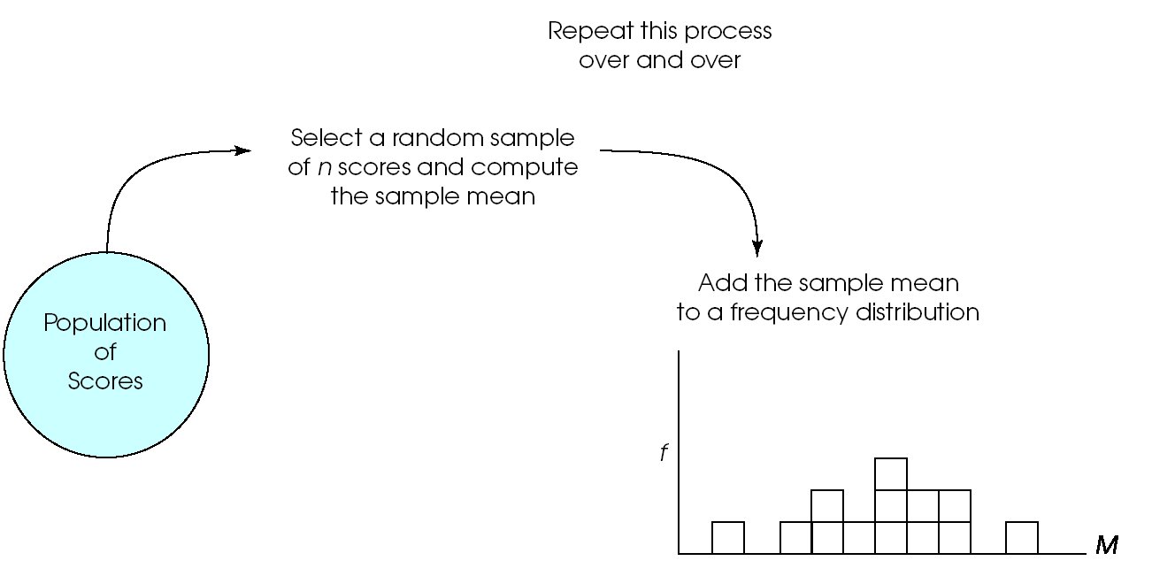

- Note that this distribution is different from distributions we have previously considered
- Until now, we’ve plotted individual scores
- Now, the values in the frequency distribution are sample means
- This sampling distribution tells us specifically what degree of sample-to-sample variability we can expect by chance as a function of sampling error
- The most basic concept underlying all statistical tests is this sampling distribution
- In most cases, we cannot list out all samples and compute all sampling means (if you do, you’ve got too much time on your hands)
- Instead we use the Central Limit Theorem

D. Central Limit Theorem

- For any population with a mean μ and a standard deviation σ, the distribution of sample means for sample size n will have a mean of μ and a standard deviation of σ /$\sqrt{n}$
- Standard deviation for distribution of sampling means is called the standard error of the mean (σ /$\sqrt{n}$), often abbreviated SE or S_{E} or σ_{M}
- SE = standard distance of the sample means from the population mean
- Indicates how much error you should expect on average between the population and sample mean
- Bigger sample = lower SE
  - Bigger sample = less error, more reliable
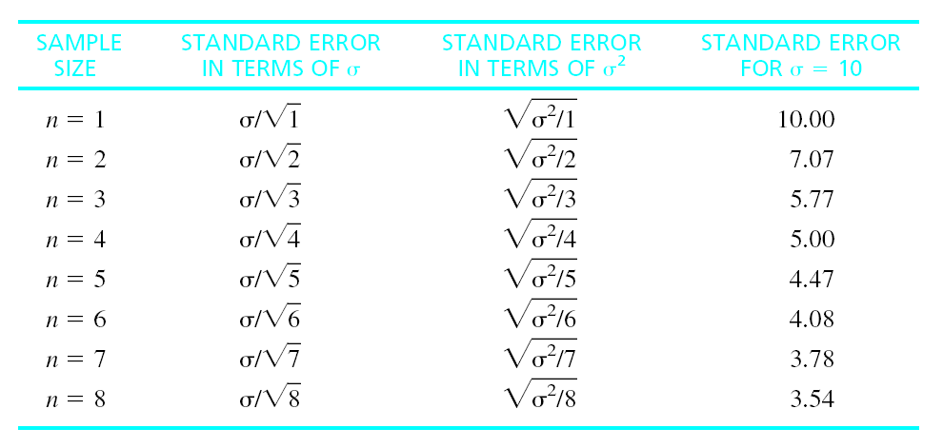
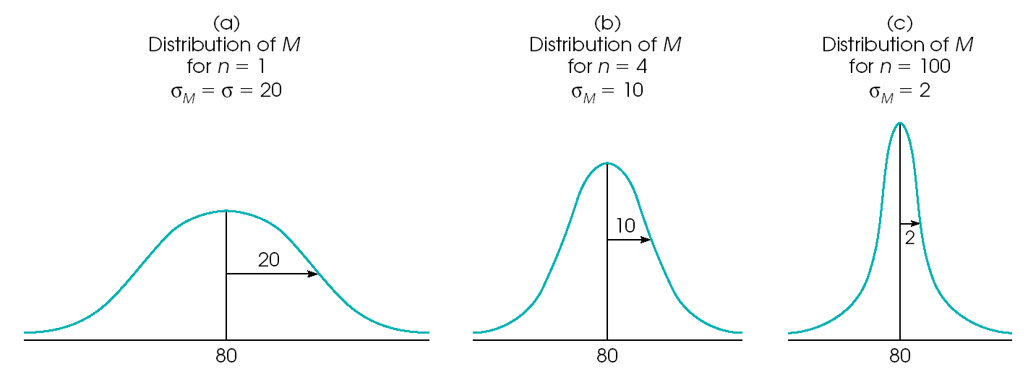

E. Probability and the Distribution of Sampling Means

- We use the distribution of sampling means to make probability calculations
- Strategy:
- Find sampling mean
- Convert sampling mean to a Z score (using a modified Z score formula)
- Use Z table to find the probability of finding a Z that is more extreme

- Note: This is no different than what we have been doing, except we use a different formula for Z when we have a sample mean instead of an individual score

Individual Score | Sample of Scores
Z = (X – μ) / σ | Z = (M – μ) / (SE)  where SE = (σ /$\sqrt{n}$)
Can be used to find the probability (likelihood) of an individual score | Can be used to find the probability (likelihood) of a sample mean

After working in a psychiatric hospital you notice that the people with schizophrenia have many difficulties and wonder if their IQ is similar to the rest of the population (μ = 100, σ = 15). You recruit 9 people with schizophrenia to take IQ tests and find that their average score is an 85.

Any sample will have some variation. Find the probability that a mean of 85 would occur in a sample of 9 people by chance (due to sampling error).

Step 1: Find sampling mean.

M = 85 (duh!)

Step 2. Find Z score for sample mean.
SE = (σ /$\sqrt{n}$)
= 15 / $\sqrt{9}$
= 15 / 3.0
= 5.0
Z = (M – μ) / (SE)

= (85 – 100) / (5)
= -15 / 5 = -3.00

Step 3. Look up Z value in table. Find probability of a more extreme Z value.

p ≈ 0.001 or 0.1%

This is the probability that our sampling mean only differed from the population due to sampling error (chance, bad sample).

What might we infer?

- Take the Z score based on the sampling mean, and use the Z table to find the probability of a Z that is more extreme
  - This tells us roughly the probability of finding the results just due to sampling error

F. Sampling Distribution and Hypothesis Testing

- You may be curious if your sample is different from the population
- If the sample is similar to the population on whatever variable you are measuring, the Z score will be low
  - Any differences are probably due to sampling error (high probability, big p)
- If the sample is very different from the population on whatever variable you are measuring, the Z value will be high
  - Only a small chance that differences are due to sampling error (low probability, small p)
- Rule of thumb: If Z is more extreme than ±2, the results are unlikely due to sampling error, results are “statistically significant”
  - If Z is less extreme than ±2, we say the results are “non-significant,” possibly just due to sampling error

