Review for Exam #4
PSY 211
11-12-07

A. Highlights from this Section

Hypothesis Testing: 4 Steps

- Step 1: State hypotheses at the population level
  - Null vs. Alternative hypothesis

- Step 2: Set critical region for sample
  - z = ±1.96
  - For t, based on df (n – 1), use table

- Step 3: Calculate sample statistics
  - Use various z and t formulas
  - OR use SPSS, read Output
  - Calculate Cohen’s d, also

- Step 4: Report results in APA format
  - If significant, report p < .05
  - If non-significant, report ns
OR
  - If using SPSS, you can report the exact
p value, if you like
  - p is the probability that the results could have occurred by sampling error, so low p is good
  - Large sample statistics (z or t) corresponds to low p value

Old Pop Quiz

 |  | True Finding in Population
 |  | No Effect | Some Effect
Your study finding | Accept Ho | (A) | (B)
Your study finding | Reject Ho,  Accept H1 | (C) | (D)

Name A, B, C, and D.
You can use the following options:
“Correct Decision,” “Type I Error,” “Type II Error”

Distributions

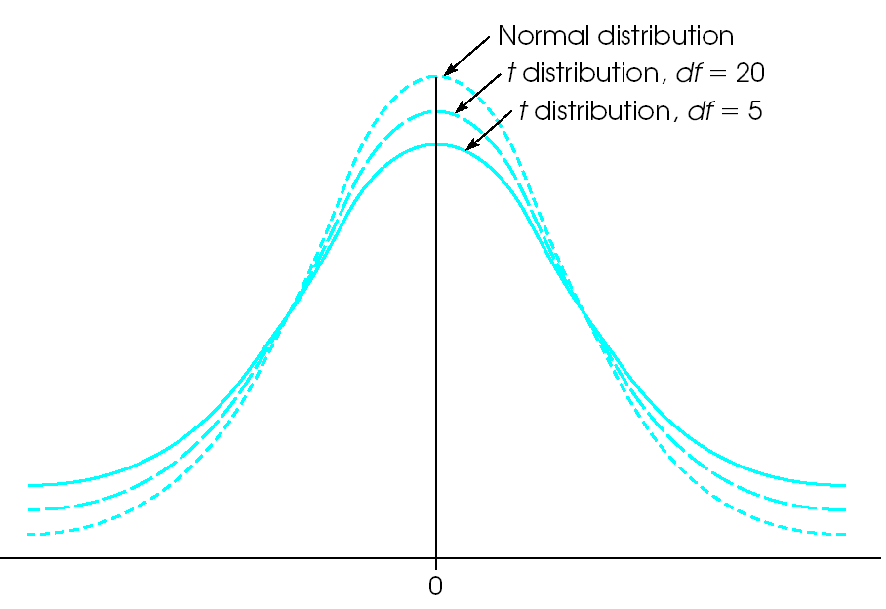

Test | Description | Ch.
z-test | Compare treated sample to untreated population (σ known) | 7-8
single sample t-test | Compare treated sample to untreated population (s known) | 9
between-group t-test  (between-subject t-test) | Compare two different groups of participants | 10
within-subject t-test  (repeated-measures t-test) | Compare same group of participants across two time periods | 11
ANOVA, chi square | Later in the semester

B. Sample Output

Analyses examining whether being born in Michigan (Yes/No) relates to Anti-smoking attitude (7-pt scale)

What type of t-test is this?
Is the result statistically significant?
Is the result reliable?
What is the p-value?
What is the t-value?
What is the Cohen’s d?
What is the sample size?
Analyses comparing happiness before and after Valentine’s Day among non-daters.

post
pre

pre - post

What type of t-test is this?
Is the result statistically significant?
Is the result reliable?
What is the p-value?
What is the t-value?
What is the Cohen’s d?
What is the sample size?

C. Choosing the Correct Test

What statistical test would you likely use to determine whether level of pain decreases from before treatment to after treatment?

A. z-test
B. single-sample t-test
C. between group t-test
D. repeated measures t-test

To determine whether IQ scores differ between cocaine users and the rest of the population, you administer IQ tests to a sample of 10 cocaine users. What statistical test would you likely use?

A. z-test
B. single-sample t-test
C. between group t-test
D. repeated measures t-test

You design a study to examine how gender differences relate to changes in mood after eating chocolate. Before eating chocolate, males and females have similar mood. After eating chocolate females are in a much better mood than males. How could you analyze whether these post-chocolate gender differences in mood are significant?

A. z-test
B. single-sample t-test
C. between group t-test
D. repeated measures t-test

D. Effect Size

r² = 0.25
near-zero, small, medium, or large?

d = 0.25
near-zero, small, medium, or large?

r = -0.25
near-zero, small, medium, or large?

F. Calculations

Students randomly assigned to Study Group A
(n = 10) score an average of 80 points on a math exam (SD = 10), and students in Study Group B (n = 10) score an average of 70 points on the same math exam (SD = 12). Can we conclude that Study Group A is reliably better than Study Group B? Write-up the results in APA-format.

Before starting group treatment for alcohol abuse, participants (n = 19) reported drinking an average of 8 drinks per day. Three participants failed to complete the entire program. 6 months after treatment, those completing the program reported drinking an average of 3 drinks per day. In summary, on average, drinking decreased by 5 drinks (SD = 2.0). Can we conclude that the program decreases drinking? Write-up the results in APA-format.

