Regression + Structural Equation Modeling
PSY 211
9-24-07 and 9-26-07

A. Regression (R)

- Definition: Statistical technique for finding the best fitting straight line for a set of data
- Advanced version of correlation
- Predict specific scores on Y from X
- Can use multiple predictors (X₁, X₂, X₃, etc.)

B. Predicting Scores

- Put the predictor variable (independent variable) on the X axis and outcome variable (dependent variable) on the Y axis
- Correlation Example. Predict Helpfulness (Y) from Agreeableness (X): r = 0.29

- Regression Example: Predict Helpfulness (Y) from Agreeableness (X): R = 0.29
- Scatterplot shows a best fit line used for prediction
- The best fit line always gives you the best estimate of Y, based on X
- Any other line would not be as useful for prediction

- If we know a person’s score on X, we can predict their score on Y by visually inspecting the best fit line that SPSS generates on the scatterplot

- Tough to be accurate inspecting visually
- From algebra, we could determine an equation for the line to predict more accurately
  - $$\overset{\hat{}=\text{bX}+a}{Y}$$
  - the $\overset{\hat{}}{Y}$is pronounced “Y hat” and means the predicted Y score
- Because this is an introductory course, we will let SPSS give us the equation rather than calculate it ourselves

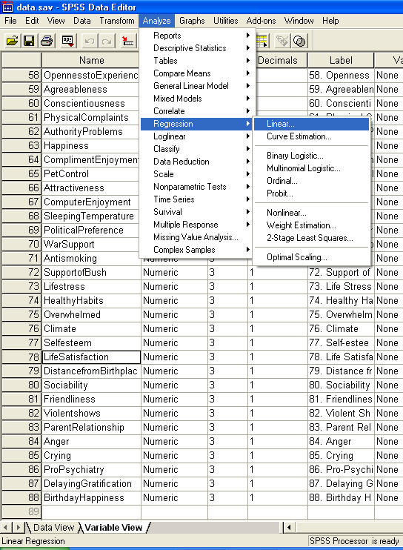

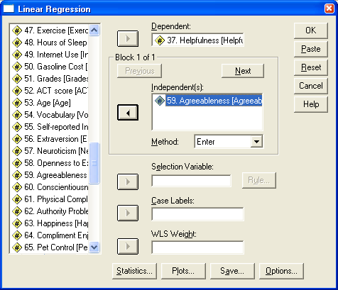

- This yields a lot of Output, including the following:
R
X
a
R
b
Y

- $\overset{\hat{}=\text{bX}+a}{Y}$ = .288X + 3.325
- Put in a value (e.g. of 5) for X to predict Y:
.288(5) + 3.325
= 4.765
- Predicting someone’s helpfulness score from their agreeableness score is quite lame
- But you could…
  - Predict GPA from ACT scores
  - Predict odds of a sex offender’s reoffense given a survey score
  - Predict duration of rehabilitation given self-efficacy scores
  - Predict odds of divorce based on personality scores

C. Predicting Y from multiple Xs

- Behavior is multidetermined
- Usually hard to predict Y from a single X
- We will use multiple X’s to make better predictions
  - This is why you may hear regression referred to as “multiple regression” or “multiple R”
- Let’s predict Helpfulness (Y) from Agreeableness (X₁) and Self-esteem (X₂)
  - Give numbered subscripts to multiple X variables

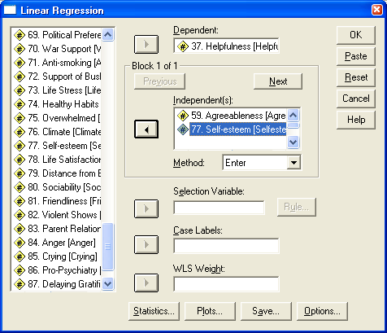

- This yields lots of Output again:

a
R
X₁
X₂
b₁
Betas
b₂
Y

- $\overset{\hat{}=b_{1}X_{1}+b_{2}X_{2}+a}{Y}$
= .267X₁ + .116X₂ + 2.776
- What if someone reported a 2 on Agreeableness and a 7 on Self-esteem?
- $\overset{\hat{}=}{Y}$.267(2) + .116(7) + 2.776 = 4.122
- What are those Betas?
  - Betas are NOT on the exam
  - β₁, β₂
  - Describe each variable’s unique contribution
  - Like r, except controlling for all other predictors
  - β₁ = .272, which means that the correlation between Agreeableness (X₁) and Helpfulness (Y) after controlling for Self-esteem (X₂) is .272
  - β₂ = .133, which means that the correlation between Self-esteem (X₂) and Helpfulness (Y) after controlling for Agreeableness (X₁)
  - Could use this for an impressive term paper of PSY 385 project

D. Path Diagrams

Simple correlation:
r = .29
Agreeableness
Helpfulness

R = .29

Multiple Regression:
r = .29
Agreeableness
Helpfulness

r = .18 R = .31
Self-esteem

Some researchers put the Betas in the diagram instead of the r values if they want to show off each variable’s unique effect.
E. More Complex Multiple Regressions

- You could add as many predictors (X’s) as you want
Touchdowns

Yards
Quarterback
Rating
Interceptions

Studying

Reading
PSY 211 Success

Going to Class

F. Reading Complicated Path Diagrams

- Often in journals, we see very complex path diagrams
- Variables are multidetermined, so complexity is a must for many important correlational studies

Interpersonal Problems
Depression
Failure
Stress
Sleep Problems
Worry
Crying

Some tips (DON’T need to know for the exam)
- If circles are used instead of rectangles, it means that the constructs were measured in multiple ways (e.g. maybe several different surveys were used to measure depression)
- Dashed lines mean a correlation is close enough to zero, we might as well ignore it
- Because these “path diagrams” or “models” show us a structure and are based on equations (like regression), you may hear them referred to as “structural equation models” …these are just synonyms
G. Examples from Journals

