Hypothesis Testing (Part II)
PSY 211
10-24-07

A. Review of Last Time

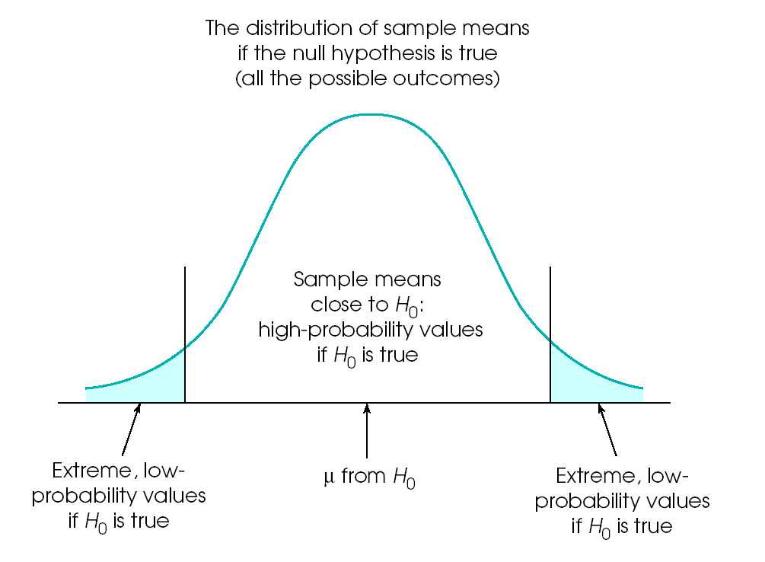
Common Outcome when Ho is true
Low probability of Ho being true, accept H1
Low probability of Ho being true, accept H1

- As Z increases, the probability decreases that the sample mean differs from the population due to chance
- As Z increases, more confidence that the obtained difference is real, not just a chance occurrence
- Exact boundary determining whether we accept or reject the null hypothesis is somewhat arbitrary:
  - Z = ± 1.96
  - Probability of mistakenly rejecting the null hypothesis is less than 5% (p < .05)

B. Alpha Level and Critical Region

- Alpha level or significance level:
Percent of the time (or probability) we will incorrectly reject the null hypothesis
  - Generally set at .05, so psychologists are willing to incorrectly reject the null hypothesis about 5% of the time
  - Used to determine cutoff point for determining “significance”
- Critical Region:
Extreme sample outcomes that are inconsistent with the null hypothesis
  - Light blue region in above figure
  - Boundary line determined by alpha level

Alpha level  α | Probability of incorrectly rejecting Ho | Z value  for cutoff
.10 | 10.0% | 1.65
.05 | 5.0% | 1.96
.01 | 1.0% | 2.58
.001 | 0.1% | 3.30

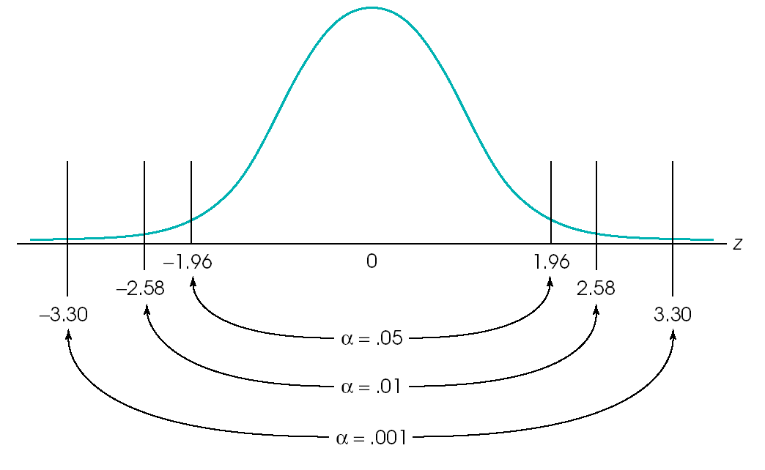
C. Probability and Errors

- Decisions that rely on probability will always be wrong a portion of the time
  - E.g. 90% chance Chauncey Billups will make a free throw

- Type I Error: Rejecting the null hypothesis when it was actually true
  - Unlucky sample (high sampling error)
  - E.g. In your sample you find males are much smarter than females.

 | Asserting something  that is not true

- Type II Error: Accepting the null hypothesis when it is actually incorrect
  - Unlucky sample, too small of sample, poor methodology
  - E.g. In a small study, drug companies find no antidepressant side effects

 | Saying nothing is going on, when something interesting is really there

- Power: ability to detect a true effect, increases with sample size
D. Different Types of Hypothesis Tests

- Two-tail (non-directional) hypothesis:
Treatment or experimental manipulation has some effect
  - Effect can be positive OR negative
  - Ho: The experimental manipulation (listening to music) will not impact subsequent test score.
  - H1: The experimental manipulation will impact test score.

- One-tail (directional) hypothesis:
Treatment or experimental manipulation has an effect in a specific direction
  - Effect can be positive only (or negative only)
  - Ho: Experimental manipulation (listening to music) will not increase test scores
  - H1: Experimental manipulation will increase test scores

- Be able to identify which is which
- Usually we find a result to be interesting, regardless of the direction, so most analyses involve two-tail tests
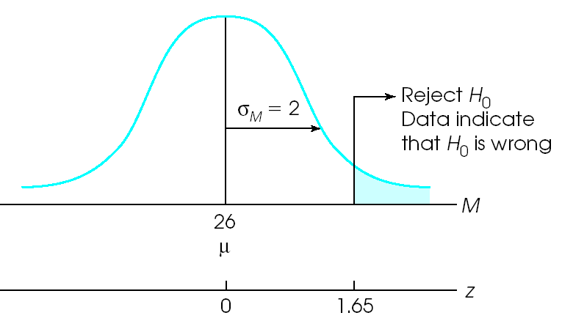

E. Cohen’s d

- Mike’s favorite statistic (hint, hint)
- Simple, doesn’t rely on much statistical knowledge
- Applies more to t-tests (next chapter) than Z scores
- We will skip it for now, and return to it next chapter, so refer back to p. 261-262 when it comes up again

 |  | True Finding in Population
 |  | No Effect | Some Effect
Your study finding | Accept Ho | (A) | (B)
Your study finding | Reject Ho,  Accept H1 | (C) | (D)

1) Name A, B, C, and D.
You can use the following options:
“Correct Decision,” “Type I Error,” “Type II Error”

2) What is power?

