Hypothesis Testing (Part I)
PSY 211
10-22-07

A. Remainder of this Course

- Statistical tests are used to evaluate hypotheses
- Draws on knowledge of probability/percentages, Z scores, and frequency distributions
- If you understand these topics, the rest of the course will be okay
- If you do not understand these topics, the rest of the course will be difficult to follow

B. Hypothesis Testing Basics

- Hypothesis testing: Statistical procedure where researchers use sample data to draw conclusions (inferences) about the population
  - Remember: It is usually impossible to test a whole population (e.g. all “people with bulimia”) so we might sample n = 25 CMU students with bulimia
- Relies on probability: Inferences will usually be correct, but are also guaranteed to be wrong a small percentage of the time
- Used for evaluating mean differences (common in experiments, such as treatment studies) and correlations (common in surveys)

C. Example (Without Too Many Statistics)
Group of Interest
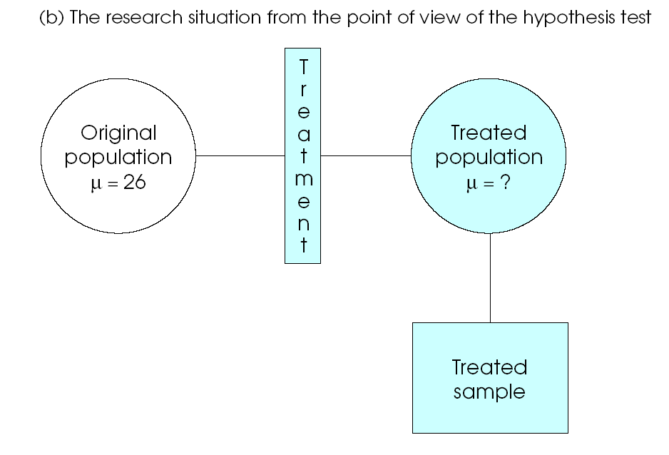
Does treatment impact their symptoms?
μ = 26 still?

- You might test how well a treatment for bulimia increases “body satisfaction” (among other important outcomes)
- Rather than treating everyone, you treat a sample of n = 25 people

Using the KNOWN mean from a sample of n = 25, we draw conclusions about the UNKNOWN treated population

- If treatment sample scores about the same as the original population, conclude the treatment had no effect. If differences were large (not likely due to “sampling error” or “chance”), you might reasonably conclude the treatment works


D. Steps to Hypothesis Testing (Using Statistics)

- State hypotheses about the population
- Use hypotheses to make predictions about the sample statistics
- Select a sample (of n people), compute the sample mean or other statistics
- Evaluate hypotheses based on those statistics

Step 1. State Hypotheses

- Null Hypothesis (H₀): the hypothesis that in the general population, there is no change, no difference, no relationship. In the context of the experiment, that there is not a treatment effect
- Alternative Hypothesis (H₁ or H_{A}): states that there is a change, a difference, or a relationship for the general population. In the context of the experiment, that there is a treatment effect

Bulimia treatment example:

H₀: The treatment program has no impact on body satisfaction, μ_{treatment} = 26 (μ_{original}).

H₁: The treatment program does impact body satisfaction, μ_{treatment} ≠ 26 (μ_{original}).

Sample of n people will be used infer the average amount that treatment will help people in general.

Step 2. Set Criteria for Rejecting the Null Hypothesis

- Review: Because of sampling error, any particular sample of n people will vary somewhat from a population (e.g. the height example from lecture)
- It would be foolish to reject the null hypothesis if our sample mean differed only slightly
  - E.g. If American’s have an average IQ of 100, but a random sample of n = 30 CMU students have an IQ of 99.5 we probably would not want to reject the null hypothesis (that the sample IQ does not differ from the population)
- We use Z scores and probabilities to determine whether it is likely or unlikely that sample means differ from the population just due to chance (sampling error)

- If Ho is true, based on the distribution of sample means, our sample mean will be near the population mean
  - Common outcomes: An observed sample mean qualifies as a common outcome if the difference between its value and that of the hypothesized population mean is small enough to be viewed as a probable outcome under the null hypothesis
- If Ho is false (that is, if H1 is true): Our samples will fall at the extreme end of the distribution, indicating that the finding is not likely due to sampling error
  - Rare outcomes: An observed sample mean qualifies as a rare outcome if the difference between its value and that of the hypothesized population mean is too large to reasonably be viewed as a probable outcome under the null hypothesis

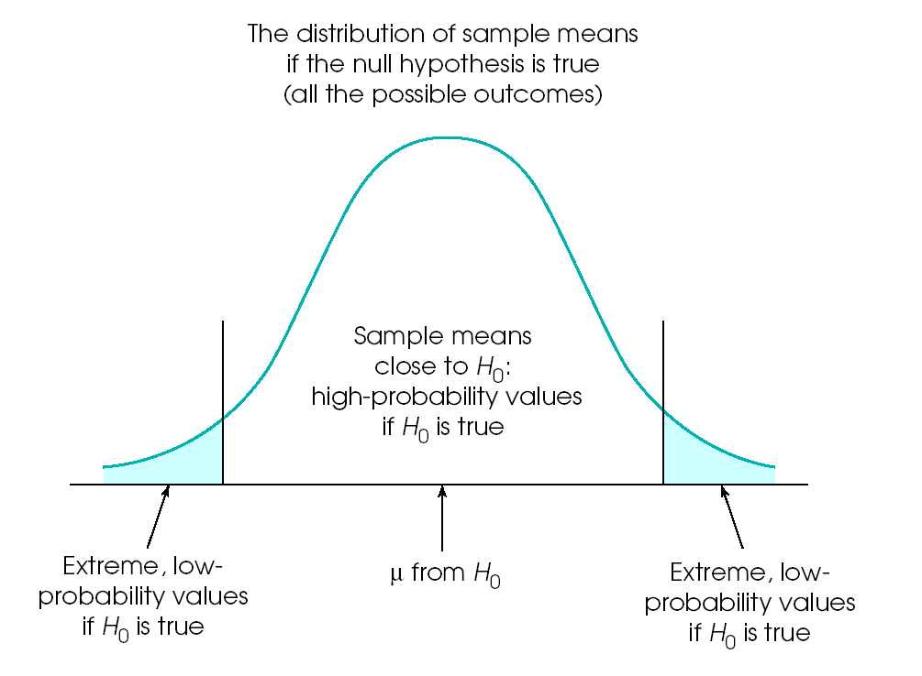
Common Outcome when Ho is true
Low probability of Ho being true, accept H1
Low probability of Ho being true, accept H1

- Generally we want to be cautious, so we only reject the null hypothesis when Z is more extreme than ±1.96

- We will only incorrectly reject the null hypothesis about 5% of the time (hence, the p < .05 you commonly see reported after statistical tests in journals)

Step 3. Collect Data. Compute Sample Statistics

Review: Z = (M – μ) / SE
where SE = σ / $\sqrt{n}$

Nationally, on a body satisfaction survey people with bulimia score μ = 26.0, σ = 4.0, median = 26.2. You devise a treatment for bulimia. Since you cannot give the treatment to everyone who has bulimia, you offer it to a sample of n = 25. After treatment, the group has a body satisfaction score of 28.4.

Z = (M – μ) / SE SE = σ / $\sqrt{n}$
=
Z =

Step 4. Make a Decision. Report Results

- Rule of Thumb:
Reject null hypothesis (accept H₁) if Z is more extreme than ±1.96
Accept the null hypothesis if Z is weak, less extreme than ±1.96

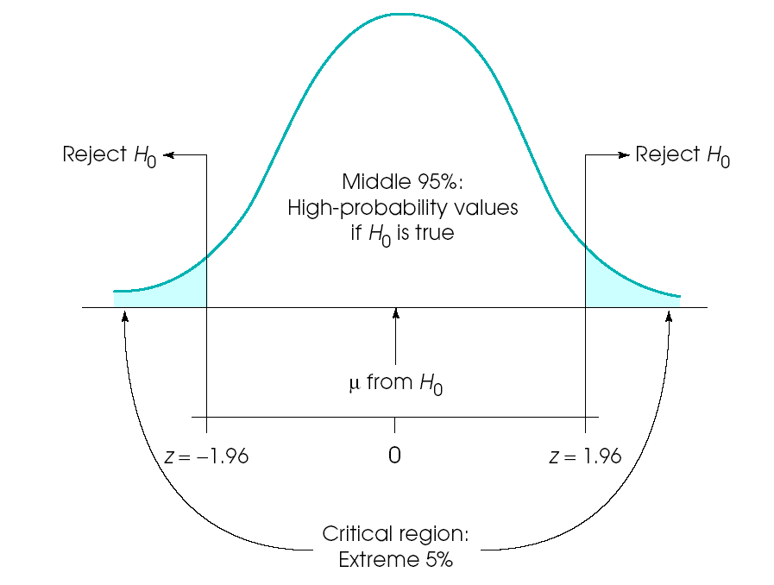
Obtained z =+ 3.00

Our result (APA format): The treatment significantly increased body satisfaction, z = 3.00, p < .05. That is, the treatment was a success.

If z was 1.84: The treatment failed to significantly increase body satisfaction, z = 1.84, ns. Thus, the treatment was unsuccessful.

If the treatment was a disaster (z = -2.28): The treatment inadvertently decreased body satisfaction,
z = -2.28, p < .05. That is, the treatment was iatrogenic.

