PSY 211
HW #9
35 points
Due Wednesday 11-28-07

Instructions: Read over the following guide to ANOVA. Neatly type up a cover sheet and type your responses to the assigned questions. Neatness and the cover page are worth 5 points, and each problem is worth 2 points (15 x 2 = 30). Hand-written responses receive no credit.

ANOVA Guide: Here are some instructions on how to run an ANOVA using SPSS. Refer back to these instructions when answering the assigned problems:

1. Open the PSY 211 data file.

2. Go to the Analyze menu. Point to Compare Means, and choose One-Way ANOVA.

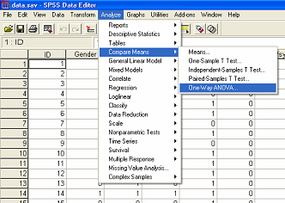

3. In the ANOVA pop-up window, click on the Post Hoc button.

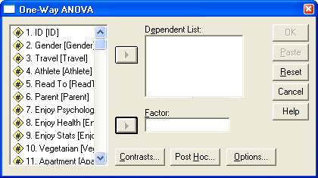

4. In the Post Hoc pop-up window, choose LSD, and click Continue.

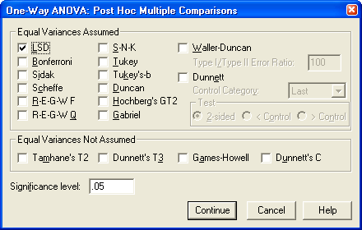

5. Back in the ANOVA pop-up window again, click on the Options button, and in the Options pop-up window, choose Descriptives and click Continue.

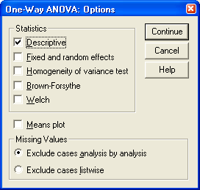

6. Back in the ANOVA pop-up window again, add the variables to be analyzed. Select one categorical variable (e.g. ethnicity, hero, etc.) and move it to the Factor box. Select a dependent variable (a continuous, outcome variable, such as extraversion, depression, etc.) and move it to the Dependent List: box. Then click OK.

7. Use the lecture notes to interpret the Output.
Assigned Problems: All can be answered using one word or number, except 2g, which should be answered using complete sentences.

1. Run an ANOVA using sleep position (#30) to predict happiness (#63). The ANOVA should include an F value of 2.70 if you have done it correctly.
- Is this F value statistically significant? YES
- The significance test tells you whether there sleep position is likely related to any differences in happiness at the population level. Would you expect there to be any population differences in happiness based on sleep position? YES
- What sleeping position has the highest average level of happiness, based on the descriptive statistics in the Output? Back
- What sleeping position has the lowest standard deviation in level happiness, based on the descriptive statistics in the Output? Back
- Based on the post hoc test, are people who sleep on their back reliably happier than people who sleep on their stomach? YES
- Are people who sleep in the fetal position reliably happier than people who sleep on their stomach? NO

2. Run an ANOVA using music preference (#29) to predict ACT score (#52).
- What is the F value? 4.07
- Are there any reliable differences in ACT score based on music preference? YES
- Based on the descriptive table, which group has the highest ACT score?
Alternative (woohoo)
- Which group has the lowest ACT score? Rap
- Do people who listen to classic rock score reliably higher on the ACT than people who listen to country music? NO
- Do people who listen to R&B score significantly higher on the ACT than people who listen to Hip Hop? NO
- A journalist for the CM Life newspaper hears of this finding and writes that students should listen to alternative rock while studying for exams. Why is this reasoning faulty? Students who listened to alternative rock had the highest ACT scores. However, people were not randomly assigned to like a certain music in life (as might be the case in an experiment), so it could be that some 3rd variable, such as personality differences or SES lead some people to both be smarted and have different music preferences. Alternatively, it could be that intelligence (as measured by the ACT) causes music preferences, the opposite interpretation of what the journalist made. Although ANOVA was used instead of correlation, some might informally say “correlation does not prove causation.” These variables are related, but it is impossible to know with complete certainty why.

3. Run an ANOVA using mode of electronic communication (#26) to predict sociability (#80).
- Are there any statistically significant differences? YES

4. Run an ANOVA using hero (#22) to predict healthy habits (#74).
- Are there any statistically significant differences? NO. Remember, first examine whether the ANOVA is significant. Ignore the post hoc tests if the ANOVA is not significant.
Oneway

Post Hoc Tests

Oneway

Post Hoc Tests

Oneway

Post Hoc Tests

Oneway

Post Hoc Tests

