Exam 2 - PSY 211 Name: _____________________________
Course Reference #22021132
Mike Hoerger

Section I. Multiple Choice [70 points: 2 points each]
CALCULATORS ALLOWED

1 | Correlation (r) below with greatest magnitude:
a) | -1.07
b) | 0.68
c) | -0.72 100% r = .00 -- too easy

2 | About how much does alcohol affect aggressive behavior?
a) | r = 0.00
b) | r = 0.20 82% r = .18
c) | r = 0.50

3 | Analyses focus on mean differences across groups:
a) | experiments 56% r = .55
b) | case studies
c) | surveys

4 | Situation where causation can be inferred more easily from correlational data:
a) | dependent variable occurs before the independent variable
b) | experiments have found different results
c) | partial correlations used to remove impact of third variables  67% r = .18

5 | Magnitude of a correlation of r = 0.27
a) | small 89% r = .18
b) | medium
c) | large

6 | The variables “happiness” and “frowns per hour” have:
a) | a direct relationship
b) | no relationship
c) | an inverse relationship 82% r = .46

7 | Coefficient of determination for a correlation of r = -0.30
a) | -0.30
b) | -0.09
c) | 0.09 96% r = .18

8 | In a scatterplot, sometimes circular shape is drawn around the spread of data points. This line circling the data is called:
a) | a best fit line
b) | an envelope 96% r = .18
c) | a bracelet

9 | You run a multiple regression in SPSS, which yields the following formula:  Predicted Income = 500*(IQ) + 2000*(Years of School) – 50,000  If someone you know has an IQ of 120 and went to school for 15 years, what would you estimate his income to be?
a) | $0 to $40,000 73% r = .18
b) | $40,001 to $80,000
c) | $80,001 to $120,000

10 | “The degree that X and Y vary together divided by the degree they vary separately”
a) | standard error of the estimate
b) | coefficient of determination
c) | correlation coefficient 73% r = .64

11 | Correlation used for ranked data:
a) | Pearson’s
b) | Spearman’s 71% r = .36
c) | Point-Biserial

12 | In a national sample of older adults, short term memory problems are strongly correlated with symptoms of dementia (cognitive difficulties). You run a similar study using CMU students as participants but find that short term memory problems are not related to symptoms of dementia. Why?
a) | weak relationship between variables
b) | range restriction 76%, r = .28
c) | outliers

13 | Lowest possible value for R:
a) | 0.00 76% r = .27
b) | -1.00
c) | -∞ (negative infinity)

14 | If intelligence causes good grades, and these two variables are correlated r = 0.5, what percent of the differences in grades are due to intelligence?
a) | 5%
b) | 25% 82% r = .55
c) | 50%

15 | The variables “sugar consumption” and “hyperactivity” have:
a) | a direct relationship
b) | no relationship 64% r = .55
c) | an inverse relationship

16 | Correlation (r) below with greatest magnitude:
a) | 1.63
b) | -0.36
c) | 0.41 98% r = .09 – too easy

17 | Correlation used for one continuous variable and one dichotomous variable:
a) | Pearson’s
b) | Spearman’s
c) | Point-Biserial 64% r = .55

18 | What do outliers do to the magnitude of correlations?
a) | increase
b) | decrease
c) | increase or decrease 73% r = .19

19 | Which of these is closest to the value of the correlation between receiving chemotherapy and number of extra days alive?
a) | r = 0.03 47% r = .73
b) | r = 0.19
c) | r = 0.37

20 | Magnitude of a correlation of r = -0.49
a) | small
b) | medium 93% r = .10 – too easy
c) | large

21 | Dr. Phil treats a depressed woman for 30 therapy sessions. Prior to treatment, she is in the 99th percentile on depression. After treatment, she is in the 60th percentile on depression. As a statistician, you are unimpressed because of this factor:
a) | standard error of the estimate
b) | regression toward the mean 82% r = .36
c) | illusory correlation

22 | Which of these is closest to the correlation between age and declining speed of mental processing?
a) | r = 0.10
b) | r = 0.30
c) | r = 0.50 38% r = .73

23 | Psychological assessments usually yield correlations that are _______ those of medical assessments.
a) | much weaker than
b) | similar to 78% r = .55
c) | much stronger than

24 | Using correlational data to determine if items on a survey are highly correlated with each other:
a) | prediction
b) | reliability 40% r = .73
c) | validity

25 | You design a vocabulary test and examine the test-retest reliability by giving the test to participants twice, a week apart. If your test is any good, the test-retest reliability should be at least:
a) | r = 0.30
b) | r = 0.50
c) | r = 0.70 58% r = .36

26 | You design a survey measuring attractiveness. To see if the survey actually measures attractiveness, you correlate scores on the survey with attractiveness ratings made by college students as well as attractiveness ratings made by plastic surgeons. In this case, correlations are used for:
a) | theory testing
b) | validity testing 76% r = .46
c) | reliability testing

27 | What conclusion would you draw based on this model?
a) | Being distressed leads people to seek family support.
b) | Stressors cause family support to decrease. 89% r = .27
c) | Well being increases family support.

28 | If a correlation is small, the data points in a scatterplot will be:
a) | far from the best fit line 98% r = .00 – too easy
b) | near the best fit line
c) | directly on top of the best fit line

29 | The following scatterplot shows the relationship between hours of work each week and college grades. Estimate the correlation:
a) | r = 0.30
b) | r = -0.20 93% r = .00
c) | r = -0.70

30 | The following scatterplot shows the relationship between sadness and anxiety. Estimate the correlation:
a) | r = 0.39
b) | r = 0.61 71% r = .46
c) | r = 0.85

31 | For the above scatterplot (#30), “sadness” is presumed to be the:
a) | independent variable 71% r = .36
b) | extraneous variable
c) | dependent variable

Use the following regression Output for questions 32 and 33:

32 | The model shows that support of President Bush predicts support of the war. Find the value of b for the following equation:  $$\overset{\hat{}=\text{bX}+a}{Y}$$
a) | 0.882
b) | 0.753 91% r = .18 – too easy
c) | 0.739

33 | For the above Output, the coefficient of determination is:
a) | 0.739
b) | 0.753
c) | 0.546 89% r = .15 – too easy

Use the following Output for questions 34 and 35:

34 | The model shows the support of Bush and political preference (conservative views) predict support of the war. The multiple R is:
a) | 0.767 87% r = .46
b) | 0.411
c) | 0.589

35 | The value of the multiple R is:
a) | small
b) | medium
c) | large 96% r = .15 – too easy

36. Scatterplot [16 points]

Here is a data file comparing weight and height.

Weight (pounds) | Height  (inches)
120  160  180  250  200 | 68  64  74  72  68 | 250  200  150  100

62 64 66 68 70 72 74 76

a) Draw a scatterplot above. [see above… mine is on the computer, so not as good]

b) Draw in a best fit line approximately where it might go. [see graph… I checked w/SPSS, only needs to be approximately correct for full credit. No art skills required]

c) Estimate the correlation coefficient. r = 0.463 according to SPSS. It’s a sub sandwich if I ever saw one, so I’d expect most people to guess somewhere between r = 0.3 and r = 0.6

d) What is the direction of the relationship? direct (“positive” gets half credit)

e) Using one word, what is the magnitude of the correlation? medium, but this just needs to match the estimated value you made for r (so “large” might be right if you said r = 0.5)

f) Estimate what R would equal. R = 0.46 ish… same value as r

g) Estimate the percent of variance in weight that can be predicted by height: r² = 0.21 or 21%, anything between 9% and 36% is OK

h) If someone was 70 inches tall, what would we predict their height to be? If they’re 70 inches tall, I would predict that their height is 70 inches! This is a typo, so everyone gets it right. dang
37. Path Diagram [5 points]

Here is a hypothesized path model that someone might theorize for several of the variables in our classroom survey data file:

 |  |  | + | Anger
Depression | + |  | +
+ | + | Sleep Problems |  | Health Problems
Anxiety |  |  | -
 |  |  |  | Friendliness

a) Your friend Neil has taken introductory psychology but not PSY 211, so he cannot understand the above model. Explain to him as concisely and accurately as possible (short and sweet) what the above model means.

The above model shows some potential causes and consequences of sleep problems. Their theory says that depression and anxiety are positively correlated and both predict increased sleep problems. They also hypothesize that sleep problems then cause increased anger, increased health problems, and decreased friendliness.
38. SPSS Output [9 points]

The following Output show that self-reported Intelligence and positive Parental Relationships predict good Grades in high school.

a) What is the value of R for this multiple regression model? 0.358

b) What is the coefficient of determination for the model? 0.128

c) Write an equation for the best fit line for this regression model.

Grades’ = 0.056(Parent Rel) + 0.151(SR Intell) + 2.391

d) Estimate Grades (GPA) for someone whose self-reported level of intelligence is “7” and whose positive parental relationships were rated “7”

Grades’ = .056(7) + 0.151(7) + 2.391 = 0.392 + 1.057 + 2.391 = 3.84
Study Guide
Exam 2
PSY 211

This is a guide of central concepts to know for the exam. You are responsible for all material covered in the assigned readings and the lectures unless noted otherwise by me. The exam consists of multiple choice and problem solving.

Not on this exam:
- Hypothesis testing information covered in 16.4
- Calculating correlations
- Standard error of the estimate
- z-scores

Suggested learning strategies:
- Ahead of time: come to lecture, read assigned material before lecture, complete homework assignments accurately
- In studying: Practice defining terms on the study guide, be able to differentiate between similar terms, make up exam questions you think I might ask
- Additional tips: the correlation coefficient is a basic unit in psychology, so know the range for r, R, r², R², and what the magnitude of these coefficients means

Important Concepts (70 pts):
- Differences between surveys and experiments
- Range of r (-1 to 1), range of R (0 to 1), just like r, but it is defined to always be positive, and it can have multiple predictors, instead of just one
- r² = coefficient of determination, the percent of variability in one variable that can be predicted by another. If the relationship is causal, it is the percent of differences in one variable caused by another.
- R² = coefficient of determination for regression, same as above, except it is the percent of variability in Y accounted for by X or multiple X’s (if there is more than one)
- Direction and magnitude of correlation coefficient
- Rule of thumb for interpreting strength of correlation coefficient
- Understand formula for correlation coefficient (“degree that X and Y vary together divided by the degree the vary separately”), but you won’t need to make any calculations
- Estimate magnitude of correlation coefficient based on scatterplots
- Various uses of the correlation coefficient
- Regression toward the mean
- Factors that impact the magnitude of the correlation coefficient (actual relationship between variables, as well as several nuisance factors, like range restriction, outliers, shape of the distribution, and the quality of the measures)
  - I might give you an example, like “Everything else being equal, would variables be more highly correlated if they are measured using single items or measured using detailed surveys?” or “Everything else being equal, would variables usually be more highly correlated if they have skewed distributions or if they have normal, symmetrical distributions?”
- Names of other types of correlations and when they would be used
- When correlation probably shows causation and when it does not
- Visually inspect scatterplots with best fit lines and estimate a score on Y, given a score on X
- Blackboard article:
  - Pay particular attention to highlighted material. Also, I went back and put red boxes around findings that are particularly interesting in the tables.
  - If I give you two variables, you should be able to estimate the correlation between them plus or minus about .20. Not too hard, since most correlations are small!
  - Definition of psychological assessment: psychological testing, or the combined use of multiple tests or surveys to form predictions
  - Psychological assessments are about as good at predicting relevant variables as are medical tests
  - The general rule is that big correlations are impressive, and small correlations are unimpressive, and this is probably a good rule of thumb 90% of the time. But sometimes small correlations can be important, and sometimes even large correlations are disappointing.
  - Notice that sometimes small correlations are very important. For example, people take aspirin to reduce heart attack risk, even though the correlation between aspirin use and decreased risk is only r = 0.02. When it’s a life or death matter, any predictive ability is important, so people take aspirin.
  - Sometimes we are not impressed by modest correlations (e.g. diagnosing cavities or home pregnancy tests)

Problem Solving (30 pts):
- Scatterplots:
  - Draw a scatterplot given a small data set
  - Draw a best fit line for the scatterplot (based on where you roughly estimate that it should go)
  - Estimate the magnitude of a correlation based on a scatterplot you draw
- SPSS:
  - Examine output to determine central tendency, variability, and frequencies
  - Examine output to determine correlation coefficients, and coefficient of determination
  - Examine output to derive an equation for a best fit line
  - Sub in values for X (or X’s) in the best fit line equation to predict values on Y
- Path Diagrams:
  - Be able to draw a path diagram, given a written description, such as “Show a path diagram where Hopelessness and Stress cause Depression, and Depression causes Insomnia and Alcohol Use.”
  - Be able to design a theory-based path diagram, using your own intuitive reasoning, given a set of variables, such as “Design a theory-based path diagram, using any combination of five of the following variables: attractiveness, leadership, extraversion, depression, intelligence, crying, conscientiousness, GPA, stress, popularity, vocabulary, unemployment. Describe what the model means in one or two sentences.”
More Tips:

Different R’s

r | R | multiple R
* 2 variables  * Ranges from -1 to 1 | * 2 variables, using a formula to predict Y from one X  * Ranges from 0 to 1 | * 3 or more variables, using a formula to predict Y from multiple X’s  * Ranges from 0 to 1

Interpretation

impossible! | more extreme than +1.00
large | +.50 to +1.00 | positive  (direct)
medium | +.30 to +.49 | positive  (direct)
small | +.10 to +.29 | positive  (direct)
zero / near-zero | 0 ish
small | -.10 to -.29 | negative  (inverse)
medium | -.30 to -.49 | negative  (inverse)
large | -.50 to -1.00 | negative  (inverse)
impossible! | more extreme than -1.00

Bb Article

I have marked a red box by correlations you should “know” (by “know” I mean, remember within about + or – 0.2). Most variables correlate weakly, so if you ever have to take a blind guess how much variables correlate, guess about r = 0.2.

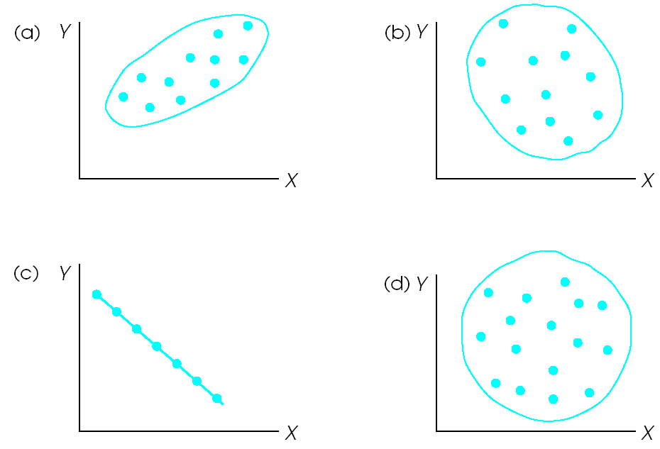

a = +0.8ish, b = -0.3ish, c = -1.0, d = 0.0

Rule of thumb:
stick = 1.0, hot dog = 0.8, sub sandwich = 0.5, egg = 0.3, circle = 0.0
If you can tell the difference between an egg and a bratwurst, you’re in good shape

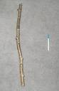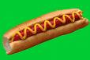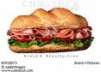

r = -0.8 | r = -0.4
r = 0.2 | r = -0.6
r = 0.0 | r = -0.3

Positive Parental Relationship means lower Authority Problems
(r = -0.31)

Correlations

Regression

r = .31, R = .31

Predicted Y = -.271(X) + 3.305

If someone rated their parental relationship (X) as a 7:
Predicted Y = Authority Problems = -.271(7) + 3.305
=1.4
= low authority problems
Multiple Regression

Parent relationship and Anger predicting Authority Problems
R = 0.39

multiple R = 0.39

Predicted Y = Authority Problems = -.213(X₁) + .202(X₂) + 2.499

If someone rated Parent Relationship as 1 and anger as 7:
Predicted Y = Authority Problems = -.213(1) + .202(7) + 2.499
= 3.7
= modest authority problems

