End of Year Review
PSY 211
12-3-07

I suggest prioritizing your studying to focus on the concepts presented in this review and in the study guide; however, an “A” performance requires greater depth of knowledge.

A. Unit 1: Basic Concepts

Distribution Shapes
- Positive skew
  - Most scores low, tail at the high end
- Negative skew
  - Most scores high, tail at the low end
- Symmetrical

What would be the shape of a distribution for…

Attractiveness scores?

Annual number of sexual partners?

Depressive symptoms?

Central Tendency
- Mean:
  - M for sample
  - μ for population
  - Sum of scores divided by n (sample size)
  - ΣX / n

- Median:
  - Middle number in a distribution
  - If two middle numbers, average them
- Mode:
  - Most popular or most common choice

  - Can have multiple modes
  - If all have the same frequency, no mode
Some quiz scores:

1 1 3 4 4 5

Mean? Median? Mode?

Variability
- Standard deviation: average distance scores vary from the mean
  - s for sample
  - σ for population
  - SD for population or sample
- Variance: standard deviation squared, commonly used in various calculations
  - s² for sample
  - σ² for population

Would the Lions rather have a football punter with high or low variability in kicking distance?

What’s the approximate standard deviation for a
7-point “happiness” scale?

B. Unit 2: Correlation and Regression

- Statistics used for describing the relationship between continuous variables

Correlation

- Pearson’s r, or just plain “r”
- Sign indicates direction
  - Positive or direct
  - Negative or inverse
- Number indicates magnitude

Indicate the direction and magnitude of these correlations:

r = 0.12

r = -0.68

r = 1.37

r = 0.08

r = -0.49

Correlation Guide:

impossible! | more extreme than +1.00
large | +.50 to +1.00 | positive  (direct)
medium | +.30 to +.49 | positive  (direct)
small | +.10 to +.29 | positive  (direct)
zero / near-zero | 0 ish
small | -.10 to -.29 | negative  (inverse)
medium | -.30 to -.49 | negative  (inverse)
large | -.50 to -1.00 | negative  (inverse)
impossible! | more extreme than -1.00
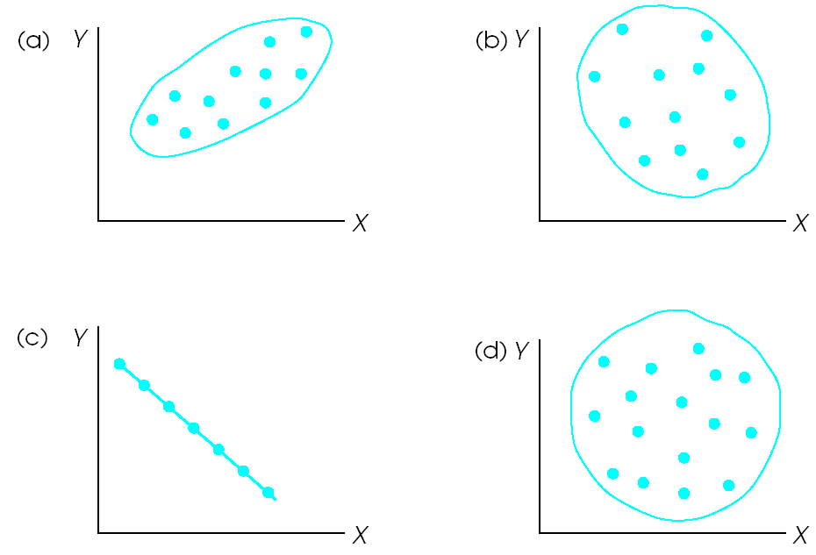

a = +0.8ish, b = -0.3ish, c = -1.0, d = 0.0
stick = 1.0, hot dog = 0.8, sub sandwich = 0.5, egg = 0.3, circle = 0.0

- We spent a lot of time on correlation, so make sure to review the notes in detail

Regression (R)

- Statistical technique for finding the best fitting straight line for a set of data
predicted Helpfulness = .288(Agreeableness) + 3.325

What if my agreeableness score is 1?

- When using one predictor, r and R are the same
- Multiple R: Examine how well multiple independent variables combine to predict the dependent variable

From Homework #7…
C. Unit 3: Probability and Standard Scores

Probability
- Calculations are de-emphasized on the exam, and no appendices from the book will be used
- Do know the 68-95-99 rule

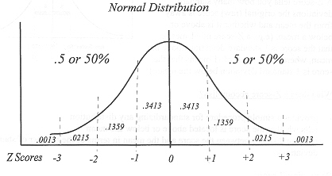
T scores 20 30 40 50 60 70 80
IQ scores 55 70 85 100 115 130 145

- I suggest re-reading probability in detail if you are struggling with issues, such as “p < .05” or determining whether a result is significant or reliable
- Probability is the basis for inferential statistics. A result is defined as statistically significant or reliable when there is less than a 5% probability that it would have occurred due to sampling error or “chance”
- p values can be thought of as the probability of incorrectly rejecting the null hypothesis, the probability of making a Type I error, or the probability that results might occur by chance
- p values are like golf scores; low is good

What proportion of the population has an IQ between 100 and 115?

Which of the following correlations are statistically significant?

r = 0.39, p = 0.23

r = 0.10, p = 0.02

r = 0.16, p = 0.06

Standard Scores

Z score = X – Mean
SD

X = Mean_{desired} + (Z score)*(SD_{desired})

- Z scale: M = 0, SD = 1
- T scale: M = 50, SD = 10
- IQ scale: M = 100, SD = 115

Which of the following scores is more extreme?

Z = 1.5
T = 30
IQ = 125

And these?

Z = -2.1
T = 70
IQ = 70

D. Unit 4: Introduction to Hypothesis Testing

- Use sample data to determine whether the findings are reliably – likely to occur at the population level
- p value indicates the probability that the findings are due to sampling error or “chance”
- Low p value, means low probability that findings are due to chance, so findings must be reliable, likely to generalize to the population

Z statistic
- Can be used to compare an individual score or a sample mean to the population mean, when the population standard deviation is know
- Critical Z value (where p < .05) always occurrs at a Z of ±1.96

Single-sample t-test
- Can be used to compare a sample mean to the population mean, when only the sample standard deviation is know (population standard deviation is unknown)
- Critical t value (where p < .05) depends on the degrees of freedom (df; n – 1) because the shape of the t distribution changes, depending on sample size; smaller samples require a higher t value to obtain a significant or reliable result
Between-group t-test
- Compare two samples (two groups within a sample) to determine whether group differences are reliable enough to likely generalize to the population
- Critical t depends on df, as for all t-tests
Within-subject t-test
- a.k.a. Repeated-measures t-test
- Compare the same group of people across two different time points to determine whether scores reliably differ over time
- Participants act as own control, so power is a bit higher than with other t-tests
- Sometimes also used for matched samples, such as twin or Alzheimer’s studies
- Critical t depends on df, as for all t-tests

Effect Size
- The p value describes whether a result is reliable and likely to generalize to the population, but it is highly dependent on sample size and does not describe how big or important a difference is
- r, r², and Cohen’s d are measures of effect size, indicating the magnitude of an effect

- p values describe whether a result is reliable, whereas effect sizes indicate how big or small the group differences may be

Cohen’s d = $\frac{(M_{1}−M_{2})}{s}$

What type of test would be used to compare gender differences in neuroticism?

What type of test would be used to compare CMU students to the overall population in terms of IQ?

Happiness scores improve from 4.7 to 6.2 during the course of therapy (SD = 1.5). What is Cohen’s d?

large | +.80 to infinity | increase  (higher)
medium | +.50 to +.79 | increase  (higher)
small | +.20 to +.49 | increase  (higher)
zero / near-zero | 0 ish
small | -.20 to -.49 | decrease  (lower)
medium | -.50 to -.79 | decrease  (lower)
large | -.80 to -infinity | decrease  (lower)

E. Unit 5: Advanced Topics in Hypothesis Testing

- t-tests are often unsatisfying because researchers want to examine more than two groups or time points

ANOVA

- Similar to the between-group t-test but can examine differences in scores across 2 or more groups
- Factor vs. level

Repeated-measures ANOVA

- Similar to the repeated-measures t-test but can examine differences in scores across 2 or more time points

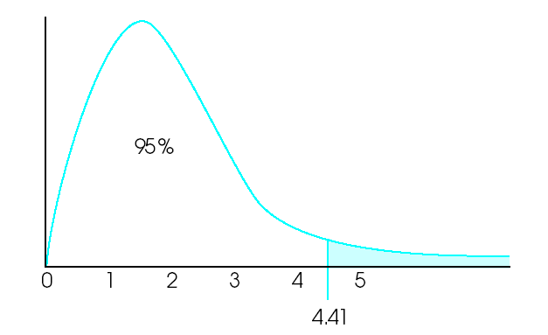
F statistic

- Both types of ANOVA rely on the F statistic, which is somewhat similar to the other distributions learned about, but F is always positive
- F = total variability
chance variability
- In other words, the F statistics indicates whether the variability in scores is more than would be expected to occur due to chance
  - Also, recall that the repeated-measures ANOVA controls for chance variability due to individual differences, so this test is more powerful
- Why would variability be greater than chance?
  - Treatment or experimental manipulation causes scores to change, increasing variability
- Critical F value (where p < .05) depends on two df values, one related to sample size and one related to number of groups
  - Recall: the critical t value was always greater than ±1.96 (and usually somewhere in the 2’s)
  - The critical F value is always greater than 1.57 (and usually somewhere between 2 and 10)
- When F is near 1, the results are likely due to chance, and when F is greater than the critical value, the results are unlikely due to chance, probably due to treatment

Are the following F values statistically significant?

F = 0.93
F = 1.28
F = 4.32

Post hoc Tests

- F tests only tell whether a result is significant; they signal that some reliable difference has occurred
- Post hoc tests help clarify which groups (or time points) differ; they tell where the differences occur
- Least Significant Difference (LSD), Bonferroni, and others

Chi-square Test for Goodness of Fit

- Involves a single categorical variable
- Used to determine whether proportions (frequencies or percentages) obtained in the sample are similar to those that are hypothesized or expected to occur in the population

Chi-square Test for Independence

- Independent (unrelated) vs. dependent (related)
- Determines whether one categorical variable can be used to predict another categorical variable

What test would be used to determine whether…

A sample is overly White?
Favorite color relates to happiness?
Treatment is effective at several follow-ups?
Gender is related to political party?
Attractiveness is related to intelligence?

F. SPSS Output

- 6 of the 30 multiple choice questions on both the next exam and on the make-up exam involve SPSS Output, so know it well

ANOVA

- Most people answered questions correctly on the ANOVA assignment, suggesting that this is well-understood

I was curious whether these groups of people differ on quality of parent relationship:
- Parent as hero (mom or dad)
- Family member, non-parent as hero (sibling or other family member)
- Non-family member as hero (all others)

Post Hoc Tests

Was the F test significant?

Are people who describe a parent as their hero reliably more likely to have better parent relationships than…
people who described a different family member as a hero?

people who described a non-family member as a hero?

Do people who choose a non-parent family member and a non-family member differ in terms of parental relationships?

Repeated-measures ANOVA

Does treatment for anxiety work?
At 6-month and 1-year follow-up?

Chi-square Test for Independence

Does sleeping position (back, side, stomach, fetal) relate to statistics enjoyment (Yes/No)?

