Correlation
PSY 211
9-17-07 and 9-19-07

A. The Great Divide

- Psychologists tend to use two methods of research:
  - Surveys (or other non-experimental studies)
  - Experiments

 | Survey | Experiment
Strategy: | Observe natural relationships between two variables | Manipulate independent variable, observe changes in dependent variable
Variables: | Usually both variables are continuous | Usually one is categorical, one continuous
Analyses: | Usually focus on correlations | Usually focus on mean differences across groups
Statistics: | r, R, and various other correlation coefficients | t-tests, ANOVA, Cohen’s d
Strengths: | Examine many variables at once, can be very complex if desired | Usually easier to prove causality
Weaknesses: | Sometimes difficult to prove causality, less control | Examine few variables, inefficient, can’t control everything (e.g. personality)
Researchers: | Willing to tolerate uncertain conclusions | Low tolerance for ambiguity
B. Correlation

- Used to examine relationship between continuous variables
- No experimental manipulation, no control
- Observe natural relationship between variables

C. Correlation Coefficient

- Typically, we use “Pearson’s r” or just plain r
- Ranges from -1.00 to +1.00
- Tells us the direction and magnitude of a relationship between two variables
- Direction: Positive (direct) or negative (inverse) relationship, indicated by + or – sign
- Magnitude (Strength): absolute value of the correlation, ignoring the ± sign
  - Ranges from 0 to 1.00
  - No relationship: r = 0.00
  - Perfect relationship r = 1.00

Determine the direction and magnitude of these correlation coefficients:

r = -0.76

r = 0.12

r = -1.46

r = 0.00

r = -1.00

D. More on Direction

- Positive (direct): High scores on X related to high scores on Y, and low scores on X related to low scores on Y
  - e.g. happiness and self-esteem (r = 0.67)

X ↑ Y ↑ AND X ↓ Y ↓

- Negative (inverse) relationship: High scores on X related to low scores on Y, and low scores on X related to high scores on Y
  - e.g. happiness and sleep problems (r = -0.28)

X ↑ Y ↓ AND X ↓ Y ↑

- No relationship: Scores on X not related to scores
on Y
  - e.g. happiness and ACT score (r = -0.01)

X ↑ Y ↓↑ AND X ↓ Y ↓↑

E. More on Magnitude

- Rule of thumb for interpreting strength of correlation coefficient:
- No relationship: r = 0.00
- Small relationship: r > 0.10
- Medium relationship: r > 0.30
- Large Relationship: r > 0.50
- Note: Sometimes even small effects are impressive
- Coefficient of Determination: fancy term for the correlation coefficient squared (r²). It tells you the percentage of variability in Y can be predicted by X.
  - E.g. ACT scores correlate (r = 0.46) with grades. Thus, r² = 0.21, so we can predict 21% of the differences in grades knowing ACT score.

Life Stress correlates r = 0.24 with Frequency of Crying. What is the magnitude of the correlation? What is the coefficient of determination? What does this mean?

Frequency of Tanning correlates r = -0.19 with Vocabulary. What is the magnitude of the correlation? The coefficient of determination? What does this mean? Is this more or less impressive than the previous correlation?

F. Formula

Pearson’s r = degree that X and Y vary together
degree that X and Y vary separately

Pearson’s r = | $$\frac{\text{SP}}{\sqrt{{\text{SS}}_{x}{\text{SS}}_{y}}}$$

- In other words, a correlation coefficient is a way of quantifying how similar two variables are
- On the exam, you will not need to calculate a correlation coefficient from a data set, but you will need to be able to draw a scatterplot and estimate the correlation coefficient

G. Making Scatterplots

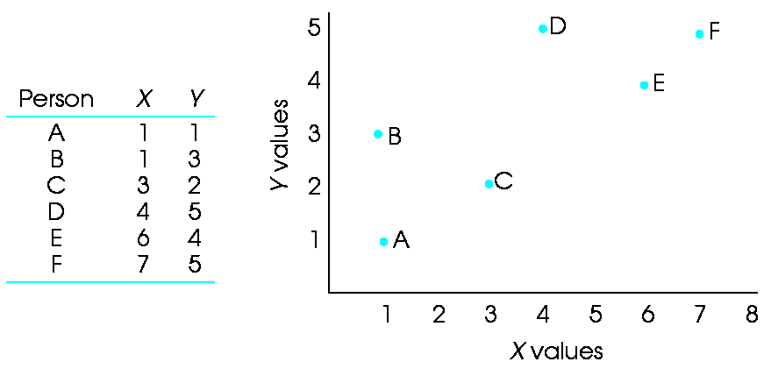

Find the correlation coefficient for these scatterplots:

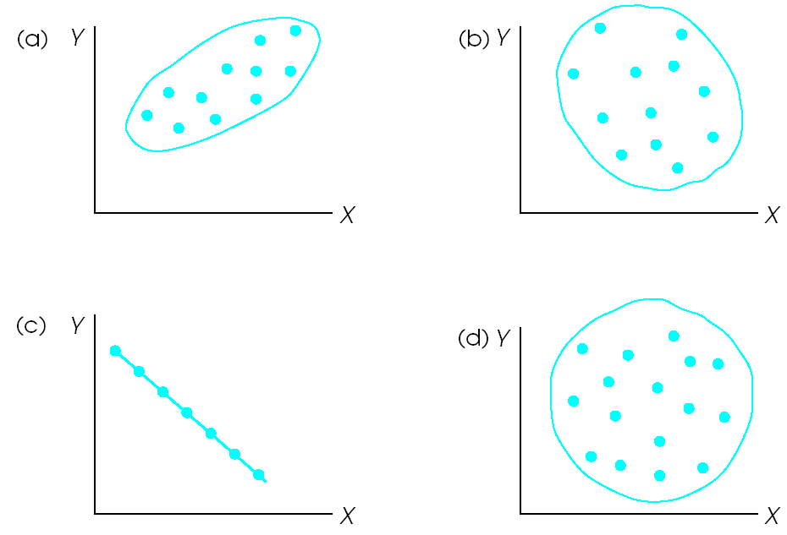
H. Using the Correlation Coefficient

- Test theory: See if two variables are related in hypothesized ways
  - Correlate a measure of “mother’s frequency of crying” with “child’s behavior problems”
- Prediction: See if one variable can be used to predict scores on another variable
  - Use ACT scores to predict grades
- Reliability:
- Internal consistency (α): whether items in a survey correlate highly with each other (and thus measure the same construct)
- Mike throws out “bad” test item
- Test-retest: whether scores on a survey administered on two occasions correlate
- IQ tests scores correlate r = 0.95 administered 3 months apart
- Validity: See if one survey correlates with surveys of related constructs
- You design a measure of “emotional intelligence” and see if it correlates with scores on related measures of “social skill” and “social problem solving”

I. Additional Considerations

- Many factors impact the magnitude of the correlation coefficient
- The correlation coefficient thrives on strong, well-measured, linear relationships, where lots of variability is present

 | Increase r | Decrease r
Actual relationship between variables | Strong relationship | Weak relationship
Range restriction | High variability | Low variability
Outliers | Depends on location | Depends on location
Shape of distribution | Normal, Symmetrical | Skewed, flat, or misshaped
Quality of measures | Multiple items summed up | Single item
Time period | Short | Long

- Range Restriction:

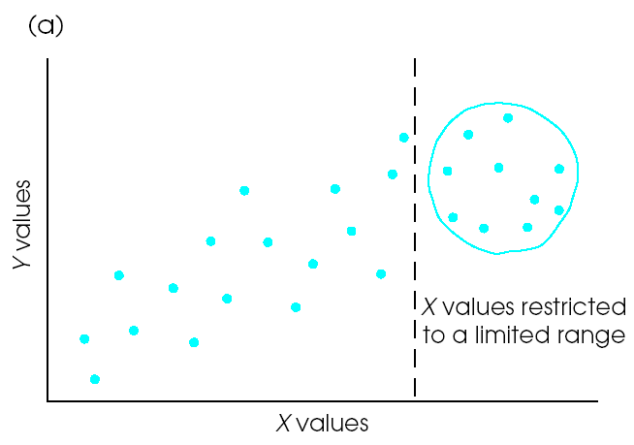

- Outliers:

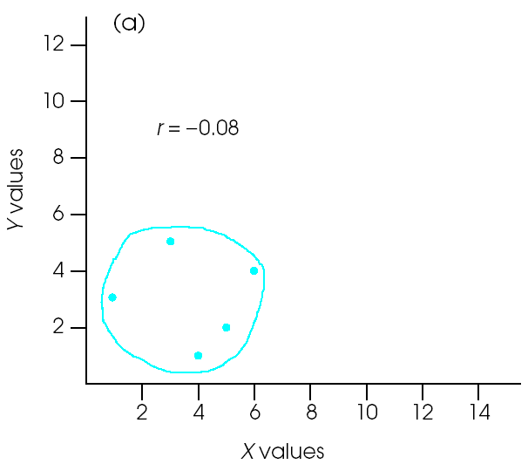
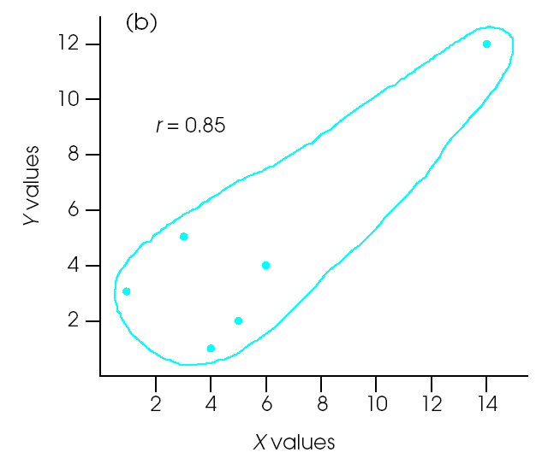

- Classroom Survey
  - Used single-item measures
  - Range restriction due to mainly college sample, where participants are fairly similar
  - Our correlations would probably be about 0.1-0.2 bigger if we were better researchers ☹
J. Other Types of Correlation Coefficients

- Generally use the Pearson r
- Under certain circumstances, correlation coefficients have different names and formulas (don’t need to know these formulas for this class)
- Spearman correlation (ρ or “rho”): Rank-ordered variables
- Point-biserial correlation (PBR or r_{pb}): One variable is continuous but the other is categorical
  - Correlation between gender and aggression
- Partial correlations: There are various types, but they all involve correlating two variables, while controlling for a 3rd variable
  - You find that Eating Pizza and frequency of Smoking Marijuana are highly correlated (r = 0.60), but suspect the correlation is due to age. You run a partial correlation between Pizza and Marijuana, controlling for age and find that it is only (r = 0.03).
- R (or multiple R): Used to estimate how well several variables can predict one variable (We will learn about this more next time)
  - Example: Predicting college grades from ACT scores, high school gpa, and conscientiousness scores combined

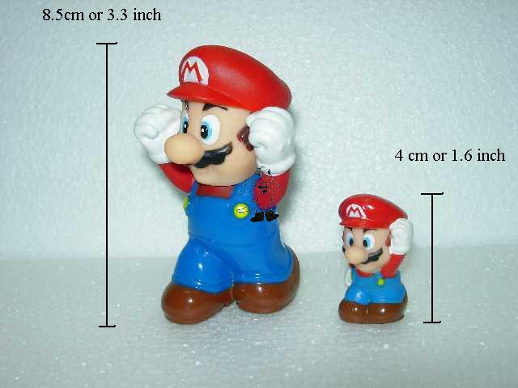
R
r
K. Correlation ≠ Causation

- Variables can be correlated (related) for three reasons:
- X causes Y
- Y causes X
- X and Y are caused by some 3rd variable
(a confounding or extraneous variable)
- Example: Depression and anxiety are correlated
- Depression might cause Anxiety
- Anxiety might cause Depression
- A 3rd variable, Stress, might cause both
- Usually all three reasons have some truth, so it is important to think critically about why variables are correlated
- So correlations are ambiguous? YES
- When can we be more certain about causality?
- One variable comes well before the other, or very early in life (e.g. gender, some traits, etc.)
- Control for important 3rd variables
- Sound theory/logic
- Experiments have shown similar results
- More advanced statistics, not covered in PSY 211, which usually involve looking at changes over time
Correlation may or may not mean causation.


L. Path Diagrams

- Thus far, we have considered the technical aspects of the correlation coefficient
- Now let’s simplify and do some drawing
- Path diagrams are drawings with shapes and arrows used to explain the relationship between variables
  - Do not confuse them with scatterplots on the exam
- Rectangles: Use rectangles to represent measures of a particular variable (e.g. a depression survey)
- Arrows: Drawn between two variables
- Single-headed Arrow: indicates that the researcher thinks one variable mainly causes the other
- Double-headed Arrow: the direction of causation is unknown, or both variables are thought to cause each other

Studying presumed to cause higher exam scores:

Hours Spent Studying
Exam Score

cause effect

Depression and anxiety presumed to cause each other or be related in some unknown or complex way:

Depression
Anxiety

- Add a sign (±) above the arrow, if you are able to hypothesize whether the correlation will be positive or negative

Hours Spent Studying
+
Exam Score

- Add the specific correlation above the arrow if it is known

Hours Spent Studying
0.23
Exam Score

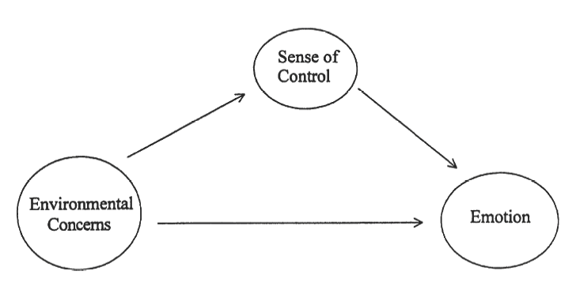

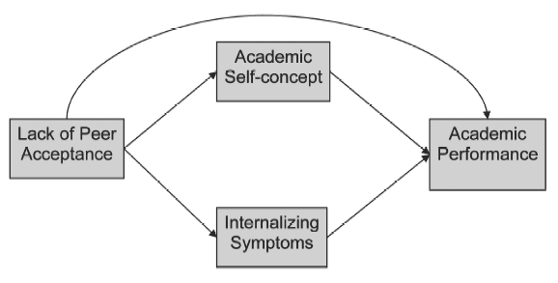

Practice. Draw a path model using the following variables:

“Number of Concussions”

“Number of Fights”

“Medical Expenses”

Practice. Draw a path model using the following variables:

“Beauty Concerns”

“Exercise”

“Tanning”

