Analysis of Variance (ANOVA)
PSY 211
11-19-07

Term papers due Wednesday
Include a copy of all sources
(Include a copy of SPSS Output, if desired)

A. Types of Analyses (some review)

- Continuous variables: Values are numbers that have meaning, such as rating scales or other numeric measurements (IQ, 9-pt attractiveness scale, height)

- Categorical variables: Groups, any numbers assigned are meaningless (gender, ethnicity, experimental condition, treatment group)

Type | Independent Variable(s) | Dependent Variable
Correlation (r) | One  continuous | One  continuous
Multiple Regression (R) | Multiple continuous | One  continuous
Between-group t-test (t) | Categorical  (2 categories) | One  continuous
ANOVA (F) | Categorical  (2+ categories) | One  continuous
Chi square (χ²) | Categorical | Categorical
B. Review of t-tests

- Two commonly used t-tests
- Between-group t-test: two groups of people are compared on some continuous outcome variable
- Repeated-measures t-test: same group of people compared on some outcome variable across two time points

C. Analysis of Variance (ANOVA)

- ANOVA: similar to the between-group t-test, except the independent variable can include
two or more categories
- Repeated-measures ANOVA: similar to repeated-measures t-test, except the same group completes some measure across
two or more time points
- Note: When dealing with a two-category variable (e.g. gender), either ANOVA or a t-test could be used. Since t-tests are simpler, in practice they’re used for two-category variables, and ANOVA is used when there are three or more categories
- Thus, ANOVA is like a more powerful t-test

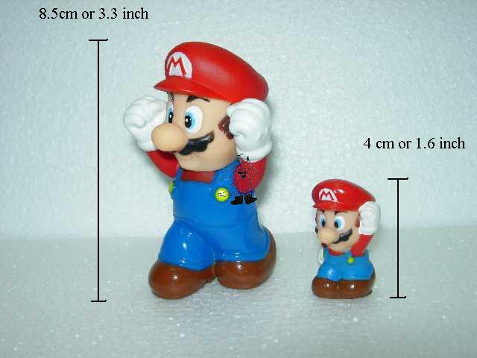
ANOVA
t-test

D. Why ANOVA?

- Often variables have more than 2 categories: favorite color, hero, favorite fast food place
- To use t-tests for these types of multiple-category variables, we had to:
- Restrict analyses to only two categories, such as McDonald’s vs. Taco Bell
- Re-classify the variables down to two categories, such as Taco Bell vs.
non-Taco Bell
- As you recall from the last computer assignment, this can be very tedious
- Also unsatisfying because the t-test cannot provide us with all of the answers we crave
- For example, we might want to know, out of all possible favorite colors, which color is reliably associated with the highest level of depression?
- Of all the possible heroes, what hero is associated with the greatest life satisfaction?

E. ANOVA Lingo

- Factor: the categorical independent variable
- Favorite color
- Level: specific value/condition within the factor
- Blue

A researcher wants to compare three treatments (placebo pill, medication, and surgery) to see which is most effective in improving heart health.

- What is the independent variable?
- What is the dependent variable?
- What is the factor?
- What are the levels?

F. Hypothesis Testing

- Hypothesis testing with ANOVA can be a bit peculiar. Let’s examine hypothesis testing, where the IV has three categories

H₀: μ₁ = μ₂ = μ₃ or
At the population level, groups 1, 2, and 3 all have the same mean on some variable.

H_{A}: At the population level, at least one mean differs from the others.

- Note: H_{A} will be true under a wide variety of conditions…
μ₁ ≠ μ₂ ≠ μ₃ (all means are different)
μ₁ = μ₃, but μ₂ is different (at least one mean differs)

- Alternative hypothesis is true if there are any mean differences at the population level

- Because of sampling error, we always expect some mild group differences in scores at the sample level
- Based on the sample size, are the amount of differences observed in the sample so reliable that they would be expected to occur at the population level?
- To determine this, ANOVA relies on the F statistic

G. Significance Testing with the F Statistic

- For PSY 211, we will not calculate the F statistic by hand; instead, we will attempt to understand how the F statistic works and allow SPSS to do the grunt work
- Some conceptual definitions of F:

F = variance (differences) between groups
variance (differences) within groups

F = total amount of variability in scores
variability due to chance


Huh?

F = total amount of variability in scores
variability due to chance

- F will be about 1 when the null hypothesis is true, and F will be large when the alternative hypothesis is true
- Example showing health scores for three groups:
Variability due to chance = average amount of variability within each group

Placebo | Medication | Surgery
10 6 2  5 8 6  9 4 8 7 | 9 4 8 7  5 8 6  10 6 2 | 5 8 6  10 6 2  9 4 8 7
Total Variability = Total amount of differences in scores

In this case, scores do not differ across groups.

Scores do differ within groups, due to chance.

F = total variability / chance variability

In this case, the total amount of variability is high, and the amount of variability within each group (chance variability) is high.

F = big number / big number = about 1ish

(e.g. maybe F = 8 / 8 = 1)

What if there was a treatment effect???

Placebo  Variability due to chance = average amount of variability within each group | Medication | Surgery
0 1 2  2 1 0  2 1 0 2 | 4 5 4 6  6 5 4  4 6 5 | 9 8 10  10 8 10  9 10 8 9
Total Variability = Total amount of differences in scores

In this case, scores differ a lot across groups.

Scores don’t differ much within groups (due to chance).

F = total variability / chance variability

Total variability is high; chance variability is low, so…

F = big number / small number = big number

(e.g. maybe F = 10 / 2 = 5)

- Thus, F increases as group differences account for more and more of the variability
- F is small (near 1.0) when most of the variability is due to chance
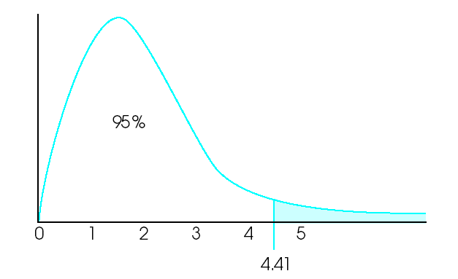
Distribution of F scores has a different shape than the z or t distributions.

Also, the critical F value for determining significance depends on sample size and the number of groups.
H. Post hoc Tests

- The F test can be used to tell us whether the null hypothesis should be rejected
- Weakness: F test tells us that at least one of the groups has a significantly different mean, but doesn’t tell us which group(s) significantly differ
- This is about as useful as saying “one of the treatment conditions had some effect”
- Obviously, we want to know which condition or conditions differed, and whether scores were significantly higher or lower
- Post hoc test: Post hoc is Latin for “after this.”
The F test tells us whether any groups differ, and the post hoc tells test us how the groups differ (e.g. whether surgery is better than medication, or vice versa)
- There are many post hoc tests. They all differ slightly in how they calculate error terms; some are liberal, some conservative in judging which groups significantly differ

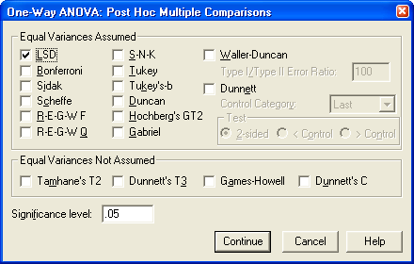
- We’ll use the LSD (Least Significant Difference) post hoc test
- The Bonferroni and Scheffe tests are also commonly used
- The LSD test is very liberal; it will pick up on any major group differences, but has the highest risk of Type I errors
- Other tests are more conservative about labeling group differences as significant, and nerds fight about which test is best to use


Different kind of LSD
I. Examples using SPSS

Is Favorite Fast Food Place related to ability to Delay Gratification?

- Arby’s, BK, McD’s, T-Bell, Wendy’s, Other
- Delay of Gratification (patience): 1=low, 7=high
- Correlation? T-test? ANOVA?
- Output is fairly easy to understand!

- Notice that all of the means are about the same. No major differences, so F is small, and there are no statistically significant differences
- There are no significant differences, so no post hoc test is needed. If the F-value was significant, what would the post hoc tests tell us?

- Ability to delay gratification was unrelated to favorite fast food place, F(5, 320) = 0.20, ns. Thus, customers are probably equally patient across fast food locations.

Is sleeping position related crying frequency?

Sleeping positions: Back, Side, Stomach, Fetal

Crying Frequency: Compared to others I cry a lot…
1 = Disagree – 7 = Agree

- Step 1: Look at the means for each group.
Who cries the most?
Who cries the least?
- Step 2: Check for significance.
What is the F value?
Is it statistically significant (reliable)?

Post Hoc Tests

- Step 3: Exam the post hoc results.
Which sleep positions significantly differ from each other in terms of crying?
Which sleep positions do not differ significantly from each other?

(More details on next page)
Comparing Back to Side (pink box), the Mean Difference is small and non-significant.
Comparing Back to Fetal Position (blue box), the mean difference in crying is much larger. The negative sign indicates that Back sleepers cry less than Fetal Position sleeper. The Sig. value (p-value) shows that this is statistically significant (reliable).

Note that the post hoc table allows us to compare any two groups with each other (kind of like a big table of t-tests all at once), and some of the information is redundant (see gray box).
- Step 4: Write up the results in APA format.

Sleeping positions is related to crying frequency, F(3, 322) = 4.75, p < .05. People who sleep in the fetal position cry the most, and people who sleep in their back cry the least.

