Single-Sample t-Test
PSY 211
3-18-08


Did people who had taken Airborne make a Type I or a Type II error?


Was this commercial guilty of a Type I or a Type II error?

A. Introduction

- The confusion of “t”:
  - Temperature
  - Time
  - T scores
  - t-tests (have nothing to do with T scores)
    - There are also several kinds of t-tests

B. Similarity to z test

Significance Tests
z tests | t tests
z = (M – μ)  σ_{M} | t = (M – μ)  s_{M}

- Main difference is how the standard error of the mean is calculated:
  - z test: σ_{M} = σ / $\sqrt{n}$
  - t test: s_{M} = s / $\sqrt{n}$

- Use the t test when we know the sample SD instead of the population SD

- Often we don’t know the population SD for every measure we want to use, so this can be very helpful

Key difficulty in statistics: Choosing the correct statistical test based on available information

C. Differences from z test

- t test is based on the t distribution
  - Like the z distribution, but shape depends on “degrees of freedom” (df = n – 1)
    - Varies by sample size
  - For large samples, similar to z distribution
  - For small samples, much flatter (like a hill instead of a mountain)
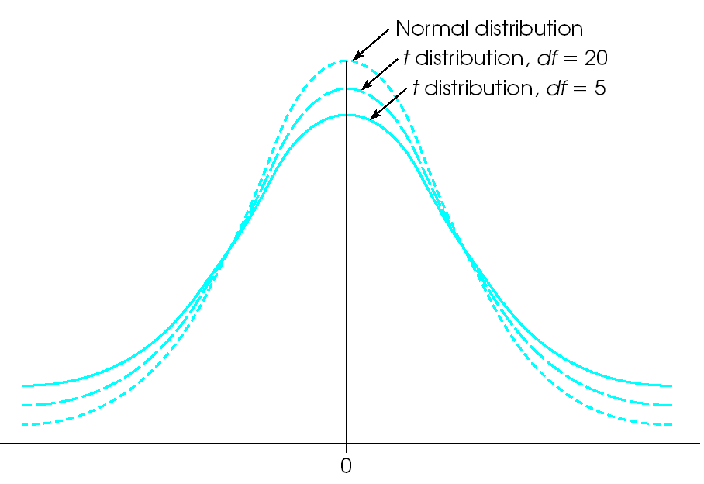
Shape depends on sample size
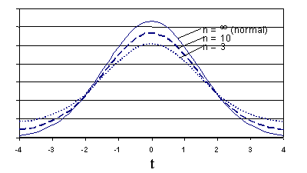
- Because the t distribution varies slightly depending on sample size, the critical value also varies depending on sample size
Alpha level

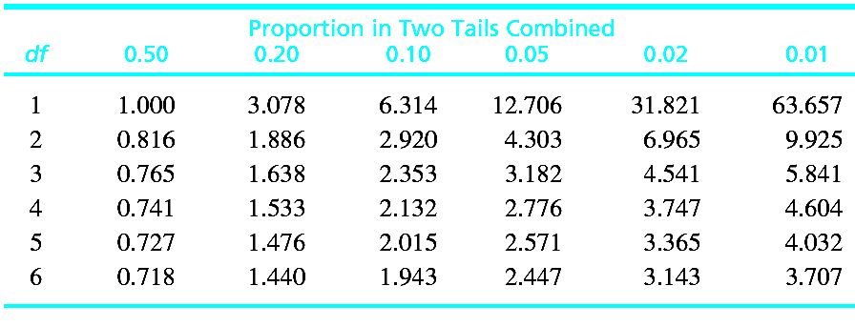

- For small samples, critical t value is very large
- In other words, it’s very difficult to get a significant result using small samples
- For large samples, the critical t value shrinks down (getting closer to the ±1.96 value we’re accustomed to)

With the z test, we generally used a critical value of ±1.96. Because the critical value for the t test depends on sample size, we must use Appendix B2 (p. 691) to find the critical value.

- What are degrees of freedom (df), and why do we use that instead of the exact sample size?

  - df = n – 1
  - Corrects the sample size to
give a slightly better estimate
  - Index number for identifying
a critical value
  - Formal definition (beyond the
scope of PSY 211): Number of independent pieces of information
needed for a calculation

- In Appendix B2, look up critical value according to df (degrees of freedom), not n (sample size)

D. Practice Problems

 | Problem #1 |  | Problem #2
Research Problem | A sociology textbook says that the average American family has 2.4 children. In a study of  n = 36 low SES families, you find that they have an average of 3.9 children (SD = 1.2). Do low SES families differ on number of children? |  | On a scale from 0 to 10, the average American reports a stress level of 5.5. A sample of n = 49 PSY 211 students report a stress level of 7.0  (SD = 2.0). Do PSY 211 students differ on level of stress?
Step 1:  Set H₀ & H_{A} | H₀:  H_{A}: |  | H₀:  H_{A}:
Step 2:  Critical t  and rejection region | α =  tails? =  df =  critical t = |  | α =  tails? =  df =  critical t =
Step 3:  Calculate t | t = |  | t =
Step 4:

Make conclusion, report in APA format

E. More on Reporting Results

- General format:
Description of statistical finding, statistic,
p value. Summary in lay terms.

- Examples:
People who graduated from college earned significantly higher incomes, t(42) = 5.67,
p < .05. Thus, graduating from college was related to increased salaries.
“42” is the df, not the sample size
A computer may give an exact p value, you can put that instead if you like (p = .013)

Adult heterosexual male patients diagnosed
with hip arthritis reported having sex with
their wives less frequently than most American males, t(14) = 2.68, p = .02. Hip arthritis leads to decreased sexual activity.
Ritalin was no more helpful in improving concentration among those diagnosed with ADHD than those in the general population, t(99) = 0.18, ns. Therefore, Ritalin’s ability to improve concentration is not restricted to a diagnostic group.

We’ll hold off on Cohen’s d and the r² material until next time.

Applied Participation Ideas
Check with me in advance to determine number of credits
Interview someone in your desired profession
- Job requirements
- How statistics are used, how decisions are made, how research is consumed or conducted
- Advice on preparation
Conduct a naturalistic observation
- Observe people from a busy, public location (e.g. main hallway of the library)
- Rate people on two continuous variables
- Put the data in SPSS and calculate the correlations
Engage in some introspection using statistics
- Often people like things but have difficulty articulating why
- Pick 10-20 items that fall into the same category (various songs, types of pop, various television shows)
- Rate each item in terms of how much you like it
- Rate several other attributes about the item and see what variable correlates most highly with how much you like each item
Attend an on-campus event
- Go to an event and do a write-up explaining how it applies to statistics, research, or your field of study
- Socialized Medicine Stinks (3/19)
- Terror at the Voting Booth (3/29)
- Student Research and Creative Endeavors Exhibition (4/23)
Research
- Go through Sona
- I may know of some lengthy research projects if anyone wants to complete all of their hours in a single day

Term Paper Ideas
Ask me for help as needed
1. Look through the classroom data file and find one variable that interests you the most.
2. Draw upon your prior knowledge or do a little research to hypothesize what else this variable might relate to. What might cause your primary variable of interest? What other variables might your primary variable cause?
3. Run some initial analyses if you like. There is no penalty for reporting on null relationships, but usually students find it more tolerable to write about supported alternative hypotheses.

- Pick a topic related to your major or primary field of study. If you have to do a short literature review, it might as well contribute to your knowledge base.
- Pick a topic you might consider investigating again in the future. If you have to design your own study for PSY 385, you’ll be a step ahead.
- Pick a topic related to research that is going on at CMU. If you’re looking to get involved in a particular lab, that could be a useful starting point.
- Pick a topic of broad interest so that you could share it with a family member or future employer.

You are not allowed to publish these term papers since we did not obtain approval from the research ethics board, but if you conducted a similar, slightly better study on your own in the future, you would be able to publish it in a lower-tier journal or online journal very easily.

