Samples and Inferential Statistics
PSY 211
2-26-08

A. Overview
- Previously, we described people using Z scores and made various predictions about individuals using probability
  - E.g. About 20% of people smoke 1 or more cigarettes per day.
  - Often used in making medical or psychological diagnoses too, e.g. 13% are depressed more days than not.
- Problem: So far we have only considered individuals (samples of 1, or n = 1). Usually in psychology or other sciences, we study group differences
  - Instead of knowing whether an individual is smoking a lot or is often depressed, we might want to know whether a group smokes a lot or is frequently depressed.
  - Instead of asking whether Jack has an extreme anxiety score, you might wonder whether psychology majors are extreme on anxiety.
- Solution: Use a more advanced Z score formula that works for group (sample) means
  - Before learning about this new type of Z score, it is helpful to have some background information on samples and sample means

B. Sampling Error (Revisited)
- Usually results are more reliable as sample size increases
  - If you want to know if lawyers have above average oral language skills, would you conduct a study involving 1 lawyer or 20?
- Even the biggest or best samples usually have some error associated with them. Your sample of lawyers does not perfectly represent the population of lawyers as a whole.
- Any particular sample will yield a similar (but slightly different) result
- Sampling Error: Amount of error between a sample statistic and the corresponding population parameter. “Chance” variation between samples and populations.
  - E.g. The population has an average IQ of 100, but in a random sample of people, you find that the mean IQ is only 99.7.
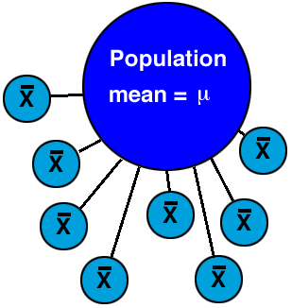

- We use probability to determine whether a sample has a mean that differs from the population more than what we would expect, based on chance (sampling error)
- Use probability to determine whether a group differs from the population due to chance or due to some real difference
- Imagine that nationally, the average college student drinks 4.1 alcoholic beverages per week. In a study of your own (n = 30), you find that the average is 4.3. In a different sample, you find that the average is 3.8. In another sample you find that the average is 4.7.
- Because most samples are a bit different, it is likely that each will yield slightly different statistics
- Thus, psychologists tend to ignore small, unreliable differences

C. Distribution of Sampling Means
- I described choosing three different samples
- Now, imagine pulling all possible samples from a population of interest. If we could compare our sample to all possible samples, we could see if our sample had an extreme score.
- This huge set of all possible samples forms an orderly pattern which makes it possible to predict the characteristics of a sample with some accuracy. This is called:
- The Distribution of Sample Means: the collection of sample means for all the possible random samples of a particular size (n) that can be obtained from a population
- An example should help:

Class Example Involving Height
Nationally, the average American adult is about 5’8”.
Let’s say we repeatedly took a bunch of samples of 10 people and recorded their average height. Graphing them would look something like this:
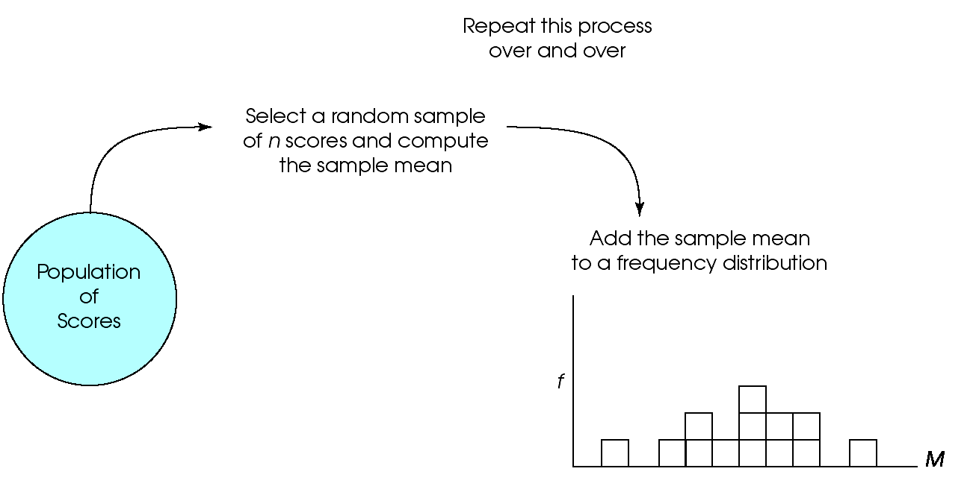
As we took more and more samples, eventually we’d have a normal distribution, with most samples having an average height near 5’8” but some samples would be tall, others short. This would be our distribution of sampling means, and we could use the distribution to determine if any particular sample was extreme.
- Note: This distribution is different from those we’ve previously considered. Instead of plotting individual scores, we are plotting sample means.

- The distribution of sample means tells us how much chance variability to expect from sample-to-sample.
- It would be impractical to study all possible samples, so usually we rely on statistics to determine how much variability to expect by chance.
D. Standard Error of the Mean
- Numeric value (statistic) describing the average amount of error (variability) for the distribution of sampling mean
- SE = SE_{M} = σ_{M} → just different abbreviations
- SE = σ/$\sqrt{n}$
- SE = average distance between sample means and the population mean, like the standard deviation but for sample means
- Indicates average amount of error between sample mean and population mean
- Bigger sample = lower SE
  - Bigger sample = less error, more reliable
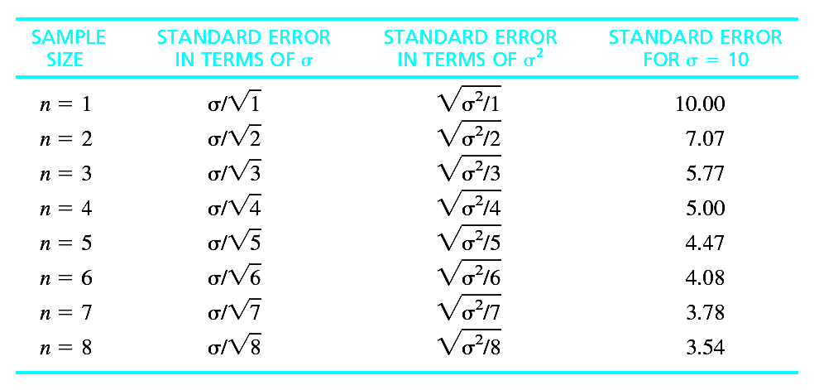
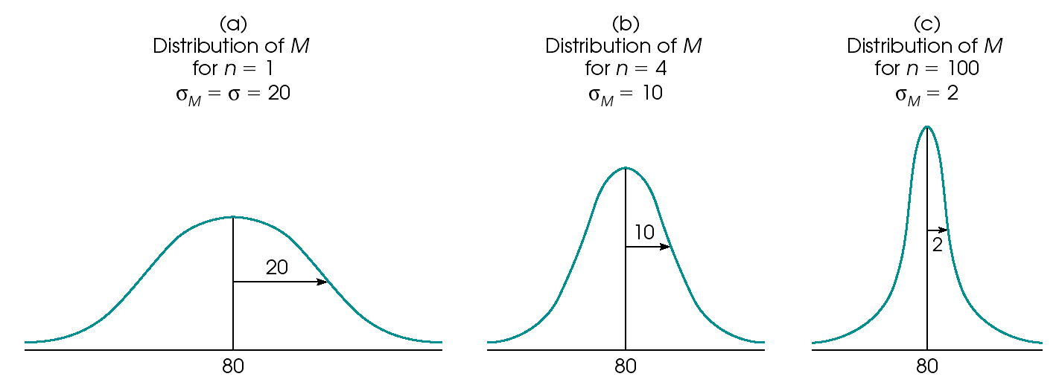
E. Probability and Distribution of Sampling Means
- We use the distribution of sampling means to make probability calculations
- Strategy:
- Find sampling mean
- Convert sampling mean to a Z score (using a modified Z score formula)
- Use Z table to find the probability of finding a Z that is more extreme

- Note: This is no different than what we have been doing, except we use a different formula for Z when we have a sample mean instead of an individual score

Individual Score | Sample of Scores
Z = (X – μ) / σ | Z = (M – μ) / (SE)  where SE = (σ /$\sqrt{n}$)
Can be used to find the probability (likelihood) of an individual score | Can be used to find the probability (likelihood) of a sample mean

- Take the Z score based on the sampling mean, and use the Z table (Appendix B.1 still) to find the probability of a Z that is more extreme
  - This tells us roughly the probability of finding the results just due to sampling error (chance)

After working in a psychiatric hospital you notice that the people with schizophrenia have many difficulties and wonder if their IQ is similar to the rest of the population (μ = 100, σ = 15). You recruit 9 people with schizophrenia to take IQ tests and find that their average score is 90.
On the test, I will probably include some irrelevant information, like median and mode.

Any sample will have some variation. Find the probability that a mean of 90 would occur in a sample of 9 people by chance (due to sampling error).

Step 1: Find sampling mean.

M = 90 (duh!)

Step 2. Find Z score for sample mean.
SE = (σ /$\sqrt{n}$)
= 15 / $\sqrt{9}$
= 15 / 3.0
= 5.0
Z = (M – μ) / (SE)

= (90 – 100) / (5)
= -10 / 5 = -2.00

Step 3. Look up Z value in table. Find probability of a more extreme Z value.

p ≈ 0.0228 or 2%

This is the probability that our sampling mean only differed from the population due to sampling error (chance, bad sample).

What might we infer?

F. Introduction to Hypothesis Testing
- As the example shows, we can use the Z score for a sample to determine whether that sample likely differs from the population
- If the sample is similar to the population, Z will be near zero. If the sample is very different from the population, Z will be more extreme.
You might remember those “p-values” from the first SPSS assignment.
- p = probability that finding is due to sampling error (chance). If p is small, the result is not likely due to chance. If p is large, the result is probably just due to chance.
A “p” looks like a golf club. In golf, low scores are good.
  - Low p is good, means interesting result
- All of these descriptors – “near zero,” “extreme,” “small,” and “large” are pretty arbitrary. How do we determine whether to conclude that a finding is due to chance or some real difference?
- Rule of thumb: We will only get a Z that is more extreme than ±1.96 by chance 5% of the time. If Z > 1.96 or Z < -1.96, conclude that the result is extreme and not likely due to chance (YAY!)
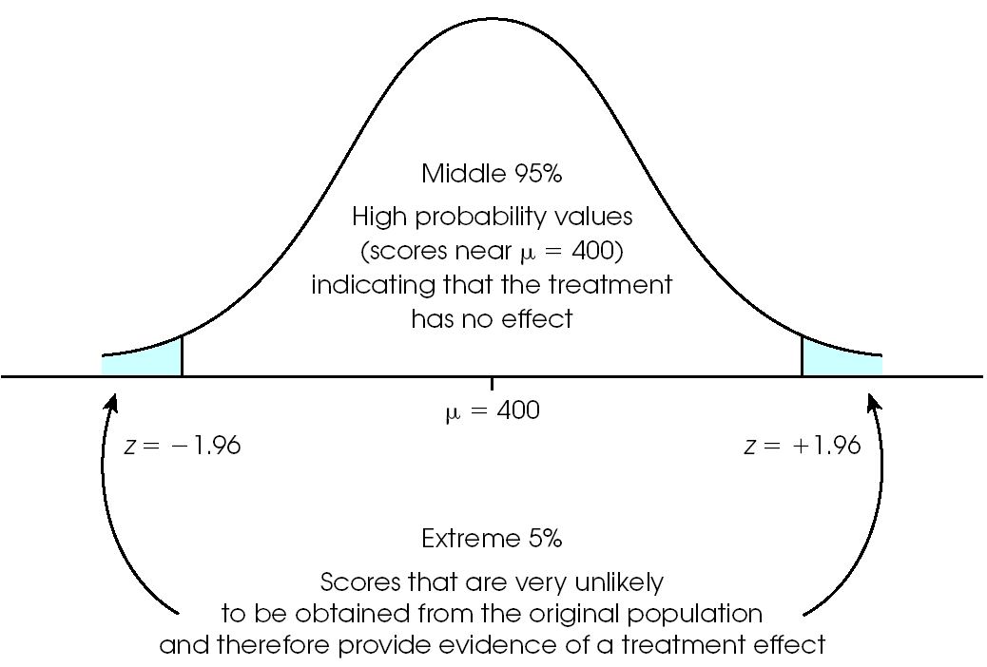

G. Converting Percentile Ranks to Z scores

- Usually we convert Z scores to percentiles, but it is also possible to convert a percentile rank to a Z score
  - Usually done with Z scores for individuals
- Use Appendix B.1, work in reverse
- If percentile rank > 50%, use column B.
- If percentile rank < 50%, use column C, and make Z score negative.

Find the Z score for someone who is in the 95th percentile on math.

Table B.1 column B: Z ≈ 1.64

Find the IQ score for someone who is at the bottom 1st percentile on intelligence.

Table B.1 column C: Z ≈ - 2.33
Z → IQ
IQ = 100 + (Z*15) = 100 + (-2.33*15) = 65

