Variability
PSY 211
2-3-09

A. Variability

- Central tendency = similarities
- Variability = differences
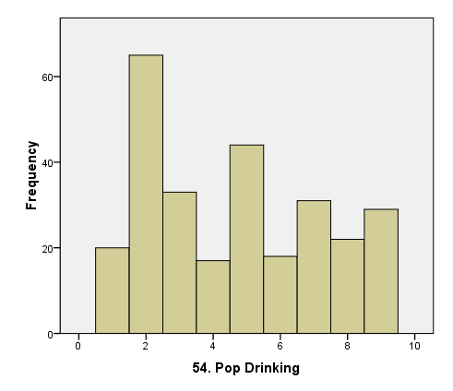
High variability

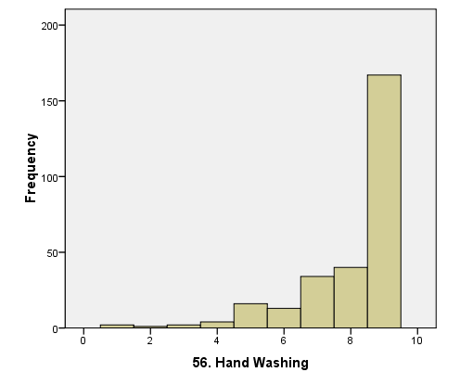
Low variability
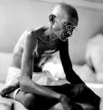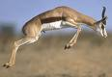

- As scientists, we are fascinated by variability:
  - IQ, extraversion, neuroticism, coping
- A good definition of prejudice is focusing on mean differences and ignoring variability
- Statistics describing variability indicate how much scores vary or differ from the mean

Which has more variability, the time class starts or the time class ends?
Start: 11:01 11:00 10:59 11:03 11:00
End: 12:14 12:08 12:15 12:12 12:06

You are treating two chronic pain patients. Here are their pain scores over 10 sessions. Who did you treat most successfully?

Ted: 10 6 8 2 9 4 8 2 9 5
Jill: 10 9 8 9 7 5 6 5 4 5

- Football example

B. Range

- The upper real limit of the highest score minus the lower real limit of the lowest score

Find the range of these numbers:
2 3 5 7 9
- The range ≠ 9 - 2
- Upper real limit of biggest number (9) = 9.5
- Lower real limit of lowest number (2) = 1.5
9.5 – 1.5 = 8.0

- Shortcut: Range = 1 + high value – low value
1 + 9 – 2 = 10 – 2 = 8.0
- Count on fingers from low number to high number
2 3 4 5 6 7 8 9 = 8 numbers

- Problem: range only takes into account two scores

These data sets have the same range:
A) 1 1 2 2 98 98 99 100
B) 1 99 99 99 99 99 100
C) 1 10 30 50 70 90 100

C. Standard Deviation

- Measure of the typical distance scores vary from the mean
- Unlike the range, it uses information from all scores
- Most common and most important measure of variability
- Looks complex to calculate, but gets easier after a few tries
- Formula differs slightly for population vs. sample
D. Calculating Population Standard Deviation

- Step 1: Determine the “deviation score” or distance from the mean for each score
  - Deviation score
= X – μ
= individual score minus the mean
= how many points above (+) or below (-)
the mean an individual score is

Find the deviation scores for these data:
7 4 1 8
X | (X – μ)
8
7
4
1
ΣX =
N =
μ = ΣX / N =

- Step 2: Square each deviation score
  - Why square them?
- Deviation scores always add up to zero
- We want a positive number to indicate amount of variation

Square the deviation scores for these data:
7 4 1 8
X | (X – μ) | (X – μ)²
8 | +3
7 | +2
4 | -1
1 | -4
ΣX = 20 | Σ(X – μ) = 0
N = 4
μ = ΣX / N = 20 / 4 = 5
- Step 3: Determine the sum of squared deviation scores (or “Sum of Squares” or SS)

Square the deviation scores for these data:
7 4 1 8
X | (X – μ) | (X – μ)²
8 | +3 | 9
7 | +2 | 4
4 | -1 | 1
1 | -4 | 16
ΣX = 20 | Σ(X – μ) = 0 | Σ(X – μ)² =
N = 4
μ = ΣX / N = 20 / 4 = 5

- Step 4: Find the average of the Sum of Squares. This is called the Variance (σ²)

Variance (σ²) = ∑(X – μ) ² = SS
N N

Find the variance for the above data:
Variance = SS / N = 30 / 4 = 7.5

- Step 5: Remember, we squared the deviations to begin with. To get them back on the original units, now we take the square root of the variance, called the Standard Deviation (σ or SD)

Standard Deviation (σ) = = $\sqrt{σ^{2}}$
N
)
X
(
2
∑
μ
−

Find the standard deviation from the above variance:
Standard Deviation = $\sqrt{\text{Variance}}$= 7.5
= 2.7

Thus, the scores have a mean of 5 and typically differ from the mean by about 2.7 points
μ = 5 σ = 2.7

- What’s it look like?

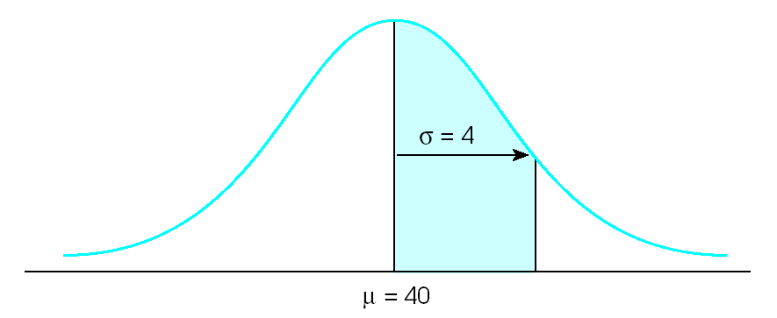
5
2.7

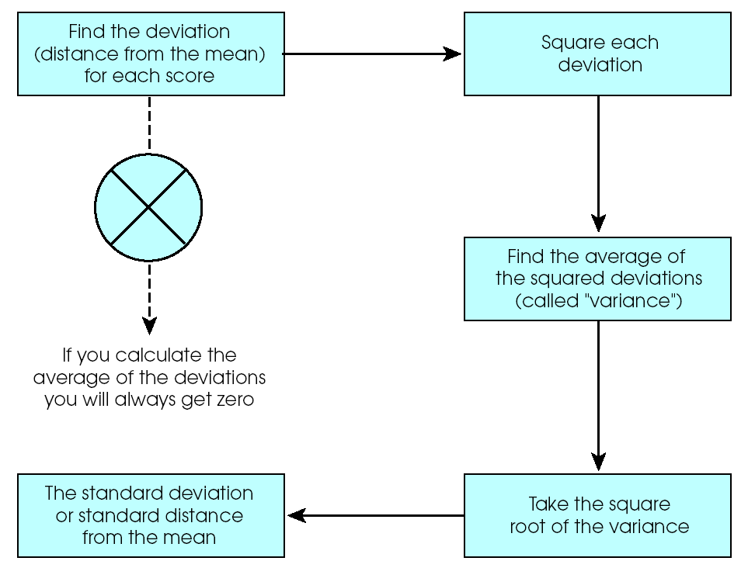
E. Calculating a Sample Standard Deviation

- Calculations are nearly identical to those used for population standard deviation, but we make one slight change

- Step 1: Calculate deviation scores for each X

Deviation score = X – M

- Step 2: Square each deviation score

- Step 3: Sum (add up) each of the squared deviation scores

SS = Σ(X – M)²

- Step 4: Find the Variance. BUT we use a slightly different formula for samples

Variance (s²) =
1
n
)
M
X
(
2
−
∑
−

- Step 5: Find the Standard Deviation by taking the square root of the Variance

Standard Deviation = s =
1
n
)
M
X
(
2
−
∑
−

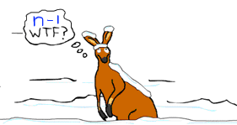

Standard Deviation and Variance for a Sample (Why n – 1 ?): The standard deviation is a curious thing. When we calculate the mean for a sample the best guess of the mean for the population is the same value. However, the standard deviation doesn't work like that. When we calculate the standard deviation for a sample, it is likely to be an underestimate of the standard deviation for the population, so rather than divide by n, we divide by n-1. This corrects the underestimation of the population standard deviation. (See Fig. 4.7 in book)

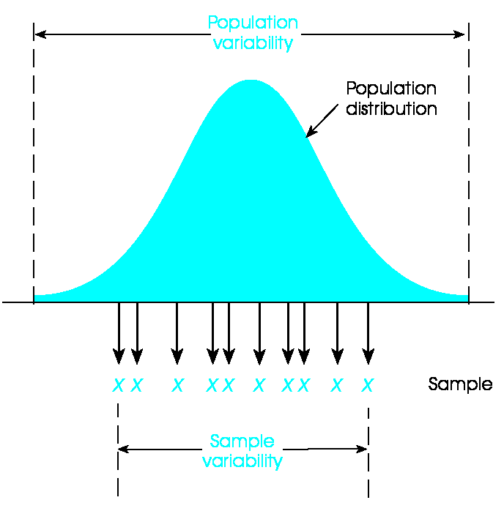

A sample of 5 people (n = 5) were asked how many pairs of shoes they own. Compute the sample standard deviation from these scores:
2 5 3 9 4

X | (X - M) | (X - M)²
9
5
4
3
2
ΣX = | Σ(X - M) = | Σ(X - M)² =
n = 5
M = ΣX / n =

Variance = SS / (n-1) =
Standard Deviation = $\sqrt{\text{Variance}}$ =

F. Additional Characteristics of Standard Deviation

- Adding (or subtracting) a constant from each score does not change the standard deviation
- Multiplying (or dividing) each score by a constant causes the standard deviation to multiplied (or divided) by the same constant
- Standard deviation generally positive
- When standard deviation is zero, all scores are the same (no variability)… or you miscalculated
- When standard deviation is negative… you must have miscalculated

What would it means if the scores for an exam were this?
(a) M = 80.0, SD = 5

What about this?
(b) M = 80.0, SD = 10

And this?
(c) M = 80.0, SD = 0

What would happen if I took the scores from part (a) and added 5 points to everyone’s score?
(a₁) M = ???, SD = ???

What would happen if I took the scores from part (a) and multiplied them by 10?
(a₂) M = ???, SD = ???

Helpful Formulas

Formulas for SD
 | Population | Sample
Deviation score  (how far your score deviates from the mean) | $X−μ$ | $X−\overline{X}$*
Sum of deviation score  (will be always zero) | $$\sum{(X−}μ)$$ | $$\sum{(}X−\overline{X})$$
Sum of squares
(SS)

Variance | $\frac{\text{SS}}{N}$ $\frac{\text{SS}}{n−1}$
1
n
)
X
X
(
2
−
∑
−
Standard deviation | $\sqrt{\frac{\text{SS}}{N}}$ $\sqrt{\frac{\text{SS}}{n−1}}$
1
n
)
X
X
(
2
−
∑
−

* Remember that M can be used interchangeably with$\overline{X}$representing sample mean.
Variability is Beautiful

"I have called this principle, by which each slight variation, if useful, is preserved, by the term Natural Selection"
-Darwin

I would never be able to choose one project over another because it is the balance, the variation, the change that is important to me.
Trevor Dunn

That's the way I play the game… lot of variation, lot of different speed of balls, different spin, and coming in as well.
Amelie Mauresmo

“All women's dresses, in every age and country, are merely variations on the eternal struggle between the admitted desire to dress and the un-admitted desire to undress”
Lyn Yutang

“But one of the attributes of love, like art, is to bring harmony and order out of chaos, to introduce meaning and affect where before there was none, to give rhythmic variations, highs and lows to a landscape that was previously flat”
Molly Haskell

Variability is the law of life, and as no two faces are the same, so no two bodies are alike, and no two individuals react alike and behave alike under the abnormal conditions which we know as disease.
William Osler

“It is the differences that make things interesting”
Bardet-Biedl

