t-Test for Two Independent Groups
PSY 211
3-26-09

A. Shifting Focus

- Previously, we focused on comparing the mean score for a treatment (or experimental) group to an untreated (control) population mean
  - When population M and SD are known, use z-test
  - When population M and sample SD are known, use single sample t-test
- Usually do not know much about the population
- Compare two samples instead
  - Experimental condition vs. control
  - Male vs. Female
  - Smoker vs. non-Smoker

B. Different Statistical Tests

Test | Description | Ch.
z-test | Compare treated sample to untreated population (σ known) | 7-8
single sample t-test | Compare treated sample to untreated population (s known) | 9
between-group t-test  (between-subject t-test) | Compare two different groups of participants | 10
within-subject t-test  (repeated-measures t-test) | Compare same group of participants across two time periods | 11
ANOVA, chi square | Later in the semester
C. Between Group t-test – Rationale

- We might like to compare two groups of people on some continuous variable
- IV = categorical = two groups (dichotomous)
  - Vegetarians vs. non-Vegetarians
  - Caffeine vs. Placebo
- DV = continuous variable
  - Healthiness, happiness, stress, etc.

- Cannot measure entire populations of each group, so use samples
Population A
Caffeine Users
Population B
Non-Caffeine Users
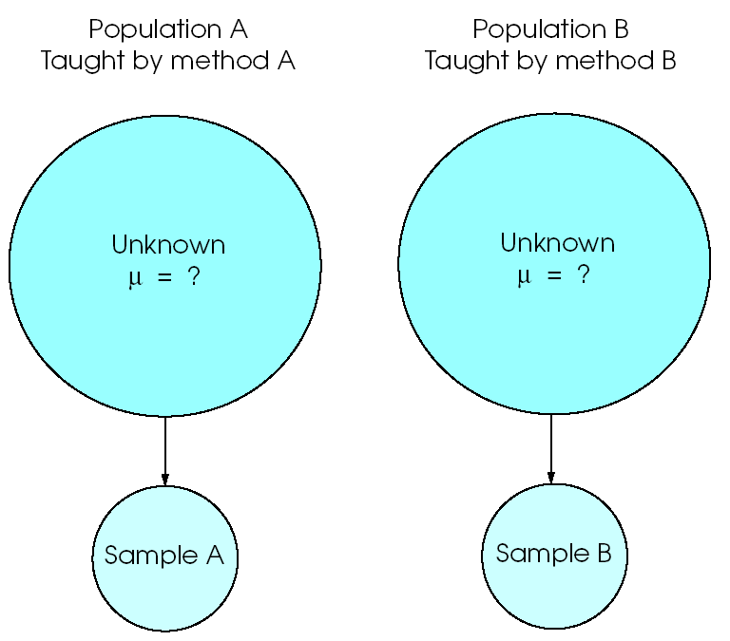

- Due to sampling error, any minor differences between groups might be a chance occurrence
- Use t-test to determine if differences are likely due to chance or group status

Dichotomous variable: Smoker vs. Non-smoker
Continuous variable: Neuroticism
Smoker
Non-Smoker

Dichotomous variable: Animal in inkblot vs. no animal
Continuous variable: Watch violent shows
Animal
Non-Animal

- Visual inspection of these histograms shows some possible group differences
- Only due to sampling error?
- Large enough that we would expect reliable differences across these groups at the population level?
D. Between-Group t-test

- H₀: μ₁ – μ ₂ = 0 (No mean difference)
- H₁: μ₁ – μ ₂ ≠ 0 (There is a mean difference)
- The book gives a very complex description of the between-group t-test formula. The formula below is slightly simpler and will work for any problems we do in PSY 211. Use this formula.
t = $\frac{(M_{1}−M_{2})}{\text{SE}}$ where SE = $\sqrt{\frac{s_{1}^{2}}{n_{1}}+\frac{s_{2}^{2}}{n_{2}}}$

- Much like the z statistic, this test is designed to tell us whether the difference we obtained (top of fraction) is more than what is expected by chance (bottom of the fraction)

On the exam, I will supply you with a formula sheet (formulas announced in advance) and any z or t tables needed.

E. Hand Calculation

In one study, 28 people said they often skip school (Skippers), and 219 people said they don’t often skip school (non-Skippers). Skippers had an average GPA of 2.91 (SD = 0.72), and non-Skippers had an average of 3.26 (SD = 0.55). Did the two groups significantly differ on GPA?

t = $\frac{(M_{1}−M_{2})}{\text{SE}}$ where SE = $\sqrt{\frac{s_{1}^{2}}{n_{1}}+\frac{s_{2}^{2}}{n_{2}}}$

SE = $\sqrt{\frac{\text{.}{\text{72}}^{2}}{\text{28}}+\frac{\text{.}{\text{55}}^{2}}{\text{219}}}$ = $\sqrt{\frac{\text{.}\text{52}}{\text{28}}+\frac{\text{.}\text{30}}{\text{219}}}$
=$\sqrt{\text{.}\text{0186}+\text{.}\text{0014}}$=
=$\sqrt{\text{.}\text{02}}$= .14

t = (3.26-2.91) / .14 = 2.50 .

What is the critical value for t?
Use Appendix B2, but what is the df?

df_{total} = df₁ + df₂ = (n₁ – 1) + (n₂ – 1) = (219-1) + (28-1) = 218 + 27 = 245
critical t = ±1.98, so it is significant!

Non-skippers reliably earn higher grades than skippers; the difference is not likely due to chance.

F. SPSS Example

- The above example shows that hand calculations for t-tests are tedious
- SPSS can do it for us
- Gender differences in crying:

Group sample sizes
Group Means
Group standard deviations

t value
df_{total}
p<.05?
M₁ – M₂
SE

Note: The p-value reported in the table (.000) is rounded. It’s not actually zero, just really small. Usually we write p < .001 in this case.

- We are mainly interested in the t value and whether it is statistically significant – very easy.

- We can double check the t value by dividing the mean difference by the SE:
t = $\frac{(M_{1}−M_{2})}{\text{SE}}$ = 2.194 / .236 = 9.295 ☺

- We can also double check using the raw values in the first box from the Output

t = $\frac{(M_{1}−M_{2})}{\text{SE}}$ where SE = $\sqrt{\frac{s_{1}^{2}}{n_{1}}+\frac{s_{2}^{2}}{n_{2}}}$

SE = $\sqrt{\frac{1\text{.}{\text{84}}^{2}}{\text{213}}+\frac{\text{.}{\text{97}}^{2}}{\text{66}}}$ = $\sqrt{\frac{3\text{.}\text{39}}{\text{213}}+\frac{\text{.}\text{94}}{\text{66}}}$
= $\sqrt{\text{.}\text{0159}+\text{.}\text{0142}}$ = $\sqrt{\text{.}\text{0301}}$
= .17

t = (4.24 – 2.05) / .17 = 2.19 / .17 = 12.88

Our hand calculation is pretty close, but differs slightly because we are using a simpler (less accurate) formula than SPSS uses. Our simple formula tends to be a bit off when the groups differ a lot in terms of sample size or when there is a very big effect present. This is why we like computers.

APA-style write-up:
Females (M = 4.24, SD = 1.84) reported crying more often than males (M = 2.05, SD = 0.97). This result was significant, t(227) = 9.30, p < .05. Thus, females cry more than males.
1) Provide the mean and standard deviation for each group.
2) Describe the result of the statistical test, including the t, df, and p values.
3) Provide a summary in plain English.

Learning Check:
What does a significant t-value mean?
What does a low p-value mean?
What does a high p-value mean?

G. Effect Size

Studies of tens of thousands of people show that Aspirin significantly (reliably) reduces headaches and fatal heart attacks, p < .05. Aspirin works for both headaches and heart health, but is Aspirin better (more effective) at treating headaches or heart problems?

Both results are statistically significant…

But Aspirin reduces maybe 70% of headaches, and only about 1% of deaths due to heart attack.

The lesson: A result can be statistically significant (trustworthy), but we would still like more information on effect size (magnitude of the effect).

- Significance testing tells whether a result is reliable – whether we can trust a result
- It does not tell us how big, important, impressive, or effective a result may be
- Because significance tests depend on sample size, most huge studies will find significant results, even for small effects

- Common measures of effect size:
r, r², Cohen’s d (see table on last page)
If you only know the SD for both individual groups, average them to estimate the overall SD, which is used in this equation.
- Cohen’s d = $\frac{(M_{1}−M_{2})}{s}$

= (Mean difference) / standard deviation

IQ Example:
Children from high SES families have an average IQ of 110, and those from low SES families have an average IQ of 90. What is the effect size?

d = (110 – 90) / 15 = 20/15 = 1.33 ← We’re done!

- You could do a t-test to see if this effect is reliable; it’s a big effect, but if the sample is small, it might just be due to sampling error. The t-test tells us whether we can trust the result.

Earlier example on Gender and crying:

d = (4.24 – 2.05) / 1.4 = 1.56

- If according to t-tests both this and the above results were significant, which would you conclude is a bigger effect?

Lesson: Do a significance test and calculate Cohen’s d, so you can show that a finding is reliable and show how big the effect is.

APA write-ups:

Females (M = 4.24, SD = 1.84) reported crying more often than males (M = 2.05, SD = 0.97). This result was significant, d = 1.56, t(2.27) = 9.30, p < .05. Thus, females cry more than males, which was a large effect.

People who are in a relationship (M = 6.23, SD = 1.90) reported lower levels of life satisfaction than those not in a relationship (M = 6.81, SD = 1.60). This result was significant, d = 0.33, t(277) = -2.74, p = .007. People are less satisfied if in a relationship, but this was a small effect.

Females (M = 6.05, SD = 1.21) reported greater levels of happiness than males (M = 5.56, SD = 1.19). This was a small effect and was not significant,
d = 0.41, t(55) = 1.36, p = .18. Thus, females were mildly happier than males, but this difference was not reliable. Further research may wish to examine this finding using a larger sample.
From a small study I did a few years ago.

The correlation coefficient is an effect size, so these results are pretty easy to write up:
When a sample is too small, even good sized correlations may not be reliable.
Intelligence was modestly correlated with happiness, but this result was not statistically significant, r = .41, ns.
Aspirin use was associated with a slight increase in heart functioning, r = .02, p < .05. Thus, Aspirin has a very small impact on heart functioning, which was reliably shown in the sample.
If a study is huge, it may be able to reliably detect miniscule effects.

Note: When reporting results, you can write the exact p-value (e.g. p = .23, p = .47, p = .05) if you want. Alternatively, some people just write p < .05 for a significant result and ns if non-significant.

Effect | r | r² | d
Small | ≥ .1 | ≥ .01 | ≥ 0.2
Medium | ≥ .3 | ≥ .09 | ≥ 0.5
Large | ≥ .5 | ≥ .25 | ≥ 0.8

Note:
- r ranges from -1 to 1
- d ranges from -∞ to ∞, but usually not too big (kind of like z)
- d values in this table are different from those on p. 262 of the book. Use these values.

