Introductory Examples
PSY 211
1-20-09

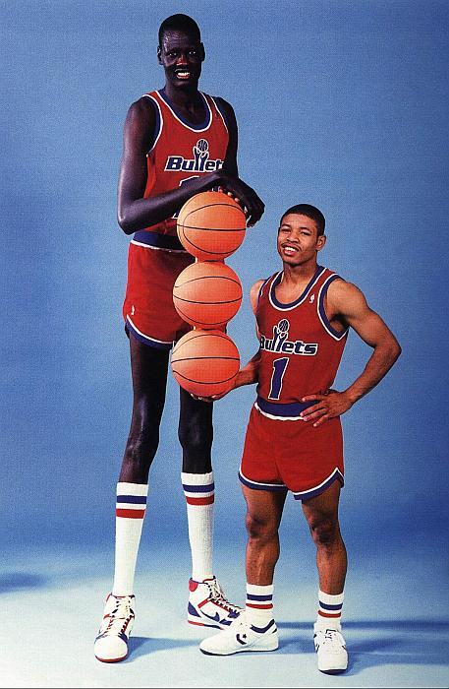
A. Population vs. Sample

Research question:
How tall is the average NBA basketball player?

What is the population?

What is the sample?

What is the difference between a statistic and a parameter?

What is the difference between a descriptive statistic and an inferential statistic?

Research Question:

How depressed is the average prisoner?

What is the population?

What is the sample?

Research Question:

Do people with schizophrenia have below average IQs?

What is the population?

What is the sample?

Research Question:
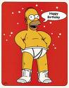
What is the correlation between extraversion and happiness?

What is the population?

What is the sample?

B. The Role of Sampling Error

Candy Example

C. Practice with Frequency Distributions

Sample Problem:
Using the following data set, construct a frequency distribution table with the following columns: x, f, p, %, c%. Make a frequency histogram and a frequency polygon.

Number of Sexual Partners in the Past Year:
0 13 1 0 2 1 0 0 1 3 5 8 9 0 1 2 3 0 1 2

Step 1? Put in order
0 0 0 0 0 0 1 1 1 1 1 2 2 2 3 3 5 8 9 13

Step 2? Outline Table
X | f | p | % | c%

Step 3? Fill in Table
X | f | p | % | c%
13 | 1 | .05 | 5 | 100
9 | 1 | .05 | 5 | 95
8 | 1 | .05 | 5 | 90
5 | 1 | .05 | 5 | 85
3 | 2 | .10 | 10 | 80
2 | 3 | .15 | 15 | 70
1 | 5 | .25 | 25 | 55
0 | 6 | .30 | 30 | 30

Step 4? Make a frequency histogram

Step 5? Make a frequency polygon

Sample test questions:
- What is the probability that a random student has had 0 sexual partners in the past year?
- What is the percentile rank for someone who has had 10 sexual partners in the past year?

Sample Problem:
Construct a frequency distribution table with the following columns: x, f, p, %, c%. Make a frequency histogram and a frequency polygon.

Math Anxiety Scores:
10 8 7 6 8 4 3 8 1 9 0 1 2 8 7 6 4 5 3 9

Step 1? Put in order
0 1 1 2 3 3 4 4 5 6 6 7 7 8 8 8 8 9 9 10

Step 2? Outline Table
X | f | p | % | c%

Step 3? Fill in Table
X | f | p | % | c%
10 | 1 | .05 | 5 | 100
9 | 2 | .10 | 10 | 95
8 | 4 | .20 | 20 | 85
7 | 2 | .10 | 10 | 65
6 | 2 | .10 | 10 | 55
5 | 1 | .05 | 5 | 45
4 | 2 | .10 | 10 | 40
3 | 2 | .10 | 10 | 30
2 | 1 | .05 | 5 | 20
1 | 2 | .10 | 10 | 15
0 | 1 | .05 | 5 | 5
Step 4? Make a frequency histogram

Step 5? Make a frequency polygon

Sample test questions:
- What percentage of students rated themselves as an 8 or higher?
- What is the probability that a student will have an anxiety rating of less than 5?
- What is the percentile rank for someone who has an anxiety score of 1?
D. Skew

Most people have positive qualities; few have negative qualities.

Sample Problem:
You survey college students and have them check off how many symptoms of schizophrenia they have, using a 25-point checklist. What shape would the distribution of scores likely have?

Sample Problem:
You survey college students and have them rate their level of attractiveness on a scale from 1 (low) to 9 (high). What shape would the distribution of scores likely have?

