Answer Sheet

Homework #7: ANOVA and chi-square using SPSS

# | Question Type | Response
1 | ANOVA in APA-style (4pts)
2 | ANOVA in APA-style (4pts)
3 | ANOVA in APA-style (4pts)
4 | χ² Goodness of Fit Description (4pts)
5 | χ² Goodness of Fit Description (4pts)
6 | χ² Test for Independence Description (4pts)
7 | χ² Test for Independence Description (4pts)
8 | Analysis Choice (1pt)
9 | Analysis Choice (1pt)
Homework #7
PSY 211
Due 4/28/09

ANOVA and chi-square using SPSS

Instructions: Type your responses to the assigned questions on the answer sheet provided. Attach a printout of your SPSS Output after the answer sheet. Be sure to include a typed cover page too.

ANOVA

ANOVA is similar to the between-group t-test. It is used when there are more than two categories or groups of people. Again, these groups are compared in terms of their scores on some continuous variable.

Go to the Analyze menu, point to Compare Means, and choose One-Way ANOVA.

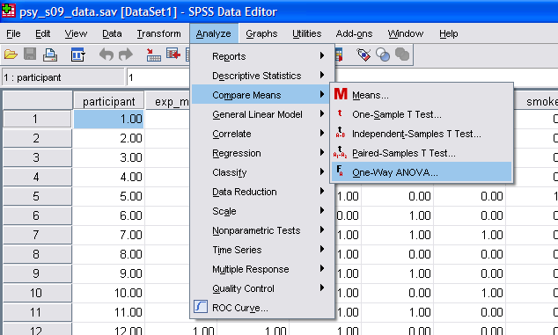

In the window that pops up, you put the categorical variable in the Factor area and the continuous dependent variable in the Dependent List area (feel free to include more than one). For practice, put Sleeping Position (#24) in the Factor area, and put Road Rage (#57) and Need for Structure (#70) in the Dependent List area. Before clicking OK, click on the Options button. Choose Descriptive in the pop-up window, telling SPSS to include basic descriptive statistics with our Output. Click Continue and then OK.

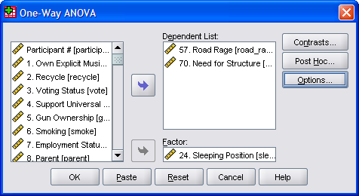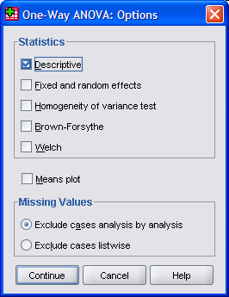

The Output should look something like this:

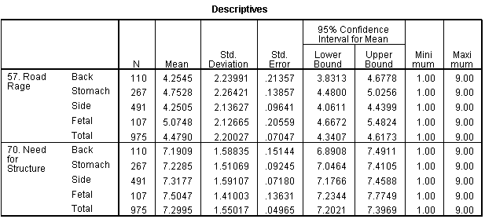

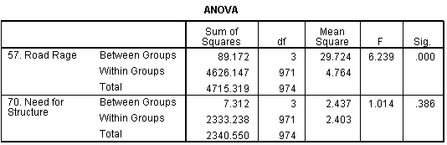

The top box is very detailed, so examine it slowly. The box tells how many people were in each group, and provides their basic descriptive statistics. For example, 107 people report sleeping in a fetal position, and as a group, they had the highest road rage scores (M = 5.07, SD = 2.13).

The second box in the SPSS Output provides the results of the ANOVA analysis, which are used to indicate whether there were any reliable differences across the groups of people. The F-value and degrees of freedom values are provided. If you are unfamiliar with these statistics from PSY 211, just be aware that they are used in the process of calculating a p-value. The p-value is listed in the table as “.000” due to rounding. [If you click on this value several times, a more exact value appears (e.g. 0.000339). The p-value can never be zero because there is always some probability that a result could be due to chance – in this case, the odds are very small.] Because p < .05, there are some reliable group differences present.

There were no significant group differences in Need for Structure because p = .39, which is obviously greater than .05. The minor mean differences in need for structure across groups are merely due to chance.

Questions: 4pts each
- Conduct an ANOVA analysis examining whether favorite Movie Genre (#23) is related to differences on the second Life Satisfaction variable (#60). Report the results in APA style, using the APA Style Guide at the end of this assignment. You do not need to include any Cohen’s d calculations but may if you like.
- Conduct an ANOVA analysis examining whether one’s Favorite Season (#22) differences in Cell Phone Use (#55). Report the results in APA style, using the APA Style Guide at the end of this assignment. You do not need to include any Cohen’s d calculations but may if you like.
- Conduct an ANOVA analysis examining whether one’s favorite Food Choice (#17) differences in Emotional Pain (#69). Report the results in APA style, using the APA Style Guide at the end of this assignment. You do not need to include any Cohen’s d calculations but may if you like.

Chi-square Test for Goodness of Fit

The chi-square test for goodness of fit is used to examine whether a sample has an unexpected number of people (proportion) in some category (e.g. more females than expected).

Go to the Analyze menu, point to Nonparametric Tests, and choose Chi-Square.

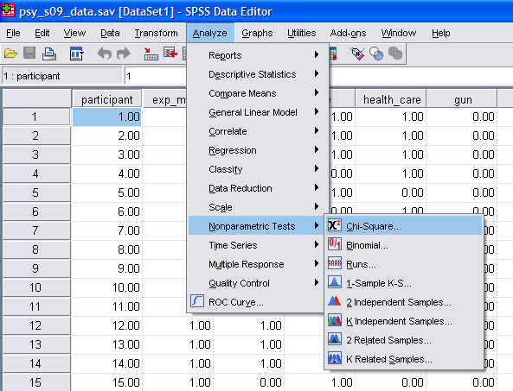

You choose a categorical variable and by default the program will determine whether the number of people in each category are roughly equal (non-significant chi-square) or whether they are reliably different (significant chi-square).

Select Gender (#11) and put it in the Test Variable List. This will tell us if there are about an equal number of females and males (non-significant chi-square) or whether there is a reliable difference in the number of people in each gender group (significant chi-square). Click OK.

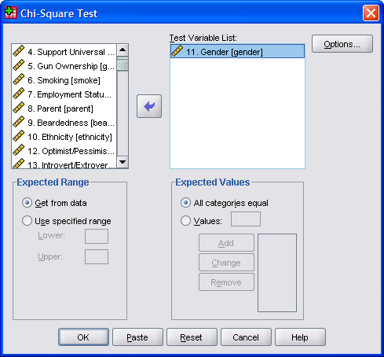

Your Output should look something like this:

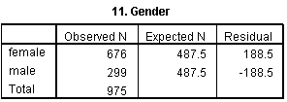

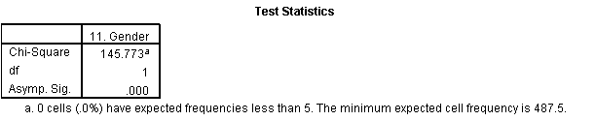

The first box tells us that there were about 189 more females than expected, and 189 fewer males than expected. The second box tells us that the chi-square value was 145.77, df = 1, and the p-value was very small (remember, “.000” really means “< .001”). Because p < .05, we know there is a reliable and unexpected gender difference.

Question: 4pts each
- Conduct the same chi-square test, but this time use Favorite Season (#22). In your own words, what do the results tell us? (APA format is not required for this problem).

Chi-square can be used to test whether all groups have an equal number, or you can specify other proportions.

Suppose you read somewhere that among college students, 75% vote and 25% do not vote. You can test whether our sample reliably differs from these proportions.

This feature is fairly poorly designed in SPSS, so if you ever use it in the future, be careful and check that your results make sense. Before we even run an analysis, examine how the Vote (#3) variable was coded. We asked people whether they voted and responses were coded as 0 = No, and 1 = Yes.

Now, go to the chi-square pop-up window and put Vote (#3) in the Test Variable List. Then, in the Expected Values area of the window (right below), choose “Values” instead of “All Categories Equal.” This is where it’s easy to make a mistake. We will tell SPSS the percentage of people we expect in each group (voter or non-voter). We want to make sure that we tell SPSS that we expect 25% to have said no and 75% to have said yes, but if you don’t pay attention, it’s easy to accidentally say the opposite (75% no, 25% yes).

In the area next to “Values:” type in 25. Then, click Add. Type 75. Then, click Add. This tells SPSS that we think 25% will have said no and 75% will have said yes. It matches the 25 with “No” because it was coded with a lower value than “Yes” in our data file (No = 0, Yes = 1). It should always assign the percentages in the order they were coded, but double-check the Output just in case.
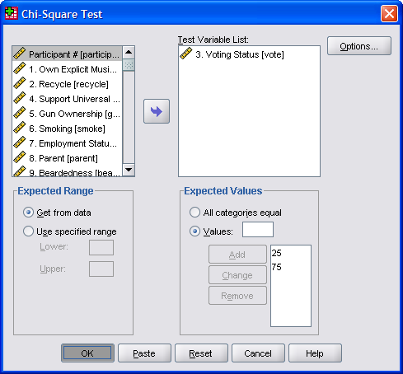

Click OK to run the test. The Output should look like this:

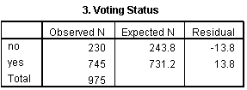
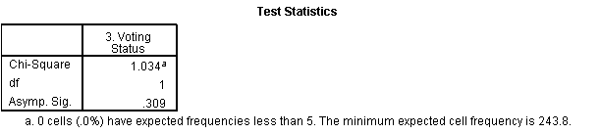

In the Output, double check that SPSS assigned the expected percentages correctly. In the Expected N column of the first box, t says we expected about 244 people to say no (25% of 975) and 731 people to say yes (75% of 975).

Our results show that the chi-square value (1.03) was non-significant (p = .31). Thus, our sample did not differ from our expectations. As expected, about 75% of the sample reported voting. The chi-square would have been statistically significant if our sample differed dramatically from our expectations (like if 40% had voted or 90% had voted).

Question: 4pts each
- A New York Times poll indicates that 60% of Americans like comedies the best, followed by action movies (15%), dramas (14%), horror movies (8%), and romance movies (3%). Run a chi-square test on our favorite Movie Genre variable (#23), using these percentages. How does our sample, consisting mainly of college woman, differ from the national statistics reported by the times? (APA format is not required for this problem).

Chi-square Test for Independence

Often students try to run correlations (r) between categorical variables. Any correlation based on a categorical variable is generally meaningless because the numbers we assign to categories do not have meaning – in other words, you’d get a different correlation simply based on how you decided to code the results. However, we can examine whether two categorical variables are related in some way, using the chi-square test for independence.

This analysis is in a different place than the previous type of chi-square. Go to the Analyze menu, point to Descriptive Statistics, and choose Crosstabs.

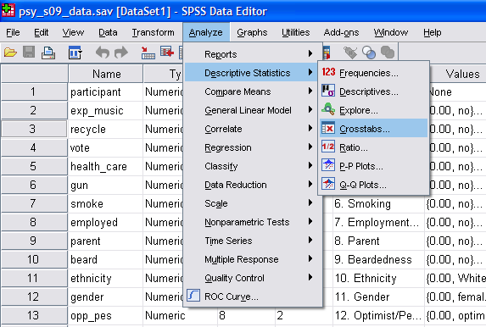

In the window that pops up, you’ll want to put one variable in the “Row(s)” area and one variable in the “Column(s)” area. It doesn’t really matter which variable goes where. [If one of your variables has a lot of categories, putting it in the Column area gives you a short and fat table, whereas putting it in the Rows area would give a tall and skinny table]

Put Employment Status (#7) in the Row area, and Relationship Status (#16) in the Column area. This will allow us to see whether having a job influences whether or not someone will have a relationship. Before hitting the OK button, we need to make a couple changes.

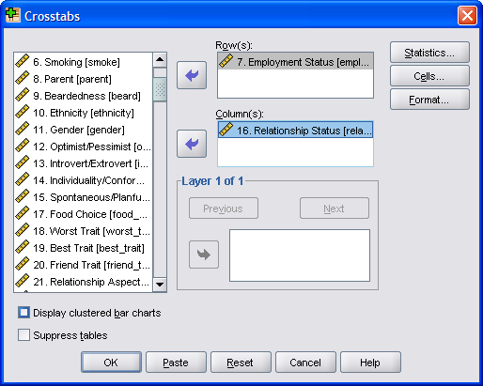

Click the Statistics button, choose Chi-square, and click Continue.
Then, click the Cells button. In the window that pops up, make sure both Observed and Expected are checked. Then, click Continue. Hit OK in the original window to run the test.

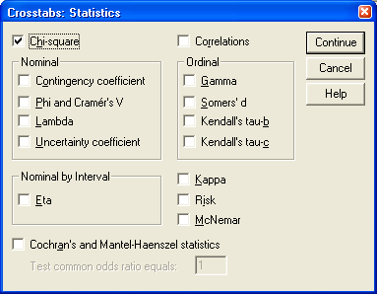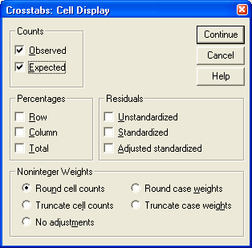

The Output we need is on the following page. Ignore the first box completely. I usually examine the final box first to see if the result is significant. In the final box, it says that the chi-square = 26.90, which is significant, p < .001. This indicates that there is some reliable effect, so examine the middle box to see what that effect is.

Examine the middle box carefully, and read over the lecture notes for help. This box tells us that there were more employees in relationships than expected, and more unemployed single people than expected. Thus, having a job is related to having a relationship.
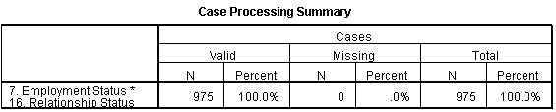

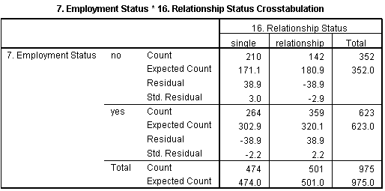

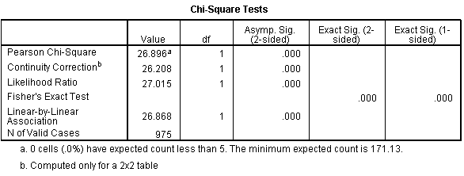

Questions: 4pts each
- Run a chi-square test for independence, comparing the Introvert/Extrovert variable (#13) to the Optimist/Pessimist variable (#12). What do the results indicate? (APA format is not required for this problem).
- Run a chi-square test for independence, examining whether there are Gender (#11) differences in what Relationship Aspect (#21) people believe is most important. What do the results indicate? (APA format is not required for this problem).

Questions: 1pt each
- What type of analysis is most appropriate for comparing Favorite Season (#22) to Test Anxiety (#31)?
- What type of analysis is most appropriate for comparing Voting Status (#3) to Anger (#34)?

APA Style Guide

ANOVA (Significant, p < .05):

Example: Music device preference was significantly related to openness to experience, F(2,972) = 4.30, p = .02. People who listen to vinyl or cassettes were highest (M = 8.33, SD = 0.78) on openness to experience, followed by .mp3 listeners (M = 6.91, SD = 1.75), followed by CD listeners (M = 6.86, SD = 1.66). People who use older music devices are more open.

Include the degrees of freedom (the top two df values in the Output), the F-value, and the p-value. Include basic descriptive statistics as well. You may calculate out a Cohen’s d to compare any two of the specific groups, if you so choose.

ANOVA (Non-Significant, p > .05):

Example: Drivers, walkers, and bikers did not differ significantly in terms of religious involvement, F(2,972) = 1.65, p = .19. Thus, transportation mode is not related to involvement with religion.

Keep the results concise. Include the degrees of freedom (the top two df values in the Output), the F-value, and the p-value. You may list ns instead of the exact p-value if you like.

