HW #3 – Answers

- 24.44
- 61.7%
- Negative skew
- It’s a bearded woman!
- r = -.23, small, yes – trustworthy
- r = .06, very small (near zero, or some other synonym), no – not trustworthy
- r = -.40. People who are more active in religion are modestly less likely to acknowledge evidence for evolution.
- r = .37. People who have more physical pain are also modestly more likely to have emotional pain too.
- R = .43, R² = .18. People who are religious, have a high need for structure, and are nationalistic, are modestly more conservative. These three variables explain 18% of the differences in people’s political views.
- R = .37, R² = .13. People who are neurotic, eat a lot of fast food, and experience shame tend to be modestly less satisfied with their bodies. These three factors explain 13% of the differences in how much body shame people experience.
- r = .46. Any estimate between .26 and .66 is acceptable.
- No, the variables are not closely related.
- M = 6
- Range = 7
- SD = 2.00 or 2.19 [Either answer is acceptable and earns full credit, as I did not specify whether to use the population or sample formula. Typically, we use the sample formulas in psychology.]

Homework #3
PSY 211
Due 2/17/09

Rationale:
This assignment is designed to ensure (1) that you can run correlational and regression analyses using SPSS, and (2) that you can calculate range and standard deviation by hand.

Instructions:
Your assignment should include the following:
- Typed cover sheet
- Part A. Type your answers to all questions. Afterwards, attach all Output (the charts and graphs SPSS gives you when you perform a statistical operation).
- Part B. Your answers and work may be typed or neatly handwritten. Either is acceptable.

Part A: Working with SPSS

Accessing the Classroom Data File

For this course, lecture notes and other basic course materials are on the course web site. However, information that must be kept private (grades, published articles, data files, etc.) is on BlackBoard. Thus, to access our data file, log on to BlackBoard:
http://blackboard.cmich.edu

Go to the Course Materials folder. There are two important files. Students who do not take a few extra minutes to thoughtfully examine these files may struggle throughout the course.

(1) An SPSS document, called Data File (psy_s09_data.sav), includes all of the survey data. This is an important file. I suggest looking over it in Data View and Variable View (see HW#2) to make sure you understand the file as well as possible. If you’re curious about any variables, you can run some basic descriptive statistics (see HW#2).

(2) An Excel document, called Data Guide (psy_s09_data_guide.xls), describes the data file in excellent detail. You should refer to this file for more detail about specific survey questions. If you print the file using Landscape Orientation, it should only be about 6-8 pages. I’d recommend printing it out so you can easily refer back to it throughout the semester.

Review Questions (refer to HW#2 if confused; remember to print off your Output and attach it to the back of your homework):

- What was the Mean ACT score (variable #113) for our sample?
- What percentage of our participants report sleeping on either their side or back? See the Sleeping Position variable (#24).
- What is the shape of the distribution for Racial Acceptance (#86)?
- Examine participant 552 on variables 1 – 12. What is atypical about this participant?

Correlational Analyses

This is a brief introduction to correlations. You should also be familiar with the information presented in the book and lecture.
- Correlations range from -1.00 to +1.00.
- The sign (+/-) tells how the variables are related. A positive correlation means that as scores on one variable increase so do scores on the other variable. For negative correlations, as scores on one variable increase, scores on the other variable tend to decrease.
- The numeric value tells you how strong the relationship is. If the number is .10 or higher, the correlation is small; .30 or higher is medium/modest; .50 or higher is large/strong (see lecture notes).
- Correlations should only be used to compare two continuous variables
- Each correlation is accompanied by a probability value, called a p-value, which helps to determine whether a correlation is trustworthy. The p-value tells you the probability that a particular correlation would be obtained randomly by chance. If p is smaller than .05 (p<.05), we say that the results is “statistically significant” – it’s probably a trustworthy finding because there are very small odds it would occur by chance. If p is bigger than .05 (p>.05), we say that the result is “nonsignificant” – it may just be due to chance, so it’s not reliable. Usually this happens when the sample is too small or the correlation is very weak.

To find a correlation in SPSS, go to the Analyze menu, point to Correlate, and choose Bivariate. A pop-up window appears. To practice, we’ll find the correlation between being Disorganized (#58) and experiencing Anxiety (#59). Select each variable and move it to the pane on the right side of the pop-up window. Then, click OK.

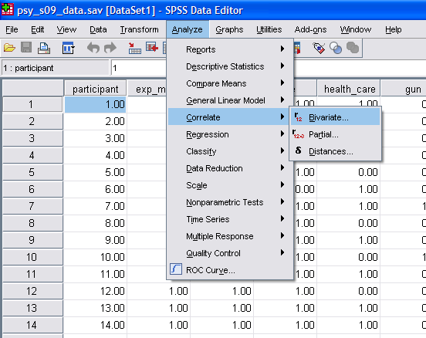

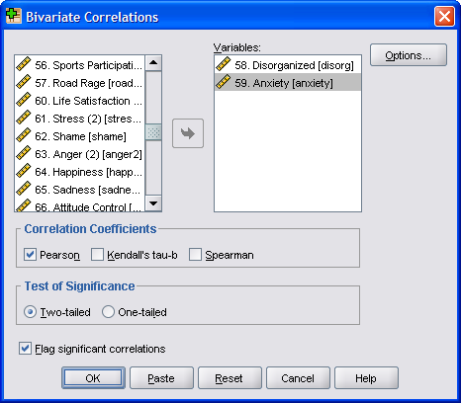

Your Output should look something like this:

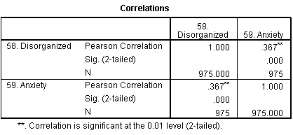

Study the Output carefully. There are four main boxes on the right side, containing various numbers. Much of this information is repetitive. For example, the upper left box is the same as the lower right box. The upper right box is the same as the lower left box.

The upper left box (and lower right box) shows the correlation between the Disorganized variable and itself. Any variable correlates perfectly with itself (r = 1.00). The sample size is 975. This box is not particularly useful. It remains a mystery why SPSS includes it.

The upper right box (and lower left box) is more interesting. Three statistics are presented. The value .367 is the correlation between being disorganized and having anxiety (labeled ‘Pearson Correlation’ off to the left). It is positive. As disorganization increases, anxiety increases too. In other words, disorganized people have more anxiety. The correlation is modest. The next value .000 is the p-value (labeled ‘Sig 2-tailed’ off to the left, indicating that the value is for a significance test). If p<.05, the finding is reliable. Here the p-value is definitely lower than .05, so the finding is statistically significant (trustworthy, not just due to chance). Thus, the correlation is modest and trustworthy. The sample size, presented again, is 975.

You can also examine several correlations at the same time by running a correlation with more than two variables. Follow the above instructions again, but this time include the variables Disorganized (#58), Anxiety (#59), and ACT score (#113).

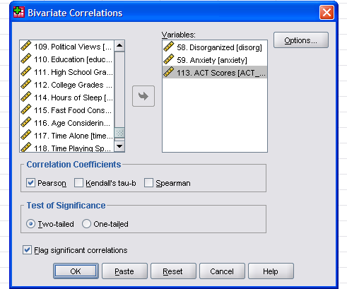

The Output should look something like this:
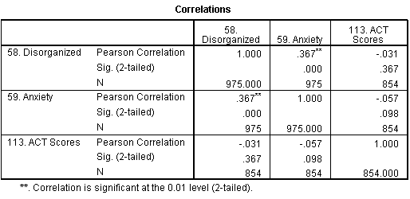

Now the Output includes additional results. The correlation between the Disorganized variable and ACT Scores is r = -.03. Also, p = .37. Because p > .05, the result is not statistically significant; it might just be a chance correlation, which is not surprising, given that it’s so small. The correlation between ACT scores and Anxiety is also nonsignificant. Note that the sample size for analyses involving the ACT scores is only 854 because not all participants took the ACTs.

Questions (remember to print off your Output and attach it to the back of your homework):

- What is the correlation between US Nationalism (#80) and Protest Enjoyment (#88)? How would you describe it (e.g. small/medium/large)? Is it a trustworthy correlation?
- What is the correlation between Racial Acceptance (#86) and Leadership (#89)? How would you describe it (e.g. small/medium/large)? Is it a trustworthy correlation?
- What is the correlation between Religious Fundamentalism (#77) and Evolution Acknowledgement (#78)? Explain exactly what the correlation means using simple language that a non-statistics student could understand.
- What is the correlation between Physical Pain (#68) and Emotional Pain (#69)? Explain exactly what the correlation means using simple language that a non-statistics student could understand.

Multiple Regression

When conducting correlational analyses, you may be disappointed to see that correlation values are often fairly small. The main reason for this is that behavior is multidetermined. Usually several different factors combine to make people who they are and behave in certain ways.

Multiple regression allows us to examine how well several factors combine to predict a single variable. Instead of the symbol r, we use R to represent a correlation when using multiple regression. R values are interpreted the same way as r values for the most part, but R simply shows how well multiple variables combine to predict some outcome. R ranges from 0 to 1.

Multiple regression has three steps.
- Come up with a theory. For example, we might think that having loving parental relationships (#93), time for leisure (#103) and a good education (#110) all combine to make people happy (#64).
- Test that theory with correlations (just like you learned to conduct above). For example, we could see whether these three hypothesized variables actually correlate with happiness (see correlation table below). Our theory was partially correct. Loving parental relationships and satisfaction with leisure time both correlated with happiness. However, one’s level of education did not correlate significantly.
- After figuring out which variables correlate with the desired outcome, see how well they combine to predict the outcome using multiple regression. For example, we can examine the combined effect of loving parental relationships and leisure satisfaction on happiness, using one big correlation. We ignore the education variable because it was unrelated to happiness. For an explanation of how to run multiple regression, see below.

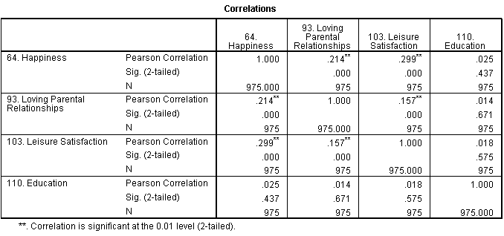

The multiple regression analyses are not very difficult. Simply go to the Analyze menu, point to Regression, and choose Linear.

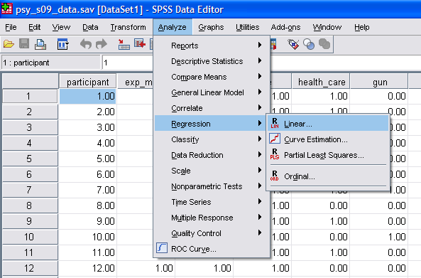

A window pops up. Where it says Independent(s), we enter our Independent variables, the predictors or causes (usually there are several). Where it says Dependent, we enter the single dependent variable, which is also known as the outcome variable or effect. To practice using our example, enter Happiness (#64) for the Dependent variable. Enter Loving Parental Relationships (#93) and Leisure Satisfaction (#103) in the Independents section. Then, press OK.

The Output should look something like this:

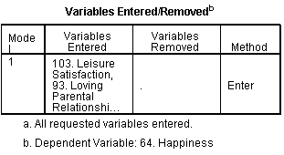
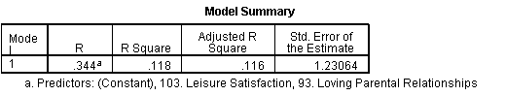
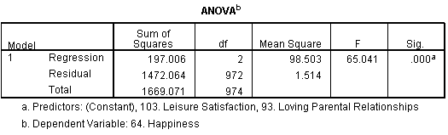
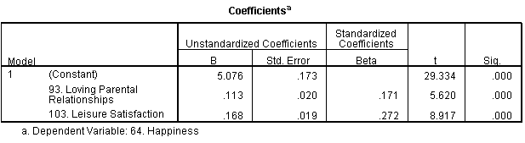

In this entire section of Output, we can actually ignore most of the information. Everything we need is in the 2nd and 3rd boxes.
- The box I have shaded blue (where it says “R”) is the R value. It is similar to the r-values you’re already familiar with; however, it indicates the combined effect of both predictors. In this case, loving parental relationships and leisure satisfaction combine to correlate R = .34 with happiness. That is, together they modestly predict happiness.
- The R Square value in the red box stands for R² and is similar to r². It tells how much of the variability in the outcome variable we’re able to account for. In this example, loving parental relationships and leisure satisfaction account for 12% of the variability in happiness.
- Finally, in the green box is a p-value, similar to the p-values you’ve already learned about. If p<.05, the finding is trustworthy. It is obviously lower than .05, so the finding is trustworthy.

Questions (remember to print off your Output and attach it to the back of your homework):

- Your friend says that Religiosity (#83), having a Spoiled Upbringing (#96), a Need for Structure (#70), and US Nationalism (#80) all lead someone to have more conservative Political Views (#109). Examine these correlations. If any of these variable significantly predict political views (p<.05), incorporate them into a multiple regression. What is the R value using the significant predictors to predict political views? What is the R² value? Using plain English, that a non-statistics student could understand, what do these findings mean?
- Your friend argues that someone you know has low Body Satisfaction (#84) due to several factors, including Eating too Much (#46), Shame (#62), and Neuroticism (#105). Examine these correlations. If any of these variable significantly predict body satisfaction (p<.05), incorporate them into a multiple regression. What is the R value using the significant predictors to predict body satisfaction? What is the R² value? Using plain English, that a non-statistics student could understand, what do these findings mean?

Scatterplots

Although SPSS has many statistical features, it is also useful for generating various graphs. To make a scatterplot, go to the Graphs menu, point to Legacy Dialogs, and choose Scatter/Dot (note different versions of SPSS organize menus differently, so simply find the Scatter/Dot command).

A pop-up window will appear. Select Simple Scatter and click the Define button. A new window pops up. To make a scatterplot, move one variable to the X Axis area and one to the Y axis area, then click the OK button. For example, move Anxiety (#59) to the X Axis area and Tanning (#44) to the Y Axis area; click OK.

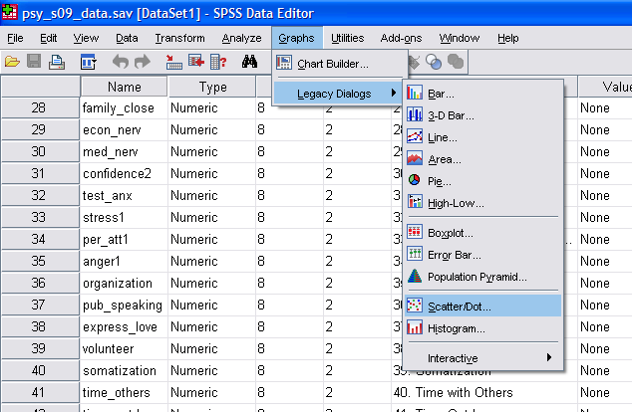

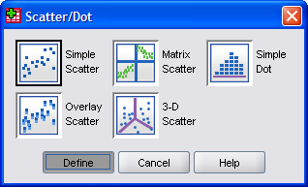

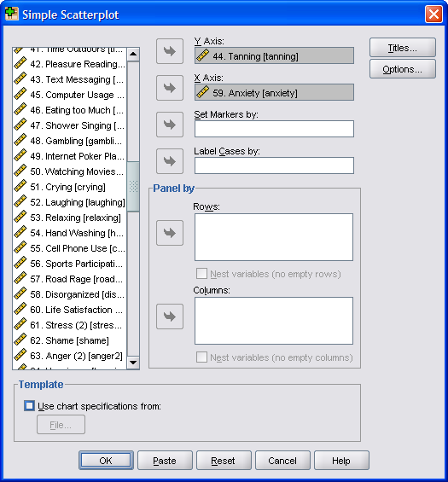
Your Output should look something like this:

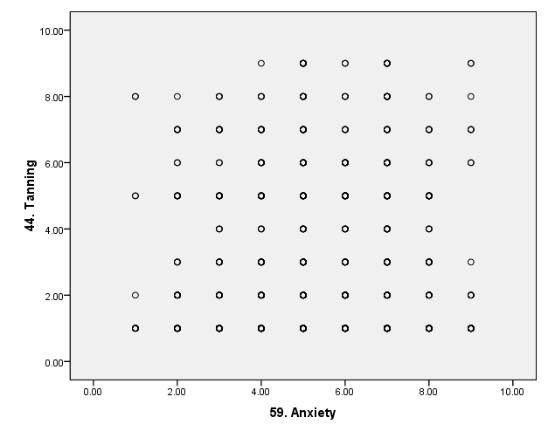

There does not appear to be much of a correlation between anxiety and tanning frequency.

Questions (remember to print off your Output and attach it to the back of your homework):

- Make a scatterplot with Vocabulary (#123) on the X Axis and ACT Scores (#113) on the Y Axis. By estimating, what is the approximate correlation between the two variables?
- A friend of yours says he thinks his girlfriend is unhappy because she cries so much. Make a scatterplot comparing Happiness (#64) to frequency of Crying (#51). Are the two variables closely related?

Part B: Hand Calculations

Use the following data set:

- 3 5 6 8 9

Questions (remember to print off your Output and attach it to the back of your homework):

- What is the mean for the data set?
- What is the range for the data set?
- What is the standard deviation for the data set? (Show all steps needed for calculating)

