Homework #2 – Answers

1) 36.1
2) 39.0
3) Below
4) Below
5) Negative skew
6) Negative skew
7) 10%
8) 5%
9) 3 [There are 3 modes present – 30, 32, and 36 – but looking at the wrong area of the Output could lead to erroneous conclusions]
10) 40%
11) mean = 6.5, median = 7, mode = 7 and 8
12)
X | f | % | c%
10 | 1 | 5% | 100%
9 | 3 | 15% | 95%
8 | 4 | 20% | 80%
7 | 4 | 20% | 60%
6 | 3 | 15% | 40%
5 | 1 | 5% | 25%
4 | 1 | 5% | 20%
3 | 1 | 5% | 15%
2 | 1 | 5% | 10%
1 | 1 | 5% | 5%

13) [hand drawn polygon]
14) [hand drawn relative frequency histogram]
15) Negative skew
Homework #2
PSY 211
Due 1/29/09

Rationale:
This assignment is designed to ensure (1) that you can work with basic statistical operations covered in class and the textbook, and (2) that you can access and use a computer program, SPSS, to begin analyzing data. You will likely need to attend a computer lab to complete part of this assignment.

Instructions:
Your assignment should include the following:
- Typed cover sheet
- Part A. Type your answers to all questions. Afterwards, attach all Output (the charts and graphs SPSS gives you when you perform a statistical operation).
- Part B. Your answers and work may be typed or neatly handwritten. Either is acceptable.

Part A: Working with SPSS

Accessing SPSS
Find a computer on campus that has SPSS, the computer program we will use to perform some statistical operations (it’s sort of like Microsoft Excel). Most computers in Woldt, Grawn, and the Library should have SPSS. Many smaller computer labs also have SPSS. I suggest going someplace that has a free working printer.

Once you log on, go to the Start menu in the lower left corner of the screen and find SPSS. If you have difficulty finding it, ask one of the lab assistants for help.

Creating a New Document
Our goal is to begin with a new SPSS document. If a pop-up window appears when SPSS loads, just click Cancel. Usually a blank document will be open automatically. If not, go to the File menu, point to New, and select Data.

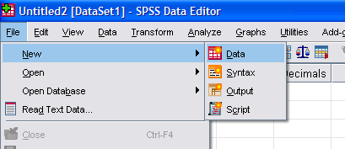

A blank document should look something like the following picture.

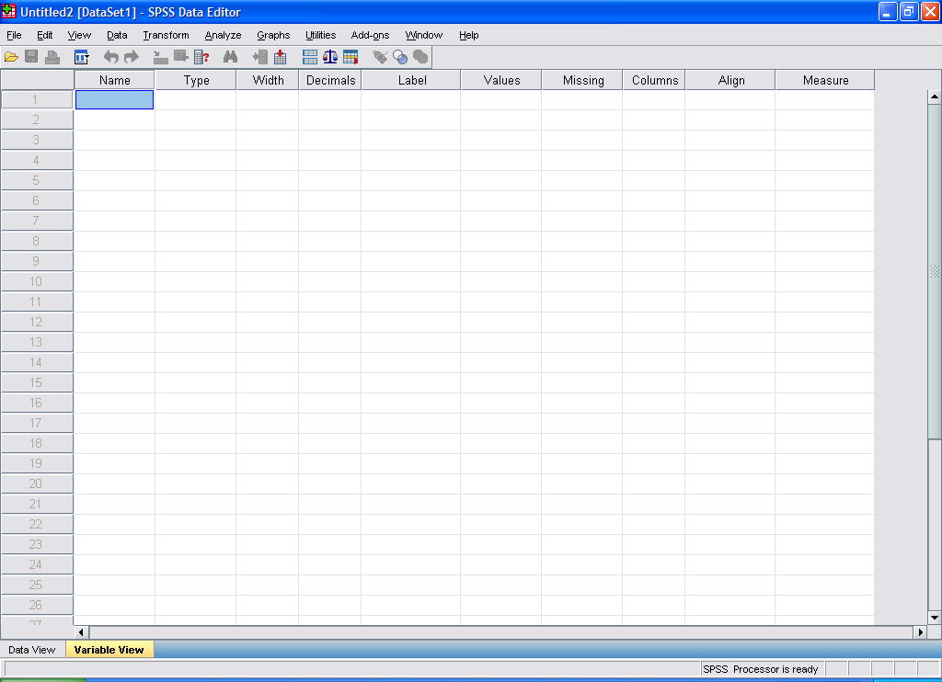

Or this…

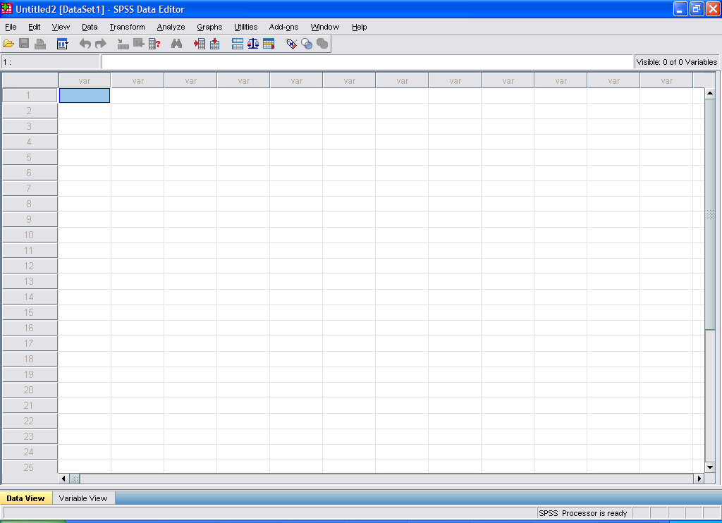

Explore SPSS
SPSS has two views, called Data View and Variable View. You can switch from one to the other by clicking the Data View or Variable View buttons in the bottom left corner of the SPSS window (the gray or orange buttons on the previous page). They both look pretty similar since the document is blank.

Data View is where you enter data. For example, you might type in each participant’s scores on a variety of measures. Variable View allows you to perform more advanced features, such as labeling variables.

Take some time to browse through each of the menus at the top of the SPSS window to familiarize yourself with the program. Here is an overview of each menu.

File. Contains commands for opening and closing files
Edit. Contains Copy/Paste commands and features for searching text
View. Controls the on-screen layout (rarely needed)
Data. Contains commands for sorting the data or grouping the data in various ways
Transform. Used to perform basic calculations or re-code variables
Analyze. Contains most of the functions for running statistical tests (often needed)
Graphs. Contains functions for examining the data visually

Entering Data
Make sure you are in Data View. The Data View button in the lower left should be orange (or highlighted in some way).

When you are in Data View, the numbers along the side represent individual participants. Each column (labeled “var” at the top) represents a different variable.

Enter the data set that appears on the following page. The column names will change from “var” to something new (like VAR00001, VAR00002, etc) when you start entering data. [Note: If you try to enter data and the numbers do not appear, you may be using an unlicensed version of SPSS. Consult with the computer lab assistant, as you may need to use a different computer or lab].

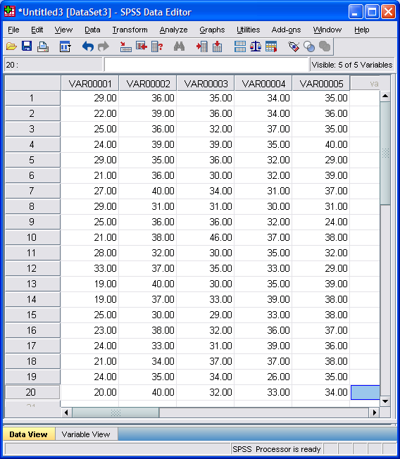

Each row going across represents a different participant. Each column represents the person’s scores on a different variable. For example, participant #7 scored a 37 on whatever the 5th variable is (circled above).

Saving Data
It is important to save everything periodically, as computers freeze often. Always save your work. You might catch a mistake once you’re home and want to go back to the lab to fix it. If you haven’t saved your work, you may have to start over. I suggest using some type of portable disk or drive. If all else fails, save to the desktop, and e-mail a copy to yourself periodically.

To save, go to the File menu, and point to Save As. This will allow you to choose where to save the file and what to call it. When re-saving a document, you can simply click Save or press Ctrl + S (the Control key and “S” on the keyboard, at the same time).

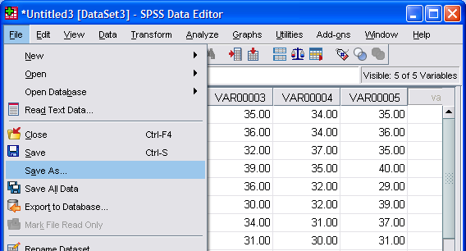

Find the appropriate folder, and save your work as something logical, like “psy211_hw2”.

Naming Variables
The data you have entered are from real participants but so far appear meaningless because the variables have no labels.

Switch to Variable View, by clicking the button in the lower left corner. In Variable View, the window should look something like the following.

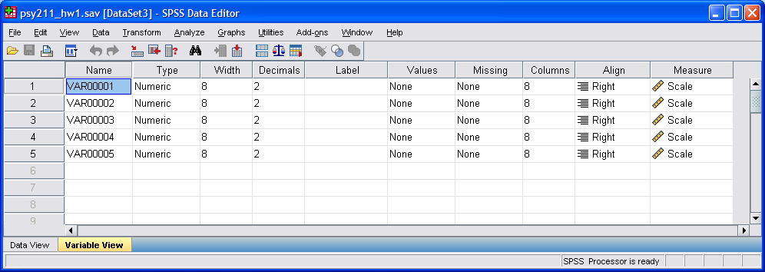

In the Name column, on the left side (where you see VAR00001, VAR00002, etc), you will enter the names for the variables. In this case, we are working with personality variables (neuroticism, extraversion, openness, agreeableness, and conscientiousness. Change the names in the Name column, so they look like this (n, e, o, a, c):

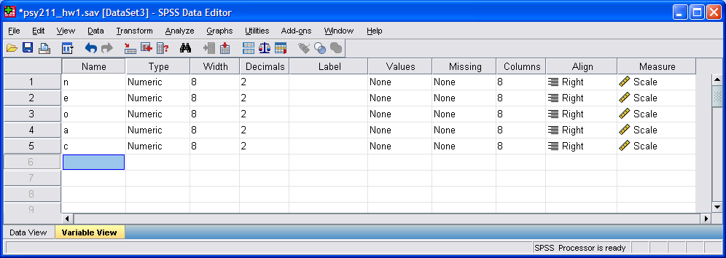

Now switch back to Data View, by clicking the button in the lower left. You should see n, e, o, a, and c as column headings in the data file now. Usually, people use short abbreviations for these column names, and this allows them to quickly and easily look over a data file.

Switch back to Variable View.

Now we are going to enter more detailed descriptions in the Label column. The Label column is where you can provide more detailed labels of variables. The Name information is used for column headings in the data file itself, whereas the Label information is used in our statistical output and printouts. These longer descriptions in the Label column will make it easier for others to understand the variables. Enter the following labels (e.g. “Self-report Neuroticism”) in the Label column:

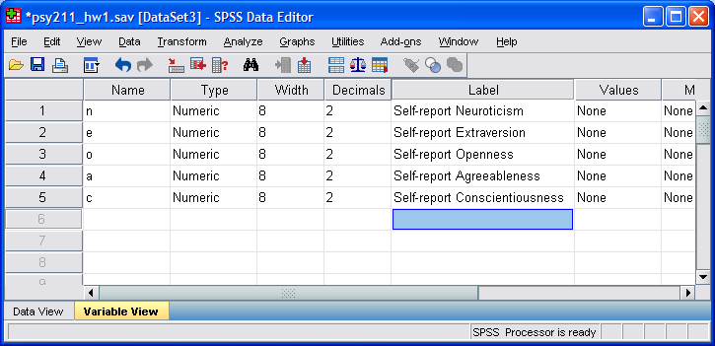

It’s easy to misspell “conscientiousness” (a synonym for work ethic, organization, and tidiness) so watch your spelling.
Re-save your data using the Save command in the File menu.

Basic Statistical Operations

There are many ways to get simple (descriptive) statistics in SPSS. Go to the Analyze menu, point to Descriptive Statistics, and choose Descriptives.

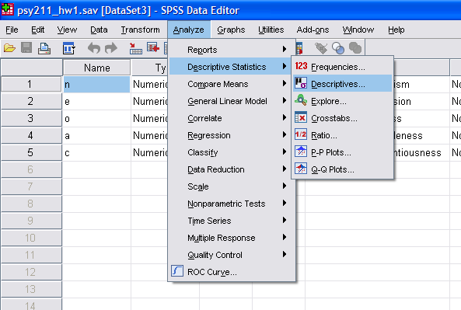

A window should pop up. In the left panel, click on the first variable (Self-report Neuroticism). Then click on the arrow button in the middle, moving Neuroticism to the Variable(s) pane on the right. Then, click OK. This will give you some basic statistics on the Neuroticism variable. [Note: SPSS allows you to move multiple variables to the right, if you want to analyze several variables at once. You can also make some choices about which statistics to include, through the Options button, if needed].

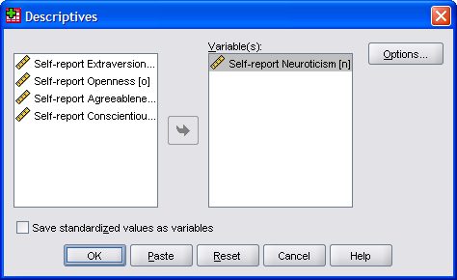
When you click OK, the following statistical Output should appear:

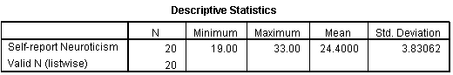

This tells you that the sample size (N) is 20. Scores ranged from 19 to 33. The mean was 24.4. The standard deviation (covered next unit, a measure of variability) was 3.83.

Questions (remember to print off your Output and attach it to the back of your homework):

- What is the Mean for the Extraversion variable?
- What was the high score (maximum) anyone had for the Agreeableness variable?
- If someone had a score of 30 on Openness, would this be considered above or below average?
- Was participant #8 above or below average on Conscientiousness?

Frequency Tables

SPSS can also make rough frequency tables. Go to the Analyze menu, point to Descriptive Statistics, and choose Frequencies.

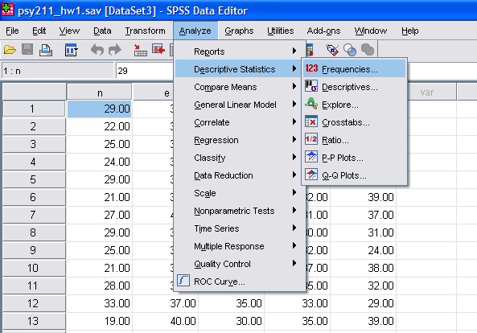

In the window that pops up, move the Neuroticism variable to the Variable(s) pane on the right. This function also has other features.

In the same pop-up window, click on the Charts button. In a new window that pops up, choose Histograms. Then click Continue, taking you back to the first pop-up window. This will include a Histogram with the Output.

Finally, click on the Statistics button on the right. In the window that pops up, select Mean, Median, and Mode. Then click Continue, taking you back to the first pop-up window. In the original pop-up window, click the OK button, producing your Output.

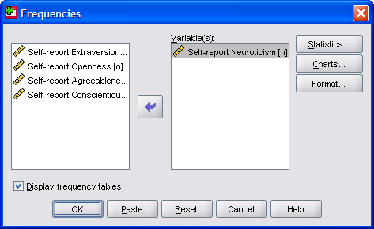

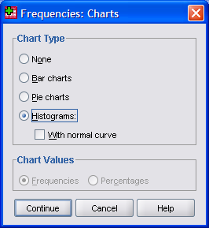

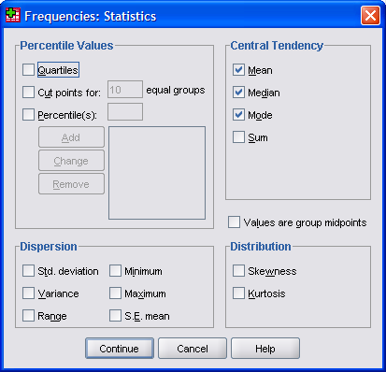

The Output should look something like this. Although typically we make frequency tables that are descending (highest number on top, lowest on the button), SPSS typically uses an ascending order (the reverse). Thus, it’s always a good idea to look over the Output carefully before answering any questions.

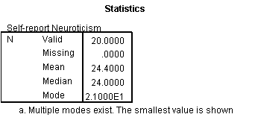
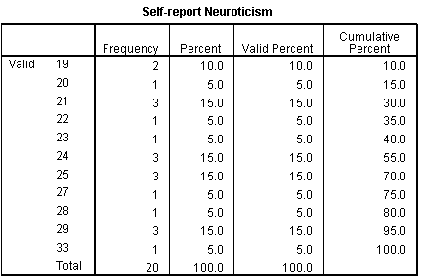
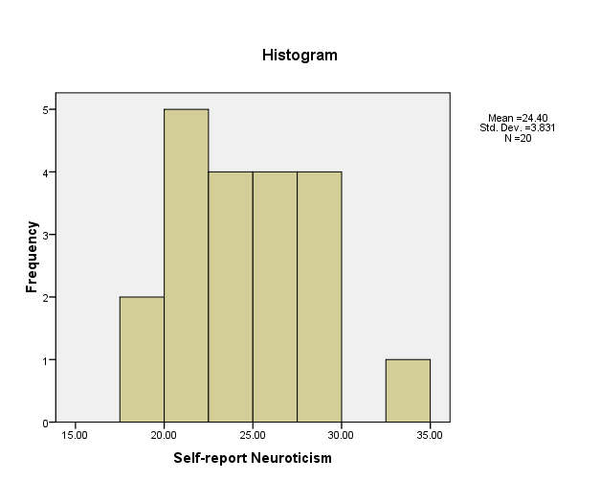
In this Output, we again see the Mean, Median, and Mode (there are many ways to find these in SPSS). The frequency table is similar to examples in the book, though numbers are in reverse order. In the left column, we see the possible Neuroticism scores. The next column has the frequency (number) of people who have each score. The Percent column places the frequency into a percentage of the total. The Valid Percent column has identical numbers (they only differ in data files where some participants have missing data – it calculates the percent based on how many people actually completed the survey, rather than how many people are merely in the data file). The Cumulative Percent shows the cumulative percentage. For example, 15% of people scored a 20 or lower. 75% scored a 27 or lower.

Questions (remember to print off your Output and attach it to the back of your homework):

- What is the shape of the Conscientiousness distribution?
- What is the shape of the Extraversion distribution?
- What percentage of participants scored 30 or lower on Agreeableness?
- What percentage of participants scored 40 or higher on Openness?
- How many Modes are present for the Openness variable? (review all sources of Output)
- What total percentage of people scored 25 through 35 on Conscientiousness?

Part B: Hand Calculations

Use this data set:
8 9 10 8 7
7 6 8 9 2
3 5 1 7 8
9 6 7 6 4

Questions (answers may be neatly hand-written for these questions only):

- Find the mean, median, and mode.
- Construct a frequency table, including the following column headings: X, f, %, c%.
- Construct a frequency polygon.
- Construct a relative frequency histogram.
- Describe the shape of the distribution.

