PSY 211 – Exam #2
Mike Hoerger

You may keep this paper copy of the exam when you have finished. You may use a simple calculator during the exam.

The exam is 120 points (3 points per question).

1 | A “3rd variable” and a “confound” are synonyms. 88%, r = .27 | T F
2 | Extreme scores on most variables tend to become less extreme over time, a term called regression toward the mean. 88%, r = .15 | T F
3 | If a regression analysis is conducted using a single predictor, the magnitude of R will be the same as for r. 66%, r = .22 | T F
4 | The sign (+/-) of a correlation coefficient provides information about the magnitude of the relationship between two variables. 78%, r = .53 | T F
5 | If five points are added to everyone’s exam score, the mean and standard deviation would both increase by five. 68%, r = .53 | T F
6 | “n – 1” is included in the formula for standard deviation of a population.  92%, r = .33 | T F
7 | According to the BlackBoard reading, there is a strong relationship between age and declining speed of information processing in adults.  71%, r = -.27 EXTRA CREDIT | T F
8 | Range restriction typically increases the magnitude of correlations. 46%, r = .47 | T F
9 | Typically, in social sciences, researchers collect data on populations, not samples. 86%, r = .27 | T F
10 | Someone who relies on stereotypes has a good understanding of variability but a poor understanding of central tendency. 69%, r = .40 | T F
11 | The correlation coefficient is primarily used to describe relationships that are linear. 73%, r = .20 | T F
12 | Outliers have problematic effects on the mean and the correlation coefficient.  90%, r = .20 | T F
13 | The minimum value for R is zero. 78%, r = .27 | T F
14 | The dependent variable goes on the Y axis of a scatterplot. 86%, r = .27 | T F
15 | Correlations are used to describe the magnitude and direction of the relationship between two variables. 97%, r = .13 (too easy) | T F
16 | Assume six students are asked how many hours they spent studying for today’s exam. Their responses were 1, 2, 3, 4, 6, and 12 hours. Therefore, the range for this data set would be 11 hours. 90%, r = .13 | T F
17 | The magnitude of the correlations we will find in our classroom data file are likely an underestimate of the true relationships between variables.  71%, r = .40 | T F
18 | A researcher is curious whether a new test measures what it claims to measure. This is a question of validity. 90%, r = .13 | T F
19 | Outliers always increase the magnitude of correlations. 85%, r = .18 | T F
20 | Statistical analyses for experimental research studies typically involve comparing a categorical variable to a continuous variable. 89%, r = .13 | T F

21 | What is the symbol for the population variance?
a) | µ
b) | σ² 75%, r = .60
c) | σ

22 | Assume r² = .16. Find r and describe its magnitude.
a) | small
b) | medium 71%, r = .47
c) | large

23 | The correlation values Mike examines for each item on the test are most closely related to…
a) | variability
b) | reliability 39%, r = .27
c) | validity

24 | According to the BlackBoard article, what is the correlation between psychotherapy and subsequent well-being?
a) | r = .13
b) | r = .32 59%, r = .20
c) | r = .53

25 | Which of the following correlations shows the strongest relationship between two variables?
a) | r = .37
b) | r = -.46 83%, r = .47
c) | r = 1.01

26 | If the correlation between Extraversion and Happiness is r = .50, this means that extraversion explains ___ % of the differences in how happy people are.
a) | 5
b) | 25 66%, r = .73
c) | 50

27 | According to the BlackBoard reading, what is the correlation between IQ and level of education?
a) | r = .04
b) | r = .24
c) | r = .44 43%, r = .36

28 | Magnitude of a correlation, r = .27
a) | small 92%, r = .27
b) | medium
c) | large

29 | What factor almost always makes correlation values larger?
a) | high variability in scores 43%, r = .27
b) | several outliers
c) | high range restriction

30 | Correlation equals causation
a) | Always
b) | Sometimes 98%, r = .07 (too easy)
c) | Never

31 | In our classroom survey, we asked participants to indicate their ACT score. For our sample, M = 24.4, Median = 24.0, Mode = 24.0, Standard Deviation = 4.1. What would the Variance be?
a) | 2.0
b) | 4.9
c) | 16.8 76%, r = .47

32 | Based on the following diagram, “Perceived Severity” causes _______ through an inverse relationship.  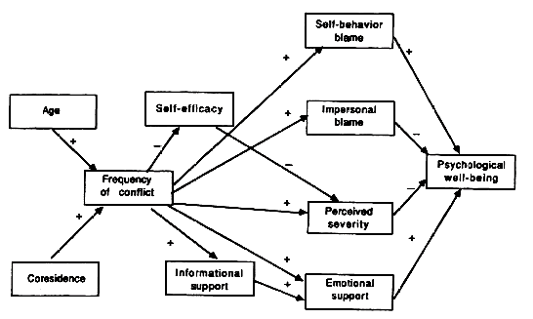
a) | Self-efficacy
b) | Frequency of Conflict
c) | Psychological Well-Being 92%, r = .20

33 | Three students are asked to describe a reason for using multiple regression. Which explanation is the WORST?
a) | “Most behaviors are multidetermined.”
b) | “It allows us to predict specific scores on the dependent variable.”
c) | “One variable can be used to predict several dependent variables.” 58%, r = .47

34 | Magnitude of a correlation, r = .53
a) | small
b) | medium
c) | large 90%, r = .20

35 | Psychological tests and medical tests are both used to predict important outcomes. Psychological tests usually yield correlations with relevant outcomes that are _______ those of medical test.
a) | much weaker than
b) | similar to 86%, r = .13
c) | much stronger than

36 | The following correlation table shows the relationships among the Big 5 personality traits (Neuroticism, Extraversion, Openness to Experience, Agreeableness, and Conscientiousness). How many of the traits correlate modestly with Openness?  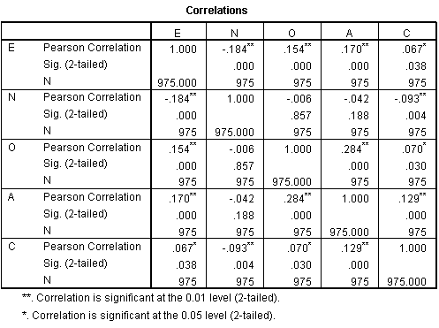
a) | 0 59%, r = .73
b) | 1
c) | 2

37 | Which correlation, if true, would likely be the most impressive and interesting?
a) | r = .50 between happiness and self-esteem
b) | r = .48 between extraversion and intelligence 61%, r = .60
c) | r = -.46 between depressive symptoms and frequency of smiling

38 | Estimate the correlation between Hours of Studying and Exam Grades, based on the following scatterplot.  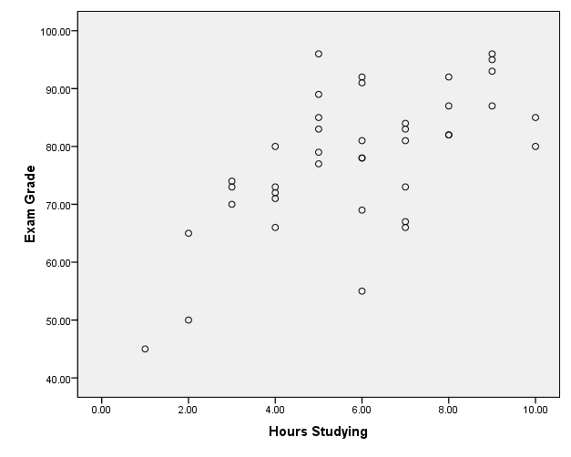
a) | r = .41
b) | r = .62 63%, r = .60
c) | r = .83

39 | The Regression Output below describes how well Shame, Anger, and Financial Distress predict Cell Phone Throwing. All variables were measured on 9-point scales, using our classroom survey. If a student has a Shame score of 5, an Anger score of 7, and a Financial Distress score of 1, what would you predict their Cell Phone Throwing score to be?
a) | less than 3.0 49%, r = .67
b) | between 3.0 and 4.0
c) | greater than 4.0

40 | The three predictors explained ___ % of the variability in cell phone throwing.
a) | 9.7
b) | 10.0 63%, r = .67
c) | 31.6
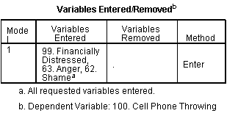
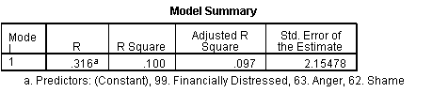
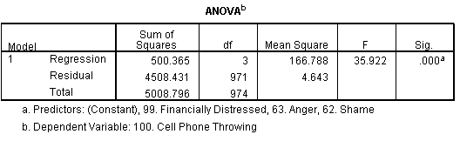
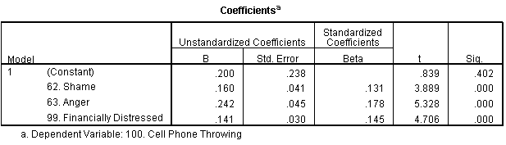

Study Guide
Exam #2
PSY 211

Disclaimer: This is a guide of the main points that I consider to be important. You are responsible for all material covered in the book or in lecture, unless otherwise noted by me.

Not on this exam:
- Interquartile range and semi-interquartile range (Section 4.3, p 107-108)
- Calculating correlation coefficients
- Hypothesis testing with the Pearson correlation (Section 16.4, p. 537, 539, 540)
- Standard error of the estimate (p. 559-564)
- z scores

Concepts to know:
- Variability
- Range, Standard deviation, Variance (and their symbols)
- Relationship between standard deviation and variance
- Population vs. Sample
- Population standard deviation vs. sample standard deviation
- Degrees of freedom = a correction number or reference number often used for improving formulas, based on sample size (for most formulas, df = n-1, though we’ll learn of exceptions later in the year)
- Differences between surveys and experiments
- Correlation coefficient: magnitude, direction, estimating from scatterplots, range of possible values, how to describe values in words (small, medium, large)
- Coefficient of determination = r² = % of the differences in the outcome variable (dependent variable) that can be explained by the predictor variable(s)
- Understand formula for correlation coefficient (“degree that X and Y vary together divided by the degree the vary separately”), but you won’t need to make any calculations
- Various uses of the correlation coefficient
- Regression toward the mean
- Factors that impact the magnitude of the correlation coefficient (actual relationship between variables, as well as several nuisance factors, like range restriction, outliers, shape of the distribution, and the quality of the measures)
  - I might give you an example, like “Everything else being equal, would variables be more highly correlated if they are measured using single items or measured using detailed surveys?” or “Everything else being equal, would variables usually be more highly correlated if they have skewed distributions or if they have normal, symmetrical distributions?”
- When correlation probably shows causation and when it does not
- Visually inspect scatterplots with best fit lines and estimate a score on Y, given a score on X
- Independent variable, dependent variable, confounding variable (aka 3rd variable)
- R and Multiple R
- Multidetermined

BlackBoard Article:
- Pay particular attention to highlighted material. Also, I went back and put red boxes around findings that are particularly interesting in the tables.
- If I give you two variables, you should be able to estimate the correlation between them plus or minus about .20. Not too hard, since most correlations are small!
- Definition of psychological assessment: psychological testing, or the combined use of multiple tests or surveys to form predictions
- Psychological assessments are about as good at predicting relevant variables as are medical tests
- The general rule is that big correlations are impressive, and small correlations are unimpressive, and this is probably a good rule of thumb 90% of the time. But sometimes small correlations can be important, and sometimes even large correlations are disappointing.
- Notice that sometimes small correlations are very important. For example, people take aspirin to reduce heart attack risk, even though the correlation between aspirin use and decreased risk is only r = 0.02. When it’s a life or death matter, any predictive ability is important, so people take aspirin.
- Sometimes we are not impressed by modest correlations (e.g. diagnosing cavities or home pregnancy tests)

Calculations and Formulas to know:
- Know how adding, subtracting, multiplying, or dividing all of the scores in a data set by a particular number impacts variability
- Mean, median, mode
- Range, variance, standard deviation (for both population and sample)
- Interpret a scatterplot
- Interpret an easy path diagram
- Interpret SPSS Output covered in the homework or in class

More Tips:

Different R’s

r | R | multiple R
* 2 variables  * Ranges from -1 to 1 | * 2 variables, using a formula to predict Y from one X  * Ranges from 0 to 1 | * 3 or more variables, using a formula to predict Y from multiple X’s  * Ranges from 0 to 1

Interpretation

impossible! | more extreme than +1.00
large | +.50 to +1.00 | positive  (direct)
medium | +.30 to +.49 | positive  (direct)
small | +.10 to +.29 | positive  (direct)
zero / near-zero | 0 ish
small | -.10 to -.29 | negative  (inverse)
medium | -.30 to -.49 | negative  (inverse)
large | -.50 to -1.00 | negative  (inverse)
impossible! | more extreme than -1.00

Bb Article

I have marked a red box by correlations you should “know” (by “know” I mean, remember within about + or – 0.2). Most variables correlate weakly, so if you ever have to take a blind guess how much variables correlate, guess about r = 0.2.

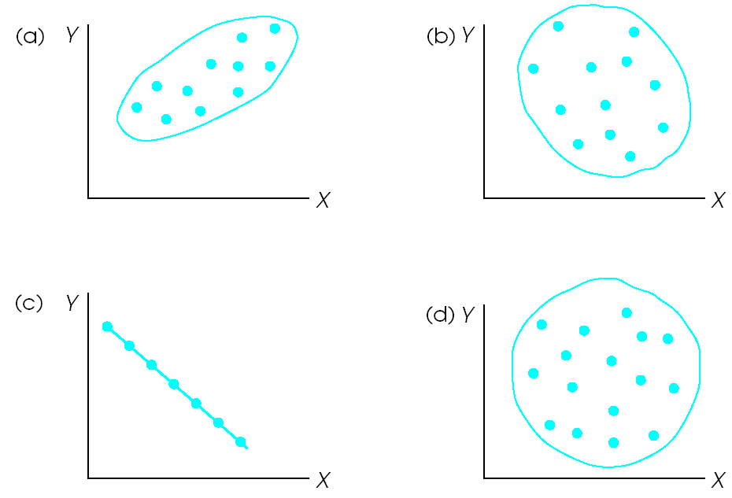

a = +0.8ish, b = -0.3ish, c = -1.0, d = 0.0

Rule of thumb:
stick = 1.0, hot dog = 0.8, sub sandwich = 0.5, egg = 0.3, circle = 0.0
If you can tell the difference between an egg and a bratwurst, you’re in good shape

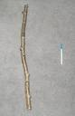

r = -0.8 | r = 0.4
r = 0.2 | r = -0.6
r = 0.0 | r = -0.3

Positive Parental Relationship means lower Authority Problems
(r = -0.31)

Correlations

Multiple Regression

Parent relationship and Anger predicting Authority Problems
R = 0.39

