PSY 211 – Exam #1
Mike Hoerger

The exam is 120 points (3 points per question).

1 | Participants are asked to rate their level of neuroticism on a scale from 0 (low) to 9 (high). Neuroticism represents a continuous variable. 83%, r = .25 | T F
2 | Adding 5 points to everyone’s exam score would increase the mean and mode by 5 points, but not the median. 92%, r = .19 | T F
3 | Statistics involves using numbers to summarize and interpret data.  98%, r = .05 (too easy) | T F
4 | The mean always occurs at the 50th percentile in the distribution. 64%, r = .19 | T F
5 | A number used to summarize data about all participants in an entire population is called a parameter. 97%, r = .06 (too easy) | T F
6 | If a group of employees want to show that their wages are low, they should probably report the mean salary instead of the median. 49%, r = .44 | T F
7 | When a data set contains several outliers, the mean should be used.  73%, r = .63 | T F
8 | For a relative frequency histogram, the numbers along the Y-axis (on the left side) should be proportions or percentages.  56%, r = -.19 (BAD ITEM, EXTRA CREDIT) | T F
9 | In an experiment, researchers manipulate the dependent variable to affect the independent variable. 86%, r = .31 | T F
10 | The statistic, r, is used to examine the relationship between two variables.  86%, r = .12 | T F
11 | The mode is less stable across samples than the mean or median. 68%, r = .19 | T F
12 | Confounding variables make correlations difficult to interpret. 89%, r = .13 | T F
13 | It is possible for a symmetrical distribution to have multiple modes.  83%, r = .25 | T F
14 | ΣX² +7 means that first you add up all of the X values to yield a total score. Then, you square the total score. Then, you add 7.  32%, r = .50 | T F
15 | The software we use to perform statistical operations is called SSPS.  51%, r = .50 | T F
16 | Assume that the day after the Super Bowl a friend who knows nothing about football claims that he knew all along who was going to win. This is characteristic of the hindsight bias. 92%, r = .10 | T F
17 | According to one psychology internship site, a student’s level of research experience is the most important variable for reliably predicting how successful interns will be on their internship. 90%, r = .25 | T F
18 | Some data sets have two medians. 94%, r = .13 | T F
19 | Assume that a researcher decides to examine which of two treatments (exercise or stretching) is most effective for reducing lower back pain. The type of treatment is considered the independent variable. 84%, r = .12 | T F
20 | Descriptive statistics use probability to draw conclusions about a population.  67%, r = .50 | T F

21 | Assume that in a small sample of males at CMU, a researcher finds that the average IQ is 104, and in a small sample of females at CMU, the same researcher finds that the average IQ is 106. The newspaper reports on the story with a large headline reading, “FEMALES ARE SMARTER THAN MALES.” Most likely, the reporters have no understanding of this concept.
a) | confirmatory bias
b) | parameters
c) | sampling error 81%, r = .19

22 | Assume 660 students in a low-income community with poor schools participated in a research study by taking an IQ test. What percentage of participants scored 55 or lower?  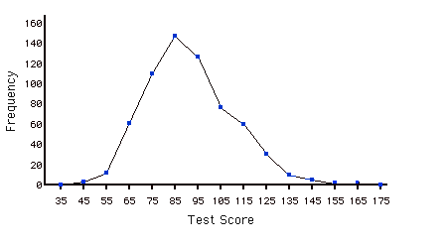
a) | 20.0%
b) | 15.0%
c) | 2.5% 56%, r = .50

23 | Correlation equals causation
a) | Always
b) | Sometimes 91%, r = .25
c) | Never

24 | If a general sample of people were asked to report their own level of attractiveness, the frequency histogram for the distribution of ratings would likely take this shape:
a) | positive skew
b) | negative skew 73%, r = .63
c) | symmetrical

25 | What is the symbol for a population mean?
a) | M
b) | µ 73%, r = .13
c) | σ

26 | Based on the following graph, which is likely the HIGHEST?  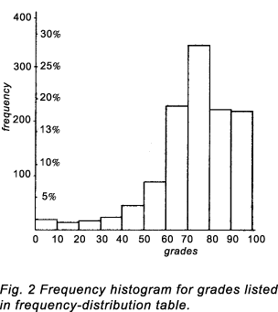
a) | mean
b) | median
c) | mode 79%, r = .44

27 | If the goal of a study is to examine the relationship between “happiness” and “job satisfaction”, which of the following is the most appropriate population?
a) | American adults who are happy
b) | All American adults
c) | American adults who are employed 89%, r = .25

28 | Which of the following is the best conceptualization of the steps in the scientific method?
a) | Theory → Hypotheses → Design / Run Study → Analyze Results → New Theory  90%, r = .19
b) | Hypotheses → Theory → Design / Run Study → Analyze Results → New Hypotheses
c) | Theory → Design / Run Study → Hypotheses → Analyze Results → New Theory

29 | A psychologist is interested in studying trichotillomania, which is a very rare syndrome characterized by compulsively pulling out one’s body hair, often leading to bald patches or bleeding. The psychologist administers a symptom survey to college students and makes a frequency histogram for the distribution of scores. What shape would the distribution have?
a) | positive skew 71%, r = .69
b) | negative skew
c) | symmetrical

30 | A researcher asks participants, “How many pets do you have?” Responses would most likely use this type of measurement scale.
a) | Ratio 23%, r = .31
b) | Ordinal
c) | Interval

31 | For the following set of data, which is the HIGHEST?  1 8 2 6 9 6 7 3 5 7 8 4 5 10 4 6 7 5 5
a) | mean
b) | median 92%, r = .19
c) | mode

32 | For the following set of data, which is the LOWEST?  82 58 72 82 72 72 60 71 60 71 71 72 72 71 91 55 91 56 56 88 88 58
a) | mean 57%, r = .12
b) | median
c) | mode

33 | Which of the following is the WEAKEST definition of a theory?
a) | A working model designed to predict events and behavior
b) | A personal experience that guides decision making 68%, r = .19
c) | A narrative describing why things are what they are

34 | Which correlation is impossible?
a) | r = .00
b) | r = -.99
c) | r = 1.25 79%, r = .63

35 | If you worked at McDonalds and someone ordered a hamburger a la mode, what else should you bring them?
a) | French fries 71%, r = .32
b) | Ice cream
c) | Pancakes

36 | For the following data set, which measure of central tendency is most appropriate?  93 91 86 78 84 88 88 79 80 69 45 13 94 76
a) | mean
b) | median 71%, r = .50
c) | mode

37 | Find the cumulative percentage of participants with an agreeableness score of 60:
  Extraversion Score | f | %
  80 | 3 | 15
  70 | 4 | 20
  60 | 7 | 35
  50 | 2 | 10
  40 | 4 | 20
a) | 35%
b) | 65% 70%, r = .50
c) | 70%

38 | Using the table from question #37, what is the probability that a person chosen randomly from the sample will have an agreeableness score of 70 or greater?
a) | .20
b) | .35 83%, r = .25
c) | .85

39 | A sample of CMU students, friends, and family indicated how many days per week they feel depressed. One of the major symptoms for the diagnosis of Dysthymia (a depressive condition) is feeling depressed “more days than not” – in other words, 4 days per week. What percentage of the sample feels depressed at least 4 days per week?  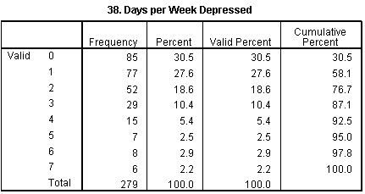
a) | 5.4%
b) | 13.0% 68%, r = .50
c) | 92.5%

40 | Participants (n = 279) indicated how many traffic tickets they’ve had in the past year. Approximately what percentage of participants had at least one traffic ticket?  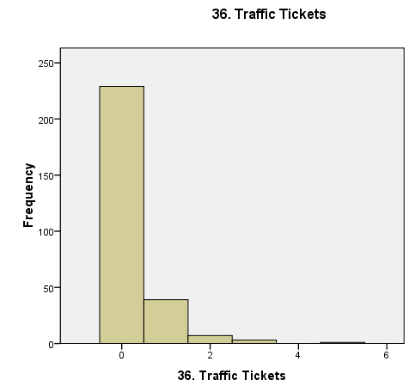
a) | 12%
b) | 18% 81%, r = .25
c) | 82%

Study Guide
Exam #1
PSY 211

Disclaimer: This is a guide of the main points that I consider to be important. You are responsible for all material covered in the book or in lecture, unless otherwise noted by me.

Concepts to know:
- Cognitive biases
- Theory
- Scientific Method
- Statistics
- Population vs. sample
- Sampling error
- Symbols for sample size, mean, standard deviation, variance, and sum
- Continuous vs. categorical variable
- Histogram vs. polygon
- Shapes of distributions: symmetrical, positive skew, negative skew
- Central tendency
- Definitions of mean, median, mode
- Correlation coefficient
- Independent variable, dependent variable, confounding variable (aka 3rd variable)

Calculations and Formulas to know:
- Frequency tables
- Frequency, percent, cumulative percent
- Mean, median, mode

Math Anxiety: There are two ways to combat math/testing anxiety. I suggest doing both.
- Overlearn the material by studying more than you normally would. Anxiety hogs cognitive resources (namely, working memory capacity). When students know the material well, they function on autopilot and don’t need many cognitive resources, so even if they’re anxious, they can still do well. For example, we’ve all “practiced” saying the alphabet so many times in our lives, that no amount of anxiety will likely disrupt our ability to say it. When students practice statistics to the point that it also becomes automatic, anxiety will rarely be a problem either.
- Another approach is to attack the anxiety itself. Find a way to relax during the test. Take a break from the exam for 30-seconds when you feel anxious or fatigued. Do some deep breathing from the diaphragm (stomach region). Bring a little snack, some juice, or some other type of comfort object. It’s also wise to avoid drinking more caffeine or smoking more cigarettes than usual.

If you want to practice calculating the mean, median, and mode, you can use the following data:

Sample #1: 3 7 8 9 6

Sample #2: 4 9 3 6 2

Sample #3: 5 5 5 6 4 7 8

Sample #4: 1 1 2 8

Sample #5: 1 6 5 8 9 8 7 4 5 6

Sample #6: 5 5 5 5 5

Sample #7: 1 2 3

