Chi-square (χ²)
PSY 211
4-21-09

LAST STATISTIC OF THE SEMESTER!
NEXT TIME: FOOD DAY, REVIEW, WRAP-UP

A. Introduction

- Parametric tests: Use at least one numeric rating, so scores can be placed in a frequency distribution that usually has a normal shape
- Correlation/Regression: Continuous variables only
- t-test/ANOVA: One categorical variable, one continuous variable
- Non-parametric tests: Do not use numerical values, scores cannot be placed on a frequency distribution (also sometimes used for numeric variables that have non-normal distributions)
- Chi-square (χ²): Categorical variables only

Pronunciation note: Chi is pronounced “khi” (from Greece), not “chai” (India), not “chee” (China)

B. Two Types of χ²

- χ² Test for Goodness of Fit
  - Involves a single categorical variable only
- χ² Test for Independence
  - Involves 2(+) categorical variables

C. χ² Test for Goodness of Fit

- Generally just involves one categorical variable
- Null hypothesis specifies the proportion of the population in each category
- Determines how well sample data conform to proportions set forth by the null hypothesis
- Test statistic (χ²) examines whether the proportions in the sample reliably differ from the null hypothesis

Examples:

- Use logic or past research to guide the null hypothesis

H₀ for Gender:

Female | 50%
Male | 50%

H₀ for Negative Childhood Emotion:

Shame | 25%
Anger | 25%
Anxiety | 25%
Sadness | 25%

- Often an equal percentage (proportion) is chosen for each group

- Alternatively, null hypothesis could be based on known proportions in a larger population
Examples:

H₀ for Ethnicity:

White | 75%
non-White | 25%

H₀ for Vegetarianism:

No | 97%
Yes | 3%

H₀ for Religious Affiliation:

Christianity | 84%
Non-religious / Don’t care | 10%
Agnosticism | 2%
Atheism | 1%
Other | 3%

- χ² used to examine whether the proportions in a sample reliably differ from those hypothesized
- Like F…
χ² ranges from 0 to ∞
Is small when the null hypothesis is likely true.
Is large when the null hypothesis is rejected.
H₀ for Gender:

Female | 50%
Male | 50%
N = 975
Proportion Female = 50% = .50
Hypothesized frequency Female = .50 * 975 = 487.5
Proportion Male = 50% = .50
Hypothesized frequency Male = .50 * 975 = 487.5

Chi-Square Test
Frequencies
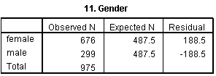
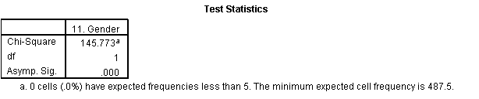

- The Observed N indicates the actual frequency in each group
- The Expected N indicates the frequency that is hypothesized, based on the null hypothesis.
- The Residual just indicates the Observed frequency minus the Expected frequency
- The Test Statistics box indicates that the χ² value is 145.77, the degrees of freedom (df) are 1, and p < .001.

The chi-square test for goodness of fit was significant, χ²(1, N = 975) = 145.77, p < .001. The sample included an unexpectedly high number of females.
H₀ for Religious Affiliation:

Christianity | 84%
Agnosticism | 2%
Atheism | 1%
Don’t Know / Don’t Care | 10%
Other | 3%

N = 279
Hypothesized frequency Christian = .84 * 279 = 234.4
… … …
Hypothesized frequency Other = .03 * 279 = 8.4

Chi-Square Test
Frequencies
The chi-square test for goodness of fit was significant, χ²(4, N = 279) = 382.77, p < .001. There were fewer Christians than expected and more people who were apathetic.

D. χ² Test for Independence

- Examines the relationship between two (or more) categorical variables to determine if they are independent
- Two variables are said to be independent if there is no relationship between them
- Two variables are said to be dependent if there is a relationship between them
- Similar to the correlation coefficient, except that instead of both variables being continuous, both variables are categorical
  - Can’t correlate Academic Major with Favorite Barnyard Animal, but you can do a chi-square!

- Null hypothesis: no relationship
- Alternative hypothesis: some relationship
Does having a job relate to employment status?

N = 975
Single = 48.6%, Relationship = 51.4%
Non-Employed = 36.1%, Employed = 63.9%

If these variables were unrelated, we’d expected this many people in each group…

 | Single | Relationship
Non-Employed | 975*.486*.361 =  171.1 | 975*.514*.361 =  108.9
Employed | 975*.486*.639 =  302.9 | 975*.514*.639 =  320.1

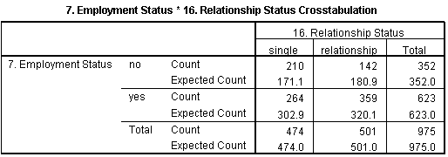
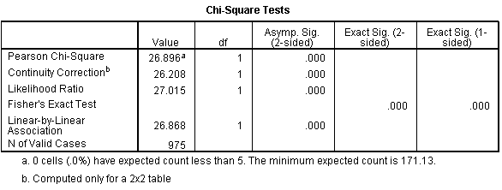

Observed frequencies compared to those that are expected, based on the null hypothesis
Sample size
Chi-square value, degrees of freedom, and p-value

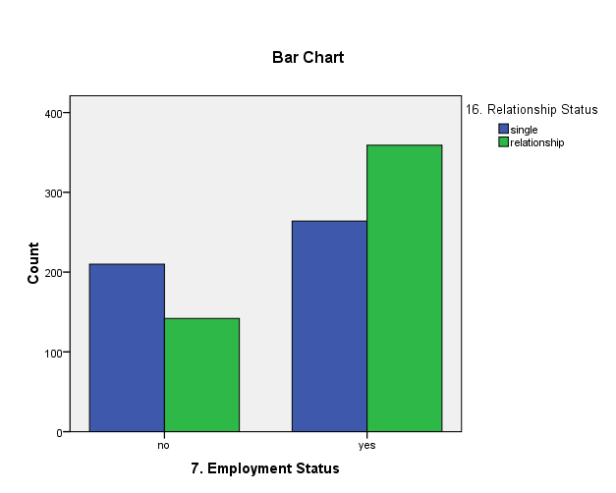
The chi-square test for independence was statistically significant, χ²(1, N = 975) = 26.90, p < .001. People who are employed are more likely to have a relationship.
Does being a parent affect favorite food choices?

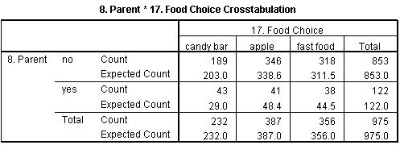

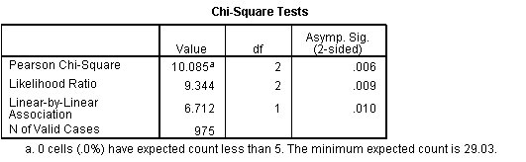
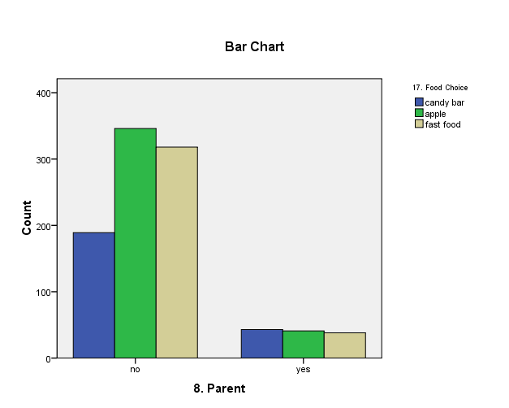

The chi-square test for independence was statistically significant, χ²(2, N = 975) = 10.09, p = .006. Candy bars are enjoyed more by parents than non-parents.

Appendix

Old Examples of Chi-Square Test for Goodness of Fit

Spring 2008
H₀ for Gender:

Female | 50%
Male | 50%
N = 279
Proportion Female = 50% = .50
Hypothesized frequency Female = .50 * 279 = 139.5
Proportion Male = 50% = .50
Hypothesized frequency Male = .50 * 279 = 139.5

Chi-Square Test
Frequencies
- The Observed N indicates the actual frequency in each group
- The Expected N indicates the frequency that is hypothesized, based on the null hypothesis.
- The Residual just indicates the Observed frequency minus the Expected frequency
- The Test Statistics box indicates that the χ² value is 44.17, the degrees of freedom (df) are 1, and p < .001.

The chi-square test for goodness of fit was significant, χ²(1, N = 279) = 77.45, p < .001. The sample included an unexpectedly high number of females.

Fall 2007
H₀ for Gender:

Female | 50%
Male | 50%

Chi-Square Test
Frequencies

The chi-square test for goodness of fit was significant, χ²(1, N = 326) = 44.17, p < .001. The sample included an unexpectedly high number of females.
Fall 2007
H₀ for Religious Affiliation:

Christianity | 84%
Non-religious / Don’t care | 10%
Agnosticism | 2%
Atheism | 1%
Other | 3%

Chi-Square Test
Frequencies
Expected frequencies based on the expected proportions identified previously. For example, for Christianity .84 x 326 = 273.84.

The chi-square test for goodness of fit was significant, χ²(4, N = 326) = 90.00, p < .001. There were fewer Christians than expected and more people than expected in every other religious group.

Spring 2008
H₀ for Yearly Physical:

No | 50%
Yes | 50%

Chi-Square Test
Frequencies

The chi-square test for goodness of fit was not significant, χ²(1, N = 279) = 0.18, p = .68. There was about an equal number of people getting yearly physicals as those who were not.
Old Examples of Chi-Square Test for Independence

Spring 2008
Does Gender related to Beliefs about Human Origins?

Observed frequencies compared to those that are expected, based on the null hypothesis
Sample size
Chi-square value, degrees of freedom, and p-value

The chi-square test for independence was non-significant, χ²(1, N = 279) = 3.32, p = .07. Gender was not reliably related to beliefs about human origins.
Spring 2008
Does being a parent impact one’s political views?

The chi-square test for independence was significant, χ²(4, N = 279) = 15.52, p = .004. Non-parents were mainly concerned with education, whereas parents were mainly concerned with the economy.
Spring 2008
Does ethnicity relate to musical preference?

The chi-square test for independence was significant, χ²(3, N = 279) = 30.70, p < .001. Compared to other ethnic groups, white people were less likely to prefer rap, hip hop, and R&B.
Fall 2007

Is Gender related to Vegetarianism?
The sample is 68% female, so females are expected to make up 68% of the vegetarians and 68% of the non-vegetarians.

Observed frequencies compared to those that are expected, based on the null hypothesis
Sample size
Chi-square value, degrees of freedom, and p-value

The chi-square test for independence was non-significant, χ²(1, N = 326) = 2.72, ns. Gender was not reliably related to vegetarianism.
Fall 2007
Does ethnicity relate to musical preference?

White people make up 90% of the sample, so they are expected to make up 90% of those who like rap, 90% of those who like R&B, etc.

The chi-square test for independence was non-significant, χ²(6, N = 326) = 7.35, ns. Ethnicity was not reliably related to music preference.
Fall 2007
Does being an athlete related to choice of hero?

The chi-square test for independence was statistically significant, χ²(8, N = 326) = 16.94, p = .03. Specifically, athletes were more likely than expected to indicate that their dad was their hero.

