Central Tendency
PSY 211
1-22-09

A. Central Tendency

- Central = Middle
- Tendency = Characteristic
- Central Tendency = statistic used to describe the middle or most representative score in a distribution
- Mean, median, mode
- These are descriptive statistics

B. Scales of Measurement (from chapter 1)

- Often the type of statistics you use depend on the type of variables being examined

Variable Types |  | Examples
Categorical | Nominal – labeled groups | Ethnicity, favorite color, major, gender
Continuous | Ordinal –  ordered numbers | Class rank, NCAA rankings
 | Interval –  ordered numbers, evenly spaced | Most psychology measures, such as IQ, personality
 | Ratio –  ordered numbers, evenly spaced, with true zero | Money, weight, height, tangible items
C. Mode

- Most frequently occurring score or category
- Tells the typical / popular response
- Excellent for categorical variables, but can be used for continuous variables too
- Tallest point in the frequency distribution
- Can have multiple modes
- No mode if all scores are the same

Find the mode of these happiness scores:
8 5 6 9 2 5 6 8 7 8 8 7 4 7 8
-Make a frequency table, graph, or order the scores:
2 4 5 5 6 6 7 7 7 8 8 8 8 8 9

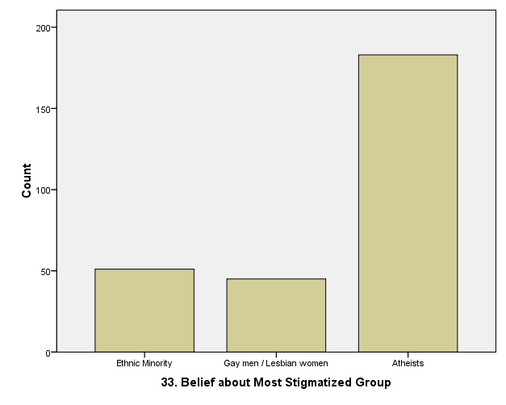

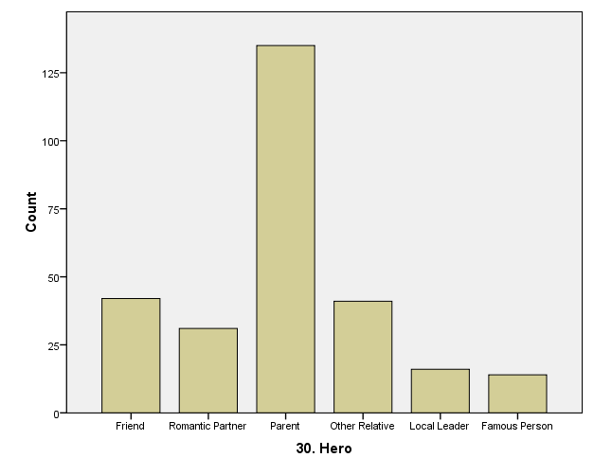
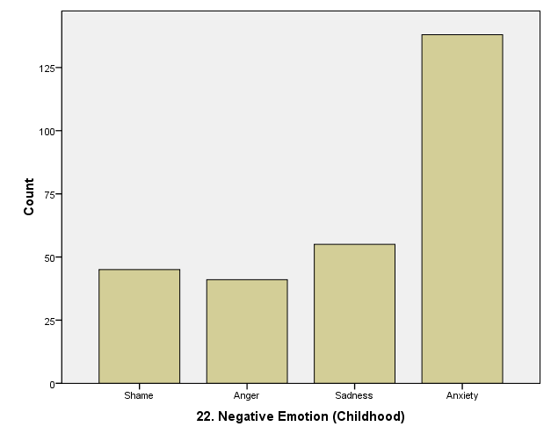

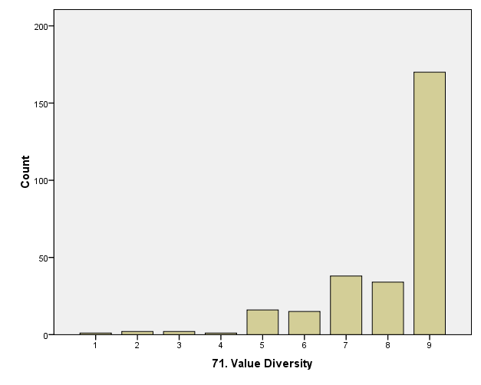

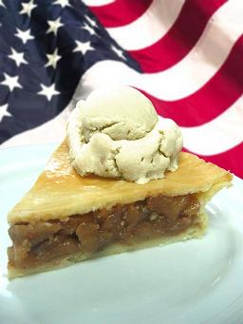
- Why is pie with ice cream
called pie a la mode?

D. Median

- Middle number
- Divides distribution in half (50th percentile)
- Good for continuous variables, but cannot be used for categorical variables. Why?
- Put the scores in order, choose the middle score
- If there are two middle scores, average them

a) Find the median of these numbers:
1 9 3 6 8 7 5
-Put them in order:
1 3 5 6 7 8 9

b) What if there are two middle numbers?
Find the median of these numbers:
2 6 8 9 3 1
-Put in order:
1 2 3 6 8 9
-If there are two middle numbers, average them:
(3+6) / 2 = 4.5

- Why is this called a median?



E. Mean

- The average
- For continuous variables only. Why?
- Mean = (ΣX) / n
    - ΣX indicates “sum of all Xs”
    - n = the number of scores
    - Add up the scores, divide by the number of scores
- µ (“mu”) for a population mean
- $\bar{X}$ (“x-bar”) or M for a sample mean
- The mean is the balance point for all scores in the frequency distribution (Figure 3.3)

Score | Difference From Mean (X-µ)
2 | -3 (three below)
2 | -3 (three below)
6 | +1 (one above)
10 | +5 (five above)

- Important facts about the mean:
  - Changing any score changes the mean
  - Introducing a new score or removing a score usually changes the mean
  - If a constant is added (or subtracted) to every score, you add (or subtract) the same value to the mean
    - E.g. If the average test score is an 80 and I add 10 points to everyone’s exam grade, the mean goes up 10 points to 90.
  - If each score is multiplied (or divided) by a constant, the mean is also multiplied (or divided) by a constant.
    - E.g. If I double everyone’s exam scores, the mean would shift from 80 to 160.

F. Tips for Using Central Tendency

Mode
Can be used for any data, best for categorical variables
+ Easy to see on a graph, no calculations needed
- Not very reliable, ignores most scores

Mean
Continuous variables only, used for calculating more complex statistics
+ Incorporates information about all scores
- Greatly affected by outliers

Median
Continuous variables only
+ Unaffected by extreme scores
- Ignores most scores

