Hypothesis Testing
PSY 211
3-11-08

A. Remainder of the Course
- Material will remain at about the same difficulty level
- We will draw heavily on probability, Z scores, and frequency
- If you’re behind now, make an effort to learn the topics you did not understand previously
- Attend class, read in advance, begin assignments earlier, review old exams, review the Advice section of the syllabus, ask questions, e-mail Mike, come to office hours, study more, start the term paper soon
  - “Your grade will be directly proportional to the amount of time you put in. If you don’t understand what this means by the end of the course, you probably won’t do well.”

- Last semester: Correlation between mid-semester and final grades is r = 0.92. Every person who put in the effort passed. Every person who did not put in the effort failed.

Last Day to Withdraw for a W
I’m going to fail… and won’t graduate… and people won’t like me…
Friday, March 21
Michelle in the main psychology office (Sloan 101) can sign your withdrawal slip

B. Hypothesis Testing Basics
- What is a Hypothesis?
  - Concise, testable statement about the expected finding
  - IQ will not be related to gender
  - People who listen to music on iPods will be more likely to have premature hearing loss
  - Depression will be related increased fast food consumption
  - The treatment group will have better shoulder mobility than the control group
- Hypothesis testing is the process of using sample statistics to draw conclusions about the population (about how people behave in general)
  - We can never be 100% sure about our findings (might have a bad sample or study design flaw), but we can use probability to determine whether it is likely that we are correct or incorrect
  - For example, our statistical analyses might tell us that there is only a 5% probability of getting the result by chance
- Rushing into conducting a study or analyzing results without having done much thinking can lead to study design flaws or poor conclusions
Taking the pressure off the choice makes us less likely to think critically.

C. Two Types of Hypotheses
- Null Hypothesis (H₀): No change, no difference, no relationship, no effect (yawn)
- Alternative Hypothesis (H_{A} or H₁): Some change, some difference, some relationship, or some effect (interesting, what we want to find)

Example #1
Study Question: Do extraverts have sex with more people than the average person?
H₀: Extraverts do not differ from the population in terms of number of sexual partners
H₁: Extraverts do differ from the population in terms of number of sexual partners
- We want to draw conclusions about the population (about how most people behave)
- Obviously, not everyone in the world will participate in the study
- How do we test our hypotheses?
  - Collect data from a sample of extraverts
  - Compare them to the population average
  - If the sample of extraverts differs only marginally from the population, accept H₀ (any small differences are due to sampling error – “chance”)
  - If the sample of extraverts differs a lot from the population, the results probably are not just due to chance, so accept H₁

Example #2
Study Question: Does SSRI medication impact symptoms of suicide?
H₀: SSRI medication does not impact symptoms of suicide.
H₁: SSRI medication does impact symptoms of suicide.
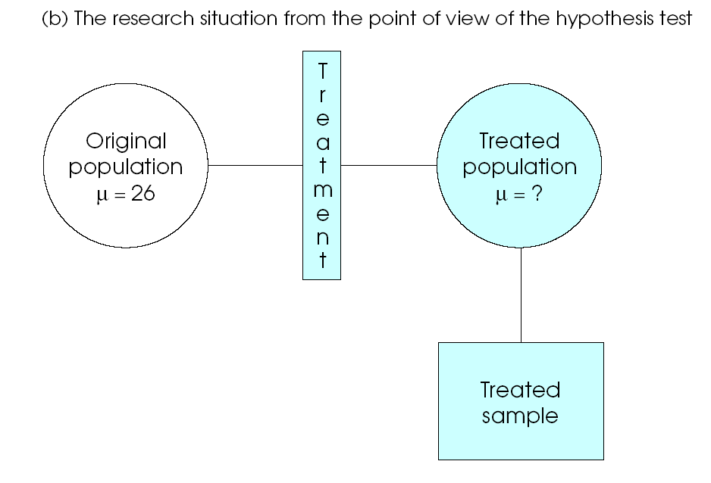
Depressed
SSRI users
SSRI users
- Draw conclusions about how populations differ, based on statistics from sample.
- If sample differs a little on suicidality, probably accept H₀
- If sample differs a lot on suicidality, probably accept H₁
- To determine whether the sample differs “a little” or “a lot” we use statistics

D. Steps of Hypothesis Testing
- State hypotheses about population
H₀ and H₁
- Set criteria (rules) for rejecting the null hypothesis (H₀)
- Calculate a statistic
- Make a decision and report results

Step #1: State Hypotheses
- State H₀: No difference, no effect at the population level
- State H₁: Some difference, some effect at the population level

Step #2: Set Criteria for Rejecting H₀
- Cannot easily compare the treated population to the untreated population (not everyone on SSRIs will be in our study)
- Next best thing: Compare a sample of SSRI users to a general population of depressed people on suicidality
- We need to determine if our sample of interest differs much from the untreated (or general) population
- Small or no mean difference → Accept H₀
- Large mean difference → Accept H₁
- Use Z statistic to determine if the sample differs from the larger population more than what would be expected by chance
- If H₀ is true (no effect), usually mean differences will be small (small Z score)
- Sometimes, even if there is no real effect, we might get a bad sample, and Z will be large, but this is very rare. In fact, just by chance (sampling error), Z will only be more extreme than ±1.96 about 5% of the time
- Thus, if we get a Z that is more extreme than ±1.96, we conclude that the result is probably not due to chance. We accept H₁ instead of H₀
- Occasionally (5% of the time), we will get an extreme result by chance, thinking we have found a real difference when in fact there is not
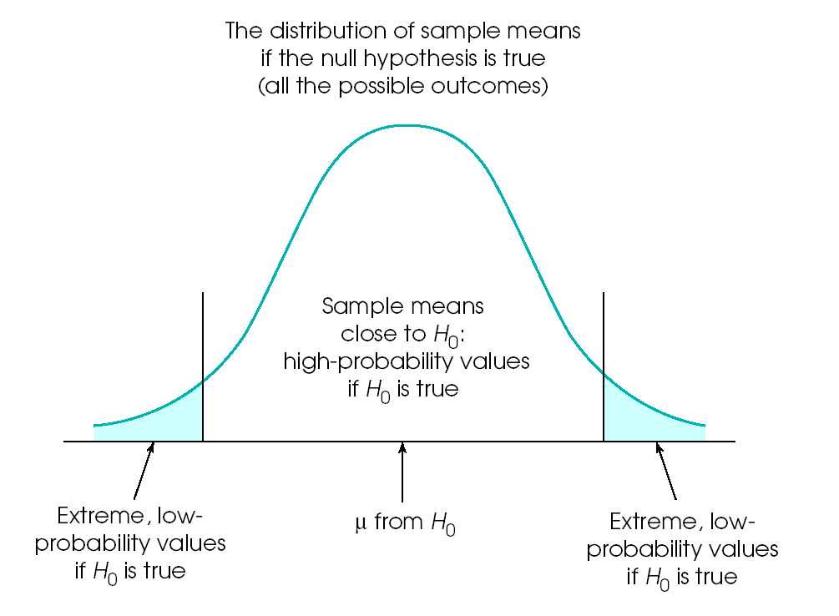
Typical Outcome when Ho is true
Low probability of Ho being true, accept H1
Low probability of Ho being true, accept H1
Still confused?
Assume there is no effect (treatment has no impact at all). Samples are never perfect (sampling error), so we always expect some small differences, even if there is no effect. In fact, if there is no effect, we would only get a Z value more extreme than ±1.96 about 5% of the time. Since it’s so rare to get an extreme Z by chance, we conclude that the differences are real – treatment had some effect.

Rules
Accept H₀ that there is no effect:
-1.96 < Z < +1.96

Accept H₁ that there is some effect:
Z ≥ +1.96 (big positive) or Z ≤ -1.96 (big negative)

Step #3: Calculate the Relevant Statistic
M = sample mean
μ = general (untreated) population mean
σ = general (untreated) population standard deviation
n = sample size

Review: Z = (M – μ) / SE
where SE = σ / $\sqrt{n}$

Most depressed people have a mild elevation on the Suicidality Questionnaire (μ = 5.0, σ = 1.3). You administer the survey to a random group of depressed people (n = 25) who are taking SSRIs and find that the average score is a 4.6.

To make any type of statistical decisions, must calculate the Z score for the sample
Z = (M – μ) / SE where SE = σ / $\sqrt{n}$
= 1.3 / $\sqrt{\text{25}}$= 0.26
Z = (4.6 – 5.0) / 0.26
= -0.4 / 0.26 = -1.54

Step #4: Make a Decision and Report Results
- Compare the obtained statistic to the decision rules
- Is the obtained Z more extreme than ±1.96?
  - If Yes
    - Less than 5% probability of getting this result by chance, accept H₁ that there is some real effect
  - If No
    - Result could just be due to chance, accept H₀ that there is no effect
    - Sometimes we get weak results due to a poor study design. Could design a better study and try again.

Accept H₀ or H₁?
Z = +0.26 Z = +3.28
Z = -2.14 Z = -1.96
Z = +1.95 Z = +3.50

Side note: The number for the Z score tells you how much your sample mean differed relative to the amount of expected error or discrepancy (SE). If Z = 3.5, it means that your sample differed from the population by three and a half times what we’d expect due to chance alone.

Writing up the results in APA style:
First, provide a sentence with the statistical information, and then explain it in simple terms.
ns = not significant, probably just a chance difference
- Our result (Z = -1.54, no effect):
SSRI use was not related to differences in suicidality, Z = -1.54, ns. SSRI use did not impact suicide.
- If Z = -1.97 (lower suicide scores):
SSRI use was related to differences in suicidality, Z = -1.97, p < .05. SSRI users had lower suicide scores.
p < .05 means the result is not likely due to chance (less than 5% probability), so assume the effect is real.
- If Z = 3.26 (higher suicide scores):
SSRI use was related to differences in suicidality, Z = 3.26, p < .05. Surprisingly, SSRI users were more suicidal, so treatment may be iatrogenic.

Now for some of the details and exceptions…
E. Alpha Level and Critical Region
Typical Outcome when Ho is true
Low probability of Ho being true, accept H1
Low probability of Ho being true, accept H1
- When Z is small, we assume the result is due to sampling error (chance)
- As Z becomes more extreme, the result is less and less likely to be due to chance
- When Z is more extreme than ±1.96, there is only a 5% probability that we would get that result by chance, so we infer that there is some real effect (not just a chance difference)

SHAPE \* MERGEFORMAT 
So if Z is 1.95, we say the result is due to chance, and if Z is 1.96, we say there is a real effect? This seems bizarre.

- Yes, this is a bit odd, but we need to draw a line somewhere if we are to have rules for making decisions (kind of like speed limits).
- Alpha level or significance level:
Percent of the time (or probability) we will incorrectly reject the null hypothesis
  - Generally set at .05, so psychologists are willing to incorrectly reject the null hypothesis about 5% of the time
  - Used to determine cutoff point for determining “significance”
- Critical Region:
Z values where result is considered significant, reliable, and unlikely to be due to chance
  - Use Z’s more extreme than ±1.96, which corresponds to the alpha level
- Rarely other standards are used:
Alpha level  α | Probability of incorrectly rejecting Ho | Z value  for cutoff
.10 | 10.0% | 1.65
.05 | 5.0% | 1.96
.01 | 1.0% | 2.58
.001 | 0.1% | 3.30
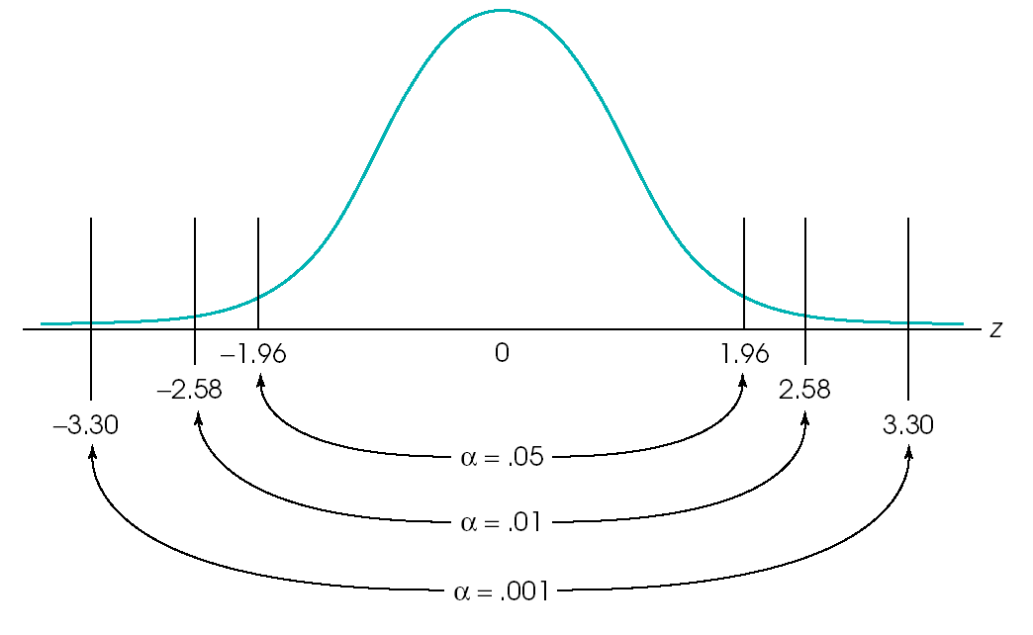

- Sometimes tiny alphas (e.g. .001) and big cut offs for Z are used in areas of research where there are more likely to be erroneous findings, such as neuroscience
- Sometimes researchers try to cheat and use big alphas (e.g. .10) and small cut offs for Z to say their results are “significant” when really they are not too reliable or impressive

F. Probability and Errors
- Decisions based on probability will always be wrong a proportion of the time
  - Billups is a 90% free throw shooter but he still misses sometimes.
  - Forecast says 80% chance of snow but this will be wrong at times too.
- Using the alpha = .05 (Z more extreme than ±1.96) rule, we will by definition be wrong about 5% of the time when we reject the null hypothesis
- Two main types of errors

Type I Errors:
- Mistakenly conclude there is an effect, when really there is no effect
- H₀ is correct, but mistakenly accept H₁
- Basically, saying something is true when it really isn’t

- Why?
- Unlucky, atypical, unusual sample
- Looked at too many variables at once, and some were related by chance
- Illusory correlations – instead of using science, draw conclusions based on anecdotal observations (e.g. superstitions)
 | 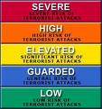

Type II Errors:
- Mistakenly conclude that there is no effect, when in fact there is an effect
- H₁ is correct, but mistakenly accept H₀
- Why?
- Could be a bad sample again
- Sample too small to draw reliable conclusions
- Study designed poorly

 | SHAPE \* MERGEFORMAT 
G. Skepticism
“It is wrong always, everywhere, and for anyone, to believe anything upon insufficient evidence.”
“The danger to society is not merely that it should believe wrong things, though that is great enough; but that it should become credulous, and lose the habit of testing things and inquiring into them; for then it must sink back into savagery.”
-William Kingdon Clifford

- Has this finding been replicated?
- Is this finding supported by sound theory?
- Is this finding too good to be true?
- Would this study have been published if the opposite result were true?
- Is it possible that studies with the opposite finding have been suppressed from publication?
- Did the authors have a vested interest in the study?
- Were the researchers on a fishing expedition?
- Are there weaknesses in the design of the study?
- Are there weaknesses in the measures used in the study?
- Were the analyses appropriate?
- Do the conclusions they draw fit with the results of their statistical analyses?

H. Different Types of Hypothesis Tests

Two-tailed hypothesis test
- Used when you want to test whether a treatment or manipulation has any effect, positive or negative
  - Does this pill impact appetite?
  - Do extra credit quizzes impact performance evaluations?
  - Does reading aloud impact retention of material when studying?
- Both positive and negative results are seen as interesting and important

One-tailed hypothesis test
- Used when you want to test whether a treatment or manipulation has an effect in a specific direction
  - Does reading make people smarter?
  - Does human growth hormone make baseball players stronger?
  - Does the tire store make more money when there are more potholes?
- Sometimes findings are only interesting and important when they occur in one direction. For example, if we found that the tire store’s business went down when there were a lot of potholes, we’d likely dismiss this finding.
Comparison
- Because One-tail tests are a bit more specific, a less strict Z value is used

Two-tail test
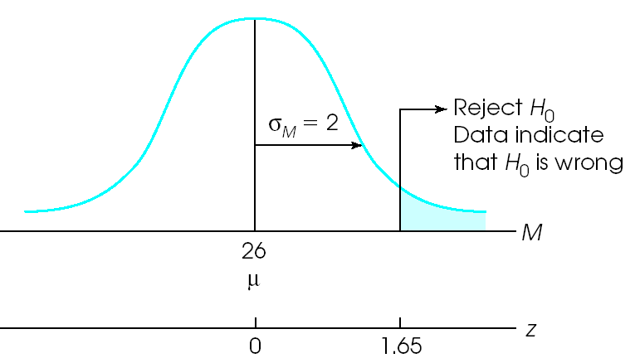
One-tail test

 | Two-tail | One-tail
Critical Z | ±1.96 | +1.65

- Probably 99% of the time, people use two tail hypothesis tests. Any extreme result is an interesting finding in most cases.

