Answer Sheet
Homework 8 and 9

Homework #8
1. Trait = | neuroticism
2. R² = | .27
3. Effect size = | large
4. Reliable? | no
5. t-value = | -2.88 (or 2.88)
6. Cohen’s d = | .41
7. p-value = | .002
8. a) Reliable? | yes
b) Group? | healthcare
9. a) Reliable? | yes
b) Season? | summer
10. a) Chi-square = | 13.10
b) Read to? | yes
11. a) Significant? | yes
b) Conclusions? | The results are unsurprising. Single people are more likely to rate a friend as a hero; people in relationships, their partner.
12. Conclusion? | In general, the negative emotion people feel most often in childhood is the same emotion they feel most often in adulthood.
Homework #9
1) Top HW Score = | ???

1.

2.

4.

5.

7.

9.

10.

11.

12.

Homework #8/9
Due Tuesday, April 22
25pts Each!

- Each number is worth up to two points. You will receive one point for neatness.
- Design your own cover sheet and use the answer sheet on the final page.
- Include a copy of your Output.
- Print a second copy for yourself to check your answers later.
- Work independently.

Review

Please see the previous SPSS assignments (#3 and #6) if you have forgotten how to conduct these analyses.

1. Which of the Big 5 personality traits (#103-107) correlate most strongly with pop drinking (#54)?
2. All of the Big 5 personality traits (#103-107) are significantly correlated with life satisfaction (#92). Run a multiple regression using these traits to predict life satisfaction. What is the value of R²?
3. Is the effect size for the R² reported in question #2 small, medium, or large?
4. Run a t-test comparing gender (#15) to activism (#81). Is there a reliable gender difference?
5. Run a t-test comparing gender (#15) to vocabulary (#110). What is the t-value?
6. What is the value of Cohen’s d for #5?

ANOVA

- To run an ANOVA, go to the Analyze menu, point to Compare Means, and select One-Way ANOVA.

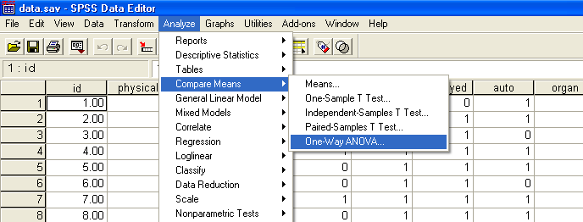

- In the window that pops up, you put the categorical variable in the Factor area and the continuous variable (or several continuous variables) in the Dependent list.
- Put Top Political Issue (#20) in the Factor area, and put Age (#44) in the Dependent List. This will allow us to see if age is related to people’s primary political concerns.

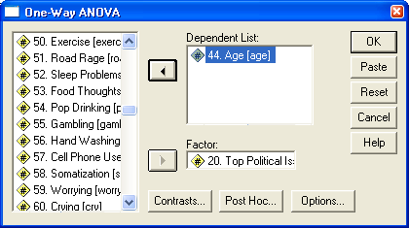

- Next, click on the Options button and choose Descriptives. This will provide us with the information on age (mean and standard deviation) in each group.

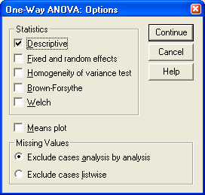

- Also, click on the Post Hoc button and choose LSD. This will allow us to get post hoc results, which provide more detail on any differences that may occur.

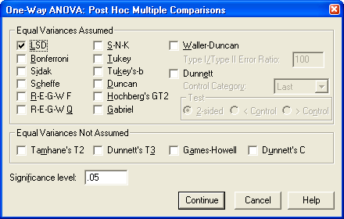

- Click the Continue button. Then click the OK button in the original pop-up window.
- Your Output should look similar to that shown below.

Post Hoc Tests

- The first box provides descriptive information, such as the number of people choosing each political issue and the average age for people in each group.
- The second box provides the results of the significance test. The top two values (4, 274) in the df column are used to determine the shape of the F distribution for this analysis. The F column has the appropriate F value. The Sig. column provides the p-value that results from the statistical test. This is the probability of obtaining the group differences simply by sampling error or “chance” and if p < .05, the result is considered significant or reliable, indicating that there is some interesting group difference in the data.
- Only examine the third box if the p-value in the second box is significant (it is for this problem). The third box is very complicated, so spend a few minutes studying it, and review the ANOVA notes from class. It basically compares each group in terms of age. It’s kind of like running a bunch of t-tests comparing all possible groups. The mean difference column tells how much two groups differ in terms of age. The Sig. column indicates whether the age difference is significant (if p < .05). There will also be an asterisk (*) by the mean difference if it is significant. For example, people who said their top issue was education differed from people who said their top issue was healthcare, with the education supporters being about 4.7 years younger, and this difference was reliable (p = .03).

7. Run an ANOVA examining how the continuous variable, Death Concerns (#74), differ across the categories of the Top Political Issues variable (#20). What is the resulting p-value for the F test?
8. For #7, examine the post hoc results. Does the Foreign policy group reliably differ from the Healthcare group on Death Concerns? Which group has greater death concerns?

Chi-square Test for Goodness of Fit

- The chi-square test for goodness of fit is used to examine whether a sample has an unexpected number of people (proportion) in some category (e.g. more females than expected).
- Go to the Analyze menu, point to Nonparametric Tests, and choose Chi-Square.

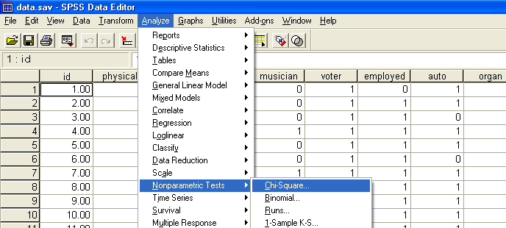
- You choose a categorical variable and by default the program will determine whether the number of people in each category are roughly equal (non-significant chi-square) or whether they are reliably different (significant chi-square).
- Select Gender (#15) and put it in the Test Variable List. This will tell us if there are about an equal number of females and males (non-significant chi-square) or whether there is a reliable difference in the number of people in each gender group (significant chi-square). Click OK.
- Your Output should look something like this:

Chi-Square Test
Frequencies

- The first box tells us that there were about 74 more females than expected, and 74 fewer males than expected. The second box tells us that the chi-square value was 77.45, df = 1, and the p-value was very small. Because p < .05, we know there is a reliable and unexpected gender difference.

9. Conduct the same test, but this time use Favorite Season (#25). If people’s favorite season was random, there would probably be an equal number (25%) in each group. The chi-square will tell us if there are any reliable differences in season preferences. Were there any reliable differences? Which season was the favorite?

- Chi-square can be used to test whether all groups have an equal number, or you can specify other proportions.
- Suppose you read somewhere that among college students, 25% vote and 75% do not vote. You can test whether our sample reliably differs from these proportions.
- This feature is fairly poorly designed in SPSS, so if you ever use it in the future, be careful and check that your results make sense. Before we even run an analysis, examine how the Voter (#6) variable was coded. We asked people whether they would vote and responses were coded as 0 = No, and 1 = Yes.
- Now, go to the chi-square pop-up window and put Voter (#6) in the Test Variable List.
- Then, in the Expected Values area of the window (right below), choose “Values” instead of “All Categories Equal”
- This is where it’s easy to make a mistake. We will tell SPSS the percentage of people we expect in each group (voter or non-voter). We want to make sure that we tell SPSS that we expect 75% to have said no and 25% to have said yes, but if you don’t pay attention, it’s easy to accidentally say the opposite (25% no, 75% yes).
- In the area next to “Values:” type in 75. Then, click Add. Type 25. Then, click Add. This tells SPSS that we think 75% will have said no and 25% will have said yes. It matches the 75 with “No” because it was coded with a lower value than “Yes” in our data file (No = 0, Yes = 1). It should always assign the percentages in the order they were coded, but double-check the Output just in case.

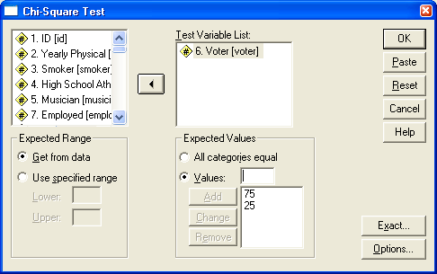

- Click OK to run the test. The Output should look like this:

- In the Output, double check that SPSS assigned the expected percentages correctly. In the Expected N column of the first box, it says we expected about 209 people (75% of 279) to have said No and about 70 people (25% of 279) to have said Yes.
- Our results show that more people than expected said they would vote, and this result is significant (I’m betting most won’t actually follow through on voting).

10. Go to the chi-square pop-up window. Hit the Reset button to clear everything. Run a similar analysis, examining the variable Read to As a Child (#10). Suppose you heard that about 30% of people are not regularly read to as a child, and 70% are regularly read to as a child. You are curious whether our sample of college students (and their acquaintances) were more likely to have been read to as a child. Run the appropriate chi-square test. What is the resulting chi-square value? Compared to people in general, was our sample more likely to have been read to as a child?

Chi-square Test for Independence

- Often students try to run correlations (r) between categorical variables. Any correlation based on a categorical variable is generally meaningless because the numbers we assign to categories do not have meaning – in other words, you’d get a different correlation simply based on how you decided to code the results. However, we can examine whether two categorical variables are related in some way, using the chi-square test for independence.
- This analysis is in a different place than the previous type of chi-square. Go to the Analyze menu, point to Descriptive Statistics, and choose Crosstabs.

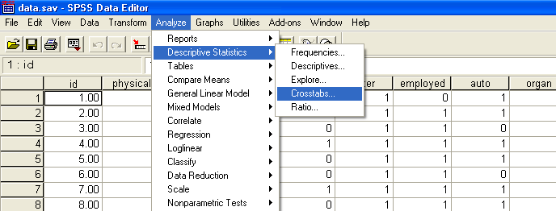

- In the window that pops up, you’ll want to put one variable in the “Row(s)” area and one variable in the “Column(s)” area. It doesn’t really matter which variable goes where. [If one of your variables has a lot of categories, putting it in the Column area gives you a short and fat table, whereas putting it in the Rows area would give a tall and skinny table]
- Put Smoker (#3) in the Row area, and Skipper (#14) in the Column area. This will allow us to see whether ever having smoked is related to skipping class. Before hitting the OK button, we need to make a couple changes.
- Click the Statistics button, choose Chi-square, and click Continue.
- Then, click the Cells button. In the window that pops up, make sure both Observed and Expected are checked. Then, click Continue. Hit OK in the original window to run the test.

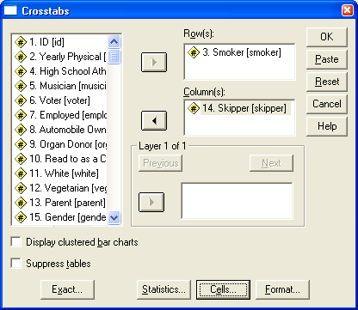

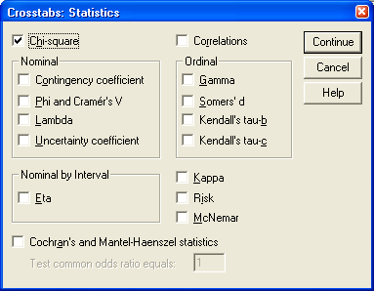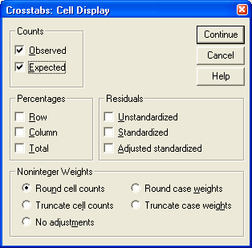

- The Output we need is on the following page. Ignore the first box completely. I usually examine the final box first to see if the result is significant. In the final box, it says that the chi-square = 11.56, which is significant, p = .001. This indicates that there is some reliable effect, so examine the second box to see what that effect is.
- Examine the second box carefully, and read over the lecture notes for help. This box tells us that there were more Non-smoker Non-skippers than expected, and more Smoker Skippers than expected. Thus, smoking was related to skipping class.

11. Now try running a new chi-square test for independence. This time, compare Relationship Status (#16) to Hero (#30). Is the chi-square significant? What type of conclusions might you draw?

12. Thus far, we’ve only examined simple cases. Let’s compare people on their most common Negative Emotion – Childhood (#22) to their most common Negative Emotion – Adulthood (#23). The Output is complex due to the number of categories, so take your time. In general, what type of conclusion would you draw?

Homework Assignment #9: Look on Blackboard, and note the highest number of points you received on any assignment. You can record this right in the final spot on the answer sheet for assignment #8, and this will be your grade for assignment #9.
Answer Sheet
Homework 8 and 9

Homework #8
1. Trait =
2. R² =
3. Effect size =
4. Reliable?
5. t-value =
6. Cohen’s d =
7. p-value =
8. a) Reliable?
b) Group?
9. a) Reliable?
b) Season?
10. a) Chi-square =
b) Read to?
11. a) Significant?
b) Conclusions?
12. Conclusion?
Homework #9
1) Top HW Score =

