Homework Assignment #5
Due Tuesday, March 18th

A) Include a cover sheet.
B) Type all of your answers neatly in the answer sheet provided on the last page; no points for handwritten responses. Please try to fit all answers on a single page, if possible.
C) Work independently and use your own words.
D) Questions are 3 points a piece. The cover page and neatness are 1 point.

1. Go to BlackBoard and calculate your current grade. What percentage of the points possible do you have, and what would your letter grade be? Is there any reason that this grade might not be the best indicator of your performance? What will you do to obtain your desired final grade?

2. Define “hypothesis” in your own words, using one or two sentences.

3. Introductory psychology students often have a vague idea of some research questions they might like to study but often have difficulty formulating those questions into concise, testable hypotheses. Based on some of the variables in the data file, describe three null hypotheses and their corresponding alternative hypotheses.

4. Why do researchers accept an alternative hypothesis only if the data yield a Z statistic that is more extreme than ±1.96?

5. In your own words or using your own examples, explain the difference between a Type I error and a Type II error in language that a non-psychology student could easily understand.

6. In general, adults with Autism have a low level of adaptive daily living skills. On the Autism Questionnaire, adults with Autism score a mean of 78.3 and standard deviation of 12.4. You run a vocational program designed to assist adults with Autism in developing daily living skills and basic work skills. At the end of your program, the group (n = 16) has a mean score of 83.6 on the Autism scale. Calculate a Z statistic for the sample. Did the intervention likely reliably improve their daily living skills?

7. Below is the first paragraph from a recent short report in the journal of Psychological Science, written by Rule and Ambady (2008, p. 109).

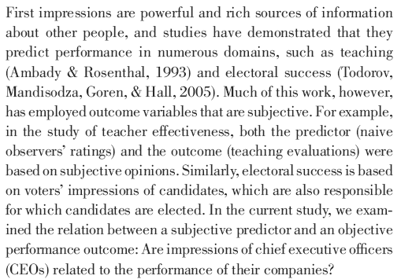

As you can see, introductory students are not the only ones who have difficulty translating vague questions into hypothesis statements. Researchers are often overloaded with work, and you can probably write more clearly than many authors if you take the time. Based on the information in their paragraph, construct a well-written hypothesis statement.

8. Below is an abstract from another recent Psychological Science article by Deary, Batty, and Gale (2008, p. 1). Write a concise hypothesis statement based on the information presented in the beginning of the abstract.

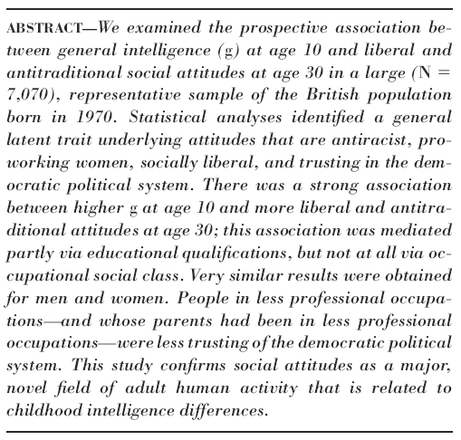

9. Bonus Question (optional, 2 extra points). For the previous two problems, presumably you stated a hypothesis describing the possible relationship between two variables. Based on your hypothesis statement for #7 or #8 (pick one), describe some ways you might actually measure these variables if you wanted to conduct their study (or a similar study) yourself.

Answer Sheet

Problem |  | Answer
1 | % = | varies
 | Letter = | varies
 | Valid? | varies
 | Plan? | varies
2 | Definition | A concise, testable statement describing the expected relationship between two variables.
3 | a. H₀ | varies
 | H₁ | varies
 | b. H₀ | varies
 | H₁ | varies
 | c. H₀ | varies
 | H₁ | varies
4 | 1.96? | Any minor differences between a sample and population could be due to sampling error. Given this cut score, researchers will only incorrectly reject the null hypothesis 5% of the time.
5 | Errors | A Type I error is when people assert some fact that is not really true, whereas a Type II error occurs when people deny the existence of a real relationship. A Type I error might occur when a drug company says that a drug works, but it really doesn’t. A Type II error might occur when people say there are no racial inequalities and injustices but there are.
6 | Z score = | Z = (83.6-78.3) / SE where SE = 12.4 / sqrt(16) = 12.4 / 4 = 3.1  Z = (83.6-78.3) / 3.1 = 5.3 / 3.1 = 1.71
 | Reliable? | No, the intervention did not offer a reliable improvement.
7 | Hypothesis | People’s impressions of CEOs will be related to the company’s performance. [Anything along these lines]
8 | Hypothesis | People who are smarter at age 10 are more likely to be liberal at age 30. [Anything along these lines]
9 | (Bonus) | For #7, they could have people watch video clips of CEOs and rate how well they make impressions with people. This could then be compared to how much money the companies make, or other sales figures.  For #8, they could measure intelligence with a short intelligence test. If that was not available, they could use grades or achievement test scores. This could be compared to a personality measure of liberalism, or liberal behavior, such as voting records.

