PSY 211: Exam #2 Name: _____________________________
Course Reference #22021132
Mike Hoerger

Multiple Choice (4 points each)
Choose the best available response.

1 | Symbol for population standard deviation:
a) | µ
b) | σ ²
c) | σ (58%, r = .39)

2 | After this exam, Mike will examine whether the exam items tend to correlate highly with each other. In this example, he is most likely using correlations to assess:
a) | reliability (49%, r = .54)
b) | validity
c) | theory

3 | A sample of students rates their level of happiness on a 9-point scale from 1 = unhappy to 9 = happy. For the ratings, the mean is 6.5, the median is 6.0, the mode is 7.0, and the standard deviation is 1.5. What would the variance be?
a) | 1.22
b) | 2.25 (80%, r = .62)
c) | 3.00

4 | Magnitude of the correlation for r = .27
a) | small (88%, r = .23)
b) | medium
c) | large

5 | What is the range for the following set of data?  95 58 95 60 60 92 92 62 86 62 76  86 76 76 64 75 64 75 75 76 76 75
a) | 58 to 95
b) | 37
c) | 38 (88%, r = .31)

6 | Dr. Phil argues that the more open people are about describing themselves, the more we like them. Based on the BlackBoard article, what is the correlation between self-disclosure and likeability?
a) | r = .02
b) | r = .14 (69%, r = .39)
c) | r = .27

7 | What is the approximate correlation between extraversion and cell phone use?
a) | r = .09
b) | r = .29 (47%, r = .23)
c) | r = .49

8 | This factor generally makes correlations larger.
a) | high variability (41%, r = .39)
b) | outliers
c) | range restriction

9 | Magnitude of the correlation for r = .51
a) | small
b) | medium
c) | large (82%, r = .31)

10 | If the variance for a set of data is 4, what would the standard deviation be?
a) | 2 (78%, r = .54)
b) | 8
c) | 16

11 | You hypothesize that people who finish exams more quickly tend to earn higher grades. To test this, you correlate the order people finish their exams with class rank. What type of correlation would you use?
a) | Spearman correlation (38%, r = .31)
b) | Point-Biserial correlation
c) | Pearson correlation

12 | If 5 points are added on to each student’s test score, what would happen to the standard deviation?
a) | stay the same (82%, r = .31)
b) | get 5 points higher
c) | get 5 times bigger

13 | Why is it important to study multiple regression?
a) | For any given predictor, there are usually multiple outcomes, and it is important to be able to study multiple dependent variables at once.
b) | Usually when doing experiments, behavior is measured at several different time points, so multiple regression combines them all into one.
c) | Behavior tends to be multidetermined, and effects of any single predictor alone tend to be small. (75%, r = .39)

14 | The relationship between tanning frequency and vocabulary:
a) | direct relationship
b) | no relationship
c) | inverse relationship (45%, r = .46)

15 | Using SPSS, you find that happiness correlates r = -.20 with physical health. This means that _____ percent of the differences in health can be explained by happiness.
a) | 2
b) | 4 (55%, r = .85)
c) | 20

16 | When making a scatterplot, what variable is generally placed on the X axis (horizontal, across the bottom)?
a) | independent variable (77%, r = .23)
b) | dependent variable
c) | extraneous variable

17 | Which of the following is the most accurate definition of the correlation coefficient (r)?
a) | A value indicating the direction and strength of the relationship between two variables. (65%, r = .54)
b) | The sum of squares of all X’s divided by the sum of squares of all Y’s, ranging from  -1.00 to 1.00.
c) | The sum of squares of all Y’s divided by the sum of squares of all X’s, ranging from  0.00 to 1.00, also the coefficient of determination squared.

18 | For a project, you design a survey measuring “feminism” but your roommate says that your survey is lame and does not really measure anything. To show that your survey actually does measure differences in feminism, you correlate scores from your survey with several other measures of feminism to see how well it holds up. In the example, you are most likely using correlations to assess:
a) | reliability
b) | validity (68%, r = .39)
c) | theory

19 | In a media broadcast, Glenn Beck asserts, “IQ is in the genes. We should stop investing in social programs, such as educational assistance.” Based on the BlackBoard article, what is the correlation between IQ and number of years of education?
a) | r = .03
b) | r = .25
c) | r = .44 (35%, r = -.08) → bad item, so extra credit

20 | Lowest possible value for R:
a) | negative infinity
b) | -1
c) | 0 (39%, r = .39)

21 | “ _____ is the law of life, and as no two faces are the same, so no two bodies are alike, and no two individuals react alike and behave alike under the abnormal conditions which we know as disease.”  - William Osler
a) | Science
b) | Cupola
c) | Variability (88%, r = .31)

22 | Depressed people participating in a clinical psychology study are randomly assigned to either receive cognitive therapy (treatment group) or no treatment at all (control group). Weirdly, at the end of the study, even people in the control group are much less depressed. What concept is most related to this unusual finding?
a) | regression toward the mean (81%, r = .18)
b) | test-retest reliability
c) | coefficient of determination

23 | Psychological tests and medical tests are both used to predict important outcomes. Psychological tests usually yield correlations with relevant outcomes that are _______ those of medical test.
a) | much stronger than
b) | similar to (71%, r = .69)
c) | much weaker than

24 | 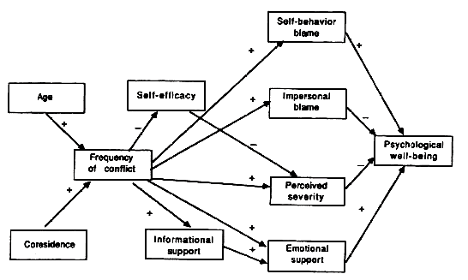  Based on the above path diagram, __________ causes “Perceived severity” through an inverse relationship.
a) | “Self-efficacy” (86%, r = .39)
b) | “Frequency of conflict”
c) | “Psychological well-being”

25 | This scatterplot shows the correlation between two different depression ratings. One rating used a 9-point scale and the other simply asked people how many days per week they feel depressed. What is the approximate correlation between these two variables?
a) | r = .93
b) | r = .72 (65%, r = .46)
c) | r = .49

26. Calculations [10 points]

You have been having sleep problems and begin recording how many hours you sleep each night for each of the past 4 days:
7 2 5 6

a) What is the average (mean) number of hours slept per night? [2 pts]
M = (7+2+5+6)/4 = 20/4 = 5.0

b) What is the range for this data set? [2 pts]
range = 1 + 7 – 2 = 6

c) What is the standard deviation for this data set? [5 pts]
[You should use the sample formula instead of the population formula because we’re just talking about a sample of four nights here, not every bad night of sleep you’ve ever had. If you made calculations based on the population formula, you only lost a half point total.]

X | X-M | (X-M)²
7 | 2 | 4
6 | 1 | 1
5 | 0 | 0
2 | -3 | 9
 |  | SS = 14

Variance = SS / (n-1) = 14 / 3 = 4.67
SD = sqrt(Variance) = sqrt(4.67) = 2.16

SD = 2.16
(If mistakenly using population formula, SD = 1.87)

d) What is the variance for this data set? [1 pts]

Variance = 4.67
(If mistakenly using population formula, Variance = 3.50)

[Incidentally, the correlation between self-reported hours of sleep and actual number of hours of sleep is near zero!]
27. SPSS Output [4 pts]

The following SPSS Output shows the correlations among the “Big 5” personality traits: Extraversion, Neuroticism, Openness to Experience, Agreeableness, and Conscientiousness.

a) Which two personality traits are most highly correlated? [2 pts]
Agreeableness and Conscientiousness – A lot of people missed this somehow!

b) What is the sample size? [1 pt]
279

c) What is the correlation between Agreeableness and Agreeableness? [1 pt]
1
28. SPSS Output [6 pts]

To examine whether parental support and physical health could be used to predict happiness, the following statistical analyses were conducted.

a) What type of analysis was conducted? [1 pt]
Regression, Multiple Regression, R, or Multiple R

b) What is the value for the coefficient of determination (do not round)? [2 pt]
.202 or something similar, not .196

c) What is the value of R? [1 pt]
.449

d) Use the information above to generate an equation for the best fit line for this analysis. [2 pts]

y’ = 3.135 + .288*X₁ + .185*X₂

or

Predicted Happiness = 3.135 + .288*(Parental Support) + .185*(Physical Health)

Study Guide
Exam #2
PSY 211

Disclaimer: This is a guide of the main points that I consider to be important. You are responsible for all material covered in the book or in lecture, unless otherwise noted by me.

Format: The exam is 120 points. There will be 25 multiple choice questions (4 points each); multiple choice includes concepts, quick calculations, and interpretation of SPSS Output covered in class or the homework. The remaining 20 points will come from some combination of calculating variability in some way, making a scatterplot, and/or designing or interpreting a path diagram.

Not on this exam:
- Interquartile range and semi-interquartile range (Section 4.3, p 107-108)
- Calculating correlation coefficients
- Hypothesis testing with the Pearson correlation (Section 16.4, p. 537, 539, 540)
- Standard error of the estimate (p. 559-564)
- z scores

Concepts to know:
- Variability
- Range, Standard deviation, Variance
- Relationship between standard deviation and variance
- Population vs. Sample
- Population standard deviation vs. sample standard deviation
- Degrees of freedom = a correction number or reference number often used for improving formulas, based on sample size (for most formulas, df = n-1, though we’ll learn of exceptions later in the year)
- Differences between surveys and experiments
- Correlation coefficient: magnitude, direction, estimating from scatterplots, range of possible values, how to describe values in words (small, medium, large)
- Coefficient of determination = r² = % of the differences in the outcome variable (dependent variable) that can be explained by the predictor variable(s)
- Understand formula for correlation coefficient (“degree that X and Y vary together divided by the degree the vary separately”), but you won’t need to make any calculations
- Various uses of the correlation coefficient
- Regression toward the mean
- Factors that impact the magnitude of the correlation coefficient (actual relationship between variables, as well as several nuisance factors, like range restriction, outliers, shape of the distribution, and the quality of the measures)
  - I might give you an example, like “Everything else being equal, would variables be more highly correlated if they are measured using single items or measured using detailed surveys?” or “Everything else being equal, would variables usually be more highly correlated if they have skewed distributions or if they have normal, symmetrical distributions?”
- Names of other types of correlations and when they would be used
- When correlation probably shows causation and when it does not
- Visually inspect scatterplots with best fit lines and estimate a score on Y, given a score on X
- Independent variable, dependent variable, confounding variable (aka 3rd variable)
- R and Multiple R
- Multidetermined

BlackBoard Article:
- Pay particular attention to highlighted material. Also, I went back and put red boxes around findings that are particularly interesting in the tables.
- If I give you two variables, you should be able to estimate the correlation between them plus or minus about .20. Not too hard, since most correlations are small!
- Definition of psychological assessment: psychological testing, or the combined use of multiple tests or surveys to form predictions
- Psychological assessments are about as good at predicting relevant variables as are medical tests
- The general rule is that big correlations are impressive, and small correlations are unimpressive, and this is probably a good rule of thumb 90% of the time. But sometimes small correlations can be important, and sometimes even large correlations are disappointing.
- Notice that sometimes small correlations are very important. For example, people take aspirin to reduce heart attack risk, even though the correlation between aspirin use and decreased risk is only r = 0.02. When it’s a life or death matter, any predictive ability is important, so people take aspirin.
- Sometimes we are not impressed by modest correlations (e.g. diagnosing cavities or home pregnancy tests)

Calculations and Formulas to know:
- Know how adding, subtracting, multiplying, or dividing all of the scores in a data set by a particular number impacts variability
- Mean, median, mode
- Range, variance, standard deviation (for both population and sample)
- Draw or interpret a scatterplot
- Draw or interpret an easy path diagram
- Interpret SPSS Output covered in the homework or in class
- Use SPSS Output to predict a specific score on Y based on the formula for the regression line

Problem Solving:
- Scatterplots:
  - Draw a scatterplot given a small data set
  - Draw a best fit line for the scatterplot (based on where you roughly estimate that it should go)
  - Estimate the magnitude of a correlation based on a scatterplot you draw
- SPSS:
  - Examine output to determine central tendency, variability, and frequencies
  - Examine output to determine correlation coefficients, and coefficient of determination
  - Examine output to derive an equation for a best fit line
  - Sub in values for X (or X’s) in the best fit line equation to predict values on Y
- Path Diagrams:
  - Be able to draw a path diagram, given a written description, such as “Show a path diagram where Hopelessness and Stress cause Depression, and Depression causes Insomnia and Alcohol Use.”
Be able to design a theory-based path diagram, using your own intuitive reasoning, given a set of variables, such as “Design a theory-based path diagram, using any combination of five of the following variables: attractiveness, leadership, extraversion, depression, intelligence, crying, conscientiousness, GPA, stress, popularity, vocabulary, unemployment. Describe what the model means in one or two sentences.”

Math Anxiety: There are two ways to combat math/testing anxiety. I suggest doing both.
- Overlearn the material by studying more than you normally would. Anxiety hogs cognitive resources (namely, working memory capacity). When students know the material well, they function on autopilot and don’t need many cognitive resources, so even if they’re anxious, they can still do well. For example, we’ve all “practiced” saying the alphabet so many times in our lives, that no amount of anxiety will likely disrupt our ability to say it. When students practice statistics to the point that it also becomes automatic, anxiety will rarely be a problem either.
- Another approach is to attack the anxiety itself. Find a way to relax during the test. Take a break from the exam for 30-seconds when you feel anxious or fatigued. Do some deep breathing from the diaphragm (stomach region). Bring a little snack, some juice, or some other type of comfort object. It’s also wise to avoid drinking more caffeine or smoking more cigarettes than usual.

If you want to practice calculating the mean and sample standard deviations, you can use the following data:

Sample #1: 3 7 8 9 6

Sample #2: 4 9 3 6 2

Sample #3: 5 5 5 6 4 7 8

Sample #4: 1 1 2 8

Sample #5: 1 6 5 8 9 8 7 4 5 6

Sample #6: 5 5 5 5 5

Sample #7: 1 2 3

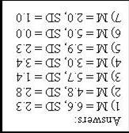

More Tips:

Different R’s

r | R | multiple R
* 2 variables  * Ranges from -1 to 1 | * 2 variables, using a formula to predict Y from one X  * Ranges from 0 to 1 | * 3 or more variables, using a formula to predict Y from multiple X’s  * Ranges from 0 to 1

Interpretation

impossible! | more extreme than +1.00
large | +.50 to +1.00 | positive  (direct)
medium | +.30 to +.49 | positive  (direct)
small | +.10 to +.29 | positive  (direct)
zero / near-zero | 0 ish
small | -.10 to -.29 | negative  (inverse)
medium | -.30 to -.49 | negative  (inverse)
large | -.50 to -1.00 | negative  (inverse)
impossible! | more extreme than -1.00

Bb Article

I have marked a red box by correlations you should “know” (by “know” I mean, remember within about + or – 0.2). Most variables correlate weakly, so if you ever have to take a blind guess how much variables correlate, guess about r = 0.2.

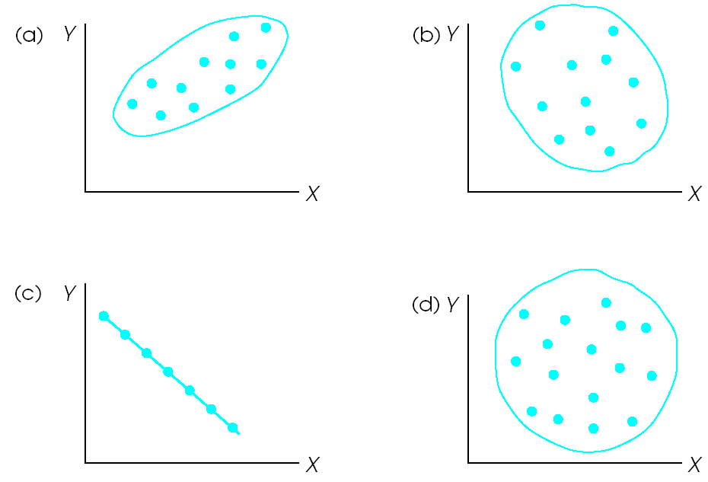

a = +0.8ish, b = -0.3ish, c = -1.0, d = 0.0

Rule of thumb:
stick = 1.0, hot dog = 0.8, sub sandwich = 0.5, egg = 0.3, circle = 0.0
If you can tell the difference between an egg and a bratwurst, you’re in good shape

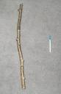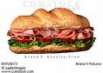

r = -0.8 | r = 0.4
r = 0.2 | r = -0.6
r = 0.0 | r = -0.3

Positive Parental Relationship means lower Authority Problems
(r = -0.31)

Correlations

Regression

r = .31, R = .31

Predicted Y = -.271(X) + 3.305

If someone rated their parental relationship (X) as a 7:
Predicted Y = Authority Problems = -.271(7) + 3.305
=1.4
= low authority problems
Multiple Regression

Parent relationship and Anger predicting Authority Problems
R = 0.39

multiple R = 0.39

Predicted Y = Authority Problems = -.213(X₁) + .202(X₂) + 2.499

If someone rated Parent Relationship as 1 and anger as 7:
Predicted Y = Authority Problems = -.213(1) + .202(7) + 2.499
= 3.7
= modest authority problems

