ANOVA
PSY 211
4-8-08

TERM PAPERS
DUE NEXT TUESDAY (4/15)
INCLUDE SPSS OUTPUT
INCLUDE 1 COPY OF ALL SOURCES

A. Types of Analyses (some review)

- Continuous variables: Values are numbers that have meaning, such as rating scales or other numeric measurements (IQ, 9-pt attractiveness scale, height)

- Categorical variables: Groups, any numbers assigned are meaningless (gender, ethnicity, experimental condition, treatment group)

Type | Independent Variable(s) | Dependent Variable
Correlation (r) | One  continuous | One  continuous
Multiple Regression (R) | Multiple continuous | One  continuous
Between-group t-test (t) | Categorical  (2 categories) | One  continuous
ANOVA (F) | Categorical  (2+ categories) | One  continuous
Chi square (χ²) | Categorical | Categorical

B. Review of t-tests

- Two commonly used t-tests
- Between-group t-test: two groups of people are compared on some continuous outcome variable
- Repeated-measures t-test: same group of people compared on some outcome variable across two time points

C. Introduction to ANOVA

- ANOVA = analysis of variance
- Two types
  - ANOVA: compares multi-category variable to a continuous variable; like the between-group t-test but can involve 2+ groups
Note: If you have two groups or two time points, technically you could do some type of t-test or some type of ANOVA, but t-tests are simpler, so we do them when we can.
  - Repeated-measures ANOVA: examines how scores change across multiple time points; like repeated-measures t-test but can involve 2+ time points
- Thus, ANOVA are like a more powerful t-tests

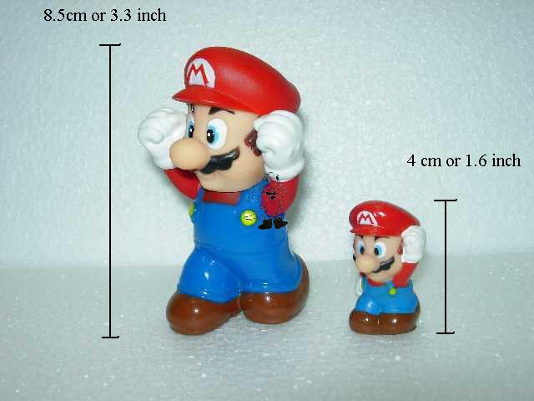
ANOVA
t-test
D. Why ANOVA?

- Often variables have more than 2 categories: favorite color, hero, favorite fast food place
- To use t-tests for these types of multiple-category variables, we had to:
- Restrict analyses to only two categories
- Re-classify the variables down to two categories
- As you recall from the last computer assignment, this can be very tedious
- Also unsatisfying because the t-test cannot provide us with all of the answers we crave

E. How does it work?

- Variance indicates amount of variability or differences
- Experimental manipulations (e.g. treatment group) or demographics (e.g. ethnicity) tend to increase variability – they cause people to get different scores on some outcome variable (e.g. anxiety)
- ANOVA examines whether the amount of variability we obtain is greater than what we’d expect by chance. If so, there are probably some interesting group differences

Assume we are examining quality of K-12 education across several ethnic groups. Just by chance, we would expect some small differences to show up in our sample. ANOVA is used to examine whether there is more variability that what we’d expect by chance.

E. ANOVA Lingo

- Factor: the categorical independent variable
- Favorite color
- Level: specific value/condition within the factor
- Blue

A researcher wants to compare three treatments (placebo pill, medication, and surgery) to see which is most effective in improving heart health.

- What is the IV? DV?
- What is the factor? Levels?

F. Hypothesis Testing

- Hypothesis testing with ANOVA can be a bit peculiar. Let’s examine hypothesis testing, where the IV has three categories

H₀: μ₁ = μ₂ = μ₃ or
At the population level, groups 1, 2, and 3 all have the same mean on some variable.
H_{A}: At the population level, at least one mean differs from the others.
- H_{A} will be true under a wide variety of conditions…
μ₁ ≠ μ₂ ≠ μ₃ (all means are different)
μ₁ = μ₃, but μ₂ is different (at least one mean differs)

- Alternative hypothesis is true if there are any mean differences at the population level
- Because of sampling error, we always expect some mild group differences in scores at the sample level
- Based on the sample size, are the amount of differences observed in the sample so reliable that they would be expected to occur at the population level?
- To determine this, ANOVA relies on the F statistic

G. Significance Testing with the F Statistic

- F ranges from 0 to ∞
- Measures whether obtained variability is greater than chance
- When F is small, go with null hypothesis
- When F is large, go with alternative hypothesis
- Like t-tests, the cut score is based on degrees of freedom, so the critical F value needed for significance varies from study to study

F < 1 | F = 1 | F > 1
Less variability than we’d expect by chance | Exact amount of variability we’d expect by chance | More variability than we’d expect by chance, but need critical F to see if it’s reliably more than chance

- For PSY 211, we will not hand-calculate F. We will learn to understand it conceptually and let SPSS take care of the grunt work
- Some conceptual definitions of F:

F = variance (differences) between groups
variance (differences) within groups

F = total amount of variability in scores
variability due to chance


Huh?

Examples:

F = differences in IQ across SES groups
differences in IQ within SES groups

F = differences in liberalism across music genres
differences in liberalism within music genres

Basically, we are checking to see whether the differences across groups are larger than the chance or meaningless differences we can observe within groups
Example with Data:

Where the null hypothesis is supported…

Health scores across groups
7 different people per group
Placebo | Medication | Surgery
1  1  2  3  5  6  8 | 1  2  3  3  5  6  8 | 2  2  2  3  5  6  8

Health scores across groups
7 different people per group
Placebo | Medication | Surgery  Differences within each group are chance differences (bottom of fraction for F equation)
1  1  2  3  5  6  8 | 1  2  3  3  5  6  8 | 2  2  2  3  5  6  8

Health scores across groups
7 different people per group
Placebo | Medication | Surgery  Differences across groups (top of fraction for F equation)
1  1  2  3  5  6  8 | 1  2  3  3  5  6  8 | 2  2  2  3  5  6  8
F = total variability / chance variability

- Here, total variability and chance variability are about the same, so F will be near one
- Why? Any number divided by itself equals one
  - 100/100 = 1
  - 2.76/2.76 = 1
  - 0.38/0.38 = 1
- When the total amount of variability (across groups) is about the same as the chance variability (within groups), F will be small

What if there was a treatment effect?
Example with Data:

Where the alternative hypothesis is supported…

Health scores across groups
7 different people per group
Placebo | Medication | Surgery
1  1  1  1  2  2  2 | 4  4  4  4  5  5  5 | 8  8  8  9  9  9  9

Health scores across groups
7 different people per group
Placebo | Medication | Surgery  Differences within each group are chance differences (bottom of fraction for F equation)
1  1  1  1  2  2  2 | 4  4  4  4  5  5  5 | 8  8  8  9  9  9  9

Health scores across groups
7 different people per group
Placebo | Medication | Surgery  Differences across groups (top of fraction for F equation)
1  1  1  1  2  2  2 | 4  4  4  4  5  5  5 | 8  8  8  9  9  9  9
F = total variability / chance variability

- Here, total variability is much greater than chance variability, so F will be large
- Why? Any big number divided by a much smaller number yields a big number
  - 100/10 = 10
  - 2.76/0.21 = 13.14
  - 0.38/0.11 = 3.45
- As the total amount of variability (across groups) gets bigger than chance variability (within groups), F will get bigger

- Thus, F increases as group differences account for more and more of the variability
- F is small (near 1.0) when most of the variability is due to chance
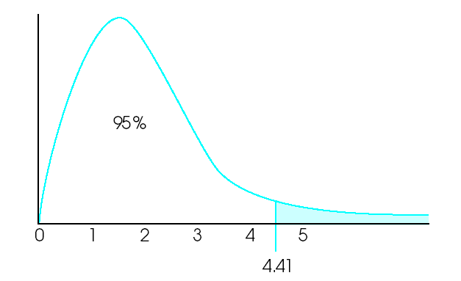
Distribution of F scores has a different shape than the z or t distributions.

Also, the critical F value for determining significance depends on sample size and the number of groups.
H. Post-hoc tests

- The F test can be used to tell us whether the null hypothesis should be rejected
- Weakness: F test tells us that at least one of the groups has a significantly different mean, but doesn’t tell us which group(s) significantly differ
- This is about as useful as saying “one of the treatment conditions had some effect”
- Obviously, we want to know which condition or conditions differed, and whether scores were significantly higher or lower
- Post hoc test: Post hoc is Latin for “after this.”
The F test tells us whether any groups differ, and the post hoc tells test us how the groups differ (e.g. whether surgery is better than medication, or vice versa)
- There are many post hoc tests. They all differ slightly in how they calculate error terms; some are liberal, some conservative in judging which groups significantly differ

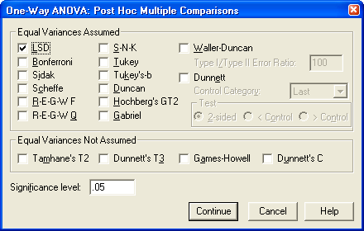

- We’ll use the LSD (Least Significant Difference) post hoc test
- The Bonferroni and Scheffe tests are also commonly used
- The LSD test is very liberal; it will pick up on any major group differences, but has the highest risk of Type I errors
- Other tests are more conservative about labeling group differences as significant, and nerds fight about which test is best to use


Different kind of LSD

I. Examples Using SPSS

Is top life priority (friends, family, love, or success) related to extraversion (9-point rating)?

1) Check the descriptives
2) Look at the p-value “Sig”
3) If p < .05, the result is significant, so look at the post-hoc test (later in Output). If p < .05, the result is not significant, so ignore any additional Output.

- ANOVA uses two different types of degrees of freedom (reference numbers) to determine the shape of the F-distribution, and thus the critical F value. One is based on sample size; the other on the number of groups.
- F is used to determine the p-value

Life priority did not significantly predict level of extraversion, F(3,275) = 0.97, p = .41.

Earlier in the year, we examined the relationship between eyewear and GPA using t-tests. Now let’s use ANOVA.

This time there is a significant effect, so we need to examine the post-hoc test to see which groups reliably differ.

- The post-hoc test is basically like running t-tests for all possible comparisons.

- Blue box: Compared glasses to contacts. The mean difference is .35, which is significant.

- Red box: Compared glasses to neither (no corrective lenses). The mean difference is .31, which is significant.

- Green box: Compared contact lenses to neither. The mean difference is .05, which is not significant.

APA-style:

Eyewear was significantly related to GPA, F(2,276) = 11.67, p < .001. The results of a post-hoc LSD test indicated that people who wore glasses had reliably lower grades than people who wore contacts or no lenses. The contact and no lens groups did not significantly differ. Thus, wearing glasses was related to lower GPA.
[Examples from last semester’s data; skip in class]

Is Favorite Fast Food Place related to ability to Delay Gratification?

- Arby’s, BK, McD’s, T-Bell, Wendy’s, Other
- Delay of Gratification (patience): 1=low, 7=high
- Correlation? T-test? ANOVA?
- Output is fairly easy to understand!

- Notice that all of the means are about the same. No major differences, so F is small, and there are no statistically significant differences
- There are no significant differences, so no post hoc test is needed. If the F-value was significant, what would the post hoc tests tell us?

- Ability to delay gratification was unrelated to favorite fast food place, F(5, 320) = 0.20, ns. Thus, customers are probably equally patient across fast food locations.

Is sleeping position related crying frequency?

Sleeping positions: Back, Side, Stomach, Fetal

Crying Frequency: Compared to others I cry a lot…
1 = Disagree – 7 = Agree

- Step 1: Look at the means for each group.
Who cries the most?
Who cries the least?
- Step 2: Check for significance.
What is the F value?
Is it statistically significant (reliable)?

Post Hoc Tests

- Step 3: Exam the post hoc results.
Which sleep positions significantly differ from each other in terms of crying?
Which sleep positions do not differ significantly from each other?

(More details on next page)
Comparing Back to Side (pink box), the Mean Difference is small and non-significant.
Comparing Back to Fetal Position (blue box), the mean difference in crying is much larger. The negative sign indicates that Back sleepers cry less than Fetal Position sleeper. The Sig. value (p-value) shows that this is statistically significant (reliable).

Note that the post hoc table allows us to compare any two groups with each other (kind of like a big table of t-tests all at once), and some of the information is redundant (see gray box).
- Step 4: Write up the results in APA format.

Sleeping positions is related to crying frequency, F(3, 322) = 4.75, p < .05. People who sleep in the fetal position cry the most, and people who sleep in their back cry the least.
J. Repeated-Measures ANOVA

- ANOVA is similar to a between-group t-test
- Repeated-measures ANOVA is similar to a repeated-measures t-test, but with more time points
Pain

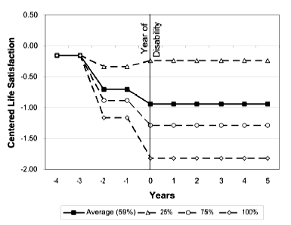
Ignore the dashed lines. The red line shows a repeated-measures ANOVA for life satisfaction across 10 different time points among people diagnosed with a disability.

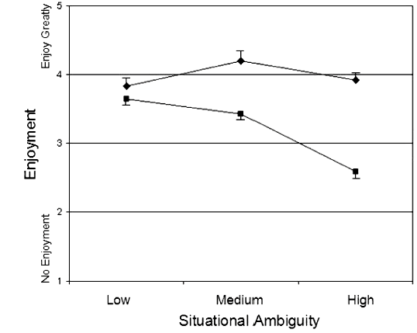
High Schizotypy
Comparison Group
Two different repeated-measures ANOVAs: The comparison group (blue line) has a non-significant ANOVA, whereas the Schizotypy group (red line) has a significant ANOVA.

- Example of hypothesis testing, where a researcher is examining how the dependent variable (e.g. pain score) differs across three time points:
The subscripts
1, 2, and 3 signify different time points.
H₀: μ₁ = μ₂ = μ₃ or
At the population level, average scores will
not differ across any time point.
H_{A}: At the population level, the mean for at least one time point will significantly differ from the others

- Note: H_{A} will be true under a wide variety of conditions…
μ₁ ≠ μ₂ ≠ μ₃ (all means are different)
μ₁ = μ₃, but μ₂ is different (at least one mean differs)

- Alternative hypothesis is true if any of the means significantly (reliably) differ from the others

- Just like ANOVA uses the F statistic to test whether there are between-group differences, the repeated-measures ANOVA uses the F statistic to examine whether means differ across time points

F = total amount of variability in scores
variability due to chance

Repeated-Measures ANOVA
Similarities to  ANOVA | - Rationale for the F-test is the same: compare total variability to the amount expected by chance  - Post-hoc tests are the same
Differences  from ANOVA | - Controls for some individual differences, so tends to be more powerful  - Smaller sample needed to obtain significant results

K. SPSS Examples for Repeated-Measures ANOVA

- Repeated-measures ANOVA is a bit complicated to run in SPSS, so it is not a requirement of PSY 211
- See the following web site if you would ever like to run one:
http://academic.reed.edu/psychology/RDDAwebsite/spssguide/anova.html

- Reading and understanding the Output is less difficult, so I will give you some Output to interpret

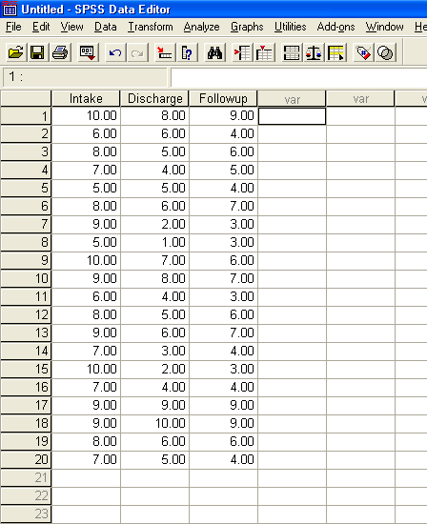

Post hoc test

Red Box: Overview of descriptive statistics for each time point

Green Box: These are the degree of freedom (df) values. Remember, the critical t value depended on the df value. The critical F value depends on two df values, one which is related to group size, and one which is related to sample size. These values help determine the critical F value, used to determine whether a finding will be significant, and they are used in the APA-style write-up too.

Blue Box: F value and p value. If p is less than .05 (p<.05), the finding is significant, indicating that there is at least one reliable mean difference across time points.

Orange Box: These values indicate the mean differences across two time points. For example, the first indicates a mean differences of 2.55 points between time 1 (Intake) and time 2 (Discharge). The next number indicates that there is a 2.40 point difference between time 1 (Intake) and time 3
(Follow-up). Stars (*) indicate a statistically significant (reliable) difference.

Pink Box: These are the precise p values for the post hoc tests. If p<.05, the difference is statistically significant. All mean differences in the Orange Box that had a star also have a p<.05.

APA Style Write-up:
Pain scores significantly differed across time, F(2, 38) = 27.41, p < .05. A post hoc LSD test indicated that pain scores at discharge and follow-up were significantly lower than at intake.
A non-significant result….

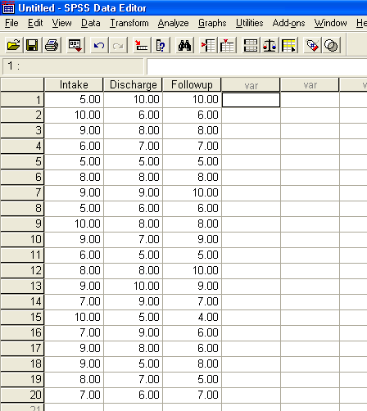

Pain scores did not significantly differ across time, F(2, 38) = 0.96, ns. Thus, the treatment was unsuccessful.

