Hoerger’s Statistical Analysis Guide (03/18/2017)

Exam 2 | Independent Variable | Dependent Variable | Covariates | Preferred Analysis | Alternative Analysis
X | 1 Continuous Variable | 1 Continuous Variable |  | Correlation (r)
X | ≥2 Continuous Variables (or Combination of Continuous and Categorical Variables) | 1 Continuous Variable | Optional | Multiple Regression (R)
X | 1 Dichotomous Categorical Variable | 1 Continuous Variable |  | t-test with Cohen’s d | Correlation (r)
X | 1 Continuous Variable | 1 Dichotomous Categorical Variable |  | t-test with Cohen’s d | Correlation (r), Logistic Regression (Odds Ratio)
 | 1 Continuous Variable | 1 Dichotomous Categorical Variable | Yes | Logistic Regression (Odds Ratio)
X | 1 Polytomous (Multicategory) Categorical Variable | 1 Continuous Variable |  | ANOVA (F) with Cohen’s d
X | ≥2 Categorical Variables | 1 Continuous Variable |  | ANOVA (F) with Cohen’s d
 | ≥1 Categorical Variable | 1 Continuous Variable | Yes | ANCOVA (F) with Cohen’s d
 | 1 Dichotomous Categorical Variable | 1 Dichotomous Categorical Variable |  | Chi-square (χ²) | Correlation (r), Logistic Regression (Odds Ratio)
 | 1 Polytomous (Multicategory) Categorical Variable | 1 Polytomous (Multicategory) Categorical Variable |  | Chi-square (χ²)

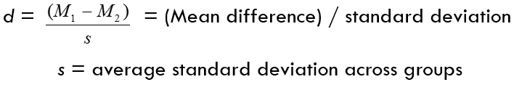

Effect Size Descriptors:
Effect | r | r² | d
Small | ≥ .1 | ≥ .01 | ≥ 0.2
Medium | ≥ .3 | ≥ .09 | ≥ 0.5
Large | ≥ .5 | ≥ .25 | ≥ 0.8

Power Calculations:
