Health Disparities
3/13/14
A. Language Considerations
- General advice
  - Be specific and accurate
  - Call people what they prefer to be called
  - Avoid reifying unjust power structures
- “Latino/a” versus “Hispanic”
- “Black” versus “African American”
- Critique of “Minority,” proposed alternatives:
  - “Underrepresented groups”
  - “Racially and ethnically diverse groups”
  - Identifying the group more specifically
- Critique of “Privileged,” “Advantaged,” “Underprivileged,” and “Disadvantaged,” proposed alternatives:
  - Alternatives: “Low income,” “Financially strained,” “Financially distressed”
- Further reading
  - Paniagua, F. A. (2005). Assessing and treating culturally diverse clients: A practical guide.
B. Causes of U.S. Socioeconomic Inequality
- Introduction (based on Norton & Ariely, 2011)
- Decline of unions, tax rates, public-funding of college education
- Increase in drug enforcement/incarceration, local restrictions on free speech
Union Density
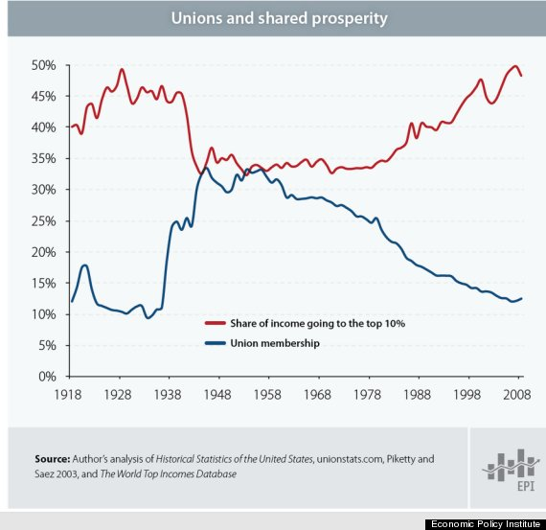
- Emerged in the post- Civil War (1865) era, estimated membership at only 2% in 1880
- National Labor Relations Act (1935) established basic rights for organizing unions, collectively bargaining, etc. at private employers
- Taft-Hartley Act (1947):
  - Outlawed unions from engaging in various types of strikes (wildcat, solidarity, political, jurisdictional), and other solidarity actions (boycotts, picketing, etc),
  - So-called “Right-to-work” laws allowed at state levels: Unions must represent all members of a bargaining unit equally, regardless of whether they pay dues
  - Bans “supervisors,” small-business people, and others from being in unions
- Public employees gained union rights locally in some cities (1920s), first recognized at a state level (1959) in Wisconsin
Taxes
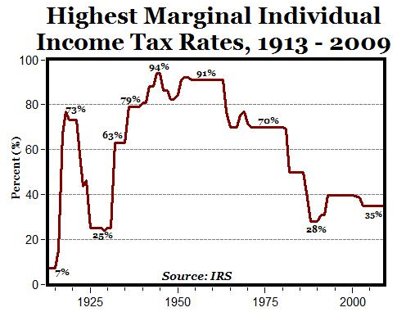
- “Highest marginal tax rate” differs from “effective tax rate” or “average tax rate,” excludes many types of taxes
- Early attempts at an income tax failed, until the passage of the 16th Amendment (1913)
- Attitudes toward tax increases:
  - Millionaires (the “1%”): 68% approve
  - Billionaires (the “.0001%”): 2% approve
- In the U.S., taxation patterns have closely followed union density; other countries vary in strategies (employee protections vs. taxes) to reduce inequality
Public Higher Education
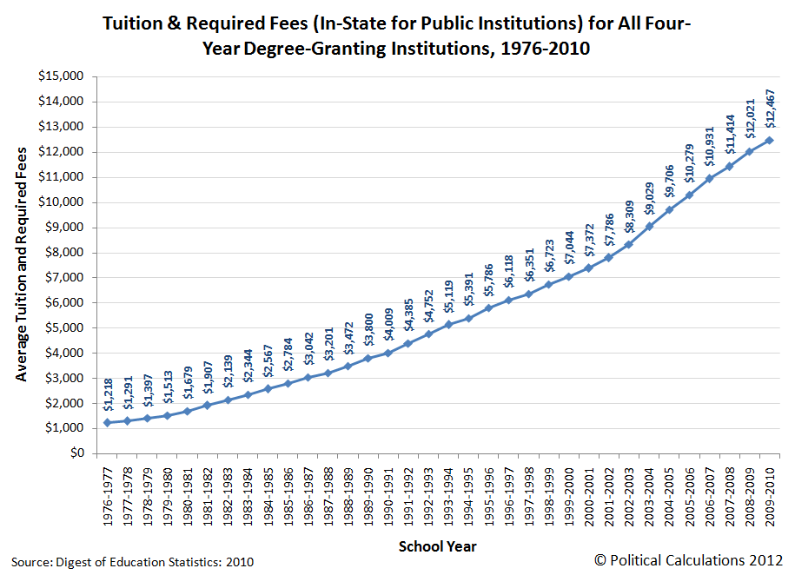
Drug Policy
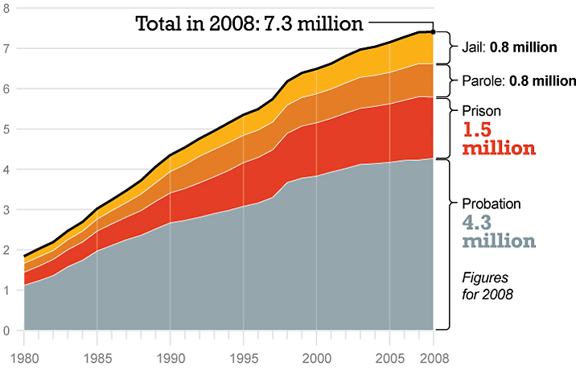
Source: Bureau of Justice Statistics, Correctional Populations in the United States, 2010
C. Reprise of Core Determinants of Health
- Schroeder et al. (2007) in Week 1
- Week 2 lecture: Largely in agreement, but also emphasized perinatal care, downplayed future importance of smoking relative to diet/exercise
- Marks et al. (2011a) Stress and Coping chapter in Week 2
  - Downplays importance of the pathway from stress → immune functioning → health
- Frieden (2010) in Week 3
- Current readings
  - In accounting for health disparities, rehashes several debates
  - Biomedical vs. biopsychosocial model
  - Stress/immune vs. behavioral (decision) pathways
  - Individual vs. societal interventions

