Foundations I: The Bio-Psycho-Social Model
1/23/14
A. Contribution of Behavior to Health
Overview
- Well-documented evidence that the U.S. experiences worse health outcomes, despite spending about twice as much as comparable nations
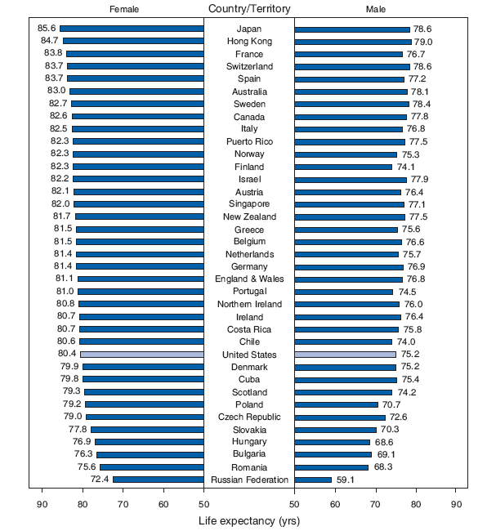
Infant Mortality...
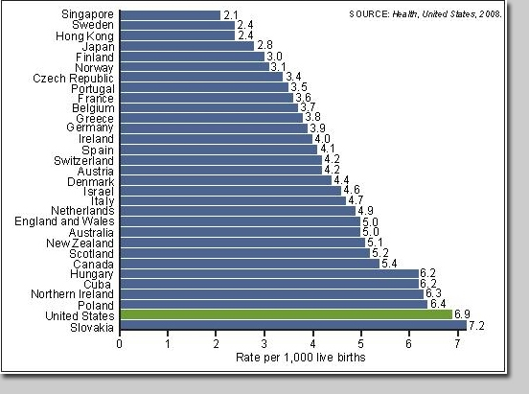
Heart disease...
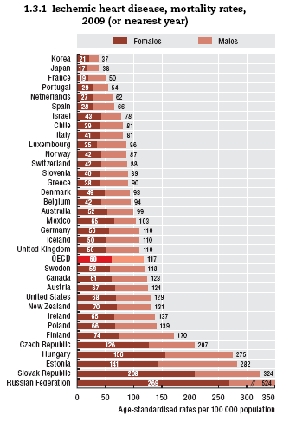

All Cancers...
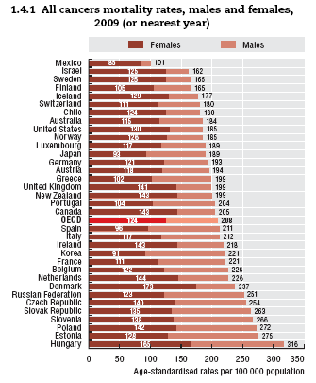
Traffic Accident Mortality...
Cigarette Smoking
- U.S. historically high, but now low
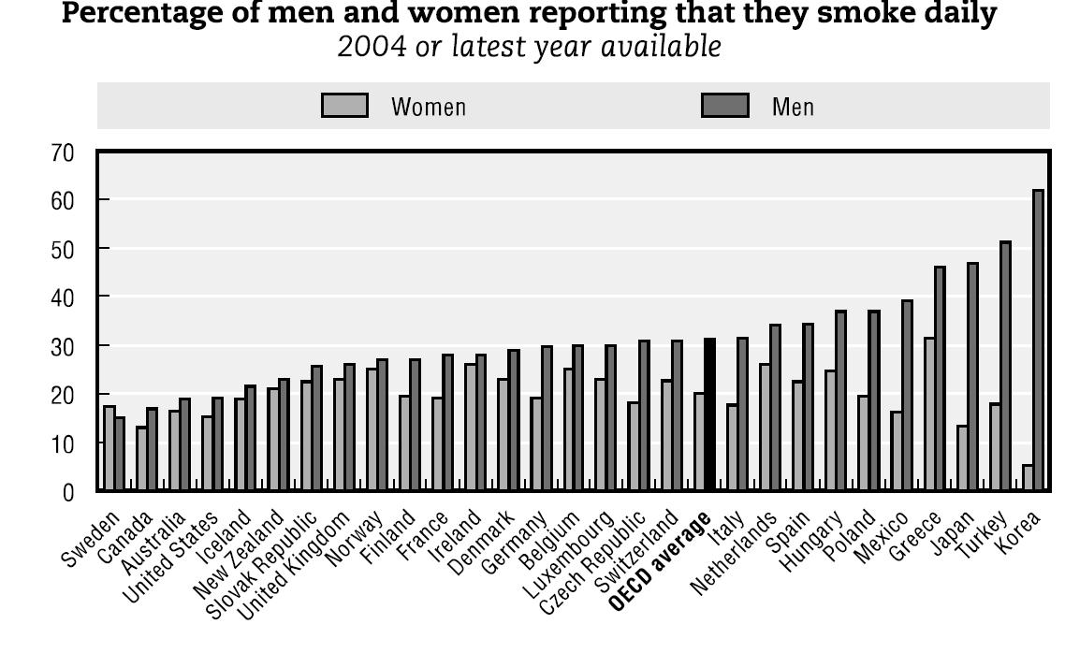
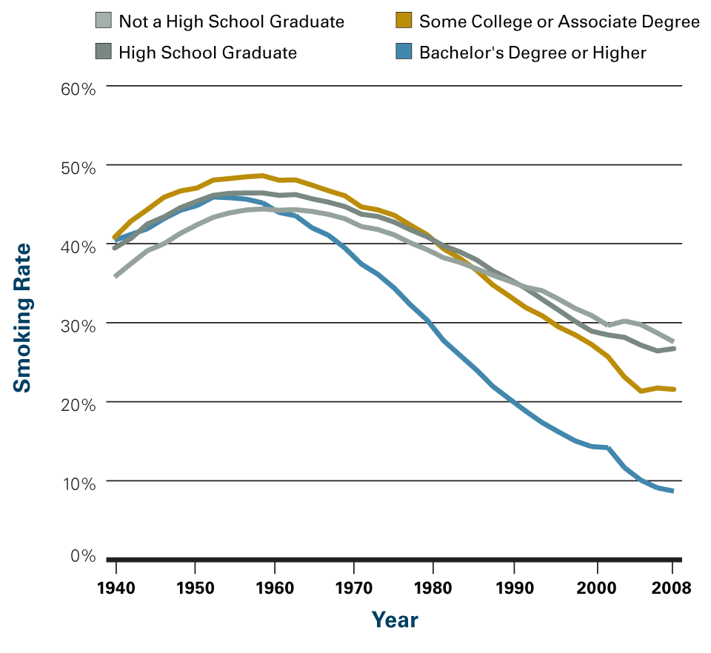
- Smoking health effects:
- 10 years shorter life expectancy
- Quitting by age 30-40 reduces the risk of smoking-related mortality by 90%
- Increased risk of death due to lung cancer (20x), chronic obstructive pulmonary disease (COPD), e.g., bronchitis and emphysema (10x), and heart disease (3x)
- Increased risk of most other cancers, particularly head and neck cancers, and particularly in combination with other risk factors
- Other consequences, include reduced fertility in men and women, infant mortality, reduce health of skin, bones, teeth, and gums, cataracts, and less easily controlled diabetes
- Second hand smoke also increases risk of these conditions, particularly heart disease
Diet/Exercise
Obesity...
Overweight children...
Diabetes...
- Poor diet and low physical activity are associated with obesity, heart disease, type 2 diabetes, hypertension, cancer
- Obesity a risk factor for those conditions, and sleep apnea, arthritis, asthma, liver disease
- Type 2 diabetes: 10 years shorter life expectancy, risk of heart disease, stroke, vision problems, kidney failure, and less easily managed comorbid diagnoses
Alcohol
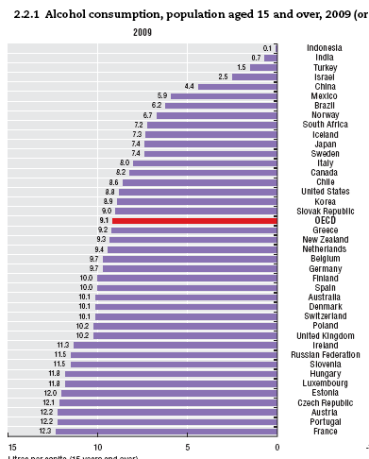
Litres (22 drinks) per person (e.g., 10 litres = 220 drinks/year)

Thun et al. (1997). NEJM. n = 490,000 Americans
- Consumption is associated with much higher health risks before age 30, but benefits increase with age, particularly after age 60, and particularly for those with high cardiovascular risk factors
- Optimal health effects at 0.5-1.0 drinks/day for women and 1.0-1.5 drinks/day for men, among those over 30; varies across demographics (e.g., 3 drinks/day is optimal for high cardiovascular risk, over 60 demographic)
- Cholesterol-lowering drugs, such as Lipitor, increase HDL (good) cholesterol levels by 8.0%, similar to the 8.3% associated with 2 drinks/day (Rimm et al., 1999, BMJ)
- No consistent evidence that the specific type of alcoholic beverage (e.g., beer, red wine, white wine, hard liquor) matters
- No consistent evidence that the daily dispersion matters
Sex
Aids...
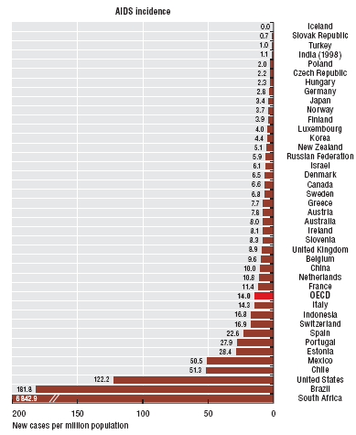
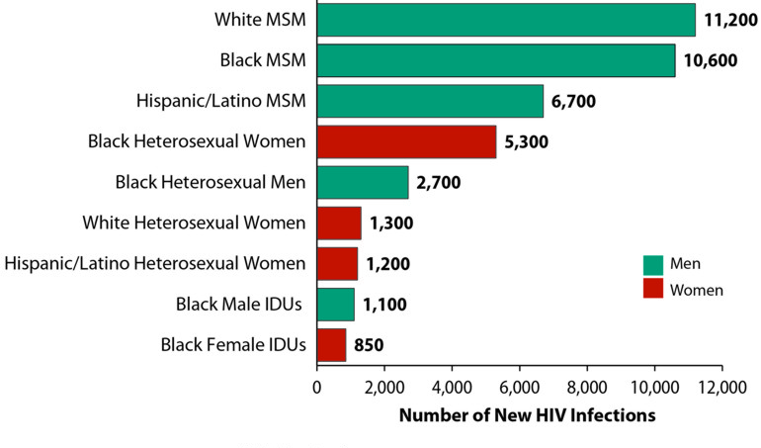
Cervical cancer...
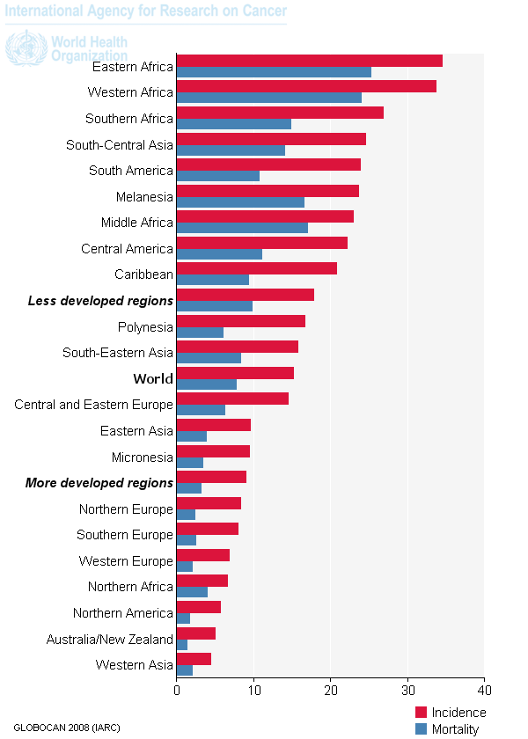
Cervical cancer screening...
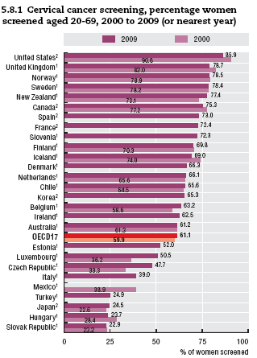
- Number of sexual partners, and safe sex practices are main risk factors of HIV and HPV
- HPV vaccine available for men and women, protects against strains causing 70% of cancers
- Estimated that 80-95% of Americans have HPV by age 50; highly adaptive virus (e.g., found under 15-30% of adult fingernails, common anally without anal sex)
B. Overview of the National Institutes of Health
- Part of the U.S. Department of Health and Human Services (USDHHS)
- 27 Institutes and Centers
  - National Cancer Institute (NCI)
  - National Heart, Lung, and Blood Institute (NHLBI)
  - National Institute on Aging (NIA)
  - National Institute on Alcohol Abuse and Alcoholism (NIAAA)
  - National Institute on Drug Abuse (NIDA)
  - National Institutes of Mental Health (NIMH)
  - National Institute of Child Health and Human Development (NICHD)
  - National Center for Advancing Translational Sciences (NCATS)
- Various types of grants
  - F = individual fellowship
  - T = institutional training grant
  - K = individual career award
  - R = general research grant
  - P = center grant
- Mentorship indicators
  - F, T, K
- Resource indicators
  - R01, P
  - Clinical and Translational Science Institutes (CTSI, a type of U grant)
- NIH Reporter search engine
C. Supplemental Information for the Readings
- Authors: Engel, Insel, Collins
- Contextualization of the biopsychosocial model within general systems theory (see Fig 1.1)
- Pathoplastic process

