Small N Designs
11/25/14

A. Overview
- Large sample sizes can be difficult to obtain
- Some researchers reject the idea that bigger samples are better
- Historical factors have contributed to the rise and fall of particular methodologies
B. Case Studies
Overview
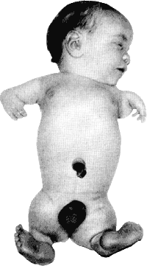
- Detailed accounts of single cases (aka, case histories, case reports)
- Various types: Prototypes, extreme cases, critical incidents
- Early examples: Charcot, Freud
- Modern examples: Thalidomide, FAS,
SSRI-induced suicidality, lung cancer
Advantages
- Excellent detail
- Focuses attention, facilitating more comprehensive research (i.e., case-control studies, experiments)
- Useful when a single incident proves a claim
- Promotes discussion and prevention
- Provides a narrative that facilitates action
Disadvantages
- Prone to biases, both of the researcher and the subject
- Could facilitate pseudoscience
- Poor external validity
- Difficult to show internal validity
Changing Paradigms
- Rise of statistical significance testing
- Then critique of statistical significance testing during the rise of behaviorism
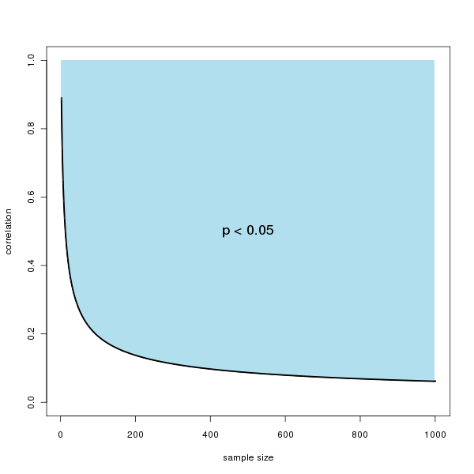
C. Single-Subject Design
Overview
- Study an individual (or small sample) in detail
- Like a case study, but much more focus on data and control
- Terminology
  - A = baseline phase, where data is collected in absence of any treatment
(a control phase)
  - B = some treatment or manipulation
  - C, D, E, etc = other treatments
  - B₁, B₂, B₃ = variation of same treatment
- Measurements of some DV gathered over time during each stage
Common Designs
- A-B, A-B-A, A-B-A-B, etc.
- Multiple baselines
- Changing Criteria
Strengths and Weaknesses
- High control, excellent for applied clinical care, changing simple behaviors or physio processes
- Low external validity
- Data collection can be extensive and tedious
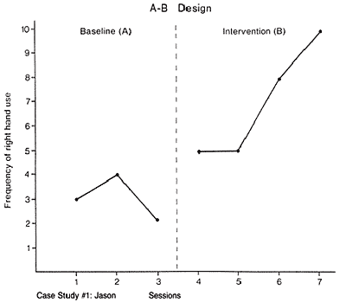

Frequency of Emotion Words

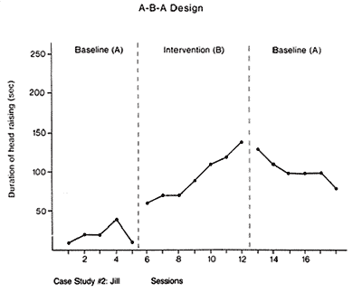

Minutes Spent Reading Each Day

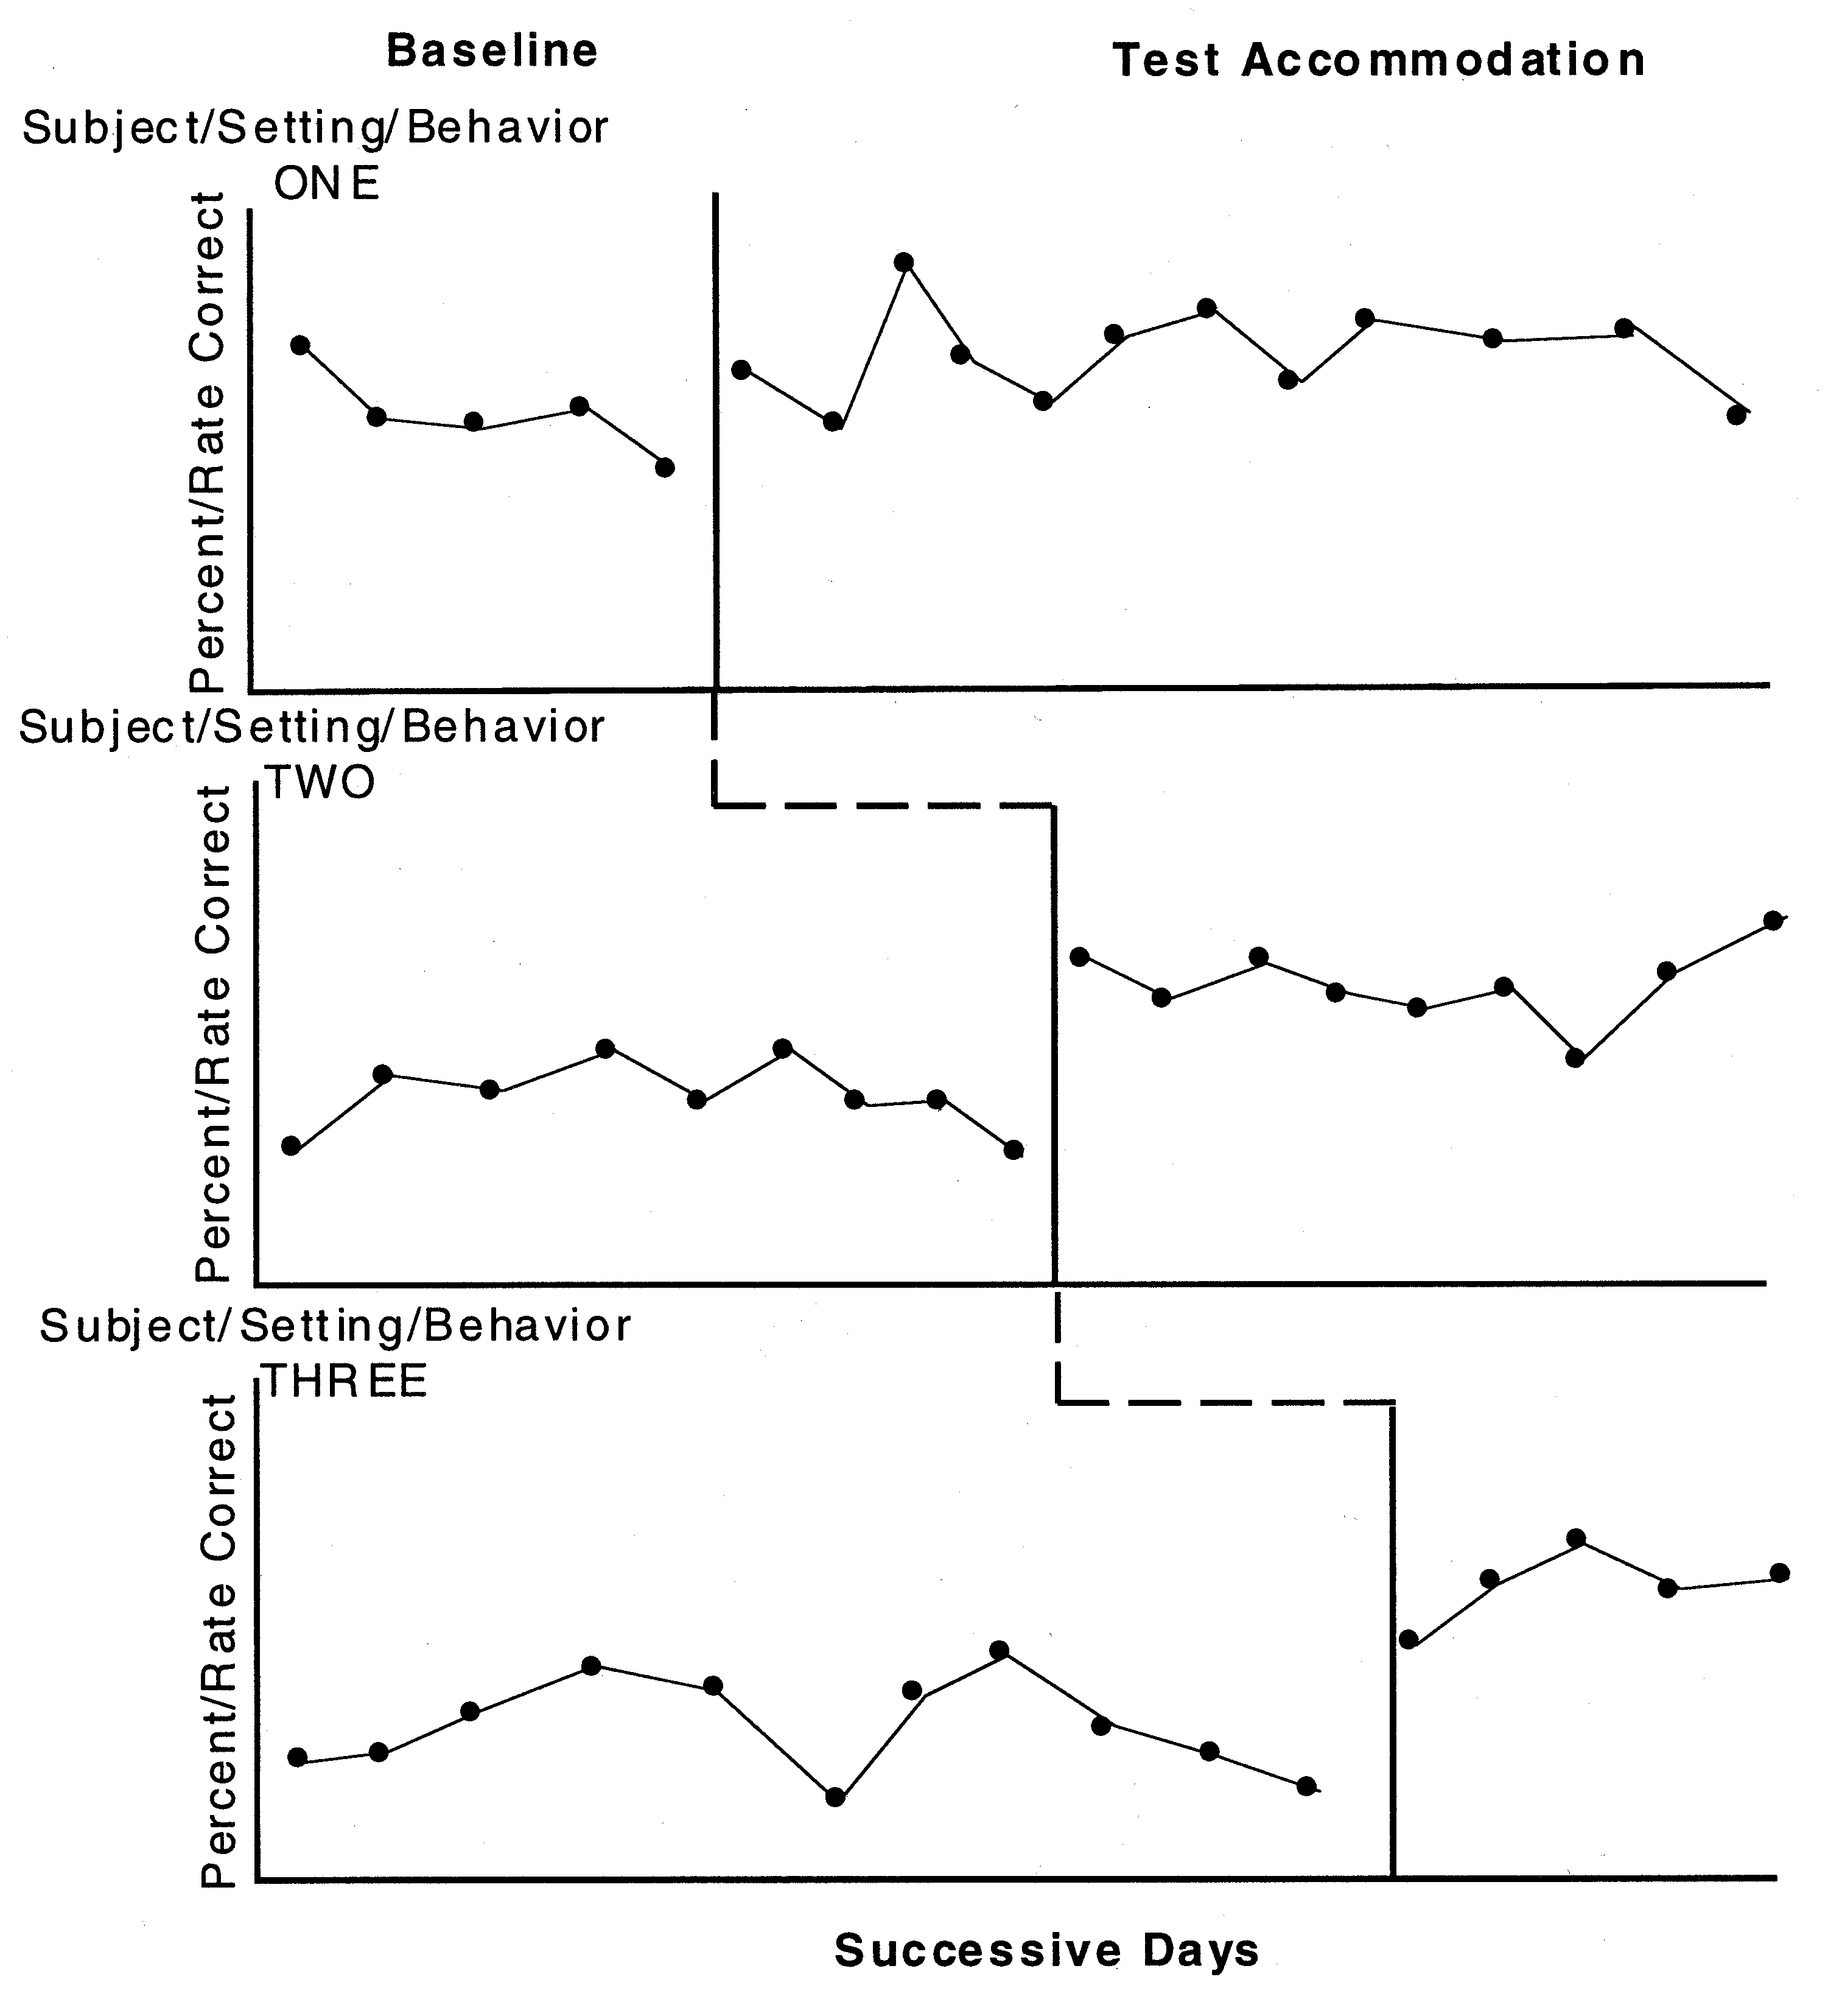
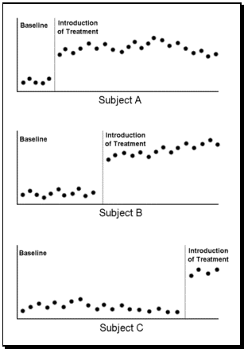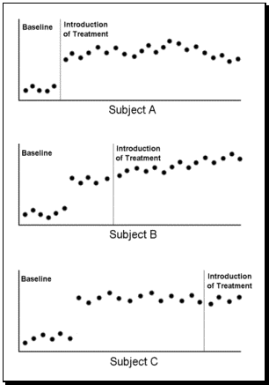

D. Self-Experimentation
Uses
- Improve a desired outcome in one’s own life
- Conduct research too meticulous or dangerous for other participants
Examples
- Ebbinghaus’ studies of memory
- LSD, soda water, ABO blood typing, local anesthesia, antabuse, snake bite vaccinations
- Mike’s (2012) daily affective forecasting study
- Barry Marshall’s (2005) Nobel Prize

