Measurement & Data Analyses
9/25/14

A. Reliability
Overview
- Definition: Extent that results are consistent across measurements
- Less measurement error = greater reliability
- Several different types
Parallel Forms Reliability
- How well two different forms of the same test correlate with each other
- Common when multiple forms of the same type of test are needed
  - Two different forms of the same neuropsych test; SAT of 2013 and of 2012
Split Half Reliability
- How well scores on one half of the test correlate with scores on the other
- First half correlated with second half; odds with evens, etc.
- Problem: Many ways to split a test in two, and different splits yield different correlations
Internal Consistency (Cronbach’s alpha)
- Average of correlations obtained using all possible split-halves
- Indicator of how well items on a scale measure the same construct
- In SPSS, can also get an indicator of how good each item is
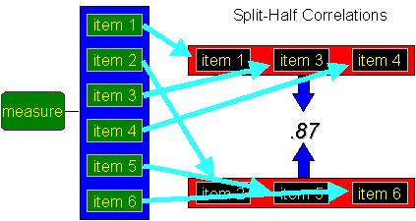
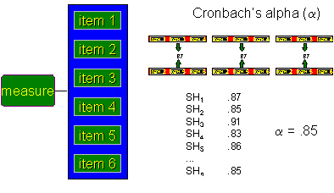
Test-retest Reliability
- Correlate scores from the same test taken at two different time points
- Measure of stability
  - IQ example, personality examples
Inter-rater Reliability
- Correlate scores from two different raters
- Measure of agreement

- Can involve more than two raters, but the computation gets complicated

B. Validity
Overview
- Definition: How well a device measures
what it is supposed to measure
- Several different types

Face Validity
- Appears to measure what it is supposed to
- Very subjective, nothing statistical

  - E.g. Depression survey looks
like it measures depression
  - Poor for projective tests, such
as the Rorschach
    - M example
Content Validity
- How well a measure covers the breadth of the construct
- Review past research and discuss with others to determine how many domains a construct should have
- E.g. If there are hypothesized to be six aspects of neuroticism, the survey should cover all six
- Additional examples: DGI, FACT-G

Criterion Validity
- “Criterion” simply means “outcome”
- Ability of a measure to predict important outcomes
- (1) Predictive Validity
  - How well a measure predicts some future criterion
  - E.g. Showing SAT scores predict future GPA
  - Very impressive
- (2) Concurrent Validity
  - How well a measure predicts some criterion administered at the same time
  - E.g. Showing SAT scores correlate with current GPA
  - Similar to predictive validity, but often longitudinal studies are too difficult
  - Less impressive
Construct Validity
- Begins with a theory: identify constructs that should be related, and ones that should be unrelated
- Show that the measures correlates with constructs it is supposed to and doesn’t correlate with the rest
- (1) Convergent Validity
  - Measure correlates with theoretically-related constructs
  - SATs correlate with ACT scores (r = .60)
- (2) Discriminant Validity
  - Measure does not correlate with theoretically-unrelated constructs
  - E.g. SAT scores do not correlate with happiness scores (r = .10)
- Good construct validity if correlations for (1) are greater than those for (2)

C. Scales of Measurement
Scale | Nominal | Ordinal | Interval | Ratio
Examples | Major, gender, ethnicity, favorite color | Football seed, popularity ranking | Extraversion, attractiveness, intelligence | Weight, age, time, number  of health conditions
Type | Categorical | Continuous | Continuous | Continuous
Numbers have meaning  (rank ordered) |  | X | X | X
Equal intervals between numbers |  |  | X | X
Zero = absence of attribute |  |  |  | X


D. Basic Descriptive Statistics
Central Tendency
- Median = middle number in distribution

  - If two middle numbers, average them
- Mode = most popular response
  - Can have multiple modes or no mode
- Mean (M or $\overline{X}$) = arithmetic average; $\frac{\sum{X}}{N}$
  - $\sum{X}$ = sum of all Xs; add up the scores
  - N = sample size
Variation
- Standard Deviation
  - Average amount that scores deviate or vary from the mean
  - If SD = 15.0 on IQ tests, it means that on average scores vary from the mean by about 15 points
  - 68-95-99 rule
- Variance
  - SD², commonly used in calculating other statistics

E. Advanced Descriptive Statistics: Effect Size
- Describe the magnitude of a finding
- Correlation Coefficient (r)
- Cohen’s d
- Covered in more detail later

F. Inferential Statistics
Overview
- Go beyond merely describing the data
- Use probability to infer whether findings are likely due to chance or are likely to hold up across other studies
- Examples: t-test, F-test (ANOVA)
Rationale
- In a study involving 7 people, you get a correlation of r = .38 between height and happiness. Is this finding trustworthy or simply due to chance?
- In a study involving 3,038 people, you get a correlation of r = .32 between happiness and extraversion. Trustworthy or due to chance?
- A result becomes more trustworthy based on two factors:
  - Sample Size, larger = more trustworthy
  - Effect Size, bigger effect = more trustworthy
- We use inferential statistics to calculate
p-values, which are a measure of how “untrustworthy” a result is
p-values
- Based on the sample size and how extreme a result is, we can calculate the probability that we would obtain that result merely by chance
- Main reason for conducting inferential tests is that they yield p-values
- p-value = the probability that a result would be obtained by sampling error or “chance”
- Low p-value: Results not likely due to chance; keep the finding, trustworthy
- High p-value: Results could be due to chance; disregard the finding, not trustworthy

- “High” versus “low” is very subjective, so we need a cut score or alpha level
- Arbitrary cut off: p < .05
  - If p is lower that .05, there is less than a 5% probability of obtaining the results by chance, so keep the finding
  - 5% of the time we will accept a result that just occurred by chance (doh!)
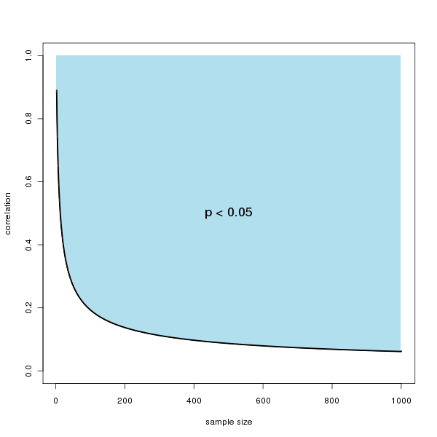

G. Hypothesis Testing
Null Hypothesis
- Two variables are unrelated
Alternative Hypothesis
- Two variables are related

H. Errors in Statistical Decision Making
Type I
- Find a significant result when there is no real-world relationship
- Happens by chance 5% of the time
Type II
- Failure to find a significant result that really exists in the real-world
- Could be unlucky
- Could be due to poor measurement
- Could be due to small sample size

