Developing Research Ideas
9/11/14

A. Varieties of Psychological Research
- Basic vs. Applied vs. Translational Research (more on this in a week)
- Laboratory vs. field research
- Quantitative vs. Qualitative
B. Measurement Issues
Overt Behavior
- Any actions that can be objectively recorded
- Examples: number of cigarettes smoked, frequency of crying, number of yawns, responses on a survey
Construct
- Abstract concepts or factors studied in psychology that cannot be directly recorded
- Examples: Extraversion, attractiveness, anger, depression, peer influence, love, creativity
- Must be operationalized, or defined in measurable terms
- Tardiness = arriving more than 1 minute late
- Popularity = average for number of Facebook friends and cell phone contacts
- Depression = score on the Beck Depression Inventory

C. Ideas from Theory
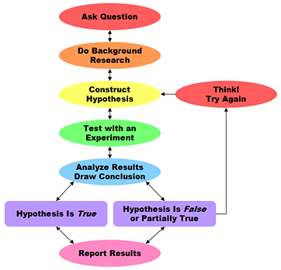
Scientific Method (Intro PSYC)
- Theory – framework based on
logic and prior research
- Hypotheses – specific predictions
- Design + Run the Study
- Analyze and Report Results
- Revise and Expand Theory

Utility of Theories
- Theory: A well-accepted (productive), falsifiable, parsimonious explanation
of existing evidence
- “Future Directions” sections often
supplies avenues for future research
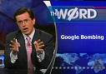
- Critiques of the theory, or conflicts between theories also supply avenues for future research
The market has spoken
- Heuristic for judging acceptance of
a theory
- What is the modal number of
times an article is cited?

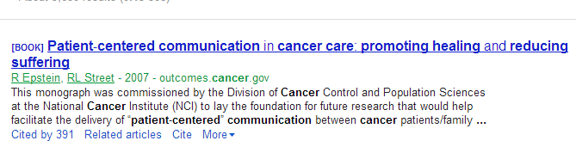
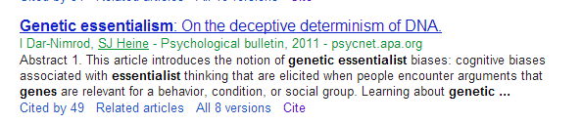
Dar-Nimrod, I., & Heine, S. J. (2011). Genetic essentialism: On the deceptive determinism of DNA. Psychological Bulletin, 137, 800-817.

B.F. Skinner’s Rules
- Rejected textbook explanation
of the scientific method
- “But it is time to insist that science does not progress through carefully designed steps called ‘experiments,’ each of which has a well-defined beginning and end.” - Skinner
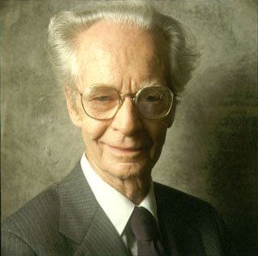
- (1) “When you run onto something interesting, drop everything else and study it.”
- (2) “Some ways of doing research are easier than others.”
- (3) “Some people are lucky.”
- (4) “Apparatuses sometimes break down.”
- (5) “Serendipity – the art of finding one thing
while looking for something else.”

D. Ideas through Exploration
- Sometimes theories have not described a particular context, method, or population
  - Qualitative approach
  - Quantitative approach with focus on replication
- Sometimes time constraints prevent a detailed review of theory
  - Pick some phenomena of interest and add a potpourri of potential IVs or DVs
- Sometimes you have little control over a broader research study
  - Add-a-measure approach
- Potential for GIGO and False Discoveries
- “Ideas” Handout
E. Ideas from Other Researchers
- “What do you think would happen if we did X?”
- “What is the most interesting finding in your research that you have not had time to publish?”
- NIH Reporter

F. Ideas from Observation

Observation Facilitates Hypotheses
- Self-observation
- Real-world social interactions
- Applied psychological activities
- Clinical or research interactions
- Video footage
Case Example: Paul Meehl
- University of Minnesota psychologist, emphasizing diagnostic research
- “Dr. Meehl sees patients on the campus and at the Nicollet Clinic, averaging, so we are told, around a dozen hours a week of psychotherapy. With the exception of a short period when he was APA president, he has been continuously engaged in the practice of psychotherapy for almost thirty years. It is well known that he not only thinks it important for a psychologist to work as a responsible professional with real-life clinical problems but, further, considers the purely ‘theoretical’ personality research of academic psychologists to be unusually naïve and unrealistic when the researcher is not a seasoned practicing clinician.”

G. Significance and Innovation
- Significance = importance for societal health and well-being
  - Number of people affected
  - Severity of the problem
  - Ability to solve the problem
- Innovation = novelty
  - “First study”
  - New context, method, population
  - Potential for a scientific breakthrough, rapid uptake

