Experiments IV
11/18/14

A. Notation Examples

B. Results Examples

1
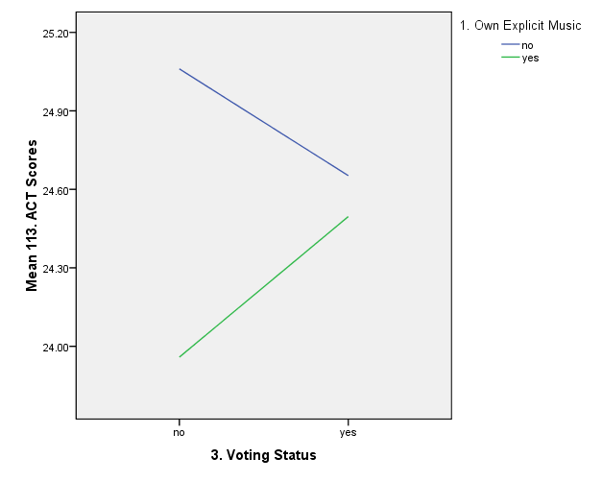

2
3
4
5

6
7

