Correlations: Part II, Advanced Techniques
10/7/14

A. Finish up the Basics: p-Values
- Last time, examined magnitude of correlations
- But in small samples, even large correlations may not be trustworthy
- Look at p-value. If p < .05, results not likely due to chance

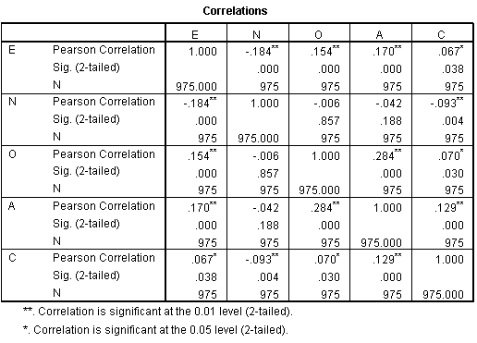
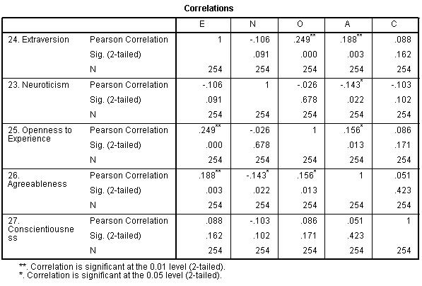

- Which sample has the bigger E-C correlation?
- Which sample has a statistically significant E-C correlation?
- Why?

B. Review: Problems with Correlational Research
- Unreliable measures decrease correlations
- Individual predictors often weak
- Correlation ≠ causation

C. Improving Measurement Reliability
- Single measures often unreliable
- (1) Summated scale scores: Add up scores on several variables to make a composite
- (2) Factor analysis: A statistical procedure for combining scores on multiple measures to reduce error
Factor Analysis combines the reliable aspects or “shared variance” from each measure into a single variable, dropping the measurement error.

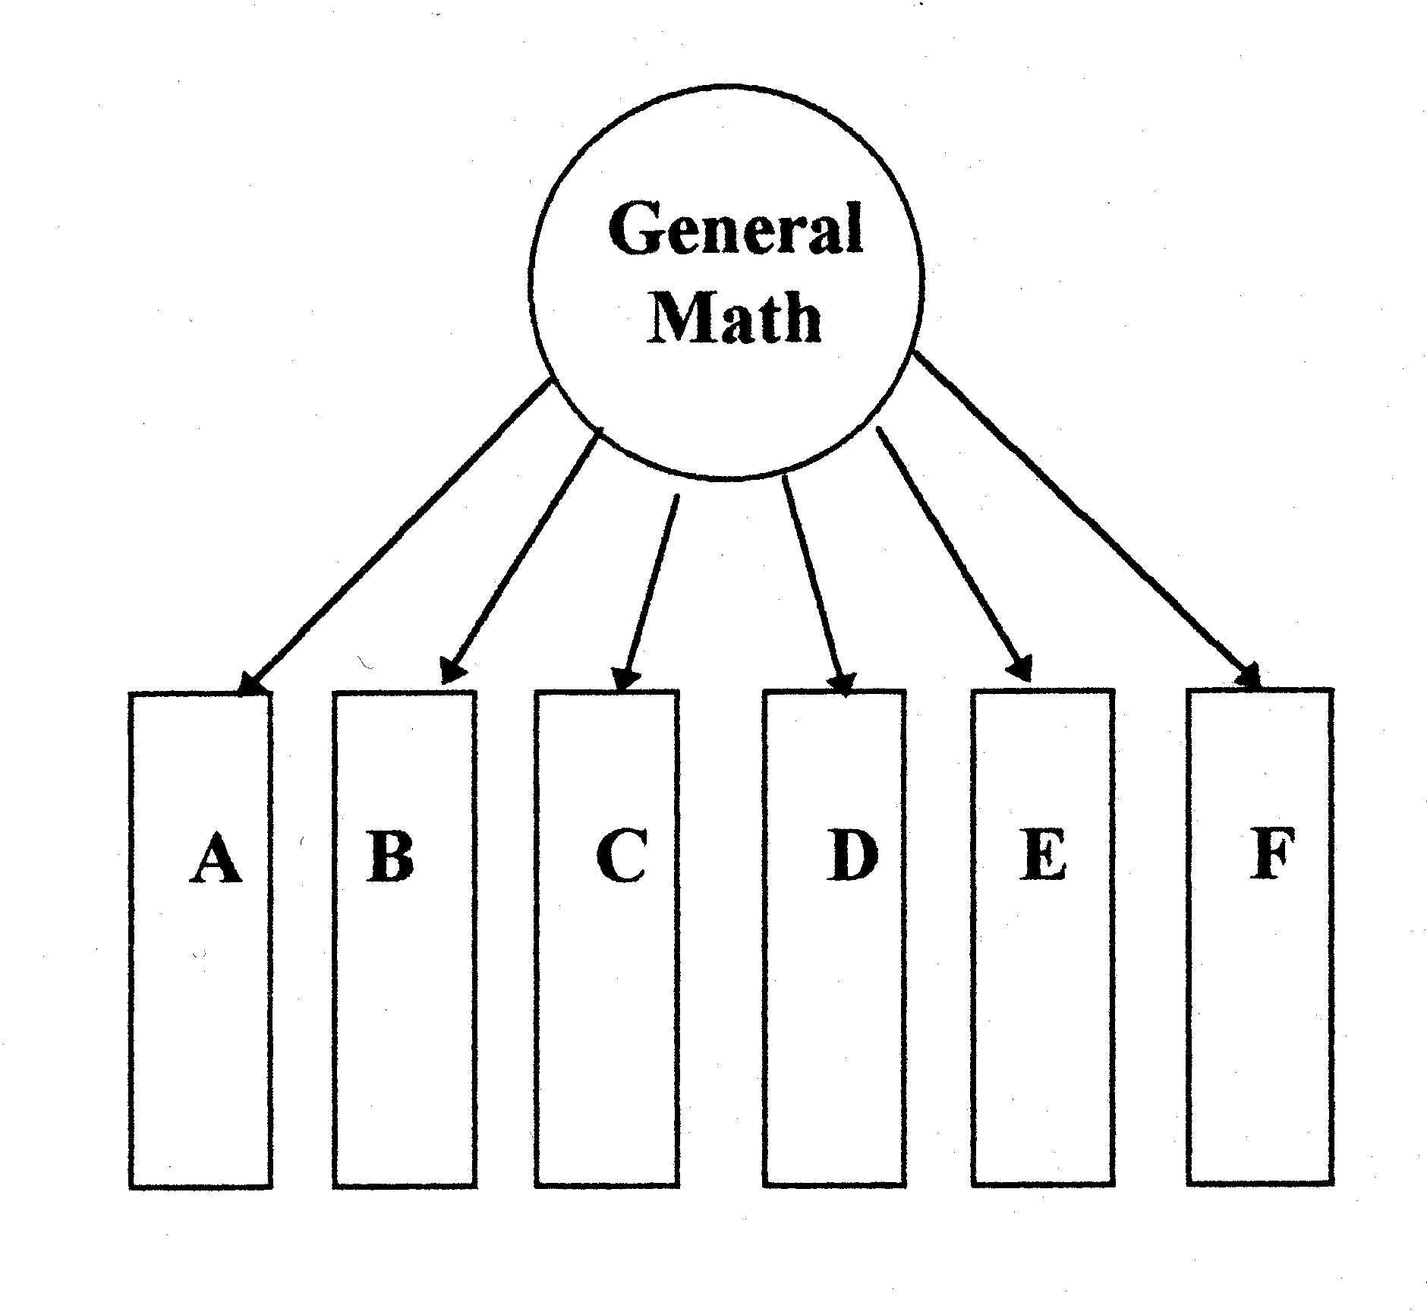
Write
Math
Read
IQ
Judges
Survey
Partner
Beauty

- Statistical underpinnings are complex, require matrix algebra
Anxiety Example
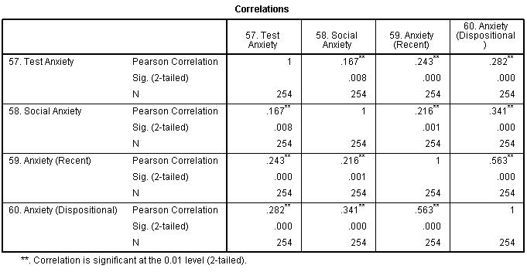

Political Example
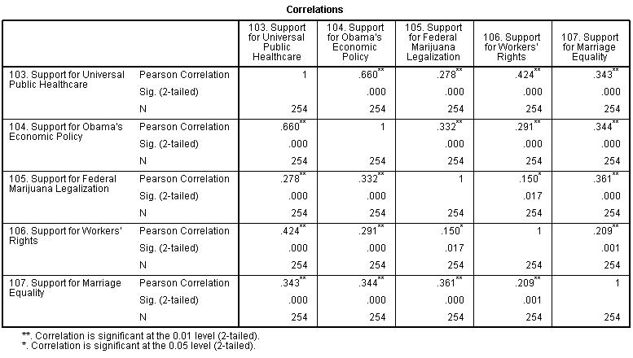
Summated Composite

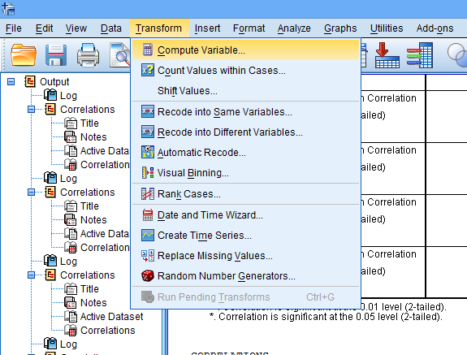

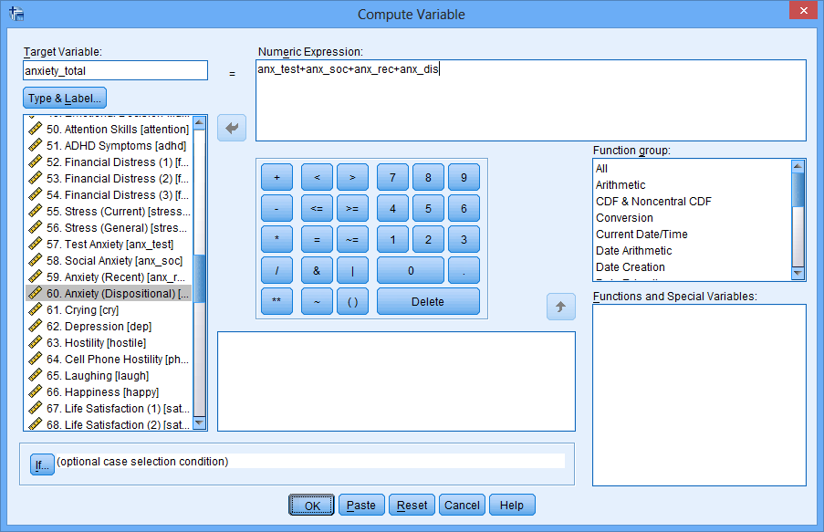
Factor Analysis
- Not shown
Correlations with Other Variables
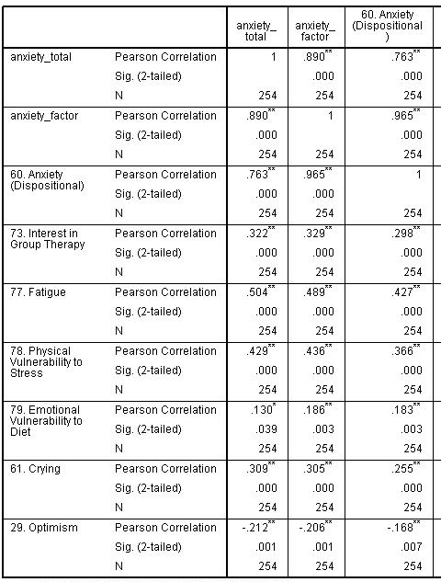

Repeated with Political Example
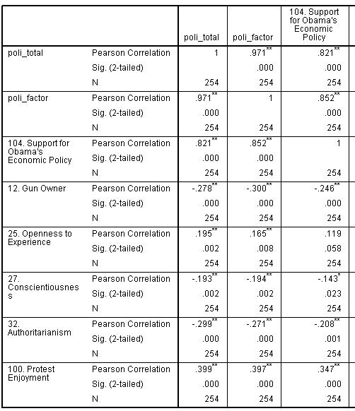

MBSR Example
- See Table
C. Multiple Regression
- Human behavior is multidetermined
- Examining a single predictor yields relatively weak results
- Can be used to examine how well several very different independent variables combine to predict a single important dependent variable
- R instead of r, symbolizes combined predictive ability
r = .30, r² = .09

Correlation:
Authoritarian Father
Rebelliousness

Multiple Regression:
Authoritarian Father

R = .60, R² = .36

Rebelliousness

One predictor… not bad

Try to find some more predictors…

Now take the significant predictors and use regression…

D. When Correlation is Causation
Problem
- Directionality problem
- 3rd variable problem
  - AKA confounding variables
Time-lagged Designs: Directionality
- Incorporate a time gap between variables
- Variable measured first thought to cause the variable measured later
Methodologically Control 3rd Variables
- If worried about a 3rd variable, control for them in your sample
- If age is a potential confound, make sure everyone in the study is the same age
- If worried about SES, only use a sample of doctors
Measure 3rd Variables
- Measure potential confounds and show that they are not correlated with the variables you wish to study
Statistically Control 3rd Variables
- If a confounding variable is present, control for it statistically
- Partial correlations!
- Only works well if the confounding variable is measured very well
Partial Correlation Example

You want to sue McDonalds. Fast food may cause health problems.
BUT
McDonalds says this correlation is merely due to a third variable. They say that “stupidity” causes people to eat fast food and leads people to have health problems through risky behavior.

Check if intelligence even relates to fast food eating and health.

Third variable does not appear to be a problem. Do you win the law suit?
Now McDonald’s says that pop drinking causes people to eat fast food more often (it’s addictive) and causes health problems.

Run the correlations…

Pop drinking does correlate with both. Maybe McDonald’s is right. Let’s statistically hold pop drinking constant with a partial correlation…

The correlation is significant, even after controlling for pop consumption. It looks like you might have a case against McDonald’s
E. When Correlation is Not Causation
Prediction and Description
- Even when relationships are not causal, correlations still allow us to make important predictions
- Given a small number of facts about someone, often we can predict several aspects about their personality

