Quasi-Experimental and Applied Research
12/2/14

A. Overview
Applied Research
- Conducting research in real-world situations, often under circumstances that are not ideal
  - How can we improve depression outcomes at our group therapy practice?
  - How can we prevent obesity among children in New Orleans?
  - How can we recruit people for our RSO?
  - What can we do about discrimination against LGBT college students?
- Often when developing or examining a new program, we lack a real control group and face many potential confounds

B. Quasi-Experimental Designs
Overview
- Quasi-Experiments: “quasi” = almost
- Missing some important component of a real experiment
Control Groups in Experiments
- A control group is identical to an experimental group, except for one missing component
- Participants are randomly assigned
Control Groups in Quasi-Experiments
- May not even have a control group
- If a control group is present, it may differ from the experimental group in a number of uncontrolled ways
- No random assignment
Non-Equivalent Control Group Design
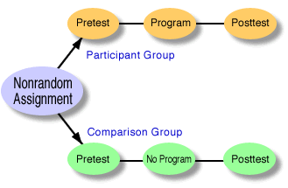
In quasi-experimental designs, the term “comparison group” is generally used instead of “control group”
- Choose two groups (e.g., two schools) that are similar
- Make one group the experimental group and one the comparison group
- Examine how scores on a DV change before and after the experimental program is implemented
- Because there was no random assignment, the two groups probably differ in a number of ways (e.g. age, gender, ethnicity, personality)
  - Confounds reduce internal validity (ability to draw causal conclusions)
- Reduce the problem of these confounds by choosing a comparison group that matches the experimental group as closely as possible
Interrupted Time Series Design
- Usually no comparison group
- Gather data extensively before and after a program is implemented
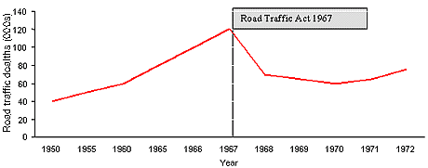
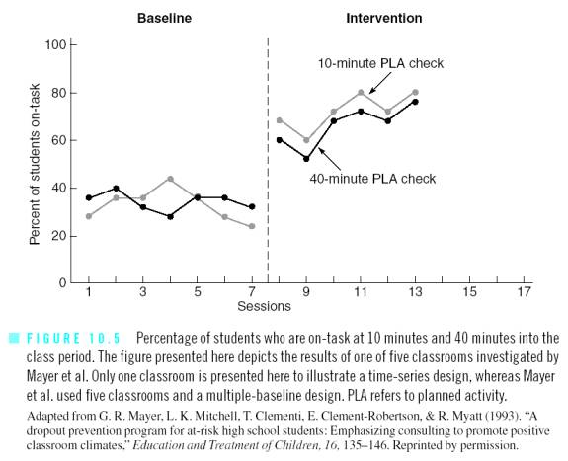

- Can combine time series design with non-equivalent comparison group design

C. Program Evaluation
Overview
- Program evaluation: study geared toward evaluating the effectiveness of specific programs
- Often draws upon quasi-experimental designs, but includes other aspects of research
Needs Analysis (or Needs Assessment)
- Three main steps
  - Determine whether a sufficient number of people believe a problem exists
  - Review research to determine whether an appropriate intervention exists
  - Determine whether people facing the problem would make use of the intervention program
- Sufficient support?
  - Availability heuristic problem
  - Census or other public demographic data
  - Examine available resources (competitors)
  - Use survey research; don’t need IRB approval if for informal use only
  - Key informants, focus groups, and community forums
Formative Evaluations
- Monitor progress of a program
- Fidelity check: examine whether the program is being implemented as planned
- Program audit: continued collection of data on how a program is being used
- Pilot studies: examine initial success; consider modifying aspects of the program
Summative Evaluations
- Assess overall effectiveness of a program
- Often avoided by groups that have a vested interest in finding a particular outcome (e.g., politicians, corporations, think-tanks)
Cost-Effectiveness Analysis
- Used to examine the efficiency of competing programs
- Outcomes are measured in improvement per dollar

